**SQL QUERIES AND RESULTS**

**Q1. How many unique post types are found in the 'fact_content' table?**

**SQL Query:**

SELECT

COUNT(DISTINCT Post_type) AS unique_post_types_count,

GROUP_CONCAT(DISTINCT Post_type`) AS post_type_names

FROM fact_content;

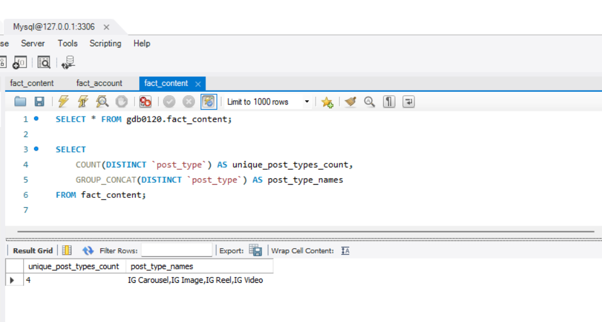

**2. What are the highest and lowest recorded impressions for each post type?**

**SQL Query:**

SELECT

Post type AS post_type,

MAX(Impressions) AS highest_impressions,

MIN(Impressions) AS lowest_impressions

FROM fact_content

GROUP BY Post_type;

**3. Filter all the posts that were published on a weekend in the month of March and April and export them to a separate csv file.**

**SQL Query:**

SELECT fc.*

FROM fact_content fc

JOIN dim_date dd ON fc.date = dd.date

WHERE dd.month_name IN ('March', 'April')

AND dd.Weekday&Weekend = 'Weekend';

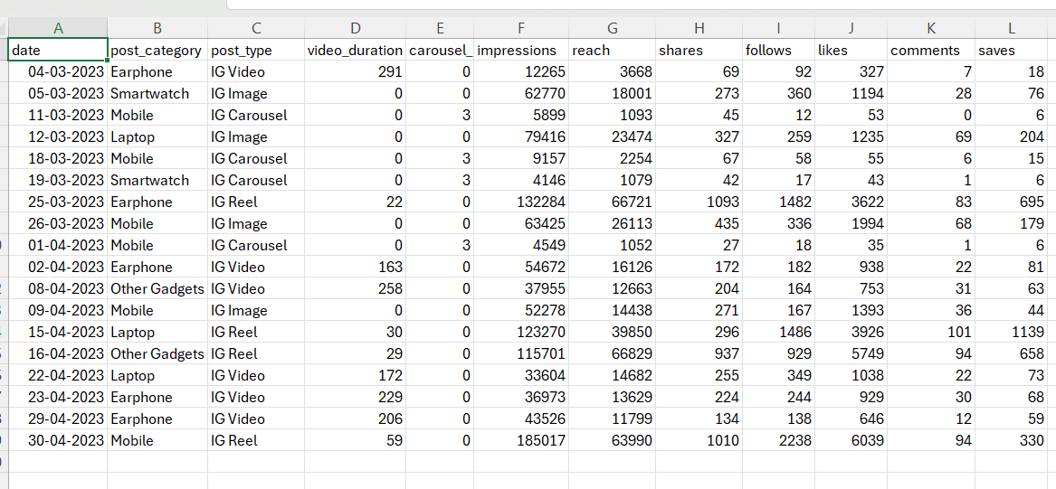

**4. Create a report to get the statistics for the account. The final output includes the following fields:**

* **month_name**
* **total_profile_visits**
* **total_new_followers**

**SQL Query:**

SELECT

dd.Month Name AS month_name,

SUM(fa.Profile Visits) AS total_profile_visits,

SUM(fa.New Followers) AS total_new_followers

FROM fact_account fa

JOIN dim_date dd ON fa.Date = dd.Date

GROUP BY dd.Month Name

ORDER BY FIELD (dd.`Month Name`, 'January', 'February', 'March', 'April', 'May', 'June’, ‘July', 'August', 'September');

**5.Write a CTE that calculates the total number of 'likes’ for each 'post_category' during the month of 'July' and subsequently, arrange the 'post_category' values in descending order according to their total**

**SQL Query:**

WITH july_likes AS (

SELECT

fc.Post category / Segment AS post_category,

fc.Likes

FROM

fact_content fc

JOIN

dim_date dd ON fc.Date = dd.Date

WHERE dd.Month Name = 'July'

)

SELECT

post_category,

SUM(likes) AS total_likes

FROM july_likes

GROUP BY post_category

ORDER BY total_likes DESC;

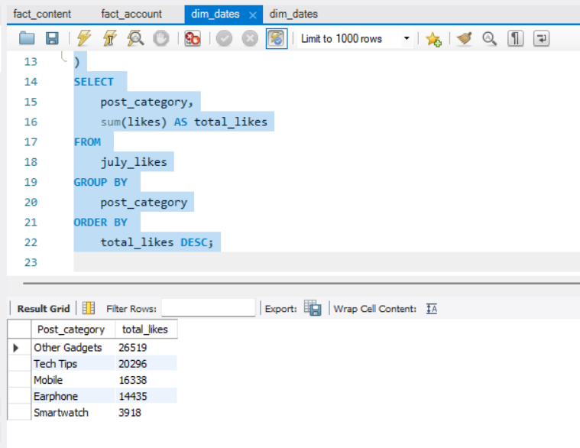

**6. Create a report that displays the unique post_category names alongside their respective counts for each month. The output should have three columns:**

**• month_name**

**• post_category_names**

**• post_category_count**

**SQL Query:**

SELECT

dd.Month Name AS month_name,

GROUP_CONCAT(DISTINCT fc.Post category / Segment

ORDER BY fc.Post category / Segment) AS post_category_names,

COUNT(DISTINCT fc.Post category / Segment) AS post_category_count

FROM

fact_content fc

JOIN

dim_date dd ON fc.Date = dd.Date

GROUP BY

dd.Month Name

ORDER BY

FIELD(dd.MonthName,'January','February','March','April','May','June','July','August','September');

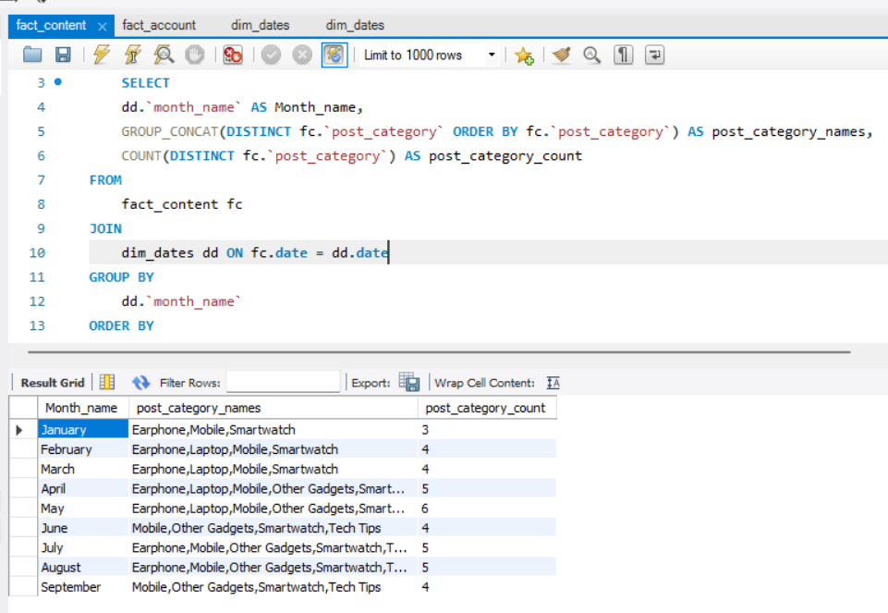

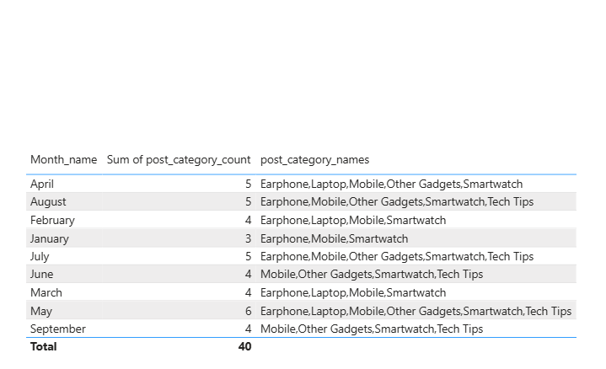

**7. What is the percentage breakdown of total reach by post type? The final output includes the following fields:**

**• post_type**

**• total_reach**

**• reach_percentage**

**SQL Query:**

SELECT

`Post type` AS post_type,

SUM(Reach) AS total_reach,

ROUND((SUM(Reach) / (SELECT SUM(Reach) FROM fact_content)) * 100, 2) AS reach_percentage

FROM fact_content

GROUP BY `Post type`

ORDER BY total_reach DESC;

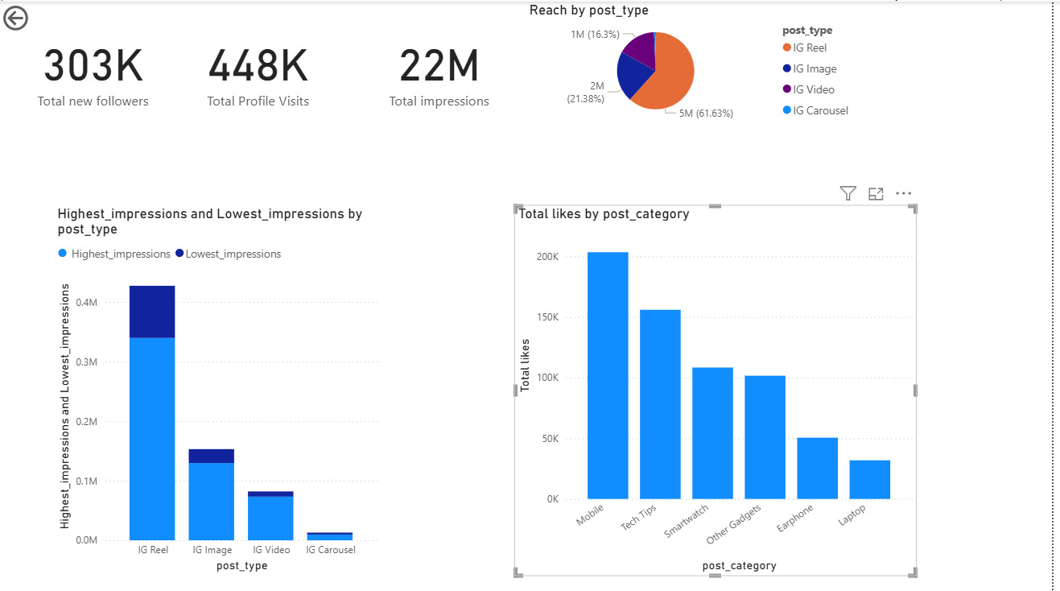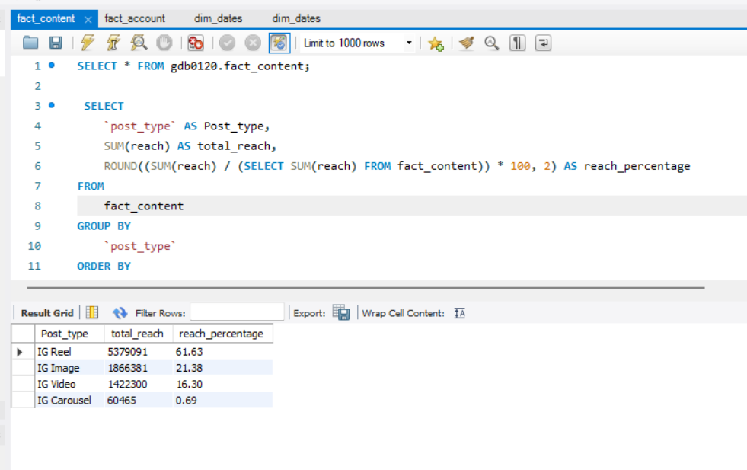

**8. Create a report that includes the quarter, total comments, and total saves recorded for each post category. Assign the following quarter groupings: (January, February, March) → “Q1” (April, May, June) → “Q2” (July, August, September) → “Q3” The final output columns should consist of:**

**• post_category**

**• quarter**

**• total_comments**

**• total_saves**

**SQL Query:**

SELECT

fc.Post category / Segment AS post_category,

CASE

WHEN dd.Month Name IN ('January', 'February', 'March') THEN 'Q1'

WHEN dd.Month Name IN ('April', 'May', 'June') THEN 'Q2'

WHEN dd.Month Name IN ('July', 'August', 'September') THEN 'Q3'

END AS quarter,

SUM(fc.Comments) AS total_comments,

SUM(fc.Saves) AS total_saves

FROM fact_content fc

JOIN dim_date dd ON fc.Date = dd.Date

GROUP BY post_category, quarter

ORDER BY quarter, post_category;

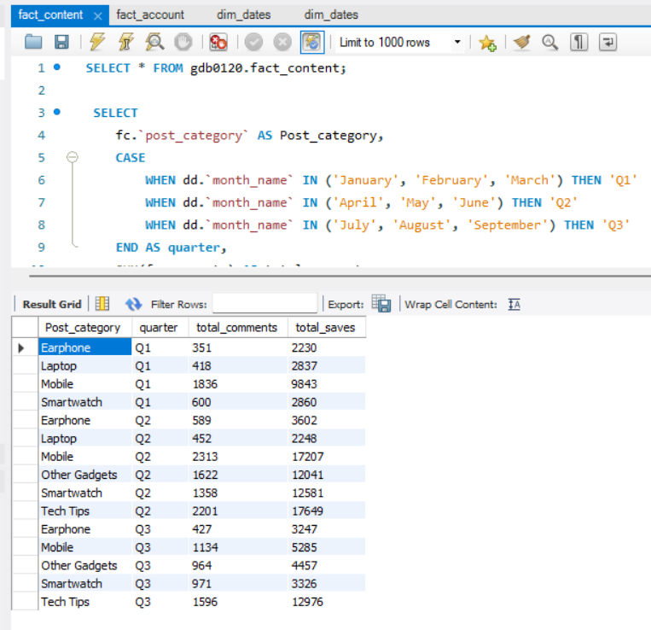

**9. List the top three dates in each month with the highest number of new followers. The final output should include the following columns:**

**• month**

**• date**

**• new_followers**

**SQL Query:**

WITH ranked_dates AS (

SELECT

dd.Month Name AS month,

fa.Date,

fa.New Followers AS new_followers,

RANK() OVER (PARTITION BY dd.Month Name ORDER BY fa.New Followers DESC) AS rank_val

FROM fact_account fa

JOIN dim_date dd ON fa.Date = dd.Date

)

SELECT

month,

Date,

new_followers

FROM ranked_dates

WHERE rank_val <= 3

ORDER BY month, new_followers DESC;

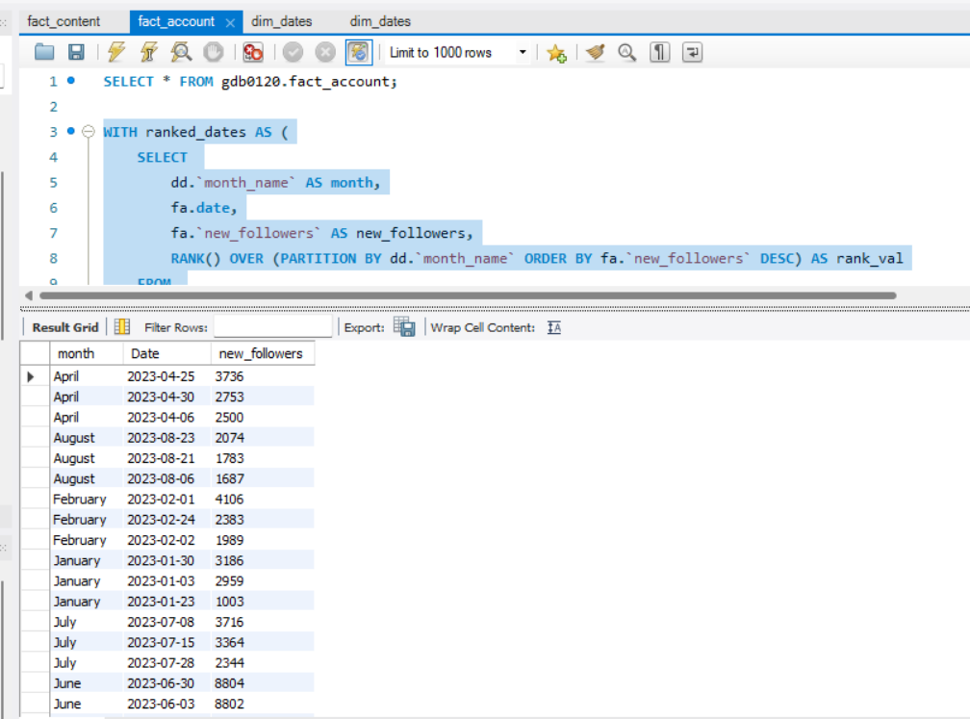

**10. Create a stored procedure that takes the 'Week_no' as input and generates a report displaying the total shares for each 'Post_type'. The output of the procedure should consist of two columns:**

**• post_type**

**• total_shares**

**SQL Query:**

DELIMITER $$

CREATE PROCEDURE GetSharesByPostType(IN input_week_no INT)

BEGIN

SELECT

fc.`Post type` AS post_type,

SUM(fc.Shares) AS total_shares

FROM

fact_content fc

JOIN

dim_date dd ON fc.Date = dd.Date

WHERE

dd.`Week No` = input_week_no

GROUP BY

fc.`Post type`;

END $$

DELIMITER ;

CALL GetSharesByPostType(19)

