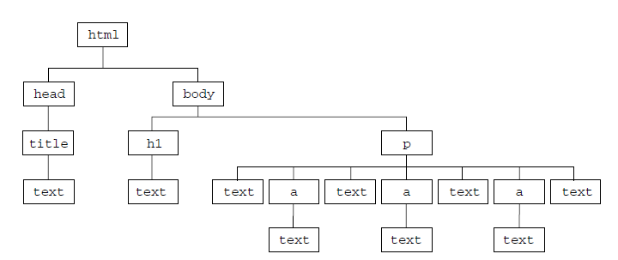

2. Traverse the doc with head, body, h1, p, – using the dom properties.

3. Use the shortcuts – to change the style of the h1 element.

4. Use the class name property to attach another class to the h1 element.

5. Add a list of movies to the page and use the dom function to add one more to the list.

6. Dom blog – use the concepts of dom to create and add new post entries with date/time stamp.