ASSIGNMENT 5

AGILE SOFTWARE ENGINEERING

**1. What is meant by Docker**

**Docker image**

**Docker Container**

**Docker file**

**Docker –** It is a container which contain software, Operating system and libraries.

**Docker image -** A Docker image is a lightweight, standalone that includes everything needed to run an application, including the code, runtime, libraries, tools, and system dependencies

**Docker Container -** Docker Container: A Docker container is a running instance of a Docker image. It is a lightweight and isolated runtime environment that encapsulates an application and its dependencies.

**Docker files** - are written using a simple syntax and a set of predefined instructions provided by Docker. By using a Docker file, you can automate the image creation process and ensure consistency across different environments and deployments.

**2. Go through the attached paper using this URL and test calculator using PYUNIT**

**https://python.plainenglish.io/python-unittest-how-to-test-your-program-the-right-way-**

**30f1a459d9d1**

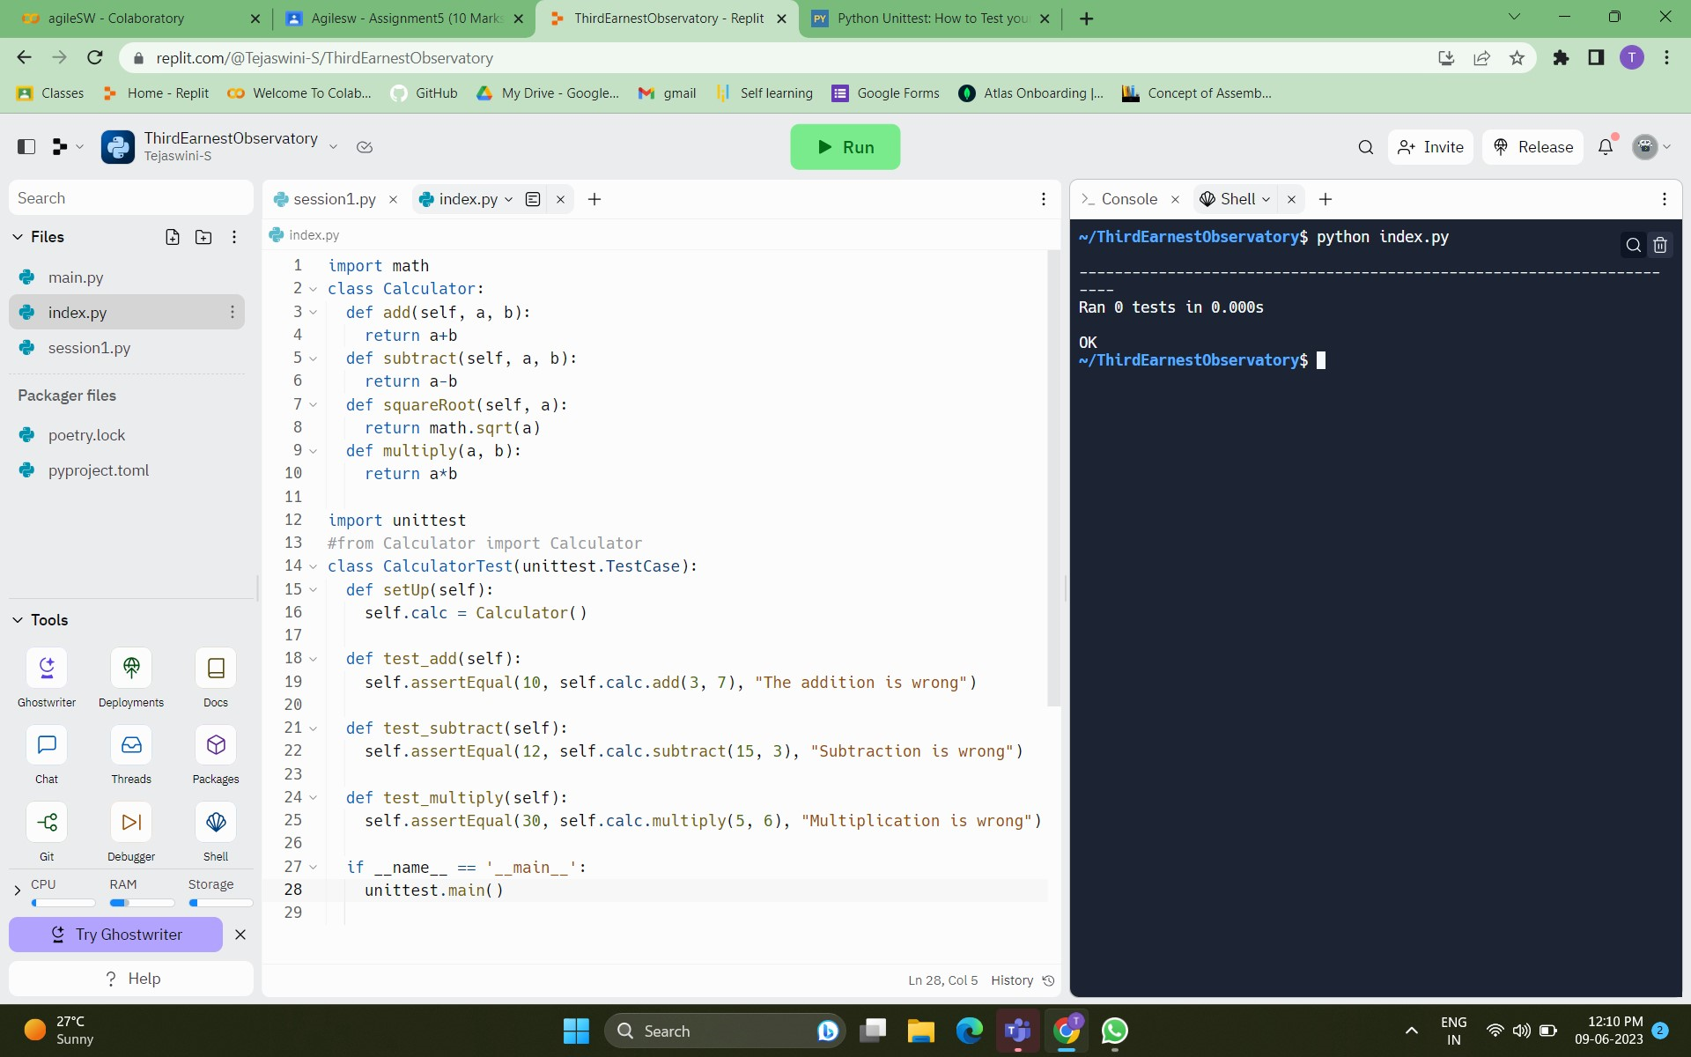

**3. Write Python Program and store it in GIT/GitHub**

a=2

b=2

if(a%b==0):

print("a equal to b")

else :

print("a is not equal to b")

Git hub link -https://github.com/tejaswinise18/Agile_software/blob/main/python.py

**4) Explain how tool maven works.**

Maven is a popular build automation and dependency management tool primarily used in Java projects. It simplifies the project build process and handles tasks such as compilation, testing, packaging, and deployment.

**5) Explain how Jenkins can be used as an orchestration tool**

Jenkins is a widely used open-source automation server that can be leveraged as an orchestration tool in various software development processes