

Software Requirements Specification

For

Machine Learning In Diabetes

Done by

Tejaswini SE

1.Introduction

**Document Purpose:** To detect if the person is suffering from diabetes using glucose and blood pressure as features and Diabetes as label.

**Product Scope:** helps to check if a person has diabetics

**Intended Audience:** Developer, Tester

2.Overall Description

**Product Overview:**

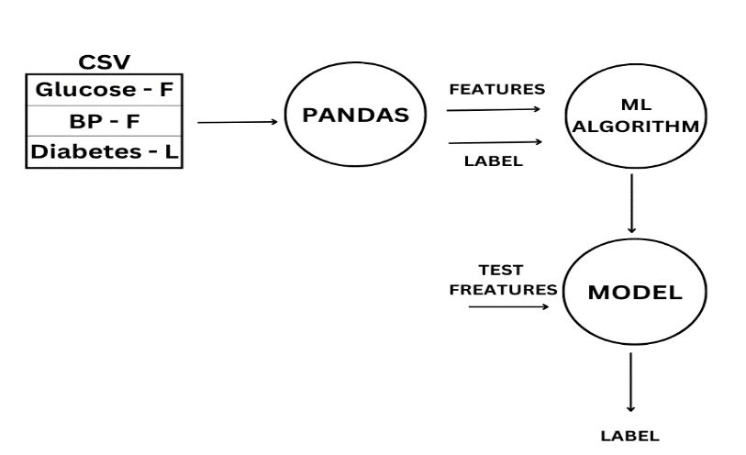

**Product Functionality:**

R1: Download data in CSV format

R2: Using pandas extract features and label from CSV file

R3: Build ML Model using ML Algorithm

R4: Predict using the test cases

3.Functional Requirements

Download data in CSV format

Using pandas extract features and label from CSV file

Build ML Model using ML Algorithm

Predict using the test cases

4.Other Requirements N/A