OPERATING SYSTEMS
WEEK-01 PRACTICAL

NAME : Raavi Bhavitha
ROLL NO : 2520030489
SECTION -07

>Develop a C program that uses the system calls open(), read(), write(), and close() to copy the contents of one file to another. Explain how control transitions between user space and kernel space during execution.
CODE:
#include <stdio.h>
#include <stdlib.h>
#include <unistd.h>
#include <sys/types.h>
#include <sys/wait.h>

int main()
{
char command[100];

printf("Enter a Linux command: ");
scanf("%s", command);

pid_t pid = fork();

if (pid < 0)
{
perror("fork failed");
return 1;
}

if (pid == 0)
{
// Child process
printf("\nChild Process\n");
printf("Child PID: %d\n", getpid());
printf("Parent PID: %d\n", getppid());

execlp(command, command, NULL);

perror("exec failed");
exit(1);
}
else
{
// Parent process
printf("\nParent Process\n");
printf("Parent PID: %d\n", getpid());
printf("Child PID: %d\n", pid);

wait(NULL);

printf("\nChild process completed.\n");
}

return 0;
}

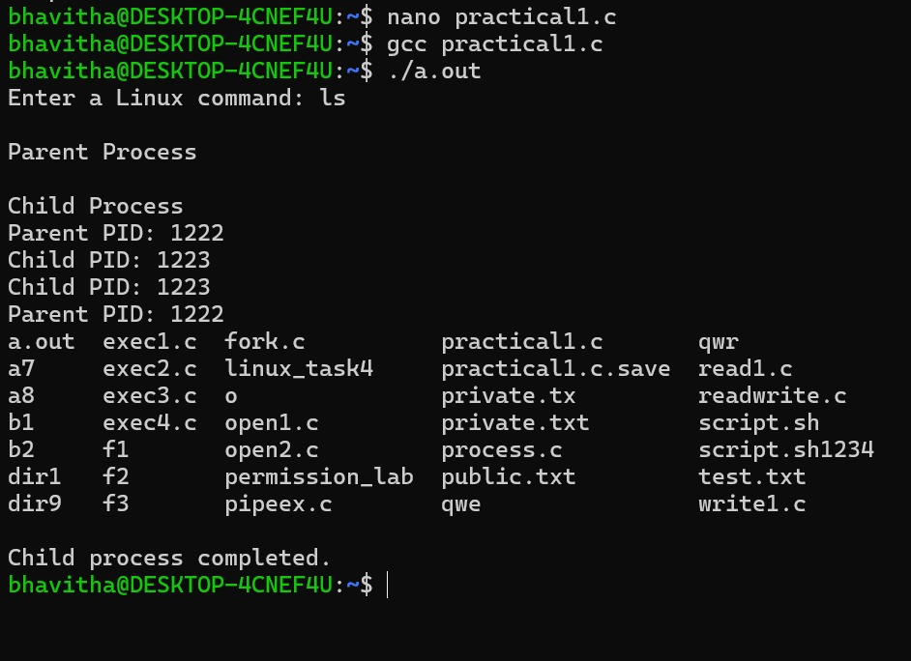

>Using Linux terminal commands (uname, lscpu, lsblk, ps, top), investigate the relationship between hardware resources and operating system services. Prepare a report explaining how the OS abstracts CPU, memory, storage, and I/O devices.
-uname
-lscpu
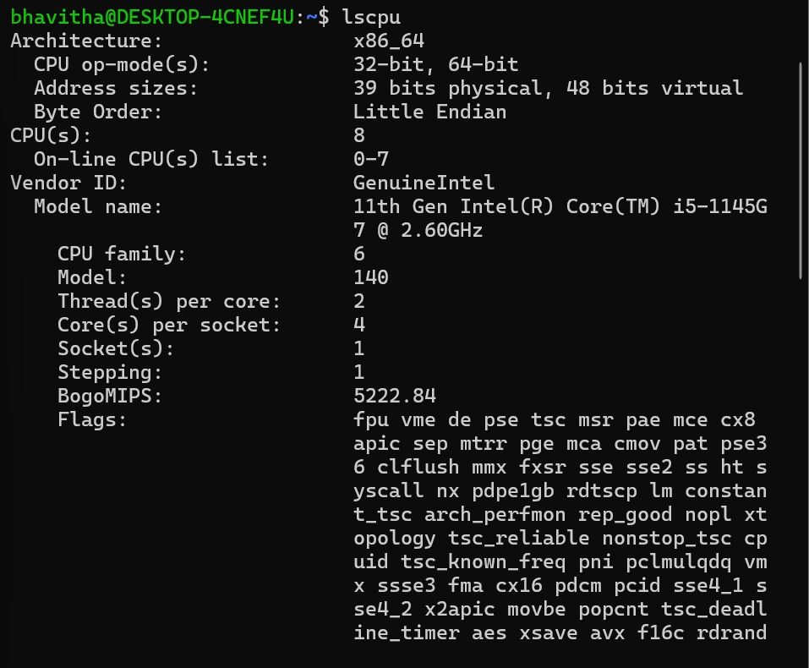

-lsblk
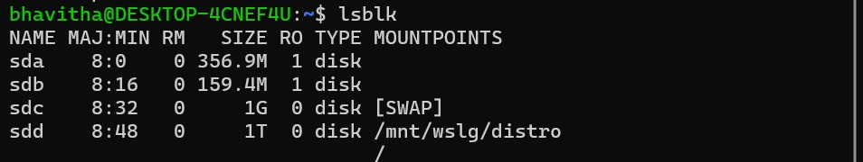
-ps
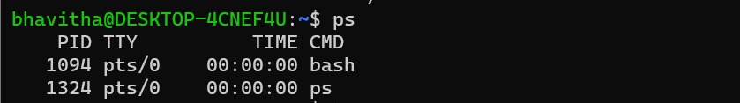

-top
