Practical - 4

Task - 1:
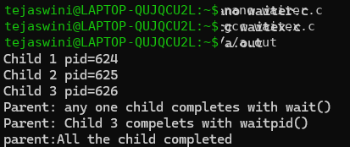

Task - 2:
zombie.c
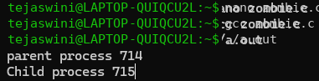

Terminal 2:

Eliminate Zombie Process:

Terminal 2:

