Ai Assisted Coding
Name: V. Tejaswini
Enroll.no:2503a52696
Batch:24
Experiment 6: AI-Based Code Completion: Working with
suggestions for classes, loops, conditionals
Task1: Use an AI code completion tool to generate a loop-based
program.
Prompt:
“Generate Python code to print all even numbers between 1 and N
using a loop.”
Expected Output:
- AI-generated loop logic.
- Identification of loop type used (for or while).
- Validation with sample inputs.
Input
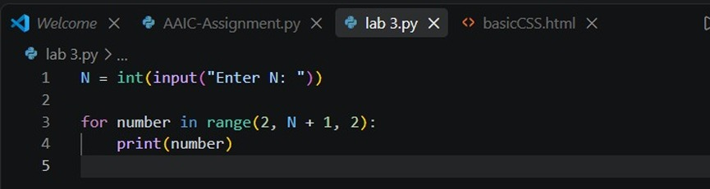
Output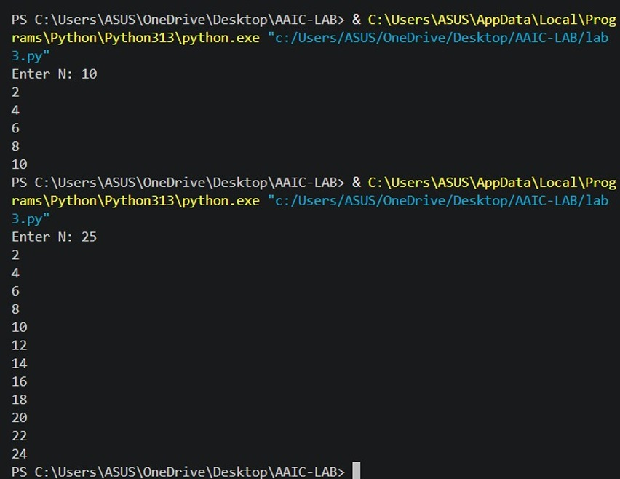

Task2: Use an AI code completion tool to combine loops and
conditionals.
Prompt:
“Generate Python code to count how many numbers in a list are even
and odd.”
Expected Output:
- AI-generated code using loop and if condition.
- Correct count validation.
- Explanation of logic flow.

Input
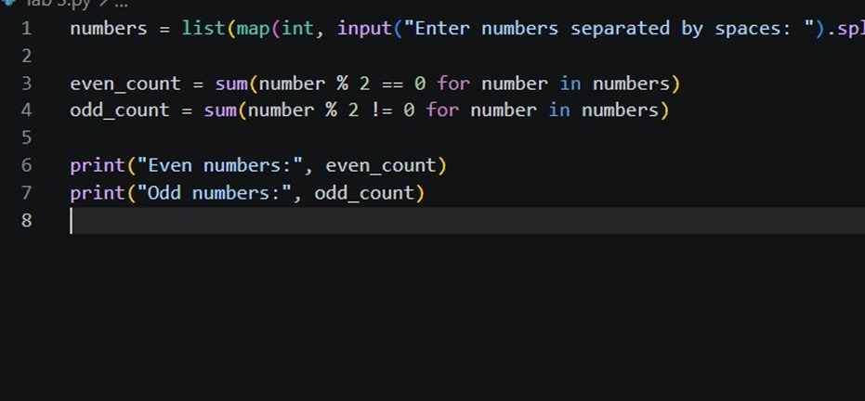
Output
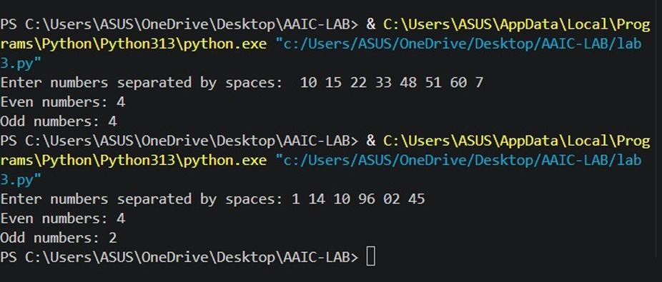
Task3: Use an AI tool to complete a Python class that validates user
input.
Prompt:
“Generate a Python class User that validates age and email using
conditional statements.”
Expected Output:
- AI-generated class with validation logic.
- Verification of condition handling.
- Test cases for valid and invalid inputs.
Input
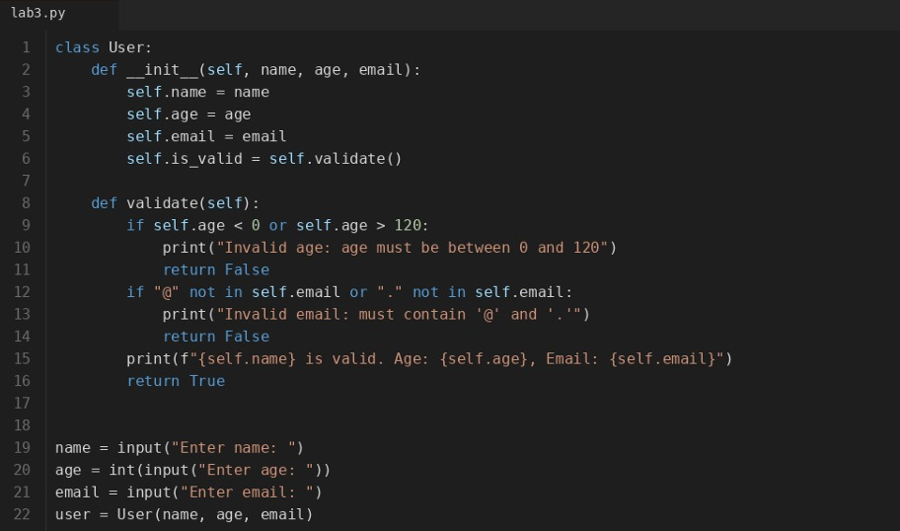
Output
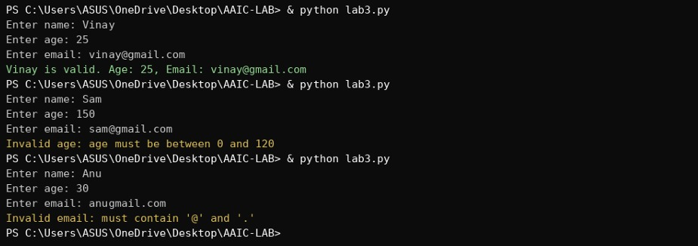
Task4: Use an AI code completion tool to generate a Python class for
managing student details.
Prompt:
“Generate a Python class Student with attributes (name, roll number,
marks) and methods to calculate total and average marks.”
Expected Output:
- AI-generated class code.
- Verification of correctness and completeness of class
structure.
- Minor manual improvements (if needed) with justification.
Input
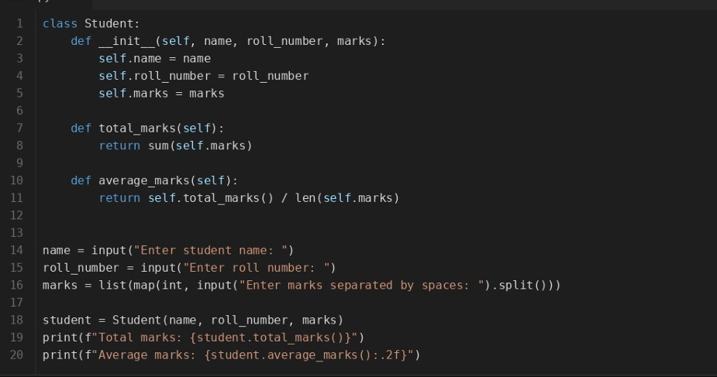

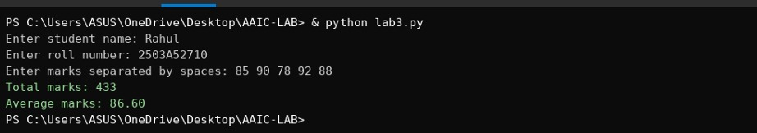
Output

Task5: Use an AI tool to generate a complete Python program using
classes, loops, and conditionals together.
Prompt:
“Generate a Python program for a simple bank account system using
class, loops, and conditional statements.”
Expected Output:
- Complete AI-generated program.
- Identification of strengths and limitations of AI suggestions.
- Reflection on how AI assisted coding productivity.

Input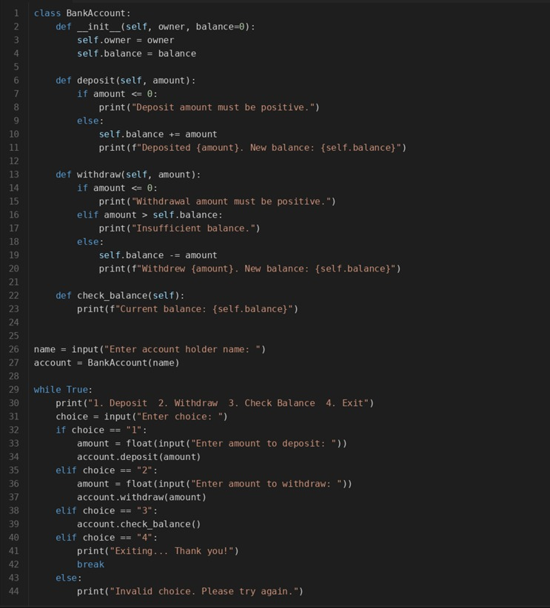

Output
