AI Assisted Coding
Lab Experiment: Prompt Engineering – Improving Prompts and Context Management
Name: V.Tejaswini
Enroll.no:2503a52696
Batch.no:24
Question 1: Zero-Shot Prompting (Palindrome Number Program)
Prompt: generate a Python code that checks whether a given number is a palindrome
INPUT
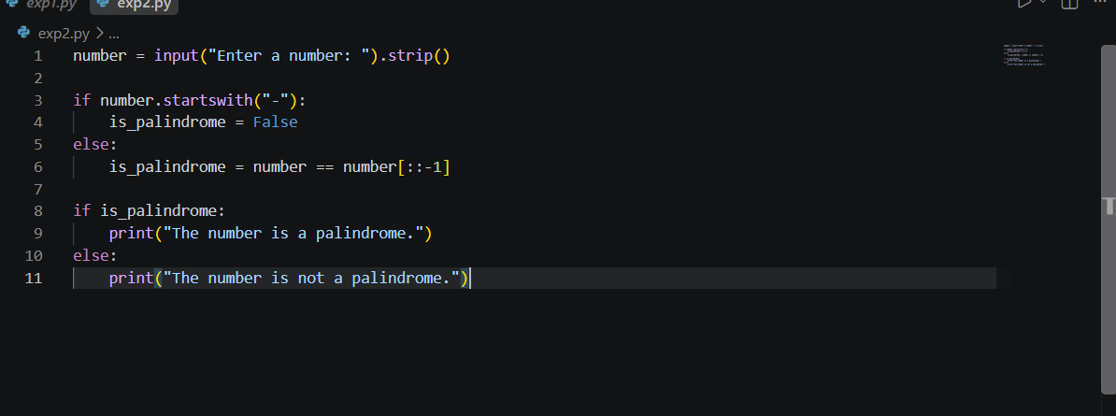
Output
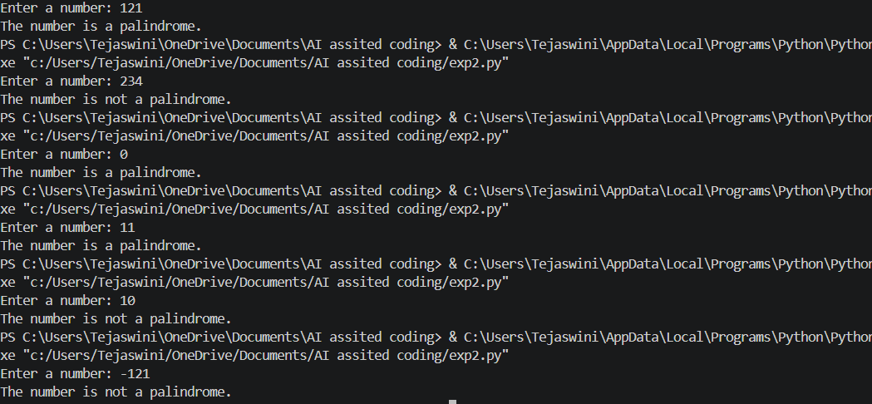
Logical Errors / Edge-Case Handling:
- The generated code correctly identifies palindrome and non-palindrome numbers by comparing the input with its reverse.
- Negative numbers (e.g., -121) are handled separately and are considered not palindromes.
- Single-digit numbers (e.g., 7) are correctly identified as palindromes.
- The code works for 0, which is also a palindrome.
- No logical errors were found during testing with the chosen inputs.
Question 2: One-Shot Prompting (Factorial Calculation)
Prompt: generate a Python function to compute the factorial of a given number. For example Input: 5 → Output: 120
Input
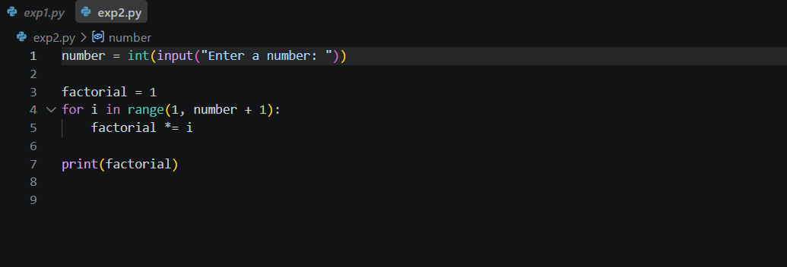
Output
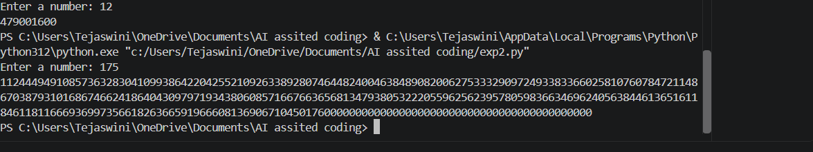
Comparison with Zero-Shot Solution
- The one-shot prompt provides an example (5 → 120), which gives the AI a clear pattern to follow.
- Compared with the zero-shot solution, the one-shot prompt can make the expected input-output relationship clearer.
- Both approaches can produce correct factorial calculations, but the one-shot prompt gives additional guidance through the example.
Question 3: Few-Shot Prompting (Armstrong Number Check)
Prompt: Generating a Python Code to check whether a given number is an Armstrong number. Examples
Input: 153 → Output: Armstrong Number
Input: 370 → Output: Armstrong Number
Input: 123 → Output: Not an Armstrong Number
Input
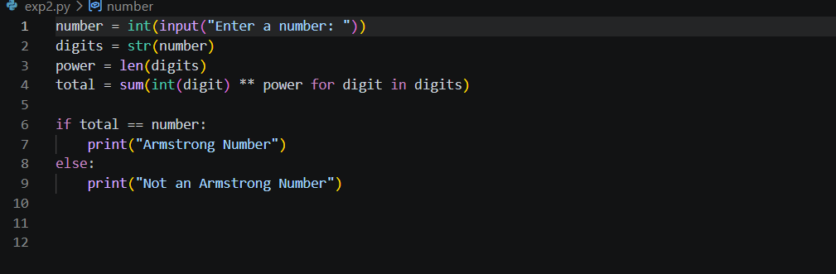
Output
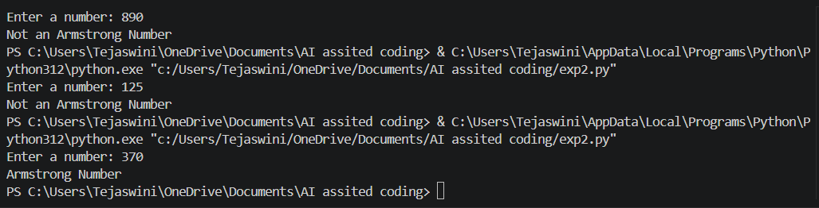

Analysis: Effect of Few-Shot Examples
Providing multiple examples helps the AI understand both possible outputs: Armstrong Number and Not an Armstrong Number.
The examples include two positive cases (153, 370) and one negative case (123), which guides the AI toward the correct comparison logic.
The generated code is simple and correctly follows the pattern shown in the examples.
Multiple examples improve clarity and reduce the chance of the AI misunderstanding what output is expected.
Question 4: Context-Managed Prompting (Optimized Number Classification)
Prompt: Create an optimized Python program to classify a number as prime, composite, or neither.
Requirements:
- Validate input properly.
- Numbers below 2 → neither.
- Check divisors only up to √n for efficiency.
- Test boundary, prime, composite, negative, and invalid inputs.
- Provide the code, sample outputs, and briefly compare it with a basic less-efficient approach.

Input:
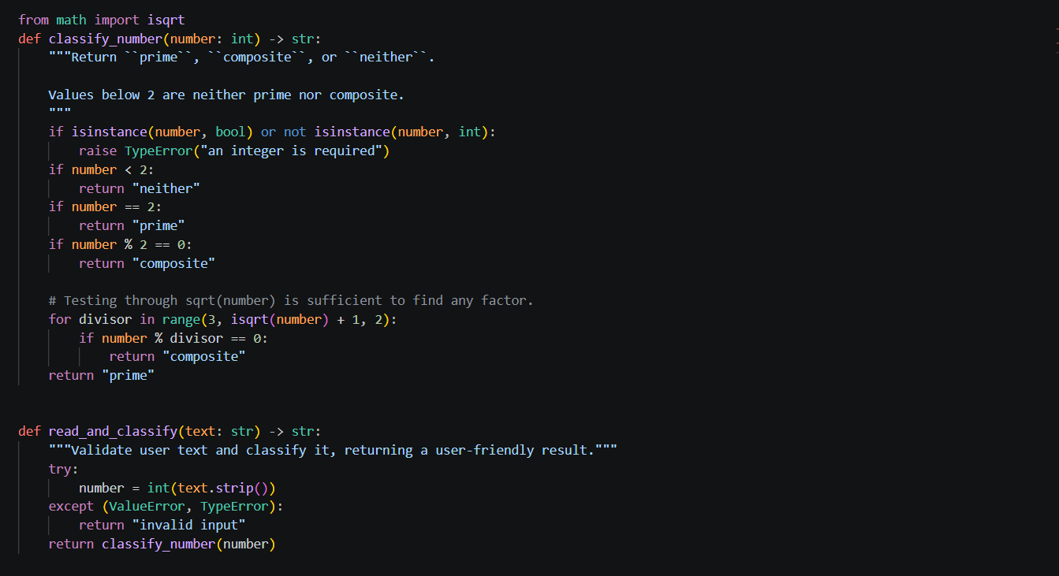
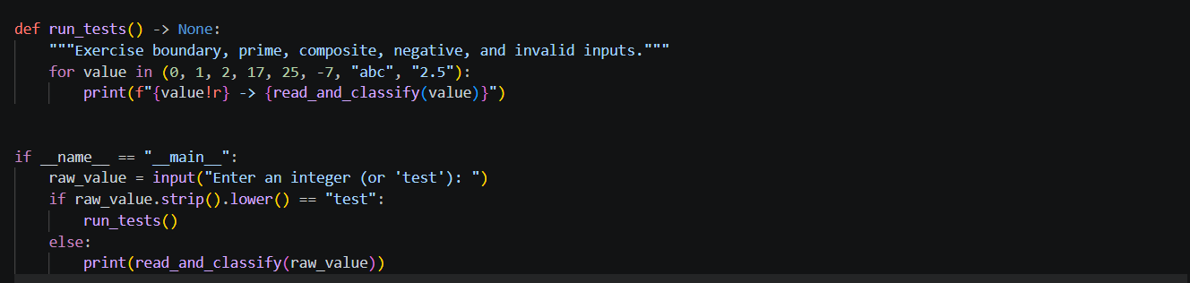
Output:
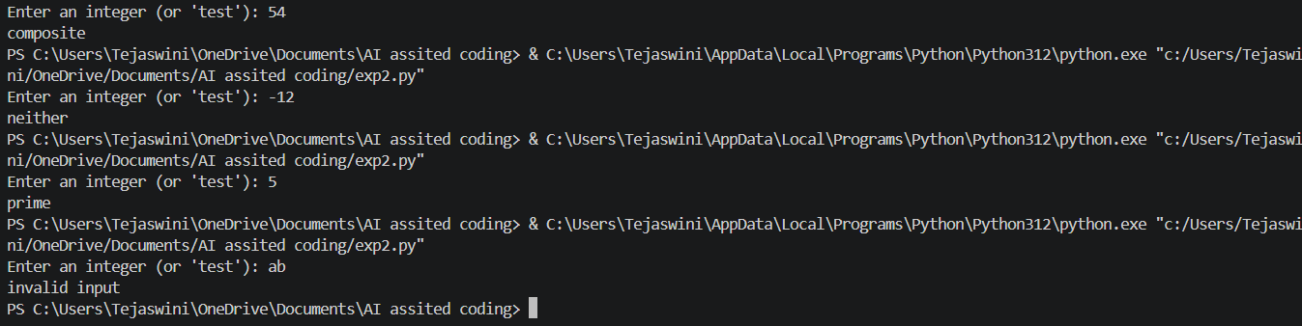

Comparison with Earlier Prompting Strategies
- The zero-shot approach gives basic instructions and may generate a simpler solution.
- The one-shot/few-shot approaches provide examples, which can help the AI understand the expected output.
- The context-managed prompt gives explicit requirements such as input validation, edge cases, and efficiency.
- Therefore, the context-managed approach produces a more complete, robust, and efficient program than the earlier basic approaches
Question 5: Zero-Shot Prompting (Perfect Number Check)
Prompt: Generate a Python function that checks whether a given number is a perfect number.
Input
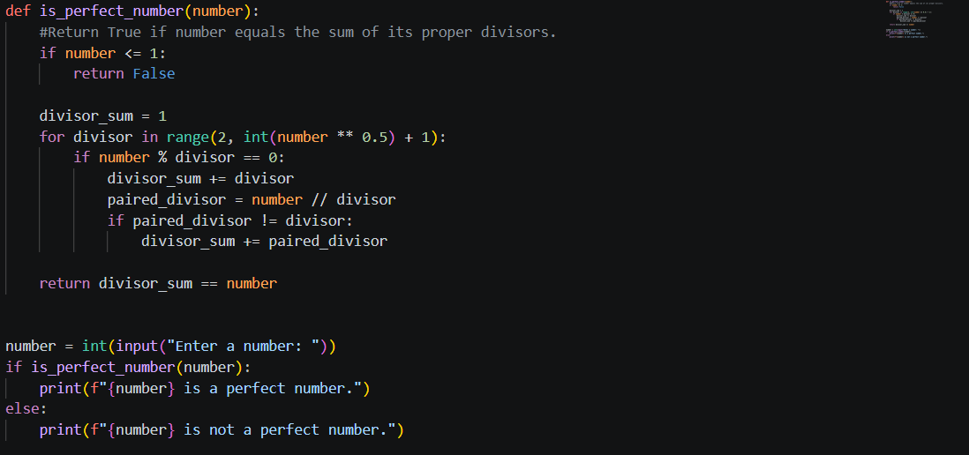

Output
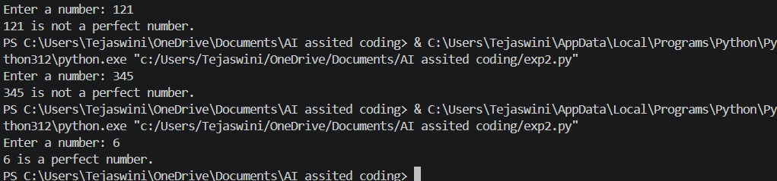
Missing Conditions:
- Invalid/non-numeric input is not handled. If the user enters text such as abc, int(input()) will cause an error.
- Negative numbers should explicitly be rejected as perfect numbers. Your if number <= 1: condition already handles this, so this is actually covered.
- 0 and 1 are correctly handled as not perfect numbers because of number <= 1.

