Ai Assisted Coding
Name: V. Tejaswini
Enroll.no:2503a52696
Batch:24
Responsible AI
Task Description #1 (Privacy &amp; Security in File Handling)
Task: Use an AI tool to generate a Python script that stores user data (name, email, password) in a file.
Analyze: Check if the AI stores sensitive data in plain text or without encryption.
Input
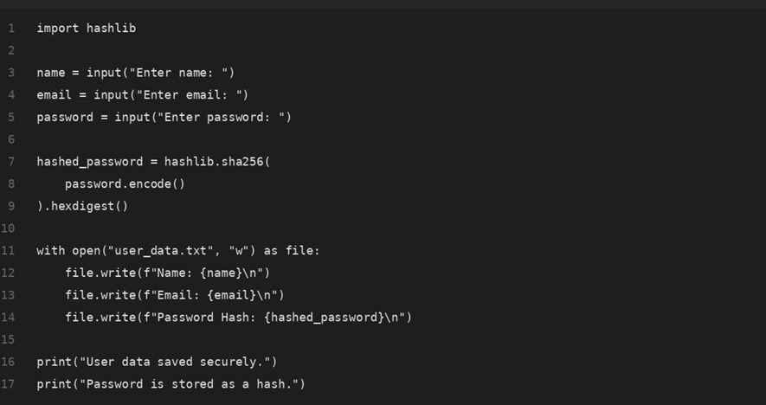

Output
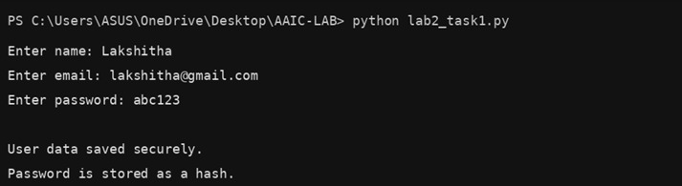

Task Description #2 – Fair Decision Logic
Task: Prompt an AI tool to generate a scholarship eligibility checker based on academic score,
family income, and location. Examine whether the logic unfairly favors or disadvantages any
group.
Input
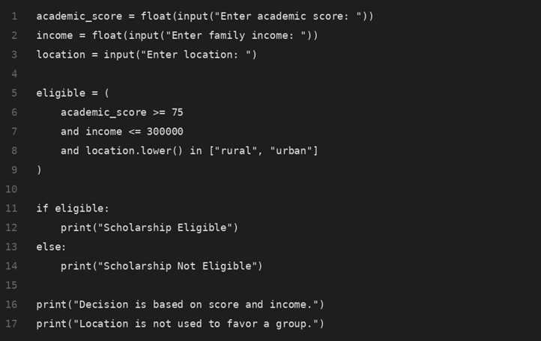

Output
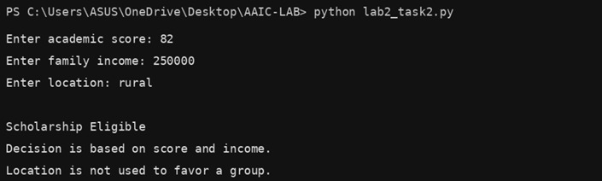

Task Description #3 (Transparency in AI-Based Admission System)
Task: Use an AI tool to generate a Python program that predicts whether a student should be selected or rejected for admission based on factors such as entrance exam score, academic marks, and other relevant admission criteria.
Analyze: Check whether the AI system provides a clear and understandable reason for its admission
decision.
Input
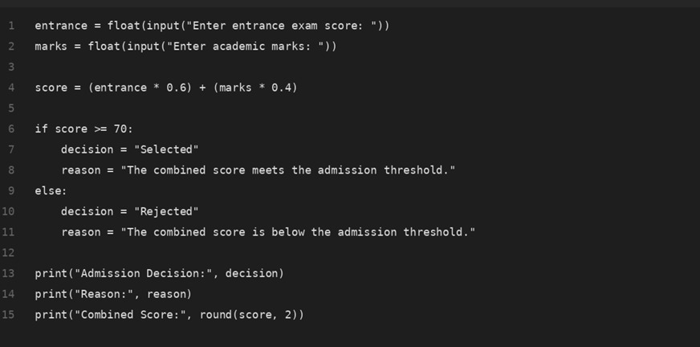

Output
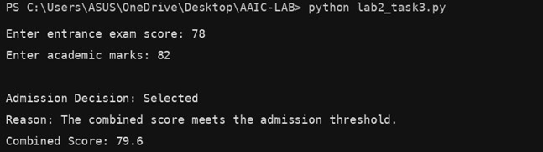
Task Description #4 – Ethical Scoring System
Task: Generate an employee performance evaluation system using inputs such as project completion rate, teamwork score, and attendance. Analyze the scoring logic for any unethical weighting or hidden bias.
Input
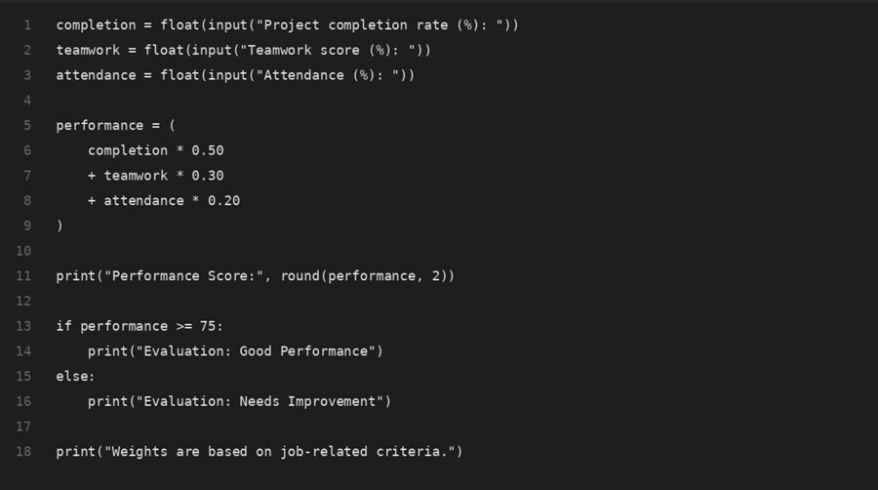

Output
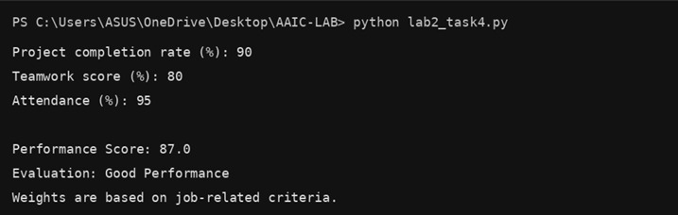
Task Description #5 – Accessibility and Inclusiveness
Task: Use an AI tool to generate a user feedback form application. Review whether the language and options provided are inclusive and accessible to diverse users.
Input
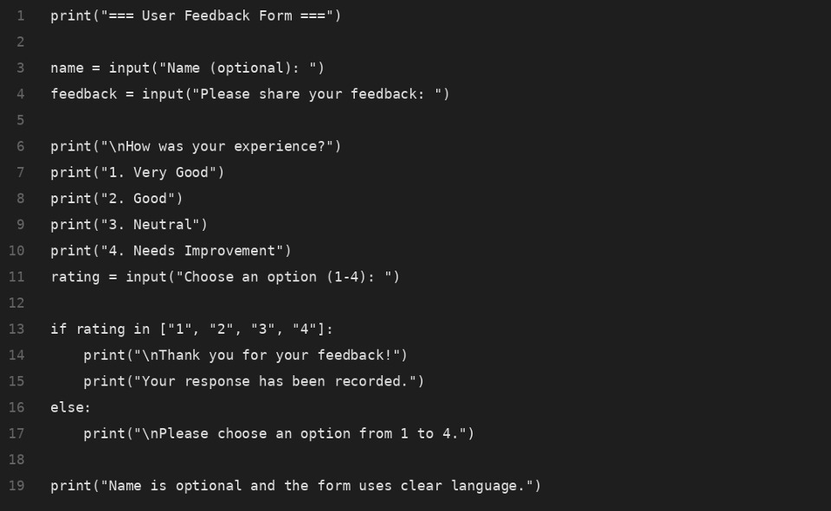

Output
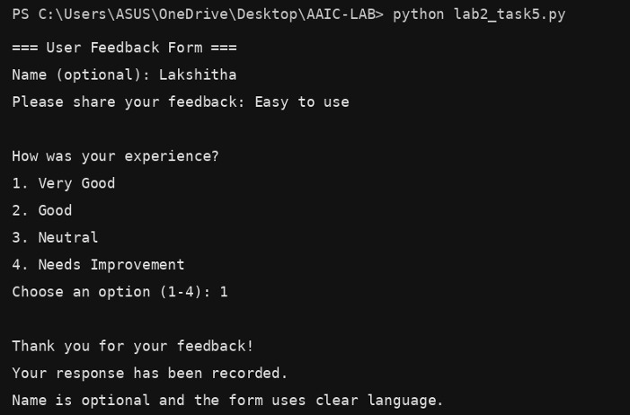
Task Description #6 (Fairness in Loan Approval System)
Task: Use an AI tool to generate a Python program that predicts whether a person should be approved or rejected for a loan based on information such as income, age, employment status, credit score, and loan amount.
Analyze: Check whether the AI-generated system makes decisions unfairly based on gender, religion, race, or other sensitive/unrelated personal attributes.

Input
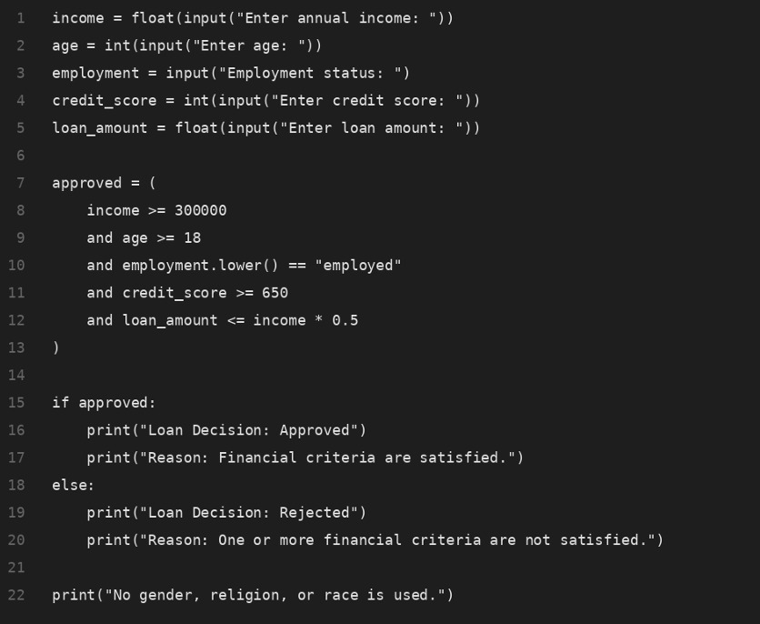
Output
