**Docker**

**Introduction**

Docker is software that allows running and deploying software application as lightweight containers. Idea behind it is to create portable lightweight containers for software applications that can be run on any machine with Docker installed.

Docker allows packaging an application with all of its dependencies into a standardized unit that will always run the same regardless of the environment it is running in.

It functions only on Linux systems, it cannot function natively on Windows and OSx, Linux on virtual machine is required for this.

**Virtual Machine vs. Docker**

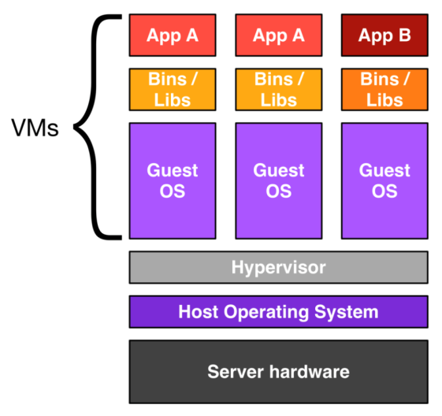

VM configuration stack has Hypervisor layer which creates virtual hardware from host OS that will be consumed by guest OS. On Guest OS software applications, binaries and libraries supported can be installed. VM provides complete isolation of host OS, where if anything goes wrong in an application or your guest OS, it won’t impact the host OS or screw up other guest Oss. The server that hosts or is running the stack has to pay a huge amount of computing resources to the virtual app.

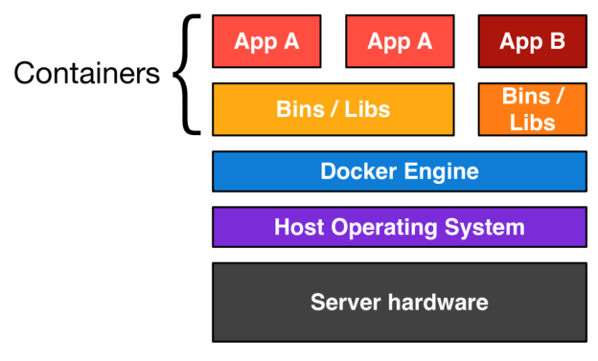

“Docker has rule of having one container for a single process.”

Docker Engine is lightweight runtime and robust tooling that builds and runs Docker containers. Container contains everything it needs to run software like code, runtime, system tools, system libraries, which guarantees same execution regardless of environment. Docker Engine provides virtual environment for multiple containers without duplicating virtual hardware in guest OSs.

**Docker Building Blocks**

**Containers**  
Containers contain everything required to run or install an application thus assuring same behavior regardless of execution environment. They are lightweight as they share same OS so they start instantly and make more efficient use of RAM. As VMs containers also isolate applications from each other and underlying infrastructure but containers are more portable and efficient due to different architectural approach.

Images

Links

Volume

Dockerfile