- Weather Forecasting Simulation System
import random
import time
# Algorithm 1: O(n log n)
def algorithm_nlogn(arr):
return sorted(arr)
# Algorithm 2: O(n² log n)
def algorithm_n2logn(arr):
n = len(arr)
# Repeat sorting n times
for i in range(n):
sorted(arr) # O(n log n)
return arr
# Test different input sizes
sizes = [100, 500, 1000, 2000]
print("{:<10} {:<15} {:<15}".format("Size", "O(n log n)", "O(n² log n)"))
for size in sizes:
data = [random.randint(1, 10000) for _ in range(size)]
# Measure O(n log n)
start = time.time()
algorithm_nlogn(data.copy())
time1 = time.time() - start
# Measure O(n² log n)
start = time.time()
algorithm_n2logn(data.copy())
time2 = time.time() - start
print("{:<10} {:<15.6f} {:<15.6f}".format(size, time1, time2))
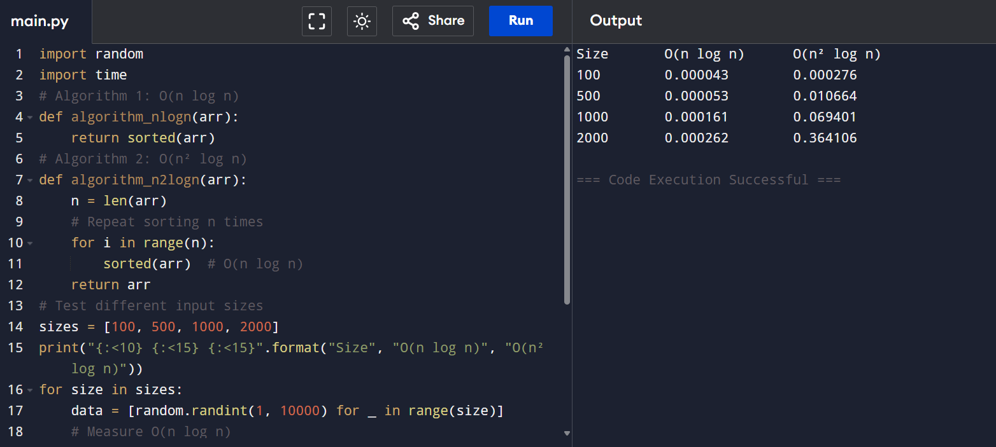

- Online Learning Recommendation System
n = int(input("Enter the number of users (n): "))
T = n * (n + 1) // 2
print(f"T({n}) = {T}")
