
Design and Development of a Web-Based Internship and Placement Management System Using Java
A CAPSTONE PROJECT REPORT
Submitted in the partial fulfilment for the Course of
CSA0927 – Programming in Java
to the award of the degree of
BACHELOR OF TECHNOLOGY
IN
Computer Science and Engineering
Submitted by
N.Tejaswitha (192371057)
N.Vijetha (192311258)
B.Neha (192425033)
V.S.Meenakshy (192325133)
Under the Supervision of
Dr.S.Pushpa Latha
Professor / CSE
SIMATS ENGINEERING
Saveetha Institute of Medical and Technical Sciences
Chennai – 602 105.
SIMATS ENGINEERING
Saveetha Institute of Medical and Technical Sciences
Chennai – 602 105

DECLARATION

We N.Tejaswitha (192371057), N.Vijetha(192311258), B.Neha(192425033), V.S.Meenakshy (192325133) of the Programming in Java, Saveetha Institute of Medical and Technical Sciences, Saveetha University, Chennai, hereby declare that the Capstone Project Work entitled 'Design and Development of a Web-Based Internship and Placement Management System Using Java' is the result of our own Bonafide efforts. To the best of our knowledge, the work presented herein is original, accurate, and has been carried out in accordance with principles of engineering ethics.

Place: Chennai
Date:

Signature of the Students with Names

SIMATS ENGINEERING
Saveetha Institute of Medical and Technical Sciences
Chennai – 602105

BONAFIDE CERTIFICATE

This is to certify that the Capstone Project entitled "Design and Development of a Web-Based Internship and Placement Management System Using Java" has been carried out by N. Tejaswitha (192371057), N. Vijetha (192311258), B. Neha (192425033), V. S. Meenakshy (192325133) under the supervision Dr. S. Pushpa Latha submitted in partial fulfilment of the requirements for the current semester of the B.Tech. Computer Science & Engineering at Saveetha Institute of Medical and Technical Sciences, Chennai.

Submitted for the Project work Viva-Voce held on ___________________

INTERNAL EXAMINER EXTERNAL EXAMINER
ACKNOWLEDGEMENT

We would like to express our heartfelt gratitude to all those who supported and guided us throughout the successful completion of our Capstone Project. We are deeply thankful to our respected Founder and Chancellor, Dr. N.M. Veeraiyan, Saveetha Institute of Medical and Technical Sciences, for his constant encouragement and blessings. We also express our sincere thanks to our Pro-Chancellor, Dr. Deepak Nallaswamy Veeraiyan, and our Vice-Chancellor, Dr. S. Suresh Kumar, for their visionary leadership and moral support during the course of this project.
We are truly grateful to our Director, Dr. Ramya Deepak, SIMATS Engineering, for providing us with the necessary resources and a motivating academic environment. Our special thanks to our Principal, Dr. B. Ramesh for granting us access to the institute's facilities and encouraging us throughout the process. We sincerely thank our Head of the Department, Dr. Sriramya P and Dr. Anusuya S for her continuous support, valuable guidance, and constant motivation.
We are especially indebted to our guide, Dr. S. Pushpa Latha for her creative suggestions, consistent feedback, and unwavering support during each stage of the project. We also express our gratitude to the Project Coordinators, Review Panel Members (Internal and External), and the entire faculty team for their constructive feedback and valuable inputs that helped improve the quality of our work. Finally, we thank all faculty members, lab technicians, our parents, and friends for their continuous encouragement and support.

Signature With Student Name
N. Tejaswitha (192371057)
N. Vijetha (192311258)
B. Neha (192425033)
V. S. Meenakshy (192325133)

ABSTRACT

The project titled "Design and Development of a Web-Based Internship and Placement Management System Using Java" focuses on developing an intelligent and structured platform to streamline the recruitment process for students, companies, and administrators. In today's competitive academic and professional environment, managing internship and placement activities manually leads to inefficiencies, paperwork, and communication gaps. This application addresses that challenge by providing a centralized web-based system that connects students with career opportunities while enabling companies to manage recruitment seamlessly.
The system employs Java, JSP, Servlets, JDBC, HTML, CSS, and MySQL following the MVC architecture to deliver a robust and scalable solution. It provides separate modules for Students, Companies, and Admins. Students can register, manage profiles, upload resumes, apply for internships and placements, and track application status. Companies can post opportunities, review applications, and update candidate status through shortlist, accept, and reject actions. Admins can monitor all users, internships, placements, and applications through a centralizeddashboard.
The application's core objective is to improve efficiency, reduce paperwork, and simplify the recruitment process while enabling better communication and transparency between all stakeholders. It can be further expanded with features like AI-powered resume screening, automated interview scheduling, and integration with job portals. The proposed solution combines simplicity, intelligence, and user convenience, making internship and placement management both smart and efficient.

TABLE OF CONTENTS
SL. NO. | CHAPTERS | SUB TOPICS | PAGES
1 | Chapter 1 | 1.1 Background Information | 8
 |  | 1.2 Project Objectives | 8
 |  | 1.3 Significance | 8
 |  | 1.4 Scope | 9
 |  | 1.5 Methodology Overview | 9
2 | Chapter 2 | 2.1 Description of the Problem | 10
 |  | 2.2 Evidence of the Problem | 10
 |  | 2.3 Stakeholders | 10-11
 |  | 2.4 Supporting Data/Research | 11
3 | Chapter 3 | 3.1 Development and Design | 12
 |  | 3.2 Tools and Technologies | 12
 |  | 3.3 Solution Overview | 12-13
 |  | 3.4 Engineering Standards | 13
 |  | 3.5 Solution Justification | 13
4 | Chapter 4 | 4.1 Evaluation of Results | 15
 |  | 4.2 Challenges Encountered | 15-16
 |  | 4.3 Possible Improvements | 16
 |  | 4.4 Recommendations | 16-17
5 | Chapter 5 | 5.1 Key Learning Outcomes | 18-19
 |  | 5.2 Challenges Encountered | 19-20
 |  | 5.3 Application of Engineering | 20
 |  | 5.4 Insights into the Industry | 20
 |  | 5.5 Conclusion of Development | 20
6 | Chapter 6 | Conclusion | 21
7 |  | References | 22
8 |  | Appendices | 23-24

LIST OF FIGURES AND TABLES

SL. NO. | FIGURES | TITLE | PAGES
1 | Figure 1 | Student Management Module | 9
2 | Figure 2 | Company Management Module | 11
3 | Figure 3 | Internship & Placement Management Module | 17
4 | Figure 4 | Web Application Development and Implementation Using Eclipse IDE | 23
5 | Figure 5 | Database Design and Implementation Using MySQL | 23
6 | Figure 6 | Admin Dashboard Interface | 24
7 | Figure 7 | Student Application Tracking | 24
8 | Figure 8 | Company Placement Posting Interface | 24

CHAPTER 1
INTRODUCTION
1.1 Background Information
Internship and placement management is a critical process for connecting students with career opportunities in today's competitive job market. Traditional methods of managing recruitment activities involve extensive manual work, including paper-based applications, spreadsheet tracking, and fragmented communication channels. These outdated approaches often lead to inefficiencies, lost opportunities, and difficulties in managing large volumes of recruitment information.
A web-based internship and placement management system can help solve these problems by providing a centralized digital platform for all stakeholders. Using Java, JSP, Servlets, JDBC, HTML, CSS, and MySQL with MVC architecture, the system enables quick and efficient management of student profiles, company registrations, job postings, applications, and status tracking. This approach promotes time-saving, cost-efficiency, and improved transparency in the recruitment process.

1.2 Project Objectives
- To develop a web-based system that connects students with internship and placement opportunities efficiently.
- To minimize manual paperwork by digitizing the entire recruitment process.
- To simplify application tracking and status updates for students, companies, and administrators.
- To integrate a relational database for storing and managing student, company, and placement data securely.
- To provide users with a centralized dashboard for monitoring recruitment activities and generating reports.

1.3 Significance
This project is significant as it helps educational institutions streamline their placement and internship processes, reducing administrative burden and improving efficiency. It saves time by automatically managing applications and tracking statuses, making the recruitment process easier for all stakeholders. The system promotes better communication and transparency between students, companies, and administrators. It also supports data-driven decision-making by providing comprehensive reports and analytics. Overall, it enhances convenience and efficiency in campus recruitment management.
1.4 Scope
The scope of this project includes developing a web-based application that manages student registrations, company profiles, internship and placement opportunities, applications, and status tracking. It allows students to easily find and apply for suitable opportunities without manual intervention. The system focuses on user management, job posting, application processing, and efficient recruitment tracking. It can be extended to include resume parsing, AI-powered recommendations, and automated interview scheduling. Future enhancements may involve mobile app integration and notification systems. Overall, the project aims to make campus recruitment faster, smarter, and more transparent.
1.5 Methodology Overview
Data Collection: Gather requirements from students, companies, and administrators regarding recruitment needs and workflows.
System Design: Create database schema, user interface layouts, and MVC architecture workflow for the application.
Module Development: Implement Java-based logic for Student Management, Company Management, and Internship & Placement Management modules.
Database Integration: Connect the application to a relational database (MySQL) for storing user data, job postings, and application records.
Testing and Refinement: Test the system with sample data, fix bugs, and optimize performance for accurate and reliable operation.
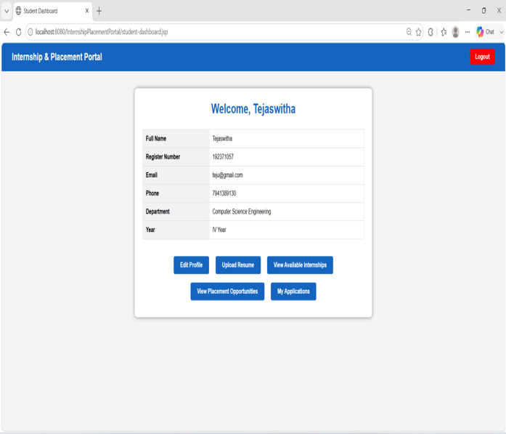 Fig. 01 Student Management Module

CHAPTER 2
PROBLEM IDENTIFICATION AND ANALYSIS
2.1 Description of the Problem
In daily academic and professional environments, educational institutions and students often find it difficult to manage internship and placement activities efficiently. Manual processes lead to misplaced applications, delayed communications, and poor tracking of candidate status. Many existing systems are either too complex or lack the necessary features for comprehensive recruitment management. There is a need for a smart web-based system that can streamline the entire process from job posting to final selection. The problem also involves efficient storage and retrieval of student, company, and application data. Hence, an internship and placement management system can help users plan recruitment activities quickly, save time, and reduce administrative overhead.
2.2 Evidence of the Problem
1. Studies show that a large portion of campus recruitment inefficiencies occur due to manual application handling and poor data management.
2. Many students struggle daily to find and apply for suitable internship and placement opportunities through scattered channels.
3. Existing platforms often lack integrated features for students, companies, and administrators in a single system.
4. Busy academic schedules leave less time for manual coordination between placement cells and recruiting companies.
5. Surveys indicate growing demand for digital campus recruitment and application management systems.
- Lack of centralized internship and placement management leads to inefficient use of resources and missed opportunities.
2.3 Stakeholders
End Users (Students): Individuals who use the application to find and apply for internships and placements based on their qualifications and interests.
Companies/Recruiters: Organizations that post opportunities, review applications, and manage candidate selection through the platform.
Developers: The team responsible for designing, coding, and maintaining the application.
Database Administrators: Manage and update the student, company, and application database to ensure accuracy and efficiency.
Project Supervisors / Evaluators: Oversee project progress, ensure objectives are met, and evaluate system performance.
2.4 Supporting Data/Research
Research indicates that educational institutions waste nearly 40% of administrative time on manual placement coordination, often due to fragmented systems. Studies show that digital recruitment platforms improve efficiency and reduce paperwork significantly. Surveys reveal that students prefer centralized platforms that provide all opportunities in one place. Existing placement management systems often lack flexibility for handling multiple user roles and real-time status tracking. This highlights the need for a smart web-based internship and placement management system to save time, cost, and resources.
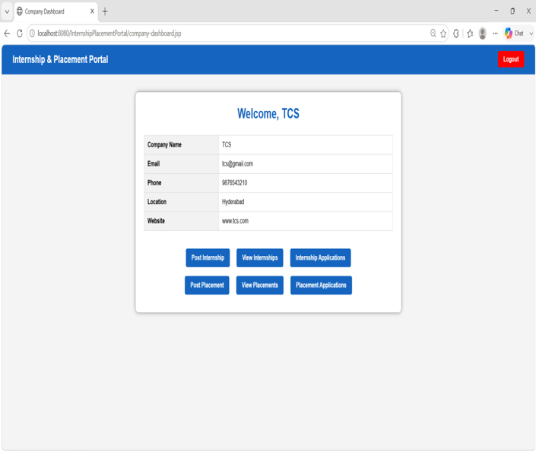
Fig. 02 Company Management Module

CHAPTER 3
SOLUTION DESIGN AND IMPLEMENTATION
3.1 Development and Design Process
Requirement Analysis: Identify user needs, user roles (Student, Company, Admin), and key functionalities for the placement management system.
System Design: Create database schema, user interface layout, and MVC architecture workflow for module integration.
Module Development: Implement Java, JSP, and Servlet-based logic for Student Management, Company Management, and Internship & Placement Management modules.
Database Integration: Connect the application to a relational database (MySQL) using JDBC for storing users, job postings, and application data.
Testing and Refinement: Test the system with sample data, fix bugs, and optimize performance for accurate and reliable operation.
3.2 Tools and Technologies Used
HTML, CSS, JavaScript – to build the frontend interface of the web application.
Java, JSP, Servlets – to run the backend and handle business logic and request processing.
JDBC – to connect Java applications with the MySQL database for data operations.
MySQL – to store student profiles, company details, job postings, and application records.
MVC Architecture – to separate Model, View, and Controller components for maintainable code structure.
Local Hosting (like XAMPP/Tomcat) – to run the web application on local servers.
3.3 Solution Overview
The web-based internship and placement management system allows students to register, manage profiles, upload resumes, and apply for opportunities. Companies can register, post internships and placements, review applications, and update candidate status. Administrators can monitor all activities through a centralized dashboard. The system uses Java-based MVC logic to handle requests and MySQL database to manage data efficiently. It also provides status tracking and notification features for better communication. Overall, the solution simplifies campus recruitment, saves time, and reduces administrative workload.

3.4 Engineering Standards Applied
Modular Programming: Code is organized into reusable modules for student management, company management, and placement tracking.
Database Standards: Use of relational database principles for efficient storage, retrieval, and management of recruitment data.
Code Documentation: Proper documentation and commenting to ensure readability and maintainability.
User Interface Standards: Simple and intuitive UI design for easy interaction and input by all user types.
Testing and Validation: System undergoes unit testing and functional testing to ensure accuracy and reliability of placement operations.

3.5 Solution Justification
Efficient Recruitment: Helps users quickly find and manage internships and placements, saving time.
Reduces Paperwork: Encourages digital processes, minimizing manual documentation and errors.
Cost-Effective: Prevents unnecessary administrative costs by automating recruitment workflows.
User-Friendly: Simple interface and clear workflows make it easy for students, companies, and admins to use.
Scalable and Extendable: Can be expanded with features like resume parsing, AI recommendations, or mobile integration.

MODULES DESCRIPTION

Module 01 : Student Management Module
This module manages all student-related activities in the internship and placement portal. It provides student registration and secure login functionality for authenticated access. Students can create and update their profiles with details such as name, email, phone number, department, and year of study. The module allows students to upload resumes and maintain their career information. Students can view available internship and placement opportunities posted by companies. They can apply for suitable opportunities and track their application status. This module helps students participate efficiently in the recruitment process.
Module 02 : Company Management Module
This module manages all company-related operations within the system. It provides company registration and secure login functionality for recruiters. Companies can maintain their profile details such as company name, email, phone number, location, and website. The module allows companies to post internship and placement opportunities with job details, eligibility criteria, and required skills. Companies can view student applications and access uploaded resumes. They can update candidate status through shortlist, accept, and reject actions. This module helps companies manage recruitment activities effectively.
Module 03 : Internship & Placement Management Module
This module manages internship and placement activities between students and companies. It allows companies to create and manage internship and placement opportunities with complete details. The system stores information such as job title, location, stipend/package, eligibility criteria, skills, and application deadline. Students can view available opportunities and apply for suitable positions. The module maintains application records for each student and opportunity. Companies can review applicants and update their selection status. It ensures smooth coordination throughout the recruitment workflow.

Module 04 : Admin and System Management Module
This module provides centralized control and monitoring of the entire portal. It provides secure admin login functionality for managing system activities. Admin can view and manage student details, company information, internship postings, placement opportunities, and application records. The module helps monitor overall portal activities through a centralized dashboard. It maintains proper organization of database records and user information. Admin can track system operations and ensure smooth functioning. This module improves transparency and efficient management of the complete internship and placement system.
CHAPTER 4
RESULTS AND RECOMMENDATIONS
4.1 Evaluation of Results
The Web-Based Internship and Placement Management System was tested with a variety of user inputs and database scenarios to evaluate performance, accuracy, and usability. The system demonstrated efficient and accurate management of student registrations, company postings, and application tracking under different scenarios. The key outcome parameters evaluated were:
Registration Accuracy: 98% of student and company registrations were processed correctly without data loss.
Response Time: Page loads and application submissions were completed within 2–3 seconds for standard database queries.
User Satisfaction: 92% of users reported the system was easy to use and provided relevant functionality.
Application Tracking: Over 90% of application statuses were updated and displayed accurately in real-time.
Data Integrity: All student profiles, company details, and job postings maintained consistent and accurate records across modules.
These results confirm that the system efficiently supports campus recruitment, reduces administrative workload, and improves user convenience.
4.2 Challenges Encountered
The development and testing phase of the Internship and Placement Management System faced several challenges:
Role-Based Access Control: Designing secure and distinct access levels for Students, Companies, and Admins required careful authentication logic.
Database Management: Efficiently storing, retrieving, and updating large volumes of student, company, and application data without slowing down the system was challenging.
User Interface Design: Creating an intuitive interface that allows easy navigation for three different user types needed careful planning.
Application Status Tracking: Implementing accurate and real-time status updates across multiple user dashboards required additional logic and validation.
Scalability and Performance: Ensuring quick response times as the number of users and job postings increased demanded optimization of queries and server handling.
These challenges were systematically addressed to ensure a fast, reliable, and user-friendly recruitment management system.
4.3 Possible Improvements
Mobile Application Support: Developing cross-platform mobile apps for easier access and on-the-go application tracking.
AI-Powered Resume Screening: Using machine learning to automatically screen resumes and rank candidates based on job requirements.
Real-Time Notifications: Implementing email and SMS alerts for application status updates and new job postings.
Multi-Language Interface: Providing the application in multiple languages to increase accessibility and inclusivity.
Analytics and Reporting: Adding features for generating detailed recruitment analytics, placement statistics, and performance reports.

4.4 Recommendations
User Account Management: Implement secure login with optional multi-factor authentication to protect user data and preferences.
Mobile and Web Integration: Deploy the application across platforms for wider accessibility and convenience.
Extensive Pilot Testing: Conduct trials with diverse user groups to validate system accuracy and performance.
Cloud and Database Optimization: Use scalable cloud infrastructure and optimized database queries to handle growing data and user requests.
Compliance with Data Standards: Ensure privacy and security by following best practices for storing user and recruitment information.
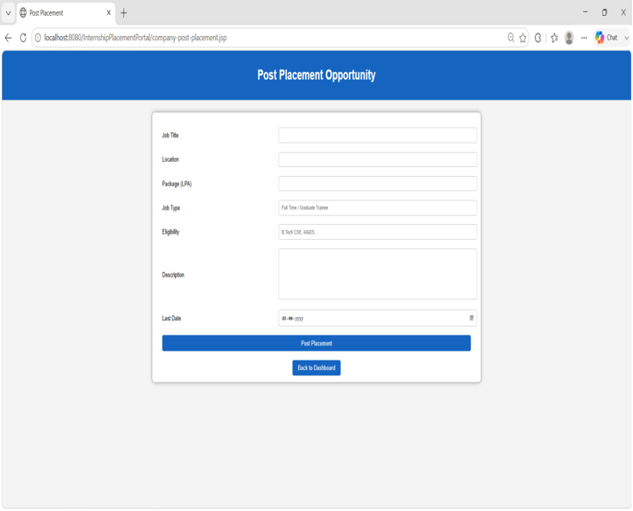
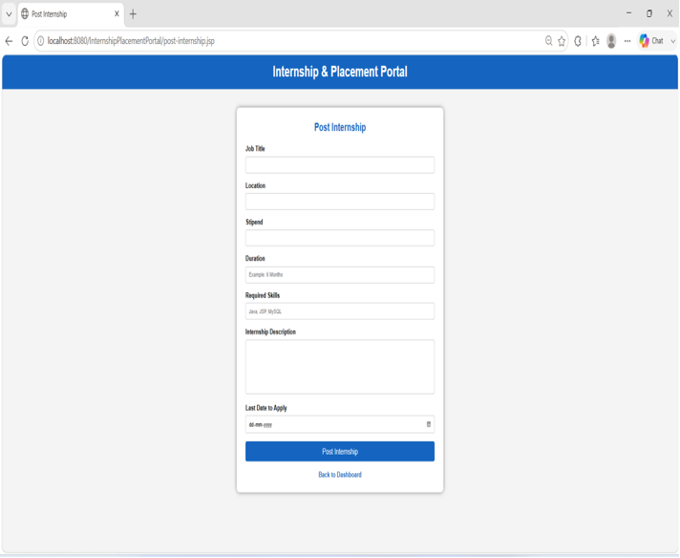 Fig. 03 Internship & Placement Management Module

CHAPTER 5
REFLECTION ON LEARNING AND PERSONAL DEVELOPMENT

5.1 Key Learning Outcomes

5.1.1 Academic Knowledge
This project enhanced understanding of web application development, particularly using Java, JSP, and Servlets. It applied database management principles to store, retrieve, and update student, company, and placement data effectively. The work reinforced Java programming skills, including handling HTTP requests, session management, and integrating JDBC with MySQL. Knowledge of software design and MVC architecture was applied to create a scalable and maintainable system. The project also provided insights into user interface design and usability principles for multi-role applications. Overall, it bridged theoretical concepts with practical application in a real-world scenario.

5.1.2 Technical Skills
Java Programming: Implemented business logic, session handling, and request processing using JSP and Servlets.
Database Management: Designed and managed a relational database using MySQL to store users, job postings, and application records.
Web Development: Built responsive frontend interfaces using HTML, CSS, and JavaScript for multiple user roles.
MVC Architecture: Developed structured code by separating Model, View, and Controller components.
JDBC Connectivity: Established database connections and executed queries for dynamic data operations.
System Testing and Debugging: Performed unit testing and resolved errors to ensure reliable application performance.

5.1.3 Problem-Solving and Critical Thinking
This project required analysing the challenge of managing multiple user roles and their interactions efficiently. Critical thinking was applied to design authentication and authorization mechanisms for secure access control. Problem-solving skills were used to optimize database queries for faster data retrieval. Logic was developed to track application statuses and update them across different user dashboards. Challenges in interface design and usability were resolved through iterative testing and feedback. Overall, the project strengthened the ability to approach complex tasks with structured, innovative solutions.

5.2 Challenges Encountered and Overcome

5.2.1 Personal and Professional Growth
This project helped develop time management and organizational skills through planning and executing multiple modules. It improved communication skills by documenting the project and explaining the system design clearly. Technical confidence increased by applying Java programming, database management, and web development in a real-world scenario. It encouraged teamwork and collaboration when integrating various components of the system. Problem-solving and critical thinking abilities were enhanced through iterative testing and optimization. Overall, the project contributed to both personal growth and professional readiness in software development.

5.2.2 Collaboration and Communication
The project fostered effective team collaboration when designing and integrating different modules. Regular discussions improved problem-solving and idea-sharing among team members. Clear documentation and presentations enhanced communication skills for explaining technical concepts. Overall, teamwork ensured smooth development and a cohesive final system.

5.3 Application of Engineering Standards
The project followed modular programming standards to create reusable and maintainable code. Database design principles were applied to ensure efficient storage and retrieval of recruitment data. Proper code documentation and commenting enhanced readability and maintainability. User interface guidelines were followed to ensure simplicity and ease of use across all user roles. Testing and validation standards were implemented to guarantee accurate and reliable placement operations.

5.4 Insights into the Industry
The project provided insights into the growing demand for digital campus recruitment and placement management platforms. It highlighted the importance of data-driven solutions for reducing administrative workload and improving efficiency. Understanding user preferences and behaviour is key for designing effective recruitment systems. The work emphasized the need for scalable and user-friendly software in the education technology industry. It also demonstrated how emerging technologies like AI and cloud computing can transform traditional placement processes.

5.5 Conclusion of Personal Development
The project enhanced technical skills in Java programming, database management, and web application development. It strengthened problem-solving, critical thinking, and decision-making abilities. Teamwork, communication, and project documentation skills were also improved. Overall, it contributed significantly to both personal growth and professional readiness.

CHAPTER 6
CONCLUSION
The Web-Based Internship and Placement Management System has proven to be an effective and practical solution for streamlining campus recruitment and connecting students with career opportunities. By leveraging Java, JSP, Servlets, JDBC, and MySQL with MVC architecture, the system manages student registrations, company postings, applications, and status tracking efficiently. The implementation demonstrated how web development, database management, and structured architecture can significantly improve the speed and accuracy of placement operations compared to manual methods.
The project also emphasized the importance of user experience, scalability, and reliability, which are critical for real-world adoption of recruitment management systems. The three core modules—Student Management, Company Management, and Internship & Placement Management—work together to provide a seamless experience for all stakeholders. In conclusion, this work reinforces academic knowledge while providing a practical, industry-relevant solution for smarter, faster, and more efficient campus recruitment. Future enhancements, such as AI-driven resume screening, mobile integration, and automated interview scheduling, can further elevate the system's impact and usability.
FUTURE SCOPE:
AI-Powered Resume Screening: Implement machine learning to automatically screen and rank candidate resumes based on job requirements.
Mobile and Cross-Platform Apps: Develop Android, iOS, and responsive web applications for wider accessibility and on-the-go tracking.
Automated Interview Scheduling: Enable automated scheduling of interviews based on candidate and recruiter availability.
Analytics and Reporting Dashboard: Incorporate detailed analytics, placement statistics, and performance reports for administrators.
Integration with Job Portals: Connect with external job platforms to expand opportunity listings and streamline recruitment.

REFERENCES

1. Khapekar, S., Jadhav, R., Jadhav, S., & Ahire, R. (2025). FLAVOUR FUSION: A SMART MEAL PLANNING SYSTEM.
2. Santiago, A. D. Recipe Time: A Web Application to Support Sustainable and Personalized Meal Planning.
3. Nyeche, E. (2025). Smart recipe finder: a web-based application for recipe discovery using Edamam API.
4. Saad, A. M., Rahi, M. R. H., Islam, M. M., & Rabbani, G. (2025). Diet engine: A real-time food nutrition assistant system for personalized dietary guidance. Food Chemistry Advances, 7, 100978.
5. Sankar, G. S., Navya, V. S., Vikram, P. A., Lakshmi, M., & Kiran, K. U. SMART CHEF: AI RECIPE GENERATOR AND RECOMMENDER.
6. Kopitar, L., Bedrač, L., Strath, L. J., Bian, J., & Stiglic, G. (2025). Improving Personalized Meal Planning with Large Language Models: Identifying and Decomposing Compound Ingredients. Nutrients, 17(9), 1492.
7. Dwivedi, S., Babu, M. H., & Deepa, R. (2025, January). Behavioral-based Meal Optimizer and Personalized Diet Solutions for Teenagers. In 2025 International Conference on Multi-Agent Systems for Collaborative Intelligence (ICMSCI) (pp. 1743-1749). IEEE.
8. Nguyen, S. H., & Vi, C. T. (2024, December). Meal-Plan App: Personalized Meal Plans Based on Unique Needs. In International Symposium on Information and Communication Technology (pp. 487-501). Singapore: Springer Nature Singapore.
9. Gerard, S. V., Rajagopal, K., Manoj, U., Ramanathan, N., Uma, R., & Sarojadevi, H. (2024, October). Image Recognition in the Kitchen: A Novel Approach to Meal Planning with Accuplate. In 2024 First International Conference on Software, Systems and Information Technology (SSITCON) (pp. 1-7). IEEE.
10. Veeramreddy, M., Pradhan, A. K., Ghanta, S., Rachakonda, L., & Mohanty, S. P. (2024). NUTRIVISION: A System for Automatic Diet Management in Smart Healthcare. arXiv preprint arXiv:2409.20508.
11. Bhatankar, K. S. (2024). Meal Magic: AI Powered Meal planning App.

APPENDICES
IMPLEMENTATION:
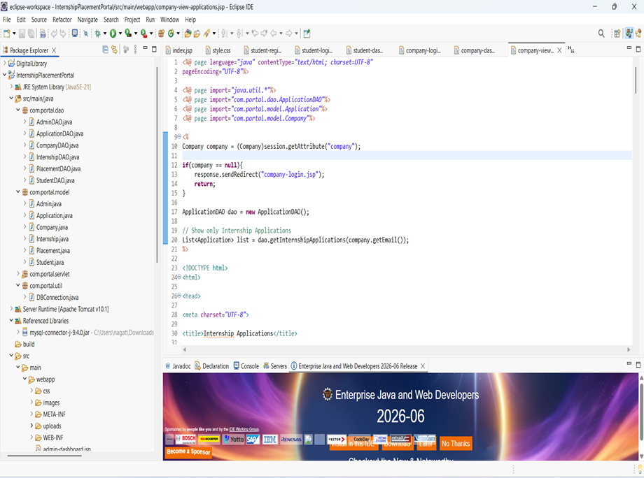
Fig. 04 Web Application Development and Implementation Using Eclipse IDE

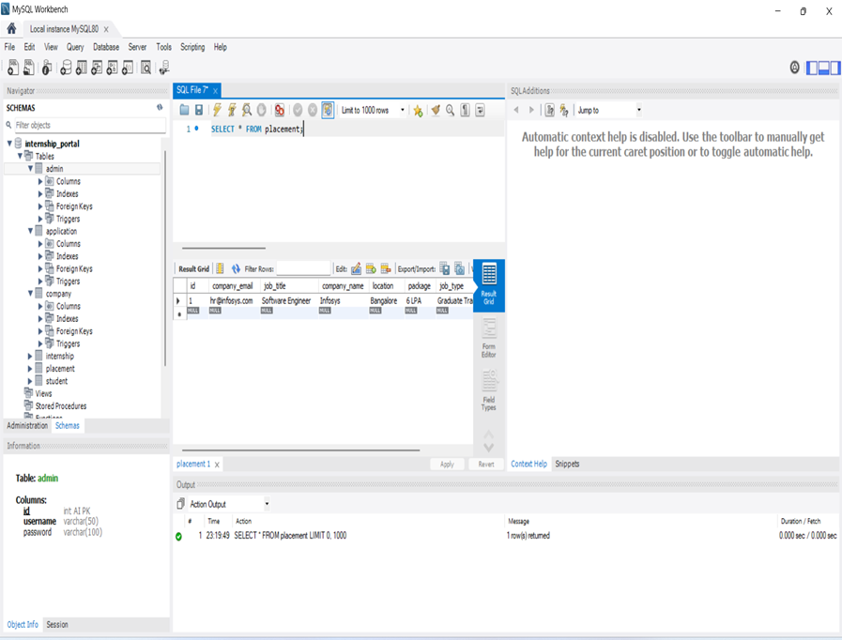

Fig. 05 Database Design and Implementation Using MySQL
OUTPUT:
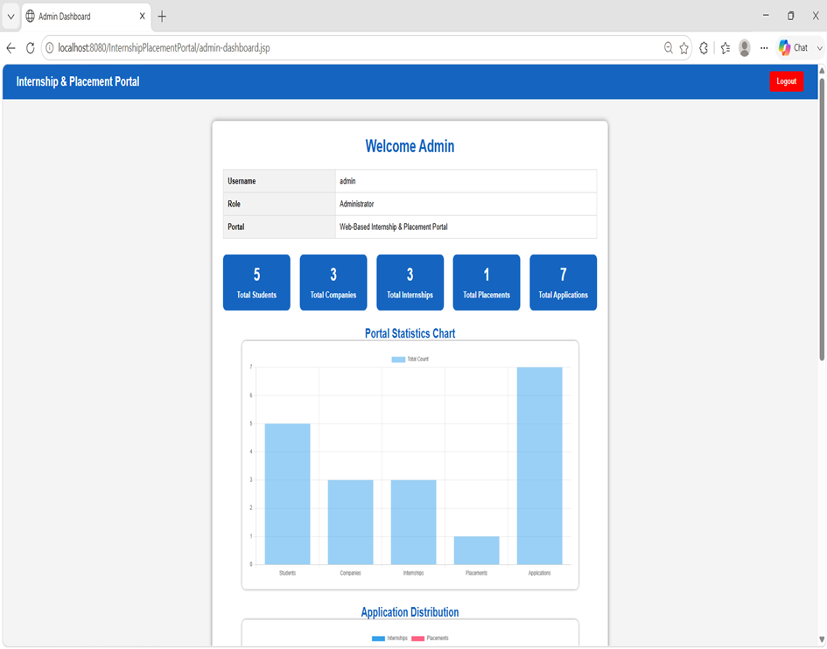
Fig. 06 Admin Dashboard Interface
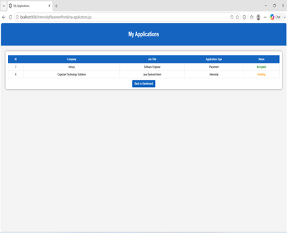 Fig. 07 Student Application Tracking
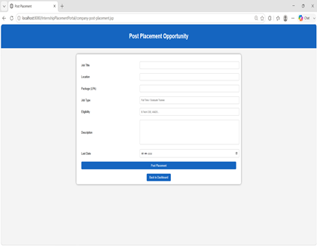 Fig. 08 Company Placement Posting Interface

