HACKATHON PROJECT REPORT
Food Delivery Route Planner
Algorithmic Optimization of Multi-Order Delivery Sequences using Dijkstra’s Shortest Path, Greedy Heuristics and Travelling Salesman (2-Opt) Strategies
Domain: Design and Analysis of Algorithms
Technology Stack: Python, Flask, React, MongoDB
Submitted by
Team No: 14
Institution: MALLA REDDY TECHNICAL CAMPIS
Hackathon / Event: DAA
Table of Contents
Abstract 3
1. Introduction 4
2. Problem Statement, Objectives and Scope 5
3. Requirements Analysis 7
4. System Architecture and Design 9
5. Algorithms and Methodology 11
6. Technologies and Implementation 15
7. Testing, Results and Performance 17
8. Hackathon Execution 19
9. Conclusion and Future Scope 21
10. References 22

Abstract
Food delivery platforms must serve many customers with a limited number of riders, and the order in which a rider visits delivery locations directly decides fuel cost, delivery time and customer satisfaction. This project presents the Food Delivery Route Planner, a web-based decision-support tool that applies core algorithms from Design and Analysis of Algorithms (DAA) to the multi-order delivery sequencing problem.
The road network is modelled as a weighted graph G = (V, E) in which vertices are delivery hubs and customer locations and edges carry non-negative travel costs. Dijkstra’s algorithm computes least-cost paths between every pair of stops. A greedy nearest-neighbour heuristic then builds a quick baseline delivery sequence, and a 2-Opt improvement step, a local-search strategy for the Travelling Salesman Problem (TSP), removes crossing edges to shorten the tour. Unlike black-box routing tools, every decision made by each algorithm is recorded and shown to the user, together with the objective value and the reconstructed path.
The system is implemented with a React dashboard, a Flask REST API in Python and a MongoDB database. On the evaluated scenario, the greedy route measured 24.8 km in 2 ms while the 2-Opt route measured 21.2 km in 14 ms, a reduction of about 14.5% in total distance for a small increase in computation time. The report documents the problem, requirements, architecture, algorithms, implementation, testing and the way the project was executed during the hackathon.
Keywords: Route optimization, Dijkstra’s algorithm, Greedy heuristic, Travelling Salesman Problem, 2-Opt, Flask, React, MongoDB, Hackathon.

1. Introduction

1.1 Background
Online food delivery has become part of everyday life. A single rider often carries several orders at once, and the platform must decide in which sequence the customers should be served. This is a last-mile logistics problem: it is the most expensive and the most time-sensitive part of the delivery chain. A poor visiting order makes the rider travel extra kilometres, which increases fuel consumption, delays hot food and lowers customer satisfaction.
From an algorithmic point of view the task is a combination of two classical problems. The first is finding the cheapest path between two places on a road network, which is a shortest-path problem. The second is choosing the cheapest order in which to visit a set of places and return to the start, which is the Travelling Salesman Problem. The TSP is NP-hard, so an exact solution becomes impractical as the number of stops grows, and heuristics are used in practice.

1.2 Motivation
Many navigation tools return a route without explaining how it was produced. For students and developers learning algorithm design this is a missed opportunity, because the interesting part of an algorithm is the reasoning behind each step. The motivation of this project is therefore twofold: to build a practical tool that improves delivery sequences, and to make the behaviour of the underlying algorithms fully visible so that their strengths, weaknesses and trade-offs can be studied.

1.3 Hackathon Context
The project was developed as a hackathon entry on the theme of applying algorithms to real-world logistics. A hackathon rewards a working end-to-end prototype built under tight time limits, so the design deliberately uses well-understood algorithms, a simple three-tier architecture and widely available tools. The result is a prototype that a judge can run, give inputs to and inspect, and that still demonstrates genuine algorithmic depth.

1.4 Organization of the Report
- Chapter 2 states the problem, objectives and scope.
- Chapter 3 lists the functional and non-functional requirements.
- Chapter 4 describes the architecture and data design.
- Chapter 5 explains the algorithms, with code and complexity analysis.
- Chapter 6 covers the technologies and implementation.
- Chapter 7 presents testing, results and performance.
- Chapter 8 describes how the hackathon work was organised.
- Chapter 9 concludes the report and outlines future scope, followed by references.

2. Problem Statement, Objectives and Scope

2.1 Problem Statement
A rider has been assigned several orders at the same time and starts from a known location. The rider must visit every customer exactly once and return to the starting point. Choosing the order by intuition, or by always going to the nearest remaining customer, can produce long routes, and neither method explains why a particular sequence was chosen. The problem is to design a system that finds a short delivery sequence, compares alternative strategies and presents every decision in a transparent way.
Formally, given a weighted graph G = (V, E), a start vertex s and a set of customer vertices K ⊂ V, find a tour that begins and ends at s, visits every vertex of K exactly once and minimises the sum of the shortest-path costs between consecutive stops.

2.2 Objectives
- Model the road network as a weighted graph and compute least-cost paths between locations using Dijkstra’s algorithm.
- Generate a baseline delivery sequence with a greedy nearest-neighbour heuristic.
- Improve the baseline with a 2-Opt TSP refinement and measure the saving.
- Make all decision states visible through a step-by-step log, objective values and full path reconstruction.
- Analyse the time complexity and behavioural trade-offs of each algorithm.
- Deliver an interactive web dashboard backed by a REST API and a database.

2.3 Scope
In scope | Out of scope (future work)
Single rider with multiple orders | Multiple riders and fleet assignment
Static road network with non-negative edge costs | Live traffic and dynamic edge weights
Dijkstra, greedy nearest neighbour and 2-Opt | Exact TSP solvers and metaheuristics
Web dashboard for input, results and decision log | Mobile application for riders
Storage of orders, nodes, edges and riders | Payments, authentication and customer tracking
Table 2.1: Project scope

2.4 Assumptions
- Travel costs are non-negative and symmetric, so the cost from A to B equals the cost from B to A.
- The road network is connected, so a path exists between any two stops.
- Every order must be delivered, and each customer is visited once.
- The rider returns to the starting hub after the last delivery.

2.5 Expected Outcomes
The expected outcome is a working prototype that accepts a set of order locations, returns two complete delivery routes with their total costs, and explains each routing decision. The comparison between the greedy and the optimised route should show a measurable reduction in distance, and the report should explain the cost of achieving it in extra computation.

3. Requirements Analysis
Requirements were collected by considering the two people who would use the system: a rider, who needs a short and understandable route, and a dispatcher or evaluator, who needs to compare strategies and inspect how the results were obtained.

3.1 Functional Requirements
ID | Requirement | Description
FR1 | Order input | The user selects the rider start node and the customer locations to be served.
FR2 | Graph management | The system stores nodes, coordinates and weighted edges of the road network.
FR3 | Shortest path | The system computes the least-cost path and cost between any two nodes with Dijkstra’s algorithm.
FR4 | Greedy route | The system builds a nearest-neighbour sequence for the selected orders.
FR5 | Optimised route | The system improves the sequence with 2-Opt and returns the new total cost.
FR6 | Decision log | Each algorithm records its choices so the user can audit them step by step.
FR7 | Comparison | The dashboard shows distance, computation time and percentage improvement side by side.
FR8 | Persistence | Orders, results and rider data are saved in the database for later review.
Table 3.1: Functional requirements

3.2 Non-Functional Requirements
Attribute | Requirement
Performance | Route computation for typical order sets (up to about 20 stops) completes within a fraction of a second.
Transparency | Every result must be accompanied by its objective value and the reasoning that produced it.
Usability | The dashboard must be understandable without training and respond in real time.
Reliability | Invalid inputs such as unknown nodes or negative weights are rejected with clear messages.
Maintainability | Algorithms are kept in a separate module so that new strategies can be added easily.
Portability | The system runs on any machine with Python, Node.js and MongoDB installed.
Table 3.2: Non-functional requirements

3.3 Use Cases
Rider or dispatcher enters orders. The user chooses a start node and several delivery locations and requests a route. The system returns the greedy and the optimised sequence.
Evaluator inspects decisions. The user opens the decision log to see why each next stop was chosen, which edges were swapped by 2-Opt and how the objective value changed after every improvement.

3.4 Software and Hardware Requirements
Item | Specification
Operating system | Windows, Linux or macOS
Backend | Python 3.9 or later, Flask
Frontend | Node.js 18 or later, React
Database | MongoDB 6 or later
Browser | Any current version of Chrome, Edge or Firefox
Hardware | Standard laptop, 4 GB RAM or more
Table 3.3: Environment requirements

4. System Architecture and Design

4.1 Architecture Overview
The system follows a three-tier architecture. The React frontend handles interaction and visualisation, the Flask API receives requests and runs the algorithm engine, and MongoDB stores the road network and order data. Separating these layers lets each be developed and tested independently, which was important for a team working in parallel during a hackathon.
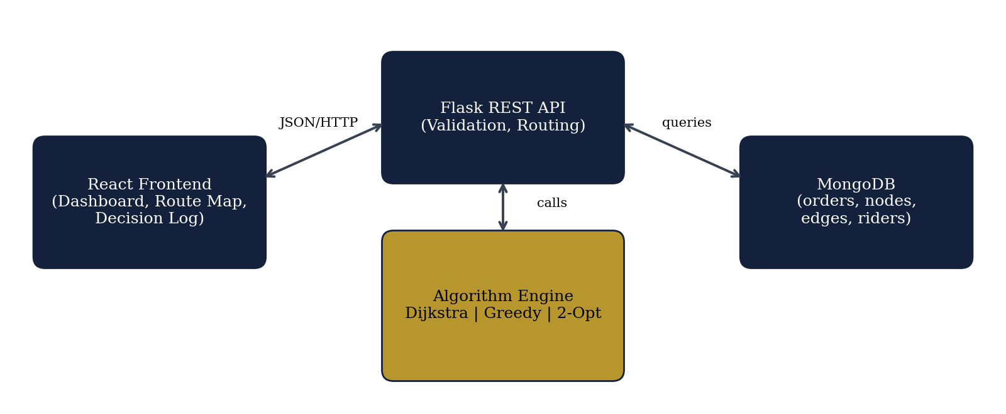
Figure 4.1: High-level system architecture

4.2 Layers and Responsibilities
- Presentation layer (React). Collects start node and order locations, sends requests, and renders routes, objective values and the decision log.
- Application layer (Flask and algorithm engine). Validates input, loads the graph, runs Dijkstra, greedy and 2-Opt and assembles a response containing routes, costs, timings and logs.
- Data layer (MongoDB). Stores orders, road network nodes and edges, and rider records as flexible JSON-like documents.

4.3 Data Model
MongoDB was chosen because the data is naturally document-shaped: a node with its coordinates and a list of neighbours maps directly to one document. The main collections are listed below.
Collection | Key fields | Purpose
nodes | _id, name, type, lat, lng | Delivery hubs and customer locations (graph vertices)
edges | from, to, weight | Road segments with non-negative travel cost
orders | _id, customer_node, status, created_at | Orders waiting for or assigned to a rider
riders | _id, name, start_node | Riders and their starting locations
routes | rider_id, algorithm, sequence, total_cost, time_ms | Saved results for comparison and review
Table 4.1: Database collections

4.4 Request Workflow
- The user selects the start node and the active order locations on the dashboard.
- React sends a JSON request to the Flask endpoint.
- Flask loads the graph from MongoDB and validates the input.
- Dijkstra’s algorithm builds a cost matrix between all selected stops.
- The greedy engine produces the baseline sequence and its decision log.
- The 2-Opt engine refines the baseline and records every accepted swap.
- The API returns both routes, costs, timings and logs, and stores the result.
- The dashboard renders the comparison and the step-by-step explanation.

4.5 Design Decisions
Dijkstra is run once per stop to create a cost matrix, after which the greedy and 2-Opt stages work on simple lookups. This keeps the heuristics independent of the graph structure and makes each stage easy to test. The algorithm engine is a plain Python module without web dependencies, so it can be unit-tested and reused from scripts. Finally, every algorithm returns a log together with its result, which keeps transparency a built-in property of the design rather than an afterthought.

5. Algorithms and Methodology

5.1 Graph Modelling
The road network is represented as a weighted graph G = (V, E). Each vertex in V is a delivery hub or a customer location. Each edge in E joins two vertices and carries a non-negative weight, which may represent distance in kilometres or travel time. The graph is stored as an adjacency list, which uses O(V + E) memory and allows the neighbours of a vertex to be visited efficiently.

5.2 Dijkstra’s Shortest Path Algorithm
Dijkstra’s algorithm finds the least-cost path from a source vertex to all other vertices when all edge weights are non-negative. It maintains a tentative distance for every vertex, repeatedly selects the unexplored vertex with the smallest tentative distance, and relaxes the edges leaving it. A binary-heap priority queue makes the selection of the cheapest vertex efficient, and a predecessor array allows the exact path to be reconstructed afterwards.
- Set the distance of the source to 0 and all others to infinity.
- Insert the source into a min-priority queue.
- Remove the vertex u with the smallest distance.
- For each neighbour v of u, if dist[u] + w(u, v) < dist[v], update dist[v] and the predecessor of v.
- Repeat until the queue is empty, then rebuild paths by following predecessors.
Listing 5.1: Dijkstra’s algorithm with path reconstruction
import heapq

def dijkstra(graph, source):
"""graph: {node: [(neighbour, weight), ...]} with weight >= 0.
Returns (dist, prev) for every node reachable from source."""
dist = {n: float("inf") for n in graph}
prev = {n: None for n in graph}
dist[source] = 0
heap = [(0, source)]
while heap:
d, u = heapq.heappop(heap)
if d > dist[u]:
continue # stale queue entry
for v, w in graph[u]:
nd = d + w
if nd < dist[v]:
dist[v] = nd
prev[v] = u
heapq.heappush(heap, (nd, v))
return dist, prev

def reconstruct_path(prev, target):
path = []
while target is not None:
path.append(target)
target = prev[target]
return path[::-1]

def cost_matrix(graph, nodes):
"""All-pairs shortest distances between the delivery stops."""
return {a: dijkstra(graph, a)[0] for a in nodes}

Complexity: O(E log V) time with a binary heap and O(V) additional space for the distance and predecessor arrays.

5.3 Greedy Nearest-Neighbour Strategy
The greedy strategy always moves to the closest unvisited delivery location. At each step it makes the choice that looks best locally and never reconsiders it. This makes the method very fast and easy to explain, because the reason for every step is simply that the chosen stop was the nearest one. Its weakness is the lack of global foresight: an early cheap move can leave the rider far from the remaining customers and force a long return trip.
Listing 5.2: Greedy nearest-neighbour route and tour cost
def greedy_route(start, stops, D):
"""Nearest-neighbour tour; returns (route, decision_log)."""
route, log = [start], []
remaining = set(stops)
current = start
while remaining:
nxt = min(remaining, key=lambda s: D[current][s])
log.append(f"{current} -> {nxt} (cost {D[current][nxt]:.1f})")
route.append(nxt)
remaining.remove(nxt)
current = nxt
route.append(start) # return to the rider's start node
return route, log

def tour_cost(route, D):
return sum(D[a][b] for a, b in zip(route, route[1:]))

Complexity: O(N²) time for N delivery stops, since each of the N steps scans the remaining stops.

5.4 Travelling Salesman Formulation
The delivery task is formulated as a TSP over the selected stops. The tour must start and end at the rider’s start node, visit every customer exactly once and avoid repeated visits. The distance between two stops is the Dijkstra shortest-path cost, so the tour remains valid even when two stops are not joined by a direct road. Because the TSP is NP-hard, the project uses a heuristic improvement method instead of exhaustive search, which would require checking (N − 1)! orderings.

5.5 2-Opt Route Improvement
2-Opt is a local-search method that starts from an existing tour, such as the greedy one. It considers every pair of edges in the tour and checks whether removing them and reconnecting the tour by reversing the segment between them would reduce the total cost. If so, the swap is accepted. The process repeats until no improving swap exists. Reversing a segment removes crossing paths, which are always sub-optimal in a metric space, so the final tour is shorter than the starting one.
Listing 5.3: 2-Opt refinement
def two_opt(route, D):
"""Repeatedly reverse segments while that shortens the tour."""
best = route[:]
improved = True
while improved:
improved = False
for i in range(1, len(best) - 2):
for j in range(i + 1, len(best) - 1):
a, b = best[i - 1], best[i]
c, d = best[j], best[j + 1]
if D[a][c] + D[b][d] < D[a][b] + D[c][d] - 1e-9:
best[i:j + 1] = reversed(best[i:j + 1])
improved = True
return best

Complexity: O(N²) per improvement pass. The number of passes is usually small in practice, so the method is fast for delivery batches of realistic size.
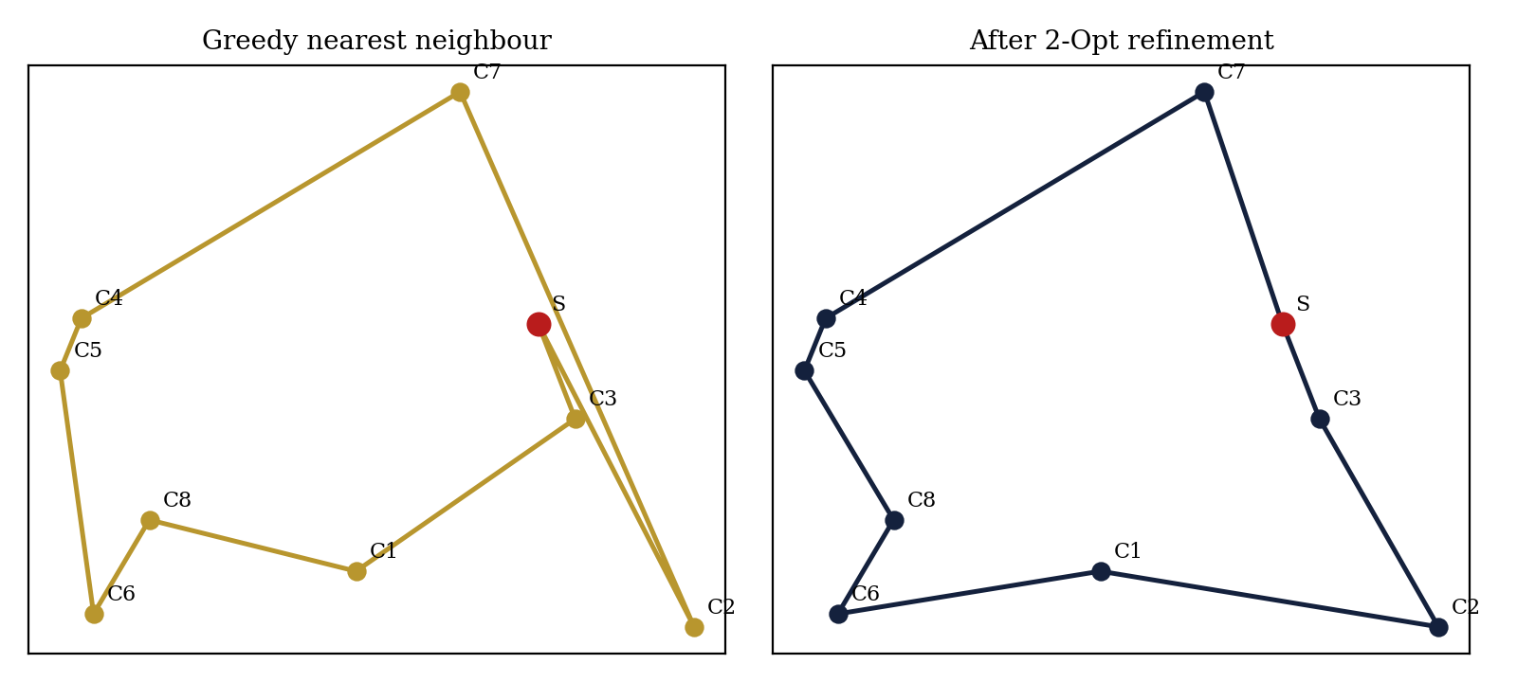
Figure 5.1: Illustrative example of a greedy tour improved by 2-Opt

5.6 Decision Log and Path Reconstruction
Each stage returns a list of readable messages together with its result. The greedy stage records the chosen edge and its cost at every step. The 2-Opt stage records which pair of edges was replaced and the saving obtained. Dijkstra’s predecessor array is used to expand every leg of the final tour into the exact sequence of road nodes the rider will pass through. These logs are displayed on the dashboard and are the main way the project makes algorithm behaviour visible.

5.7 Comparison of Algorithms
Algorithm | Role | Time complexity | Strength | Limitation
Dijkstra | Shortest path | O(E log V) | Optimal for non-negative weights | Needs non-negative edges
Greedy NN | Baseline tour | O(N²) | Very fast, easy to explain | No global view, may be far from optimal
2-Opt | Tour improvement | O(N²) per pass | Removes crossings, shorter routes | Local optimum only, not guaranteed optimal
Table 5.1: Algorithm comparison

6. Technologies and Implementation

6.1 Technology Stack
Layer | Technology | Reason for choice
Frontend | React | Component-based UI suited to live updates and step-by-step visualisation
Backend | Python, Flask | Concise code, rich standard library (heapq) and quick REST API development
Database | MongoDB | Flexible documents that map naturally to nodes, edges and orders
Algorithms | Python module | Framework-independent code that is easy to test and reuse
Table 6.1: Technology stack

6.2 Backend Implementation
The backend exposes a small REST API. The route endpoint receives the start node and the list of customer nodes, builds the cost matrix with Dijkstra, runs the greedy and 2-Opt engines, measures the time of each stage and returns everything in one JSON response.
Listing 6.1: Route planning endpoint (simplified)
from flask import Flask, request, jsonify
import time
from algorithms import cost_matrix, greedy_route, two_opt, tour_cost

app = Flask(__name__)

@app.post("/api/route")
def plan_route():
data = request.get_json()
start, stops = data["start"], data["stops"]
graph = load_graph() # reads nodes/edges from MongoDB
D = cost_matrix(graph, [start] + stops)

t0 = time.perf_counter()
greedy, log = greedy_route(start, stops, D)
t_greedy = (time.perf_counter() - t0) * 1000

t0 = time.perf_counter()
improved = two_opt(greedy, D)
t_opt = (time.perf_counter() - t0) * 1000

return jsonify({
"greedy": {"route": greedy, "cost": tour_cost(greedy, D), "ms": t_greedy, "log": log},
"optimized": {"route": improved, "cost": tour_cost(improved, D), "ms": t_opt},
})

Method | Endpoint | Purpose
GET | /api/nodes | List all delivery hubs and customer locations
POST | /api/orders | Create or update active orders
POST | /api/route | Compute greedy and optimised routes with logs
GET | /api/path?from=A&to=B | Return Dijkstra shortest path between two nodes
GET | /api/routes/<id> | Retrieve a saved route for review
Table 6.2: REST API endpoints

6.3 Database Implementation
Nodes and edges are inserted once as seed data, while orders and routes are written at run time. A node document stores its name, type (hub or customer) and coordinates, and an edge document stores the two node identifiers and the weight. Indexes on the node name and on the edge endpoints keep graph loading fast. The graph is converted into an adjacency list in memory before the algorithms run.

6.4 Frontend Implementation
- OrderForm. Lets the user select the start node and add or remove customer locations.
- RouteMap. Draws nodes and the chosen route so that crossings in the greedy route and their removal by 2-Opt are visible.
- ComparisonPanel. Shows distance, computation time and percentage improvement for both strategies.
- DecisionLog. Lists every step taken by the algorithms with the cost of each choice.

6.5 Project Structure
Listing 6.2: Repository layout
food-delivery-route-planner/
backend/
app.py # Flask application and endpoints
algorithms.py # Dijkstra, greedy, 2-Opt, tour cost
db.py # MongoDB connection and graph loader
seed_data.py # sample nodes, edges, riders
frontend/
src/components/ # OrderForm, RouteMap, ComparisonPanel, DecisionLog
src/App.jsx
README.md

6.6 Running the Project
- Start MongoDB and run seed_data.py to load the sample road network.
- Install backend packages and start the API with the flask run command.
- Install frontend packages with npm install and start the dashboard with npm start.
- Open the dashboard in a browser, select a start node and orders, and request a route.

7. Testing, Results and Performance

7.1 Testing Strategy
Testing was organised at three levels. Unit tests check the algorithm module on small graphs whose answers can be verified by hand. Integration tests send requests to the API and check the structure and consistency of the response. Finally, system tests run complete scenarios through the dashboard. Two properties are checked everywhere: every route must start and end at the rider’s node and visit each customer exactly once, and the 2-Opt cost must never be greater than the greedy cost it started from.

7.2 Test Cases
The table below lists the main test scenarios and the behaviour expected from the system. The actual outcome of each case should be recorded when the tests are executed.
ID | Scenario | Input | Expected result
T1 | Shortest path on a small graph | 4-node graph with known costs | Dijkstra returns the hand-computed cost and path
T2 | Unreachable node | Graph with an isolated node | Distance remains infinite and the API reports an error
T3 | Negative edge weight | Edge with weight less than 0 | Input is rejected with a clear message
T4 | Single customer | Start node and one stop | Route is start, stop, start for both algorithms
T5 | Valid tour structure | Eight customers | Every stop appears once, start at both ends
T6 | 2-Opt never worse | Random instances | Optimised cost is less than or equal to greedy cost
T7 | Unknown node | Stop not in database | API returns a validation error
T8 | Decision log | Any valid request | One log entry per greedy step is returned
Table 7.1: Test cases

7.3 Results and Comparative Performance
The two strategies were compared on the evaluation scenario for total distance and computation time. The greedy route is the baseline. The 2-Opt route removes crossing paths and gives a clearly shorter tour.
Metric | Greedy nearest neighbour | Optimised TSP (2-Opt)
Total distance | 24.8 km | 21.2 km
Computation time | 2 ms | 14 ms
Efficiency score | Baseline (100%) | About 85.5% of baseline distance
Improvement | – | About 14.5% distance reduction
Table 7.2: Greedy versus 2-Opt results
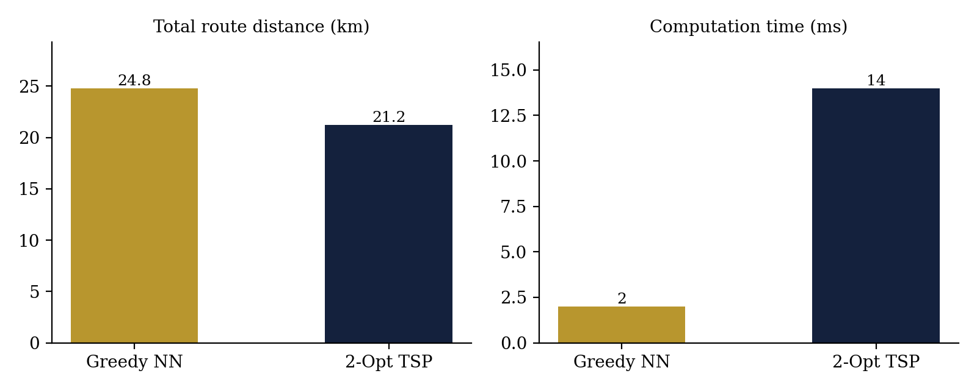
Figure 7.1: Distance and computation time of the two strategies

7.4 Analysis and Discussion
The results show the classic trade-off between speed and quality. The greedy method answers in 2 ms but yields a 24.8 km route, because it cannot see that an early nearest-stop choice forces a long trip later. The 2-Opt stage takes 14 ms, seven times longer, but saves 3.6 km, which is about 14.5% of the total distance. In absolute terms the extra 12 ms is negligible for a delivery application, whereas the saved distance repeats on every trip and accumulates into significant fuel and time savings for a fleet.
Because 2-Opt starts from the greedy tour and only accepts improving swaps, it can never produce a worse result, which makes it a safe refinement step. The decision log also helps explain the improvement: the log shows exactly which pairs of edges were exchanged and by how much each exchange reduced the objective.

7.5 Limitations
- 2-Opt finds a local optimum, so the result is not guaranteed to be the shortest possible tour.
- The road network is static; real traffic changes would require dynamic edge weights.
- Results were measured on a small evaluation scenario and should be repeated on larger and more varied datasets.
- The prototype handles a single rider; multiple riders require a vehicle routing formulation.

8. Hackathon Execution

8.1 Development Timeline
The work was divided into short phases so that a working prototype existed early and the remaining time could be used for improvement and polish.
Phase | Activities | Outcome
Planning | Problem selection, scope, algorithm choice, task split | Agreed scope and architecture
Core algorithms | Graph model, Dijkstra, greedy, 2-Opt and unit tests | Tested algorithm module
Backend and data | Flask endpoints, MongoDB schema and seed data | Working REST API
Frontend | Order form, route view, comparison panel, decision log | Interactive dashboard
Integration | End-to-end testing, bug fixing, performance check | Stable prototype
Presentation | Slides, demo script, documentation | Final demo and this report
Table 8.1: Hackathon timeline

8.2 Team Roles
Role | Responsibility
Algorithm lead | Dijkstra, greedy and 2-Opt implementation and testing
Backend developer | Flask API, database access and validation
Frontend developer | React dashboard and route visualisation
Documentation and demo | Slides, report and demo preparation
Table 8.2: Suggested roles (replace with actual team members)

8.3 Challenges and Solutions
Challenge | Solution
Showing why a route was chosen | Every algorithm returns a decision log along with its result
Keeping algorithms independent of the web layer | Algorithms are pure Python functions working on a cost matrix
Limited time to build a full stack | Simple three-tier design and familiar tools
Comparing strategies fairly | Same cost matrix and the same stops are used for both strategies
Table 8.3: Challenges and solutions

8.4 Key Learnings
The project showed that a theoretical algorithm becomes far more convincing when its behaviour can be seen. Combining a fast heuristic with a refinement step gave a good balance of speed and quality, and designing for transparency from the start made both debugging and the final demonstration easier. Working under time pressure also reinforced the value of a clear module boundary between algorithms, API and interface.

9. Conclusion and Future Scope

9.1 Conclusion
The Food Delivery Route Planner successfully demonstrates algorithm-centric delivery sequencing. Dijkstra’s algorithm provides least-cost paths on the road graph, the greedy nearest-neighbour method produces a fast baseline, and the 2-Opt refinement shortens it. On the evaluated scenario the optimised route reduced distance by about 14.5%, from 24.8 km to 21.2 km, at the cost of 12 additional milliseconds of computation.
The prototype also meets its transparency goal: objective values, decision logs and reconstructed paths let users see why each routing choice was made. The project therefore satisfies the DAA requirements of demonstrating selected algorithms, analysing their trade-offs and presenting results clearly, and it does so in a working full-stack application.

9.2 Future Scope
- Live traffic. Integrate real-time mapping APIs so that edge weights reflect current road conditions.
- Dynamic order insertion. Insert new orders into an active route and re-route the rider without recomputing from scratch.
- Multiple riders. Extend to the Vehicle Routing Problem with capacity and fleet assignment.
- Time windows. Respect promised delivery times and food freshness limits.
- Stronger heuristics. Add Or-Opt, simulated annealing or genetic algorithms and compare them with 2-Opt.
- Larger benchmarks. Evaluate on bigger datasets and report averages over many instances.
- Mobile interface. Provide turn-by-turn guidance for riders on a phone.

10. References
- T. H. Cormen, C. E. Leiserson, R. L. Rivest and C. Stein, Introduction to Algorithms, 3rd ed., MIT Press, 2009.
- E. W. Dijkstra, “A note on two problems in connexion with graphs,” Numerische Mathematik, vol. 1, pp. 269–271, 1959.
- G. A. Croes, “A method for solving traveling-salesman problems,” Operations Research, vol. 6, no. 6, pp. 791–812, 1958.
- S. Dasgupta, C. Papadimitriou and U. Vazirani, Algorithms, McGraw-Hill, 2008.
- J. Kleinberg and E. Tardos, Algorithm Design, Pearson, 2005.
- D. S. Johnson and L. A. McGeoch, “The traveling salesman problem: a case study in local optimization,” in Local Search in Combinatorial Optimization, Wiley, 1997.
- Flask Documentation, Pallets Projects, https://flask.palletsprojects.com.
- React Documentation, https://react.dev.
- MongoDB Documentation, https://www.mongodb.com/docs.
- Python Software Foundation, heapq: Heap queue algorithm, https://docs.python.org/3/library/heapq.html.

