2)

Create a dictionary where the keys are student names and the values are their grades. Allow the user to:

Add a new student and grade.

Update an existing student’s grade.

Print all student grades.

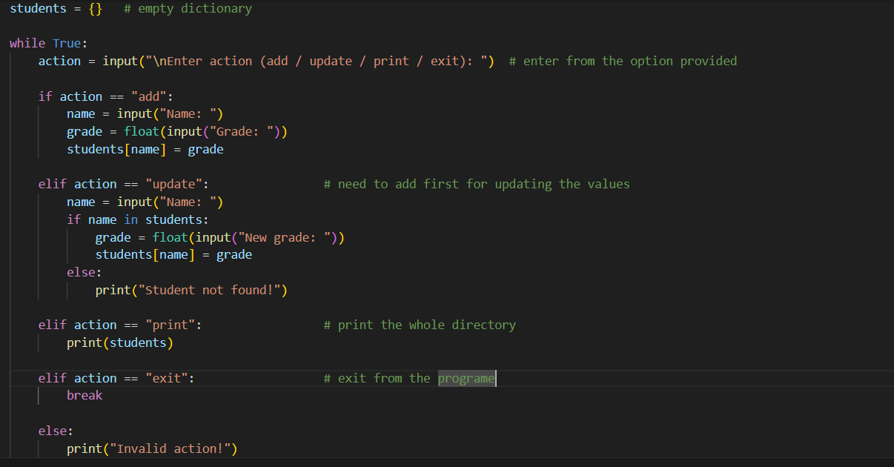

1)

Grade Checker

Take a score as input and print the grade based on the following:

90+ : "A"

80-89 : "B"

70-79 : "C"

Below 70 not eligible for test

here we used a basic if else statement to carry out marks and all.

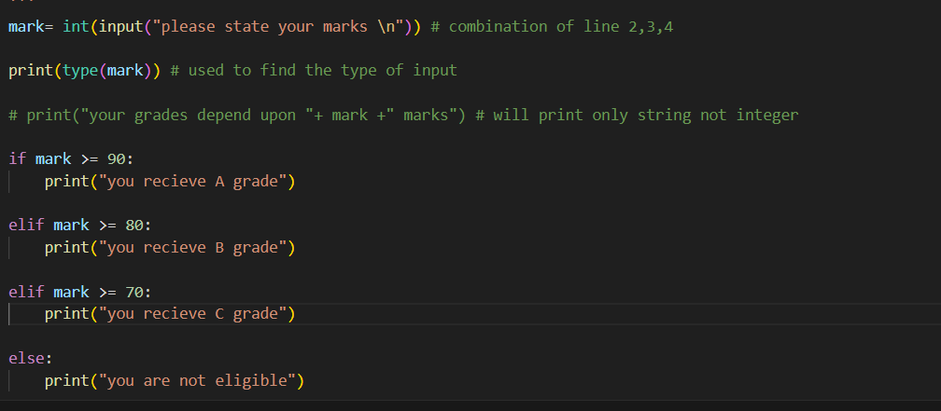

3)

Read from a File

We used open in read mode and file.read to read and print to display.

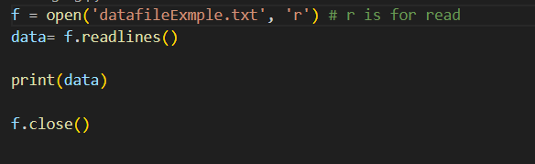

4)

Write to a File

Write a program to create a text file and write some content to it.

Using file functions like write and open.

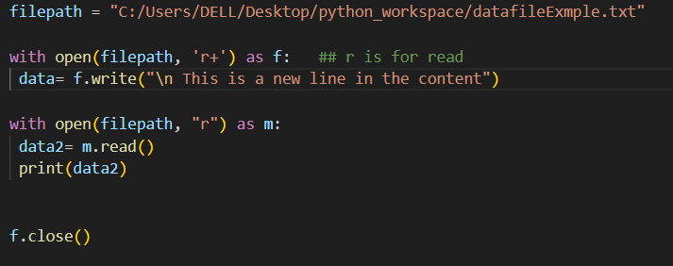

r+ = is for Read/Write both