Source: <https://www.diglocal.com/asheville/food/businesses/1159-the-southern-kitchen-and-bar>

Image: 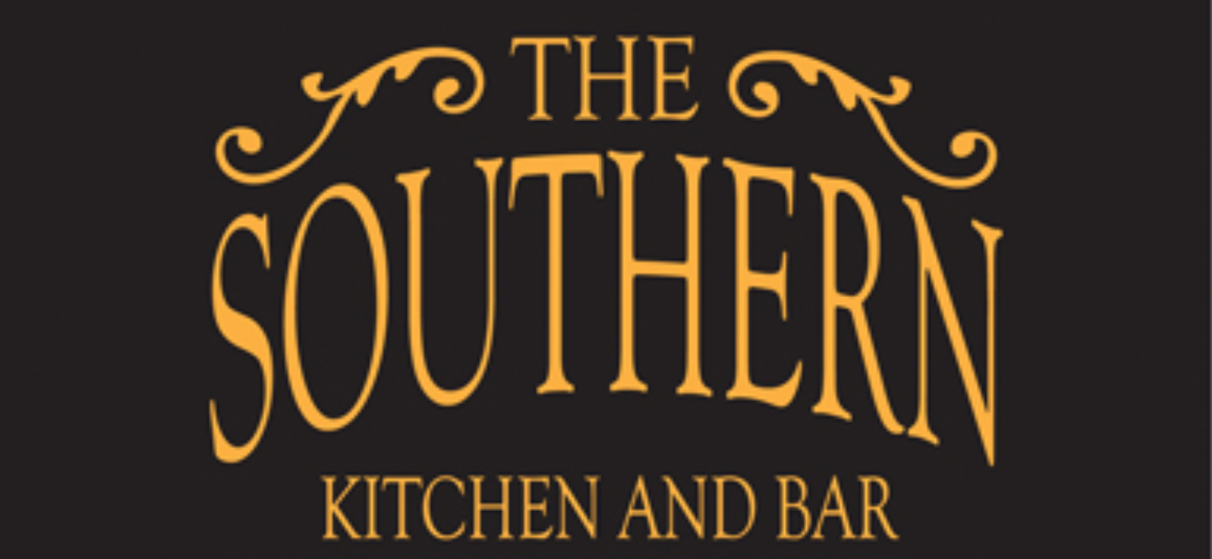

Source: <https://www.ashevillespa.com/blog/the-imperial-life-the-best-bar-snacks-in-asheville>

Image: 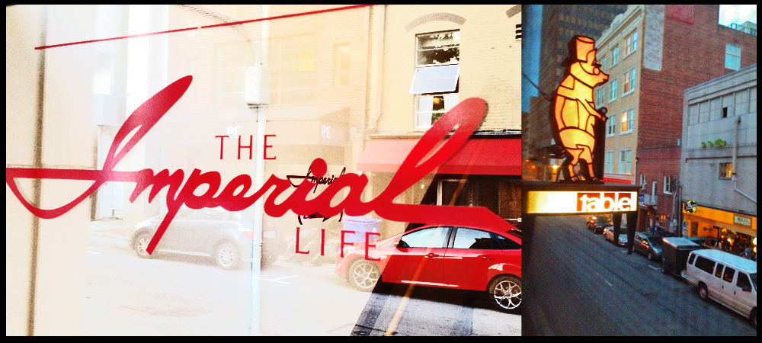

Source: <https://mountainx.com/food/school-is-in-session-south-slopes-public-school-bar-to-open-july-13/>

Image: 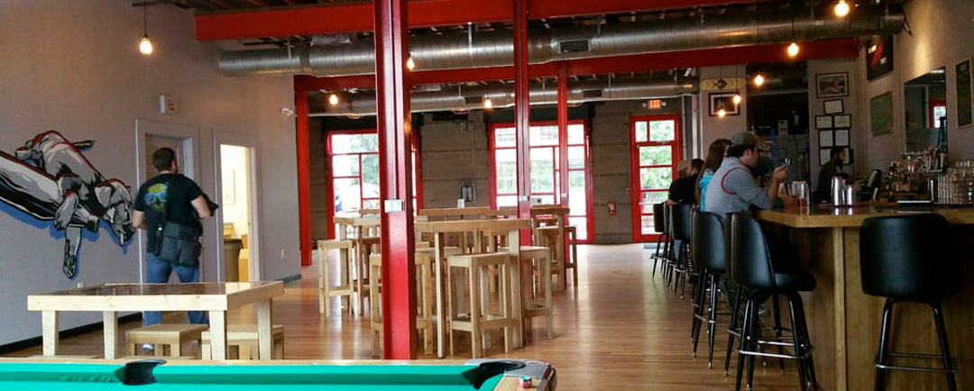

Source: <https://www.citizen-times.com/picture-gallery/entertainment/dining/2014/10/07/rankin-vault-cocktail-lounge-is-a-cross-section-of-asheville/16828645/>

Image: 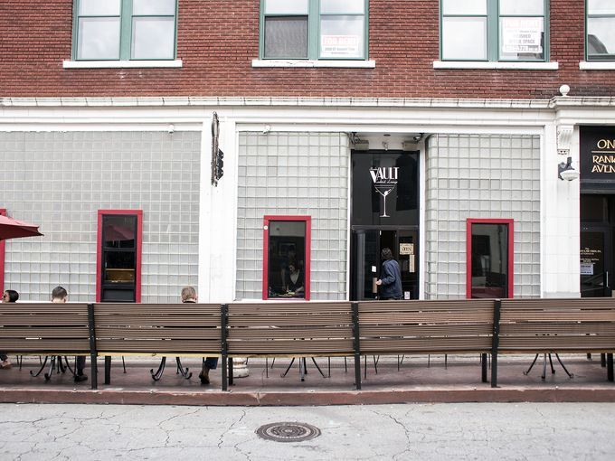

Source: <http://www.mgroadlounge.com/>

Image: 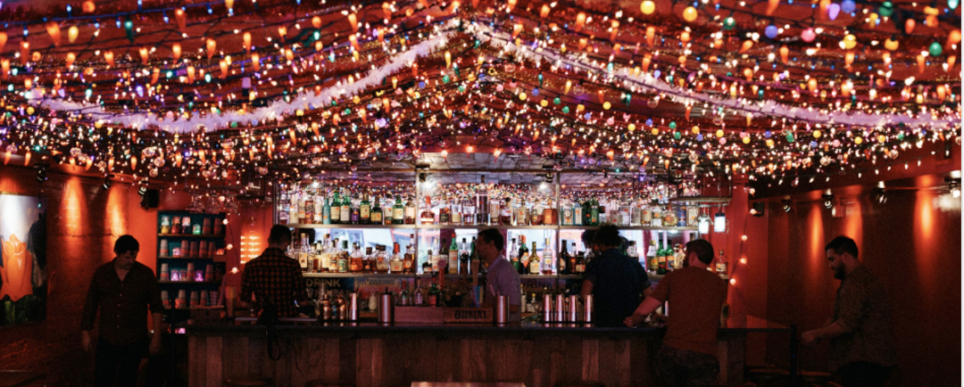

Source: <http://eatitasheville.blogspot.com/2010/07/desoto-brings-ethiopian-to-mountains.html>

Image: 