Deep Learning-Based Weather Temperature Prediction Using RNN and LSTM

Abstract: The weather prediction is very important in many applications in real-life processes like disaster management, environmental monitoring, transportation and agriculture. Proper prediction serves a good planning purpose and minimizes losses, caused by weather extremes. Classical statistical models have a hard time modeling the multifaceted time dependence of weather data. As artificial intelligence continues to advance, deep learning methods have demonstrated a great prospect of enhancing accuracy of prediction. This project introduces a time-series-based deep learning-based methodology of predicting weather temperature. The experiment employs Recurrent Neural Networks (RNN) and Long Short-Term Memory (LSTM) network models to acquire the trends of past temperatures. Processing of the dataset is done by normalization and converting the normalizations to sequences in a sliding window procedure. Several models, such as the basic RNN, conventional LSTM, and a fine-tuned LSTM are created and tested.
The results of the experiment show that all the models have a high prediction accuracy, with LSTM being the most successful because it is possible to trace long-term dependencies with it. The system is also deployed with the help of a web interface that is implemented with the help of Gradio that provides real-time predictions. In general, the project illustrates the usefulness of methods of deep learning in time-series predictions and shows that they can be effectively applied to weather forecasting systems.
Keywords: Deep Learning, Weather Prediction, Time Series Forecasting, RNN, LSTM, Temperature Prediction
1. BACKGROUND AND PROBLEM DEFINITION
Weather forecasting is a very fundamental part in most industries such as agriculture, the case of aviation, services in disaster management, and energy planning. Proper forecasting of temperature will assist in better planning and management of resources, development of safety and better decisions. Nonlinear, dynamic and time-dependent, however, weather data is a complex issue [1]. Conventional statistical models like linear regression, ARIMA, do not effectively model long term dependencies and complex time trends. Over the past few years, deep learning has become a potent technology to process sequential and time-series data. Specific networks like Recurrent Neural Networks (RNN) and long short-term memory (LSTM) networks are created to be a better fit with the timing constraints of their input. These models have the ability to learn patterns based on historical data and come up with more accurate predictions as opposed to traditional methods [2].
The key aim in this project is to come up with an effective deep learning-based programme to predict weather temperature based on the past time-series data. The issue is to analyze the trends in past temperatures and make high accuracy predictions. The system should be able to process and analyze big volumes of data, as well as to be able to perform well on its models. Also, the project will compare the various deep learning models and compare their performance based on the performance measures like RMSE and R -square. The other objective is to implement the trained model to a user-friendly interface to apply it to real-time predictions. This makes sure that the system is not only precise but also realistic and realistic to be applied in reality.
2. PROPOSED DEEP LEARNING SOLUTION
This project includes a solution to the problem of temperature prediction, based on the principles of deep learning, based on RNN and LSTM architecture. These models are especially appropriate to time-series data because they are able to remember the information of the past time-steps and learn how time is dependent [2].
The start of the solution is to preprocess the dataset where the transformation of the data into sequences is done via a sliding window approach. The sequence of inputs has 24 steps in time and predicting the next temperature value is performed by using these steps. This method enables the model to identify trends as time goes by and give correct forecasts.
In this study, three models are developed; these include:
- Simple RNN model
- Standard LSTM model
- Fine-tuned LSTM model
The RNN model is the baseline model; LSTM is a better model than RNN since it fixes the vanishing gradient issue. The fine-tuned LSTM adds more layers and parameters to optimize the learning power.
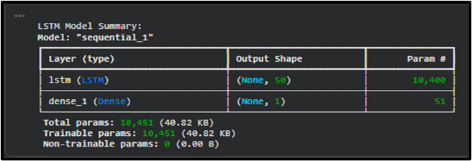
Figure1: RNN and LSTM Model Architecture Overview
The system is also implemented with the help of a Gradio interface, so a user can type in the temperature values and receive predictions in real time. This figure gives the architecture of both RNN and LSTM that will be employed in the study. It emphasizes the number of connections, units and layers between them. Based on this observation, it is evident that LSTM includes a more complicated architecture which allows it to model longer-term dependencies better than the simpler RNN architecture. This solution proposal is capable of integrating data preprocessing, model training and deployment into an entire predictive solution.
3. DATA SELECTION
The dataset throughout this project comprises past weather data acquired in the Max Planck Institute. It has 420,554 rows and 15 characteristics, such as temperature, humidity, pressure and wind speed. The data set contains detailed data that can be required in correct weather prediction.
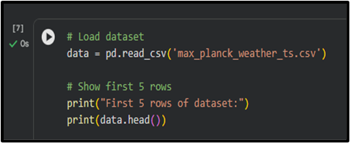
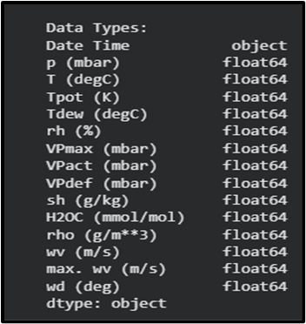
Figure 2: Initial Dataset Exploration and Summary
This amount indicates the overview of the dataset and the quantity of rows, columns, and the types of data. It establishes that the dataset comprises 420,555 entries and there are no missing values. The visualization is used to comprehend the dataset form and quality and then preprocessing and model training is carried out. The data has both numeric and time components and the column of the time workings is the Date Time, which is a timestamp. Notably, the dataset does not contain any missing values, thus providing quality and reliability to the data.
In this project, we choose temperature as the target variable, the rest of the features will be utilized to analyze and comprehend relationships. The data is not one-year long, but it covers several years and provides the model with an opportunity to grasp long and seasonal trends. The choice of this dataset is suitable since it entails a high amount and quality of time-series data, which is not only crucial when training deep learning models [4]. The variety of features also helps to analyse and comprehend the features of the environment influencing the temperature better.
4. PREPARING THE DATA
Preprocessing of data is part of the important procedure in creating a powerful deep learning model. It is then cleaned and transformed to a usable format.
The proper datetime form is created by processing the "Date Time" column (and making the index). The data will be then chronologically sorted to ensure that there is integrity of time-series analysis.
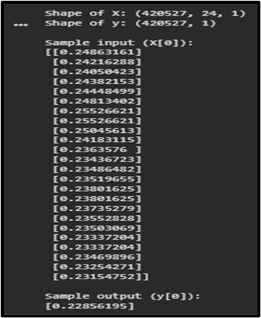
Figure 3: Time-Series Sequence Construction of Model input
This diagram illustrates the process of converting the dataset into sequential inputoutput pairs in a sliding window manner. The sequences are made up of 24-time steps to enable predicting the next value. It graphically illustrates the process of transforming the raw time-series data into a form of supervised learning that can be used by deep learning models.
It is followed by normalization with the MinMaxScaler to transform temperature values (between 0 and 1). This act will converge quicker and better model behaviour.
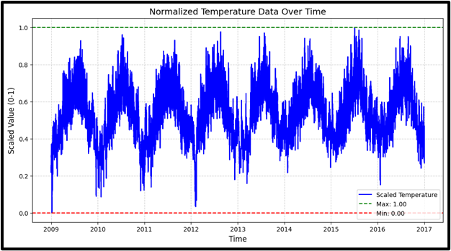
Figure 4: Normalised Temperature Time Series Plot
The values of temperature in this plot are obtained after normalization between 0 and 1. It puts more emphasis on patterns and trends per season and across time, with less effort required by the model to learn. The normalization guarantees that training remains constant and avoids the value fluctuations (large) which adversely affects the learning process [5].
This data subsequently is turned into sequences through a sliding window method with a time step of 24. This is to say that an input sequence has 24 past observations with the help of which the next value is predicted.
Lastly, the data is divided into training and testing set in a 80:20 ratio.
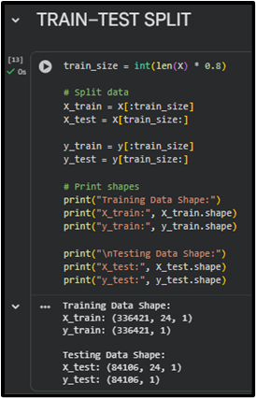
Figure 5: Training and Testing Data Split
This value depicts how the dataset is partitioned in the training and testing sets with a ratio of 80:20. It will make sure that the model is trained using one part of the data and tested using unknown data. The division is needed to evaluate the generalization ability of the model.
These initial processing procedures make sure that the data is organized, normalised and prepared to be trained using deep learning models.
5. DEFINING THE DEEP LEARNING MODEL
Deep learning models that are employed in this project are RNN and LSTM. Such models can be executed with the help of TensorFlow and Keras.
The model of the RNN has the following structure: SimpleRNN layer with 10 units, and the Dense output layer. It is created to include short-time dependencies in the information.
The LSTM model consists of 50 units and it can learn long term dependencies. It relies on gating (instead of performance) and memory cells to store valuable information in the long term [6].
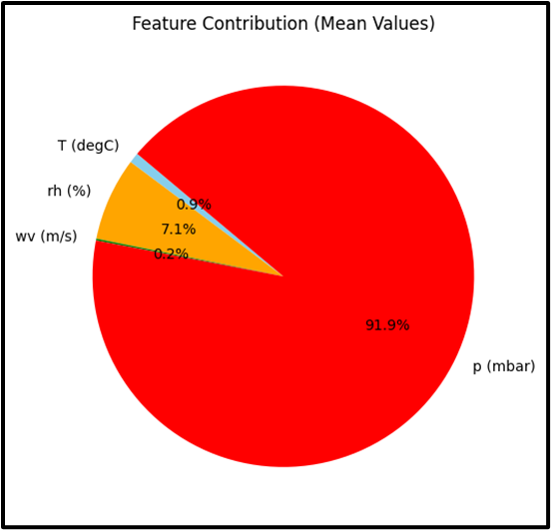
Figure 6: Feature Contribution Pie Chart
This value is the relative contribution of various weather features, i.e. pressure, humidity, temperature, and wind speed. It demonstrates that the pressure has the greatest contribution with humidity coming in second place. This evaluation assists in the comprehension of feature significance, and their role in the thermo-prediction.
The fineduned version of the LSTM model has more layers and more complexities thus being able to learn more complex patterns.
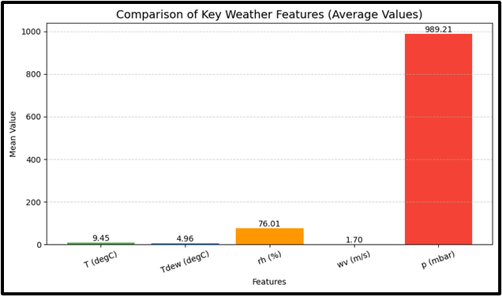
Adam optimizer and Mean Squared Error (MSE) loss function are used to compile the models. The configurations guarantee efficient training and proper predictions.
6. TRAINING AND FINE-TUNING
By varying the configurations of these models, the models are trained to test their performance.
RNN model is also trained with 3 epochs, and the training or loss is 1.711e-05 with the validation loss being 1.33e-05.
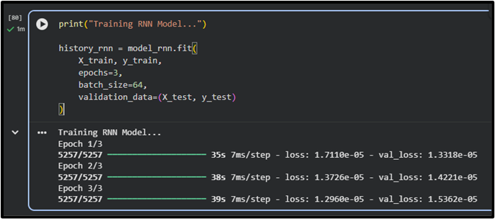
Figure 7: RNN Model Training Performance
This graph shows the training and validation loss of the RNN model in relation to the epochs. It indicates a gradual reduction in the loss saying that the model is learning well. Nonetheless, due to the small numbers of epochs, it is possible that the RNN model possesses a lower rate of learning as compared to LSTM.
The LSTM model is trained in 20 epochs and at a loss of 1.23e -05 and the validation loss of 1.18e -05.
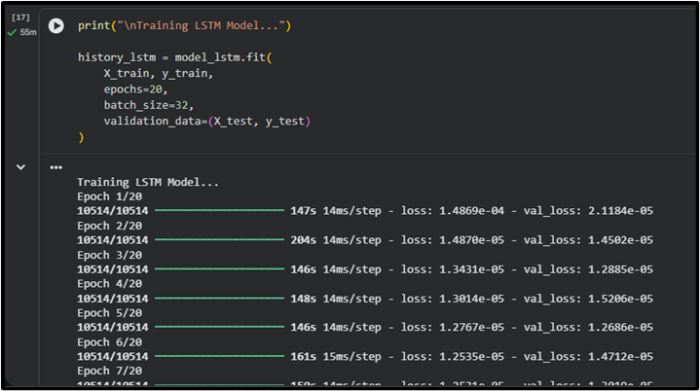
Figure 8: LSTM Training Performance
The fine-tuned LSTM model enhances learning even more but it exhibits a minor difference in the performance on validation. This graph shows the training and validation loss of the RNN model in terms of the number of epochs. It indicates a gradual reduction in the loss saying that the model is learning well. The small number of epochs however indicate that the RNN model is somewhat less in learning potential than LSTM.
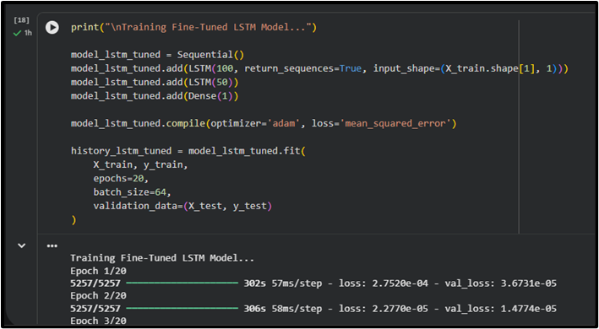
Figure 9: Fine-Tuned LSTM Training
The obtained results indicate that LSTM models are more effective time-series prediction. The following graph demonstrates the results of the LSTM model with extra layers fine-tuning. In spite of having a lower training loss, there is variation in the validation performance. It implies that more complex models do not necessarily lead to improved generalization, and can add to overfitting.
7. TESTING THE MODEL WITH NEW DATA
The trained models will be tested using unknown test data to their generalization ability.
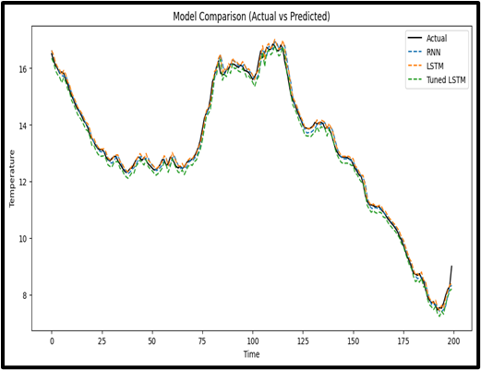
Figure 10: Model Performance comparison and prediction plot
This is a figure which compares actual and predicted temperature values to all the models. The forecast is very accurate and shows that there is a trend correlation. It demonstrates visually that deep learning models can be helpful to capture the temporal patterns and draw a successful prediction.
The RMSE values are:
- RNN: 805.35
- LSTM: 808.58
- Tuned LSTM: 797.21
The R² scores are:
- RNN: 0.998995
- LSTM: 0.999299
- Tuned LSTM: 0.998985
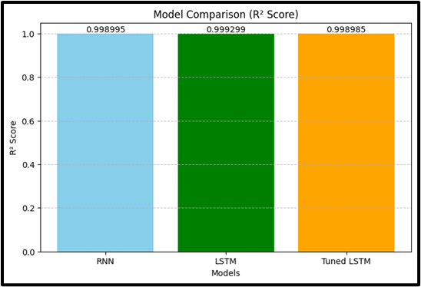
Figure 11: R² Score Comparison
This bar chart is used to compare the R 2 scores of RNN, LSTM and tuned LSTM. The values of all models are near to 1 meaning excellent performance. The LSTM model shows the highest score which proves the better performance of the model in the tasks related to the forecasting of time-series.
Moreover, the system is implemented with the help of a Gradio interface.
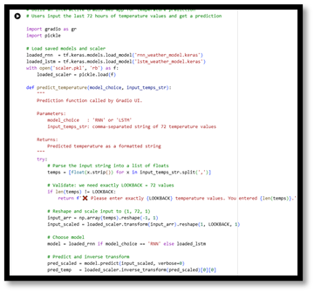
Fig 12: Gradio Application Code
This figure depicts the deployment of applications based on Gradio. It contains the code to load models, preprocess input data and give predictions. The architecture emphasises the way the backend processing goes hand in hand with a friendly interface to interact with the users in real-time.
8. DEPLOYING THE MODEL
The model is implemented on the Gradio framework, which is a simple and interactive web interface to deploy the model. The users will be able to enter the temperature values, and pick a model to obtain predictions.
The deployment combines trained models, preprocessing and prediction functions into a single application. This renders the system friendly and user friendly.
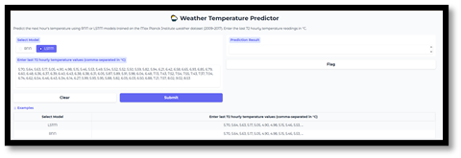
Fig 13: Weather Temperature Predictor User Interface (Input Section)
This figure shows the input component of the app deployed. Users are allowed to type temperature values and a model to be predicted upon. The interface is straightforward and user-friendly, allowing those with non-technical knowledge to use it, and forecasting in real time.
The interface Gradio makes it more usable, being able to make real-time predictions with no knowledge of technical capabilities. This shows the usefulness in application of the system.
9. RESULTS AND ANALYSIS
Results obtained show that all models are highly accurate which can be indicated by the values of R 2 being close to 1. The LSTM model is the most successful because it is able to model long-term dependencies.
Despite the slight improvement in RMSE, the tuned LSTM offers a balanced performance the most, as compared to the standard LSTM. The graphs of the prediction indicate that model outputs are close to real values.
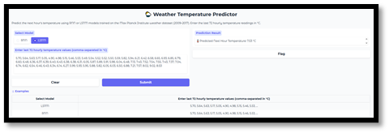
Fig 14: Model Prediction Output and Performance Display
This figure shows the output obtained by the system following prediction. It contains values of predicted temperatures as well as summary statistics (minimum, maximum and average). The visualization proves the success and applicability of the used deep learning model.
These results prove that time-series forecasting tasks are well done by deep learning.
10. CONCLUSION
Through this project, a deep learning-based weather temperature prediction system, made of RNN and LSTM models, was successfully developed. The analysis showed that data preprocessing, sequence generation as well as model selection were important in attaining accurate predictions. As the results indicate, LSTM models perform better against traditional RNN models because they can exploit long-term dependencies. The Gradio deployment also contributes to the usability of the system allowing it to make predictions in real-time.
On the whole, this project demonstrates the efficiency of the deep learning approaches to time-series forecasting and the possibility to implement them in the real-life. In future applications, adding more weather parameters and optimizing the model, as well as implementation on cloud systems to make the system as accessible as possible, may be considered.
REFERENCE
- Bochenek, B. and Ustrnul, Z., 2022. Machine learning in weather prediction and climate analyses—applications and perspectives. Atmosphere, 13(2), p.180.
- King, M., Woo, S.I. and Yune, C.Y., 2024. Utilizing a CNN-RNN machine learning approach for forecasting time-series outlet fluid temperature monitoring by long-term operation of BHEs system. Geothermics, 122, p.103082.
- Markovics, D. and Mayer, M.J., 2022. Comparison of machine learning methods for photovoltaic power forecasting based on numerical weather prediction. Renewable and Sustainable Energy Reviews, 161, p.112364.
- Saheed, Y.K., Abdulganiyu, O.H. and Ait Tchakoucht, T., 2024. Modified genetic algorithm and fine-tuned long short-term memory network for intrusion detection in the internet of things networks with edge capabilities. Applied Soft Computing, 155, p.111434 .
- Guo, Q., He, Z., Wang, Z., Qiao, S., Zhu, J. and Chen, J., 2024. A performance comparison study on climate prediction in Weifang City using different deep learning models. Water, 16(19), p.2870.
- Sadhukhan, B., Chakraborty, S. and Mukherjee, S., 2022. Investigating the relationship between earthquake occurrences and climate change using RNN-based deep learning approach. Arabian Journal of Geosciences, 15(1), p.31.

