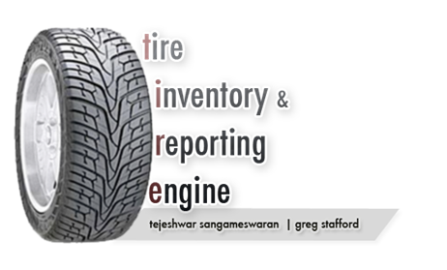

**Abstract**

This project is targeted towards solving several problems with tire management. In this project we propose a method to uniquely indentify tires. It also focuses on aggregating data about tires; data such as tire pressure and temperature.

Another focal point of this project is to mine this aggregated data and visualize it in a way that is both meaningful and useful.

Although this project is targeted towards JBHunt, it can be extended to any trucking company.

**Background**

**Targeted Problems:**

***1. Uniquely Identify Tires***  
Currently, there exists no way to uniquely identify and track tires. This is mainly due to the sheer number of them involved. The inability to distinguish them also inadvertently increases costs associated with warranty. Tracking mileage per tire is also currently impossible because of this issue.

***2. Tire Pressure***According to JBHunt, trucks can go as long as 2 ½ months without maintenance by a JBHunt technician. For a truck which runs great distances without service, if it’s tires are not at optimum pressure at all times during operation, it might prove dangerous on the long run. JBHunt faces the problem of apathetic drivers who do not refill pressure when required.  
   
**Current JBHunt Setup:**  
JBHunt currently tackles some parts of this issue by using *Doran 360CE™ Tire Pressure Monitoring System*. These RFID based sensors are installed on each tire and they transmit pressure data to a HUD which is located on the truck dashboard.

|  |  |
| --- | --- |
|  |  |
| Doran 360HD™ HUD | Doran 360HD™ Wireless Sensor |

The data collected is aggregated and relayed by an onboard computer, the *DriveTech* *TruckPC™*.

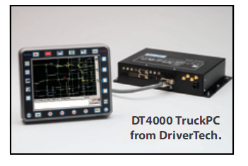

Even with this technology in place, there is no mechanism for collecting the values of the tires for each truck on the road, and the ability for central headquarters to monitor this data is basically non-existant. Our software is aimed at collecting valuable data such as this so it can be properly maintained.***3. Tire Theft***Trucking companies usually suffer from extensive theft of new tires by private truck drivers. When brand new tires have been placed on trucks, there is no guarantee that these same tires will remain on the truck. Often, the brand name tires that were placed on the trucks are replaced by used, lower quality, and less known tire brands. According to JBHunt, they lose approximately $33 million in tires (about 170,000 tires) due to theft and bad inflation.

***4. Data Reporting and notification***Although JBHunt has all the data on its servers, there is not a system in place to extract meaningful data that would make tire management more efficient. There is no warning and immediate notification system is place to alert HQ about a possible disaster. There is also no system in place to mine for patterns and no method by which to use this data for immediate profiling.

In the latest trial with the new equipment, *DriverTech* (the onboard computer) sent notification fault codes to the driver’s email and cellular phone. This is helpful, but there is no way for JBHunt headquarters to monitor the driver and ensure that the problem is alleviated. If there is a live monitoring system reporting irregular patterns within the status of the tires to both the driver and headquarters, tires can be properly maintained.

**Synopsis of Solution**

To tackle these problems, we plan to use RFID tags to uniquely identify tires. Although this is a fairly practical solution, for prototyping and testing purposes of this project, we have to revert to software simulation of the tags because of the cost involved in procuring and configuration of the hardware.

These tags will be encoded with a unique identification number and will be permanently attached each tire for its lifetime. This will allow several pieces of information about the tire to be tracked. We can store data aggregated by these unique tags and we can devise specialized algorithms to mine for information that is required.

Since we are dealing with several diverse problems in one project, it can be easy to forget the end user. Another main objective of this project is to make the resulting software as streamline and as user friendly as possible.

**Approach**

Design Flow

This diagram gives an abstract overview of our proposed solution

After meeting with *Ken Mangold* and *Veral Noland* in late October 2009, we became more familiar with the modern technology that is being used in today’s trucking companies. As they are testing new hardware for their current temperature and pressure monitoring system, it seemed to be an excellent time to devise new design patterns to process the large amount of data provided by the proposed solution.

We plan to build upon JBHunt’s current technology and system. We will attempt to refine their existing management system by simulating the current hardware and capturing the optimal algorithms for the maintenance and the inventory of tires. Once this is accomplished, we will be able to further analyze the cost and benefits of our software combined with the implemented hardware.

Much research has already been completed and several design solutions proposed by another team who worked on a very similar project last year. We’ve used their data extensively and will build upon it.

In our project we assume that the trucks are pre-installed with *Doran* and *DriverTech* instruments mentioned earlier. These two companies provide components which work together to aggregate and relay real time pressure and temperature in the tires to the HQ (every 15mins).

We plan to solve the problem of uniquely identifying tires by embedding low cost RFID tags into each of the tires. These tags will need to be embedded into a tire in a way such that it’s non-removable and tamper proof. The only data supplied by these tags would be a unique key to identify this tire. There will be RFID readers on board the truck which read these tags and beam this data to the on board computer (in this case, the *DT TruckPC*).

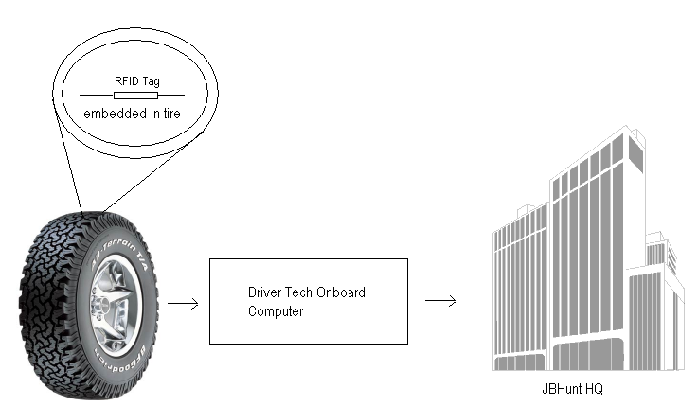

These RFID tags made to the exact specifications we are seeking are manufactured and distributed by a *Tire-Track LLC*. <http://www.tire-track.com/Products.html>

***What is the purpose of these tags?***The systems currently in place and in use by JBHunt can measure temperature and pressure of each tire, but when this information is relayed to HQ, data resolution is lost. For example, information regarding which pressure and temperature values belong to which particular tire cannot be relayed back to JBHunt because each tire cannot be uniquely identified globally.  
The RFID comes into play now and adds this missing piece of information. By directly connecting into the onboard truck computer, we can add this missing resolution of data; the unique ID for each tire is sent along with the temperature and pressure values. This data is now indexed on the sever based on this unique ID.

***How do these tags solve the problems?*Tire Pressure**: Since all data from the truck is sent back to HQ in real time, the database will always be up-to-date on the pressure and other information regarding individual tires. This data can be monitored by personnel or sever side bots. If a certain event occurs (such as a vehicle has been on road for over 50 miles with tire pressure outside the range of 95-150psi) a signal can be triggered and fleet managers can be notified automatically. When notification occurs, the managers will know exactly which tire in the truck has an issue and can instruct the driver to take action.

Also, this implementation would save the tire technician time and trouble; since all of the data is online, he can log into our software and know exactly which tires in a truck need refilling and which ones are nearing the end of their lifetime.

**Theft:** The RFID tags are embedded into the tires. If the tire has been removed from the truck, the reader will not able to receive the signal, and hence set off a flag. This monitored event can be sent back to HQ. The fleet managers could therefore be notified of a tire theft along with details of exact tire which was stolen, the time of day and the GPS can even provide the location.

**Data Reporting and notification:** An integral part of this project is to build the underlying software frameworks involved in aggregating, storing and mining the data. This software will be able to continually monitor the data collected by the trucks, which will include the status of the tires, the position of the truck, and any other relevant information collected by the onboard computer and tie them together. This software will also have a front end which will be used by employees to get quick up-to-date information about trucks and tires. So, we will be building a clean, succinct GUI running on complex algorithms to seamlessly calculate and mine data and show the users data on different levels of abstraction.

***What kind of data is now available that previously wasn’t?***

1. Uniquely identify each and every tire in the fleet (in this case, each of the 600K tires at JBHunt).
2. Temperature and pressure readings for any tire at anytime from anywhere.
3. Ability to retrieve information on mileage and pressure for ANY given individual tire in a fleet.
4. Current status of a tire such as age of tire, warranty information, etc
5. Ability to mine data such as:
   1. Life time of tire in terms of mileage
   2. Optimum pressure for tire for maximum life
   3. Driving speeds and fuel efficiency

Of course this is only a sample of the data that can be mined once this system in position, hundreds of cause and effect factors can be studied from these tables of data. This data can prove to save millions of dollars.

**Risks**

With nearly any solution come multiple risks, which is especially true in large transportation companies.  Our software will only be effective if certain hindrances do not undermine the ease of use and practical implementation of the system.  Problems will arise if the information collected from the numerous hardware units is not reliable enough for practical use and if there is incompatibility among the technology speculated to be used.

This project is operating under the assumption that all data collected is completely accurate and can be fully transmitted through satellite and be successfully recorded.  Another major risk is that the implemented hardware will be too excessive in cost when compared to the benefits of the system.

JBHunt or any other trucking fleet may or may not want to embed the new system due to cost of the hardware or even the cost of changing their current system to align with the new process.  The cost of the time consumed in retrofitting the hardware must be considered when calculating the cost and benefits.  If these risks remain minor, the project has a very real chance of becoming a major solution to the problems of tire management within JBHunt.

**Technologies Used**

**Pressure Sensor**: *Doran Tire Pressure Monitoring Systems* <http://www.doranmfg.com/tirepressuremonitorproducts.htm>

**On Board Computer/Transmitter:** *DriverTech TruckPC* <http://www.drivertech.com/commercial/index.html>

**RFID Tags:** *Tire-Track LLC*  <http://www.tire-track.com/Products.html>

**RFID Readers**: *Trossen Robotics* <http://www.trossenrobotics.com/c/usb-serial-rfid-readers-tags-kits.aspx>

**Programming Languages**: Visual C++, MySQL, Visual C#, Python

**Schedule**

|  |  |  |
| --- | --- | --- |
|  | **Fall** | **Spring** |
| 1. Understanding … |  |  |
| 2. Design … |  |  |
| 3. Implement … |  |  |
| 4. Test … |  |  |
| 5. Demonstrate |  |  |
| 6. Document … |  |  |

**Key Personnel**

**Students:**

Tejeshwar Sangameswaran

Greg Stafford

**University of Arkansas:**

Dr. Craig Thompson (Advisor)

**JBHunt Transportation Services:**

Ken Mangold – Senior Vice President, Technology

Veral Noland – Corporate Tire Manager

**References**

Hajiyev A., (2008) ‘J.B. Hunt RFID Tire Management Report’, Senior Design Capstone, 2008, University of Arkansas, USA.