My Environment:

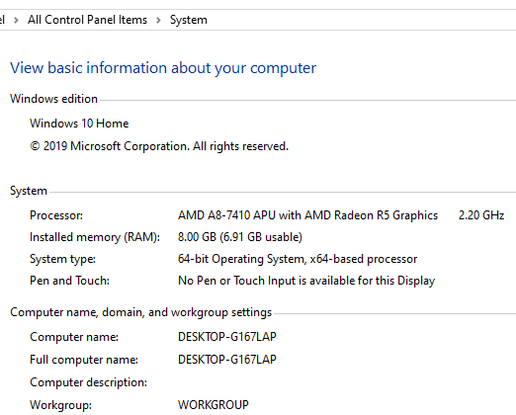

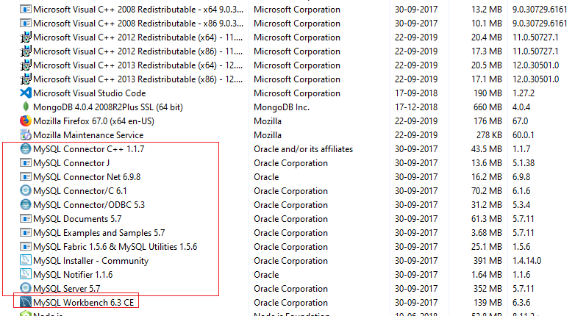

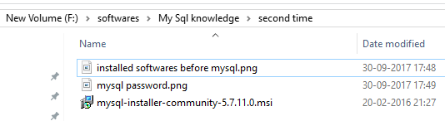

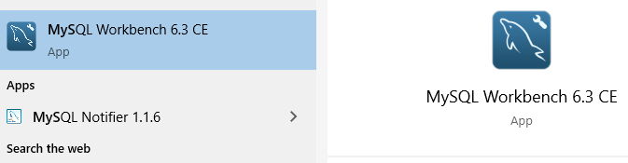

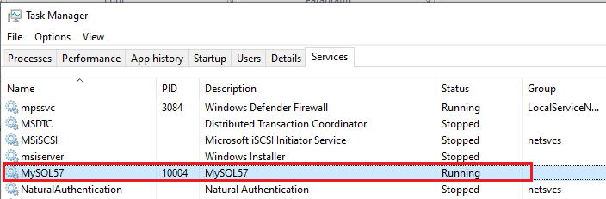

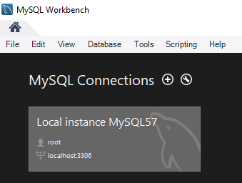

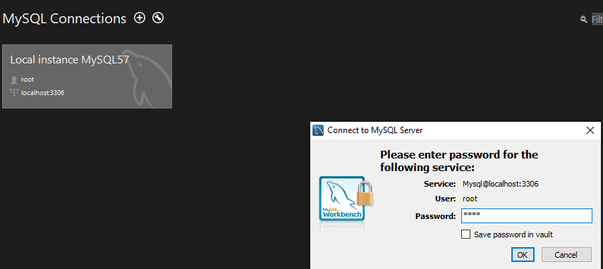

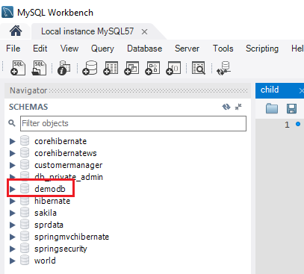

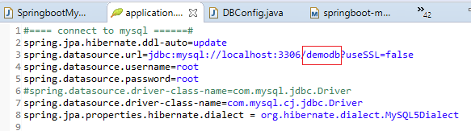

Then I just created the entities and services and controllers .

Then inserted some of the records from the postman with rest apis

<http://localhost:8080/insertDummyPersonRecords>

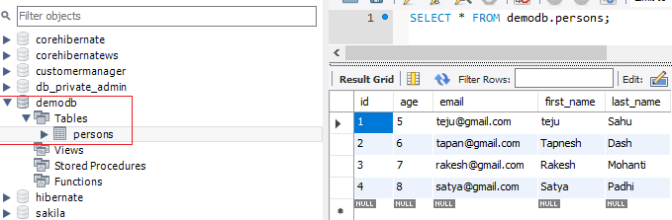

Then selected the records with the below rest api

<http://localhost:8080/getAllPersonss>

