**UNIT-TEST DOCUMENT OF STUDY-PLANNER**

**Test case-1: Landing Page**

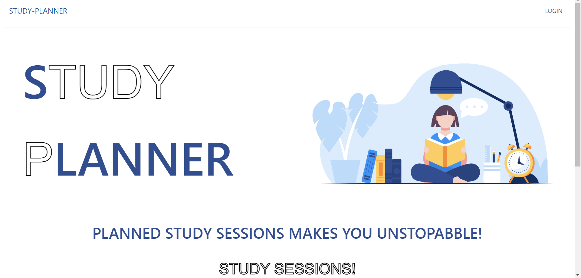

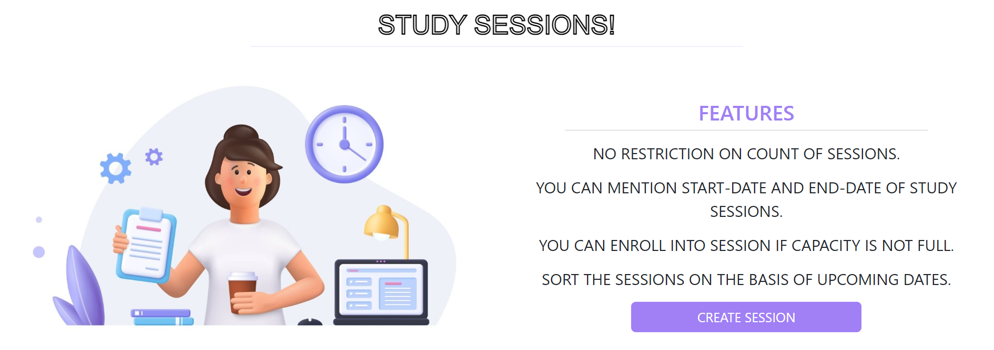

**Test case-2:** After Clicking “CREATE SESSION”, it will be redirected to Login Page.

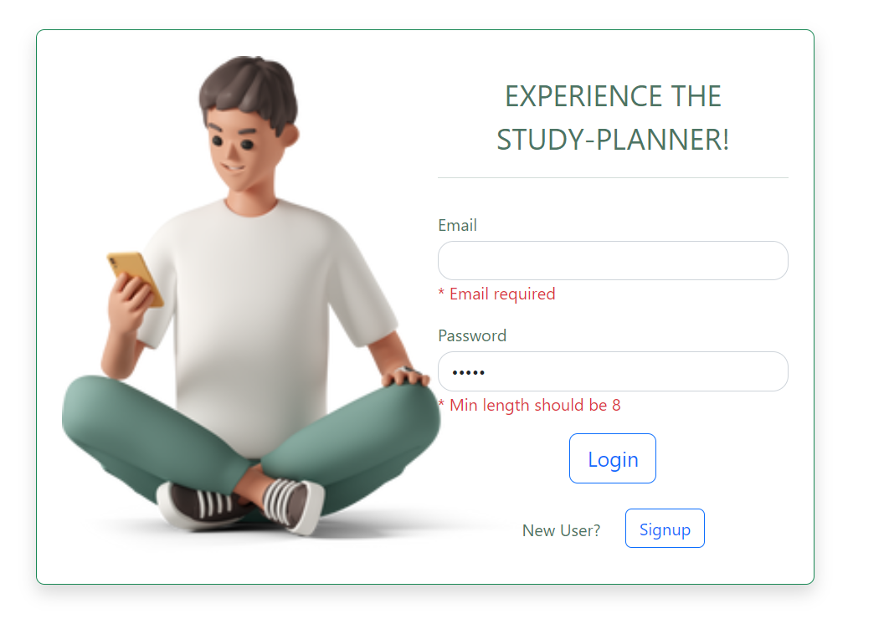

**Test case-3:** In Login Form, It doesn’t allow to login, until user enter the correct password, few measures were taken to enhance security as minimum length of password should be “8” and Email is unique for every user.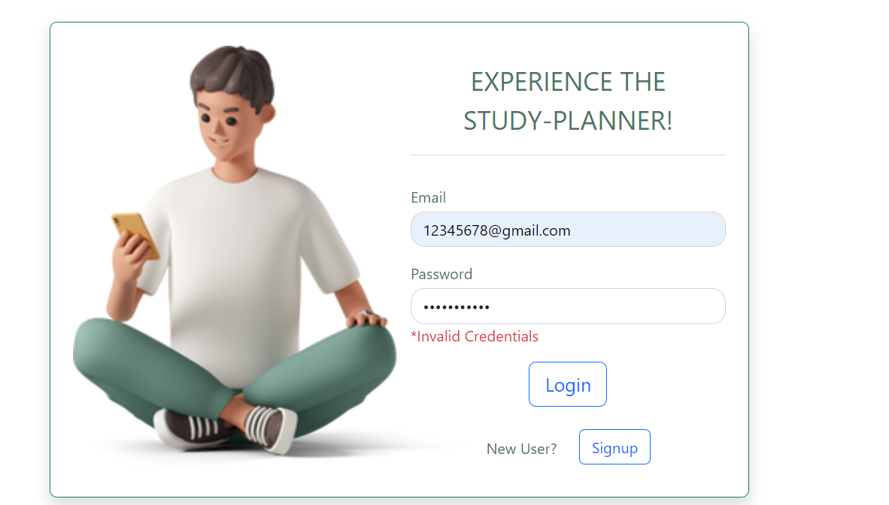

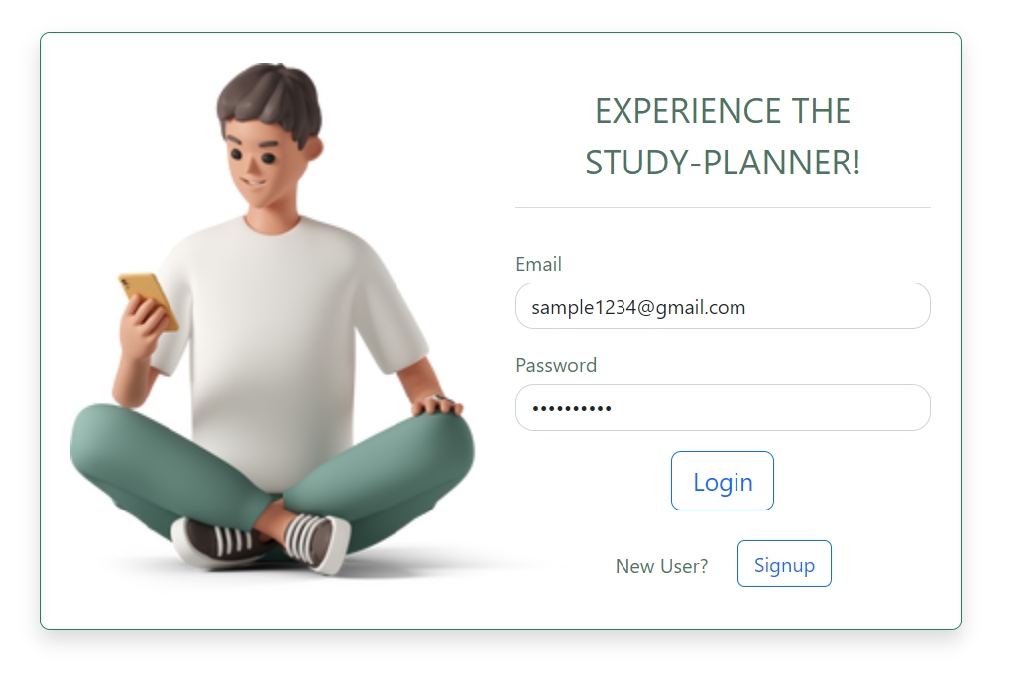

Test case-4: New user can register through signup,

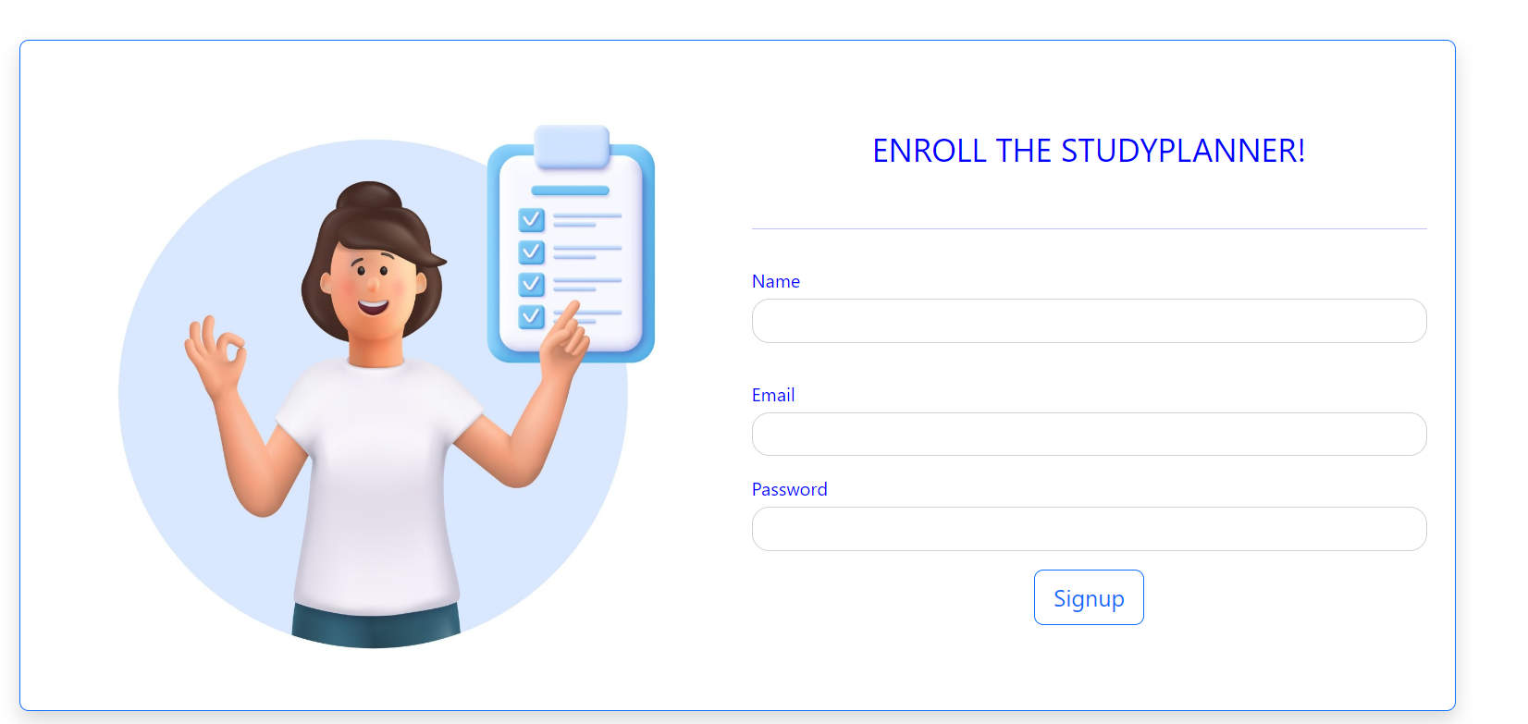

Test case-5: After logging in, Home page will be like this

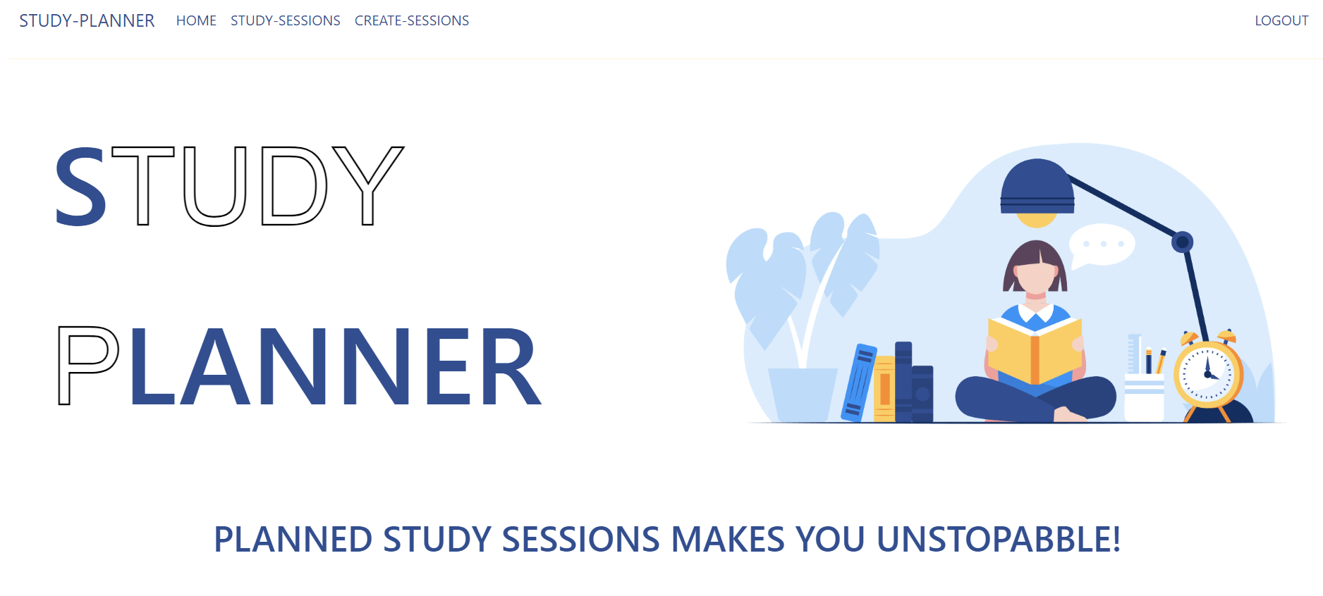

In create session, User Can create Session, in Study-sessions all study-sessions are displayed

Creator will always have open to the Session, for the other users it will be displayed as Enroll and If Session capacity is Reached maximum, the Unroll button will be disabled

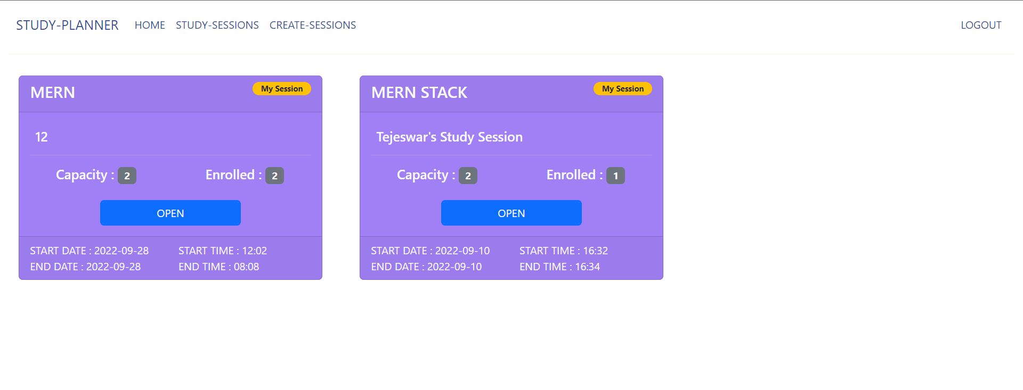

The above image will be in the perspective of user 1.

Test case-6: In the below Image The user is not Enrolled into Tejeswar’s Study Session in the perspective of user-2.

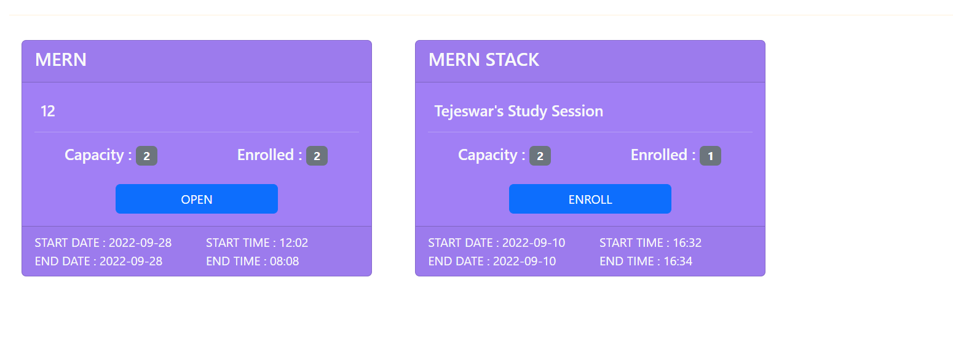

Test case-7:In the below Image, As the Session’s Capacity Reached Maximum, Enroll Button is disabled

In the user Perspective-3

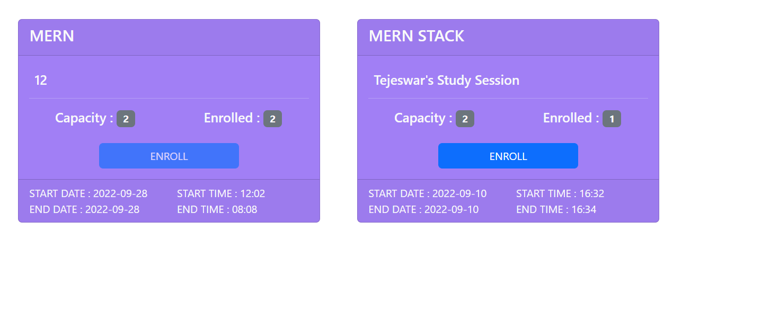

Test case-8: Users Can create any number of study sessions through “CREATE-SESSION”

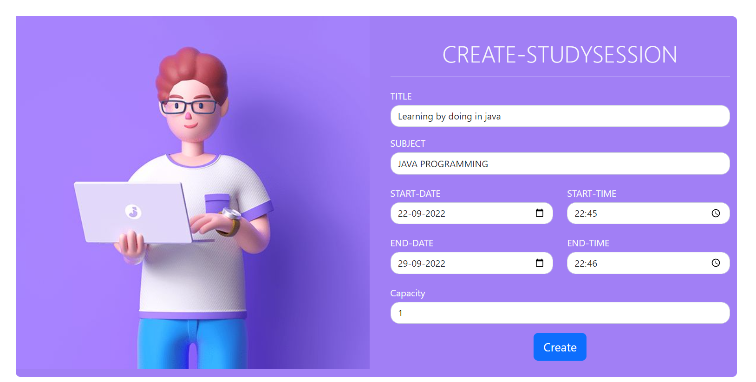

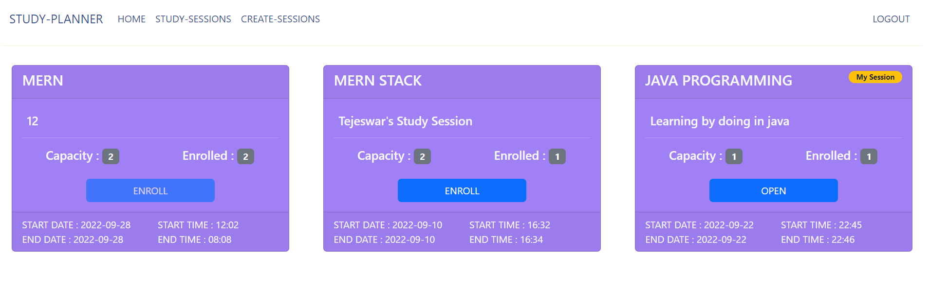

The creator’s Session will be displayed with the badge “My session”.

Test case-9:

The total App is Responsive in Nature, Several tests are provided below for landing page ,navbar ,loginpage ,etc.. 