**SSO implementation for Enterprise Applications:-**

**Contains**

1. [Adding Enterprise Application into Microsoft Entra ID](https://dev.azure.com/Kshema/SRE-DevOps/_wiki/wikis/SRE-DevOps.wiki?wikiVersion=GBwikiMaster&_a=edit&pagePath=/DevOps%20Documentation/IAM/SSO%20implementation%20for%20Zoho%20People&pageId=49&anchor=adding-enterprise-application-into-microsoft-entra-id)
2. [Adding Users/Groups into Enterprise Application](https://dev.azure.com/Kshema/SRE-DevOps/_wiki/wikis/SRE-DevOps.wiki?wikiVersion=GBwikiMaster&_a=edit&pagePath=/DevOps%20Documentation/IAM/SSO%20implementation%20for%20Zoho%20People&pageId=49&anchor=adding-users/groups-into-enterprise-application)

**Adding Enterprise Application into Microsoft Entra ID**

* Login to Microsoft Entra admin center]([https://entra.microsoft.com/](https://entra.microsoft.com/" \t "_blank) )
* Navigate to the **Identity blade**, select **enterprise application**, and then choose **new application**.

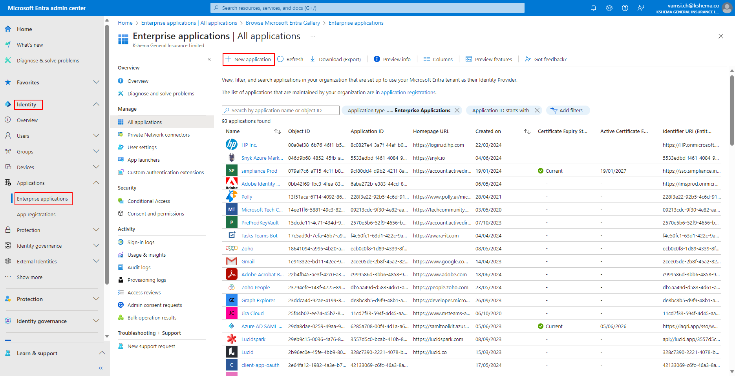

* Check if the application you want to set up Single Sign-On (SSO) for is available in the gallery. If it's not, select **create your own application**.

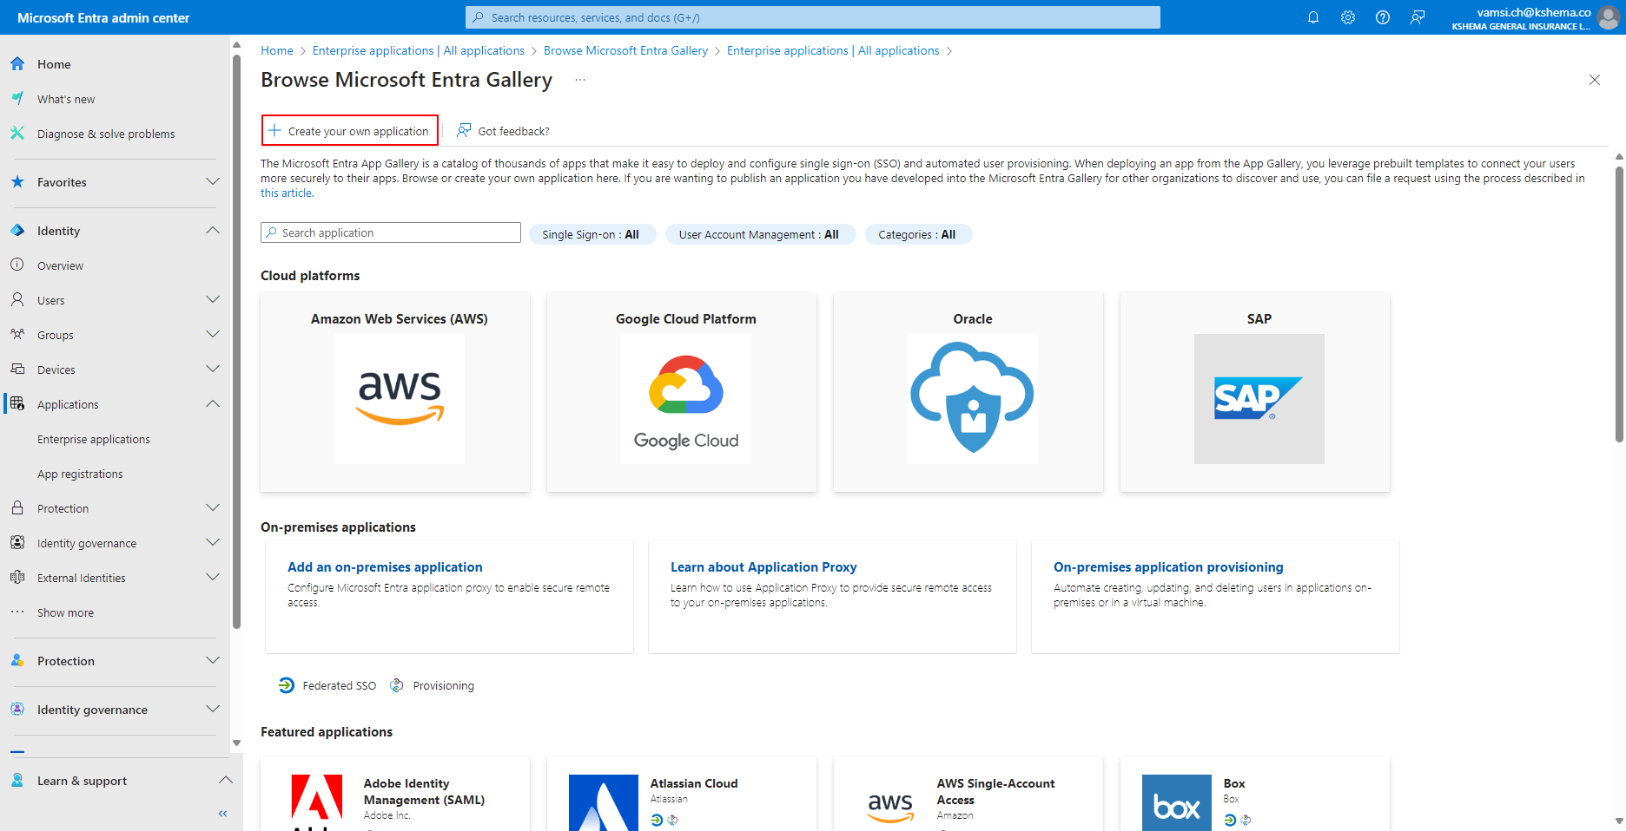

* **Name your application** and choose the option to integrate any other application that you didn't find in the gallery (Non-gallery). Then, click on **create**.

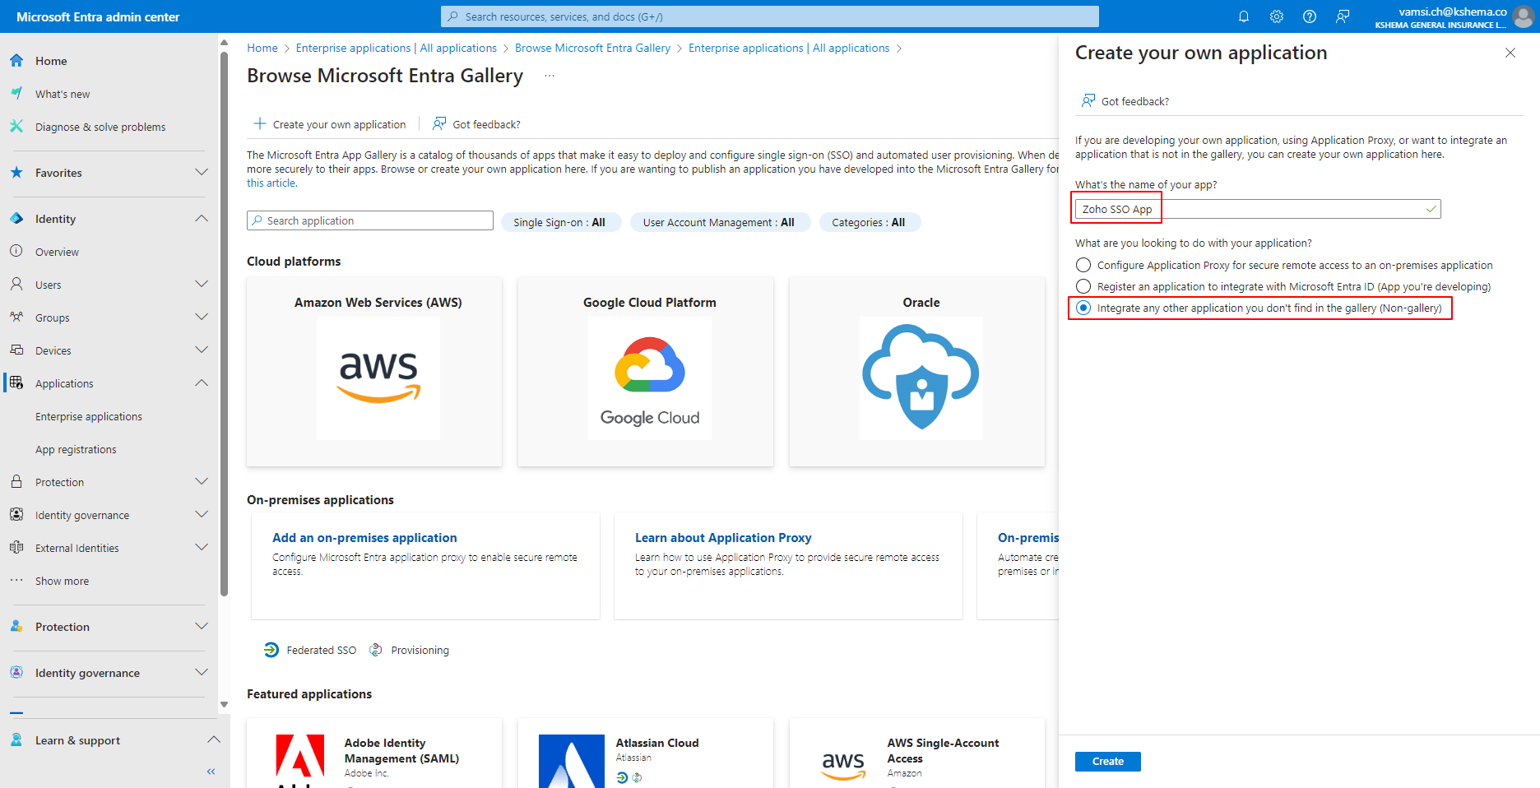

* Proceed to **set up single sign-on**.

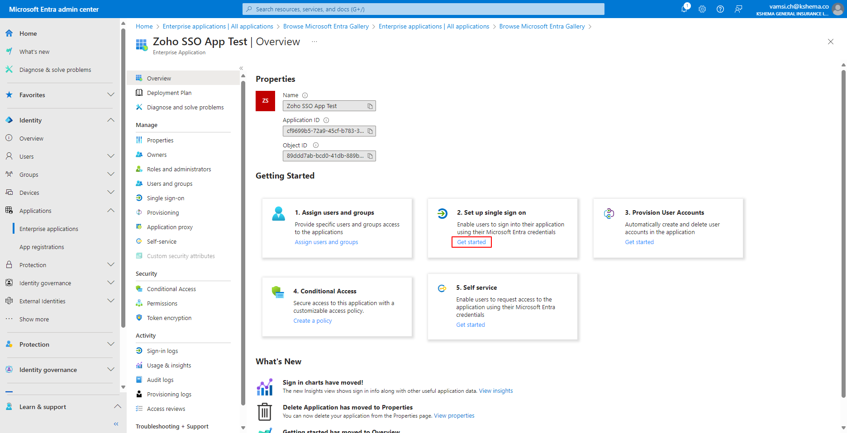

* Choose **SAML** as the method.

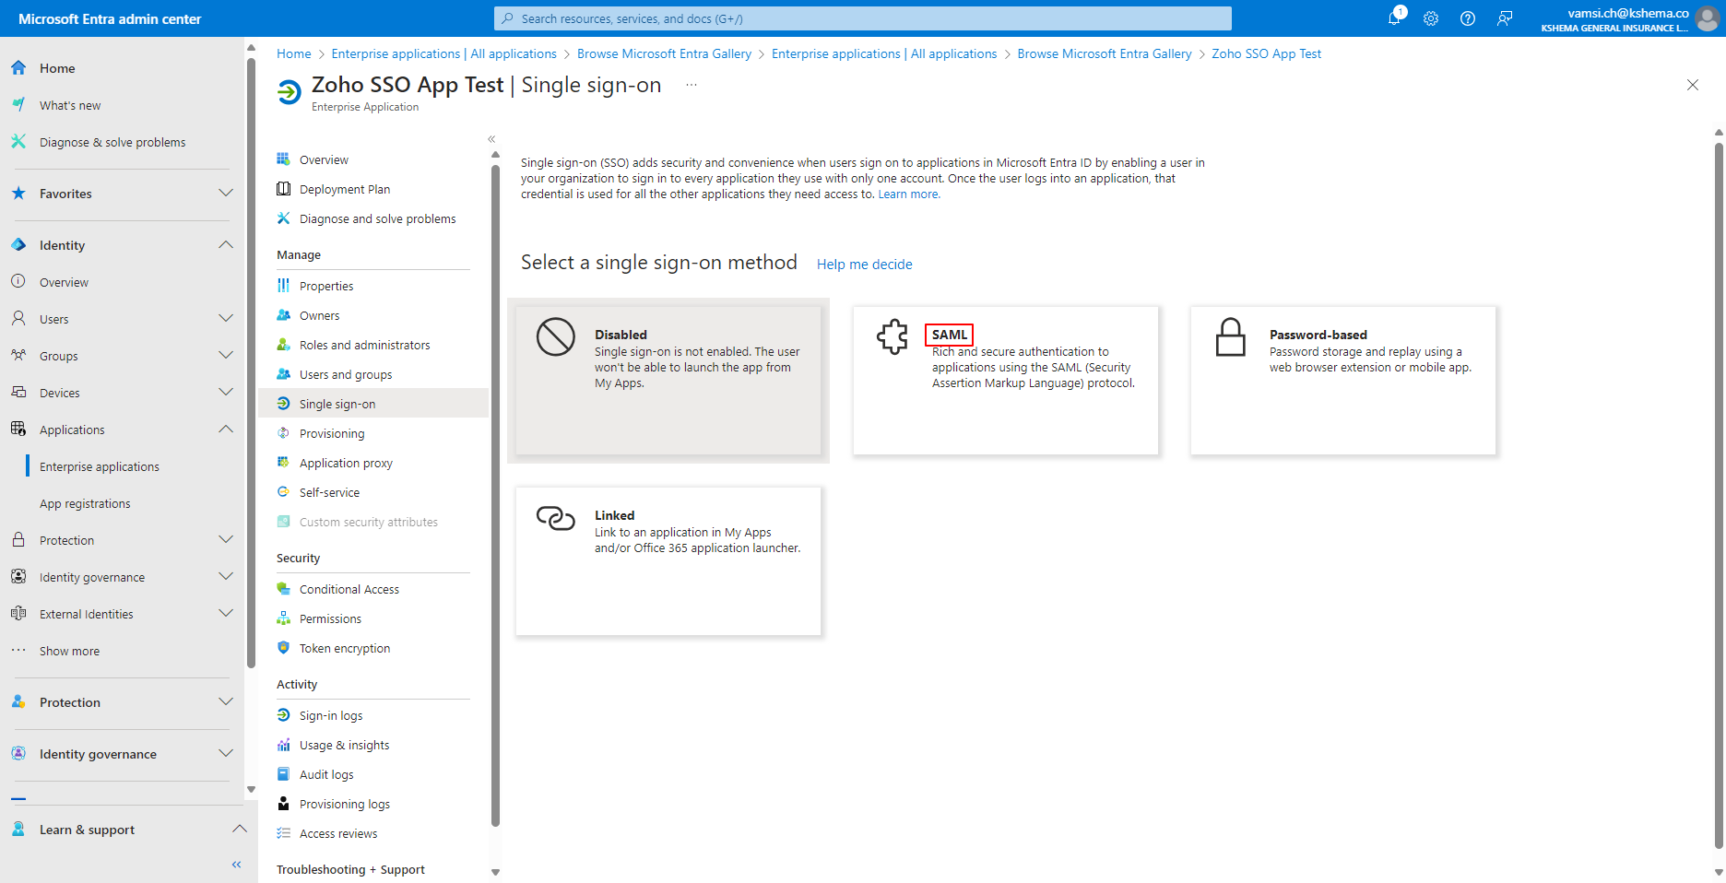

* Proceed to **edit the SAML Configuration**.

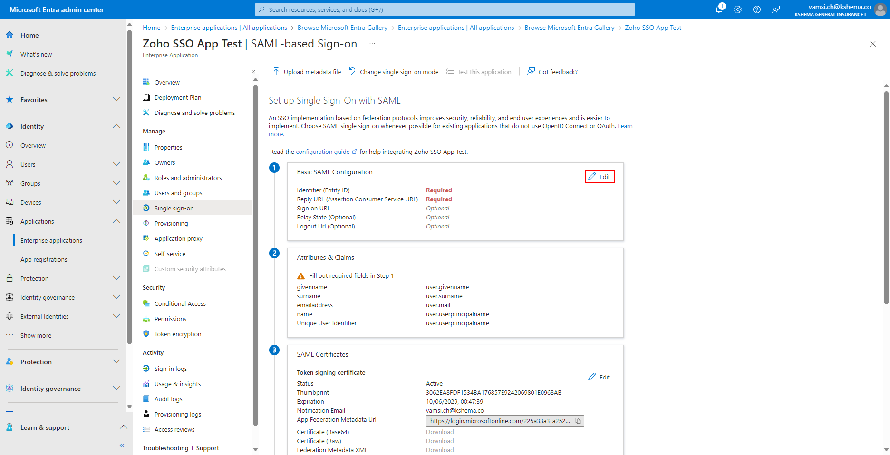

* **Enter the Entity ID and Reply URL**. These details should be provided by your Application Development Team.

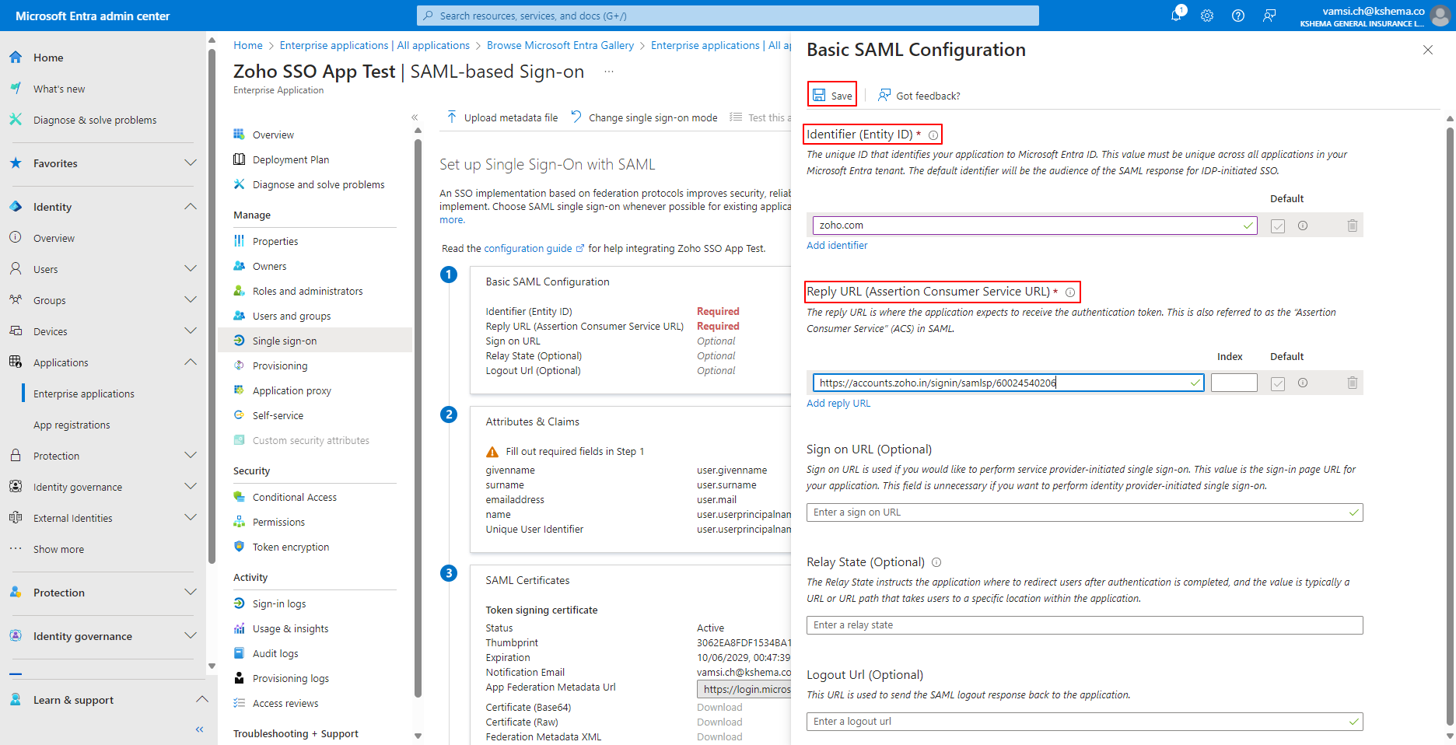

* Finally, **share the App Federation Metadata URL and Login URL** with your Application Development Team.

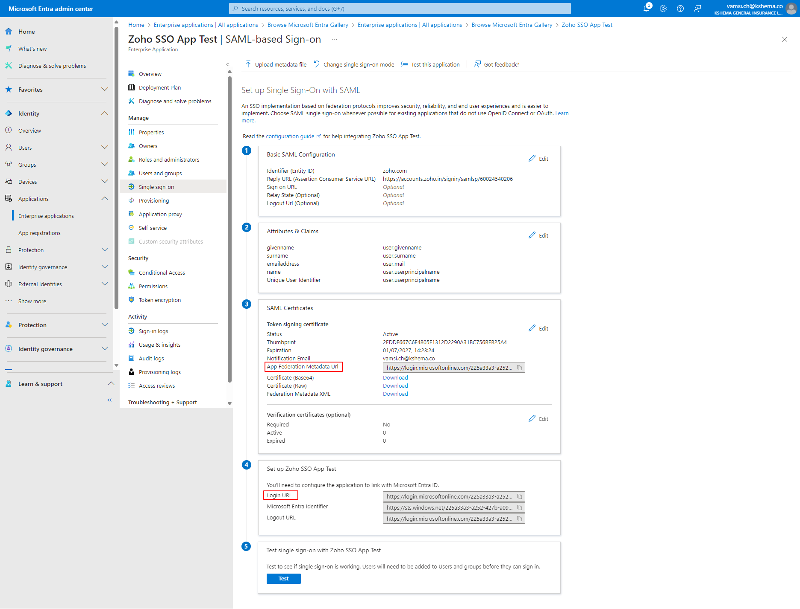**Adding Users/Groups into Enterprise Application**

To incorporate users into an application, follow these steps:

* Login to Microsoft Entra admin center](<https://entra.microsoft.com/> )
* Navigate to the Identity blade, select the enterprise application, and then look for the desired application.

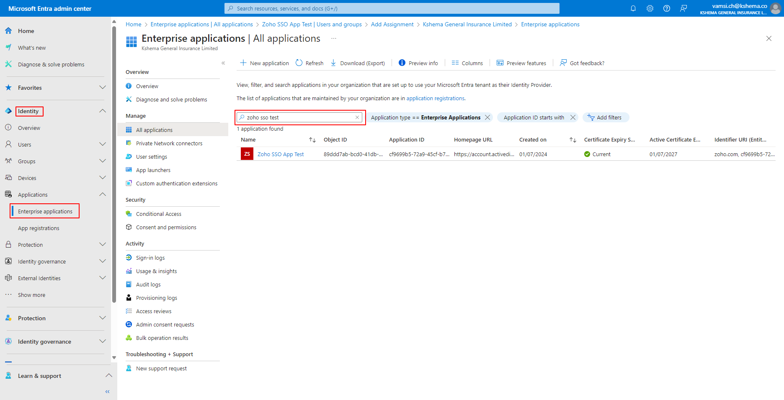

* Under the Manage section, select users and groups, then click on the add user/group option.

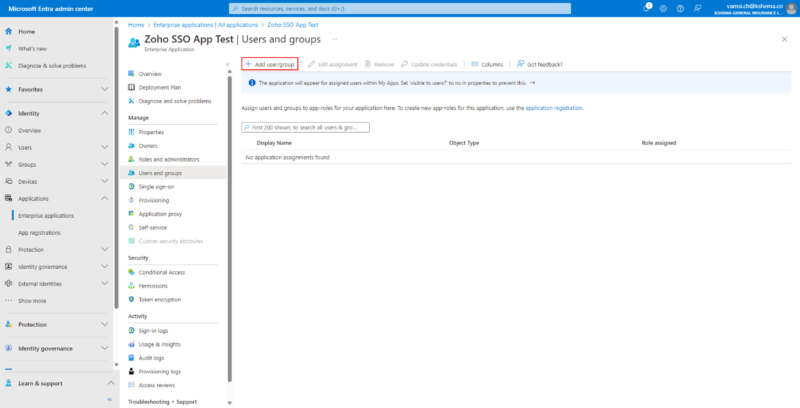

* Search for the desired group, select it, and in doing so, you can assign the group to access the application.

