LIBRARY MANAGEMENT SYSTEM
A DBMS Capstone Project Report submitted in partial fulfillment of the requirements for the award of the degree of
BACHELOR OF TECHNOLOGY
in
ARTIFICIAL INTELLIGENCE AND MACHINE LEARNING

Submitted By
Tejeswar Doolla – 25B11AIB79
Syed Saif Hussain – 25B11AIB59
Lokesh Kapparati – 25B11AI495
Ganusai Vechalapu – 25B11AIC55

Under the esteemed guidance of
Mr. T.Srinivasulu M.Tech, (Ph.D.)
Assistant Professor



DEPARTMENT OF ARTIFICIAL INTELLIGENCE AND MACHINE LEARNING
ADITYA UNIVERSITY
(Formerly Aditya Engineering College (A))
Aditya Nagar, ADB Road, Surampalem, Andhra Pradesh, India
2025 – 2026

Aditya Nagar, ADB Road, Surampalem, Andhra Pradesh, India
DEPARTMENT OF ARTIFICIAL INTELLIGENCE AND MACHINE LEARNING
CERTIFICATE
This is to certify that the DBMS Capstone Project report entitled "LIBRARY MANAGEMENT SYSTEM" is being submitted by Tejeswar Doolla (Roll No. 25B11AIB79), Syed Saif Hussain (Roll No. 25B11AIB59), Lokesh Kapparati (Roll No. 25B11AI495), and Ganusai (Roll No. 25B11AIC55) in partial fulfillment of the requirements for the award of the B.Tech. degree in Artificial Intelligence and Machine Learning. The work documented in this report was carried out as part of the Capstone Project for the course Database Management Systems (2501IT05) during the academic year 2026–2027, and records the database design, implementation, and documentation undertaken by the team.

Project Guide Head of the Department
Mr. T. Srinivasulu, M. Tech, (Ph.D.) Dr. K. Naga Bhargavi, M. Tech, Ph.D. Associate professor Associate Professor & HOD

External Examiner

DECLARATION
We hereby declare that the DBMS Capstone Project entitled "LIBRARY MANAGEMENT SYSTEM" is a genuine work carried out by us. The database design, SQL implementation, queries and documentation presented in this report are our own work, completed under the guidance of Mr. T. Srinivasulu , Department of AIML, Aditya University, Surampalem. We further declare that this work has not been submitted, in full or in part, for the award of any degree of this or any other educational institution.

Project Associates
Tejeswar Doolla (25B11AIB79)
Syed Saif Hussain (25B11AIB59)
Lokesh Kapparati (25B11AI495)
Ganusai Vechalapu (25B11AIC55)

Date: 30-09-2026
Place: Surampalem

ACKNOWLEDGEMENT
It is with immense pleasure that we express our indebted gratitude to our project guide Mr. T. Srinivasulu, M.Tech, (Ph.D.), Assistant Professor, Department of Artificial Intelligence and Machine Learning, Aditya University, who guided us throughout the DBMS Capstone Project. His constant encouragement, expert advice and valuable suggestions at every stage of the project have been instrumental in its successful completion.
We are grateful to Dr. K. Naga Bhargavi, M.Tech, Ph.D., Head of the Department of Artificial Intelligence and Machine Learning, for inspiring us and for arranging the facilities and resources needed for this project.
We extend our sincere thanks to the Management, Dr. M. Sreenivasa Reddy, Deputy Pro-Chancellor, Dr. M. B. Srinivas, Vice-Chancellor, and Dr. A. Ramesh, Pro Vice-Chancellor (Engineering & Sciences), for providing an excellent academic environment.
Not to forget, we thank the Teaching and Non-Teaching Staff, our parents and our friends, who have directly or indirectly supported us in completing this project on time.

Project Associates
Tejeswar Doolla 25B11AIB79
Syed Saif Hussain 25B11AIB59
Lokesh Kapparati 25B11AI495
Ganusai Vechalapu 25B11AIC55

ABSTRACT
The Library Management System (LMS) is a comprehensive, production-grade relational database solution designed to automate, streamline, and govern the operational workflows of an academic institutional library. Built on MySQL 8.0, the system comprises nine interrelated entities — STUDENT, BOOK, AUTHOR, PUBLISHER, CATEGORY, LIBRARIAN, BOOK_AUTHOR, ISSUE, and FINE — fully normalized to Third Normal Form (3NF) to eliminate data redundancy and update anomalies. The database enforces comprehensive integrity constraints including PRIMARY KEY, FOREIGN KEY, UNIQUE, NOT NULL, CHECK, and DEFAULT clauses across all nine tables. Key features include automated inventory synchronization via MySQL triggers, ACID-compliant transaction management using COMMIT, SAVEPOINT, and ROLLBACK, four operational views (AVAILABLE_BOOKS, CURRENT_ISSUES, STUDENT_ISSUE_HISTORY, FINE_DETAILS), multi-table JOIN queries, aggregate reporting, and correlated subqueries. The project is version-controlled on GitHub and documented with an ER diagram, relational schema, complete DDL/DML/DQL scripts (896 lines across 17 parts), and this academic report. This system demonstrates applied relational database design principles and SQL proficiency for real-world library administration.

INDEX
Chapter | Title | Page No.
1 | Introduction | 9
2 | System Study and Tools | 11
3 | Database Design (Review – I) | 12
4 | Database Implementation (Review – II) | 19
5 | SQL Operations and Queries | 24
6 | Modules and Functionalities | 28
7 | Results – Sample Outputs and Screenshots | 30
8 | Testing and Data Validation | 36
9 | GitHub Repository and Team Contribution | 37
10 | Conclusion and Future Enhancements | 39
 | References | 40
 | Appendix A – Complete SQL Script | 41
 | 1.6 Organization of the Report | 10
2 | System Study and Tools | 11
 | 2.1 Existing System and Its Limitations | 11
 | 2.2 Proposed Database System | 11
 | 2.3 Tools and Technologies Used | 11
 | 2.4 Software and Hardware Requirements | 11
3 | Database Design (Review – I) | 12
 | 3.1 Identified Entities | 12
 | 3.2 Entity Attributes and Attribute Types | 12
 | 3.3 ER Diagram | 14
 | 3.4 Relationships and Cardinality | 14
 | 3.5 Relational Database Schema | 15
 | 3.6 Primary Keys and Foreign Keys | 17
 | 3.7 Normalization up to 3NF | 18
4 | Database Implementation (Review – II) | 19
 | 4.1 Database and Table Creation – DDL | 19
 | 4.2 Sample Data Insertion – DML | 21
 | 4.3 Constraints and Data Integrity | 22
 | 4.4 Data Validation Rules | 23
5 | SQL Operations and Queries | 24
 | 5.1 DQL – Basic Retrieval Queries | 24
 | 5.2 Join Operations | 24
 | 5.3 Aggregate Functions, GROUP BY and HAVING | 25
 | 5.4 Nested and Correlated Subqueries | 25
 | 5.5 Views and Relational Set Operations | 26
 | 5.6 DCL and TCL Operations | 26
6 | Modules and Functionalities | 28
7 | Results – Sample Outputs and Screenshots | 30
8 | Testing and Data Validation | 36
9 | GitHub Repository and Team Contribution | 37
10 | Conclusion and Future Enhancements | 39
 | References | 40
 | Appendix A – Complete SQL Script | 41

LIST OF FIGURES
Figure No. | Title of the Figure | Page No.
Fig. 3.1 | ER Diagram of the Library Management System (Chen's Notation) | 12
Fig. 3.2 | Relational Database Schema Diagram (PK–FK Links) | 15
Fig. 4.1 | Successful Creation of All 9 Tables with Constraints (MySQL 8.4) | 18
Fig. 4.2 | Sample Data Inserted into Tables (CompileBytes Record Population) | 20
Fig. 4.3 | Referential Integrity Enforced by Database Constraints | 22
Fig. 7.1 | Data Retrieval Operations (DQL) in CompileBytes | 28
Fig. 7.2 | Multi-Table JOIN Operations & Circulation Mappings in CompileBytes | 29
Fig. 7.3 | Aggregate Analytics & Subquery Query Results in CompileBytes | 30
Fig. 7.4 | Operational Database Views Output in CompileBytes | 31
Fig. 7.5 | CompileBytes Cloud SQL Environment & Demonstration Queries | 32

LIST OF TABLES
Table No. | Title of the Table | Page No.
Table 2.1 | Tools and Technologies Used | 7
Table 2.2 | Software and Hardware Requirements | 8
Table 3.1 | Entities Identified for the Selected Domain | 9
Table 3.2 | Attributes of Each Entity | 10
Table 3.3 | Relationships and Cardinality | 13
Table 3.4 | Relational Database Schema | 14
Table 3.5 | Primary Key and Foreign Key Definitions | 16
Table 3.6 | Normalization Steps up to 3NF | 17
Table 4.1 | Sample Data Summary | 19
Table 4.2 | Constraints and Data Integrity Rules | 21

CHAPTER 1: INTRODUCTION

1.1 Introduction to the Domain
Academic libraries serve as the intellectual backbone of higher education institutions, providing students, faculty, and researchers with access to an extensive and diverse collection of books, research journals, reference materials, and digital resources. At Aditya University, the library houses thousands of titles spanning engineering, sciences, humanities, and technology disciplines. Managing this vast collection — including acquisitions, cataloguing, member registration, book issuance, returns, and fine enforcement — demands a structured, automated, and reliable information management system. The Library Management System (LMS) addresses this need by providing a centralized relational database that governs all library workflows, ensures data integrity, and enables efficient reporting and record retrieval.

1.2 Problem Statement
Conventional library administration relies on manual registers, physical borrower cards, and standalone spreadsheets, introducing critical operational limitations: (1) Duplicate borrowing records and inconsistent book inventory data; (2) No real-time updates on available book copies after issuance or return; (3) Inability to track and enforce overdue fines automatically; (4) No centralized, searchable catalog of students, books, or borrowing history; (5) Data redundancy with author and publisher information duplicated across records; (6) Absence of referential integrity allows orphan transaction records. A normalized, constraint-enforced relational database system is required to eliminate these deficiencies and provide a reliable, automated library management platform.

1.3 Motivation and Need for a Database
A relational Database Management System (DBMS) is required for the Library domain because: (1) Files and spreadsheets cannot enforce referential integrity between students, books, and transactions; (2) SQL's declarative query language enables complex multi-table reporting (e.g., overdue students, popular books) in a single statement; (3) ACID transactions guarantee that book issuance and inventory updates are atomic — no partial updates; (4) Constraints (CHECK, UNIQUE, FOREIGN KEY) enforce domain rules at the database engine level, not the application layer; (5) Views provide role-specific data access without exposing sensitive columns; (6) MySQL 8.0 triggers automate inventory synchronization on every issue and return.

1.4 Objectives of the Project
- To design a fully normalized (3NF) relational database schema with 9 core entities to manage all library operations with zero data redundancy.
- To implement the database with appropriate PRIMARY KEY, FOREIGN KEY, UNIQUE, NOT NULL, CHECK and DEFAULT constraints enforced across all nine tables.
- To automate real-time inventory synchronization of available book copies upon issuance and return using MySQL database triggers.
- To implement ACID-compliant transaction workflows (COMMIT, SAVEPOINT, ROLLBACK) and comprehensive CRUD operations for reliable circulation tracking and fine calculation.
- To develop optimized multi-table JOIN queries, aggregate functions, subqueries, and four operational views for fast reporting and data access.

1.5 Scope of the Project
The LMS database covers: student/member registration and management; book cataloguing with author, publisher, and category linkage; book issuance and return tracking; automated fine calculation; multi-table reporting and analytics; and trigger-based inventory management. The current implementation does not cover: a graphical front-end application; RFID/barcode scanning integration; role-based access control (RBAC); digital resources (e-books, journals); or automated email/SMS notifications.

1.6 Organization of the Report
This report is organized into ten chapters. Chapter 2 presents the system study and the tools used. Chapter 3 covers the complete database design including the ER diagram, relational schema and normalization. Chapter 4 describes the database implementation with DDL and sample data. Chapter 5 presents the SQL operations and queries executed. Chapter 6 explains the modules and functionalities. Chapter 7 presents the results with sample outputs. Chapter 8 covers testing and data validation. Chapter 9 details the GitHub repository and the contribution of each team member. Chapter 10 concludes the report and outlines future enhancements.

CHAPTER 2: SYSTEM STUDY AND TOOLS

2.1 Existing System and Its Limitations
The existing library management approach at most academic institutions relies on manual record-keeping using registers, logbooks, and spreadsheets. Limitations include: (1) No automated inventory tracking — librarians must manually count available copies; (2) No centralized search capability for books or borrowers; (3) Manual fine calculation prone to errors and omissions; (4) No data validation — duplicate student IDs or invalid entries are possible; (5) Data loss risk — physical registers can be damaged or misplaced; (6) No audit trail — borrowing history cannot be reliably retrieved.

2.2 Proposed Database System
The proposed Library Management System database provides: (1) A centralized MySQL 8.0 relational database with 9 normalized tables; (2) Automatic inventory updates via AFTER INSERT/UPDATE triggers on the ISSUE table; (3) Constraint-based data validation (PRIMARY KEY, FOREIGN KEY, CHECK, UNIQUE, NOT NULL); (4) ACID-compliant transactions for reliable issue/return workflows; (5) Four operational views for instant librarian reporting; (6) Complex multi-table JOIN queries for borrowing history, overdue tracking, and popularity analytics. The system eliminates manual errors, enforces data integrity at the database engine level, and provides a scalable foundation for future enhancements.

2.3 Tools and Technologies Used
Table 2.1: Tools and Technologies Used
Category | Tool / Technology Used | Version / Remarks
Database Server | MySQL 8.0 Community Server Edition | v8.0.36
Query / Admin Tool | MySQL Command Line Client / MySQL Workbench | v8.0
ER Diagram Tool | draw.io / diagrams.net | Online (Free)
Version Control | Git & GitHub | github.com
Documentation Tool | Microsoft Word 2021 / python-docx | v1.1.2
Script Language | Python 3.12 (python-pptx, python-docx) | v3.12.0

2.4 Software and Hardware Requirements
Table 2.2: Software and Hardware Requirements
Requirement Type | Specification
Operating System | Windows 10 / 11 (64-bit) or Linux Ubuntu 22.04 LTS
Database Server | MySQL 8.0 Community Edition (Free, Open Source)
RAM | Minimum 4 GB (8 GB Recommended)
Processor | Intel Core i3 or equivalent (2 GHz+)
Storage | Minimum 20 GB free disk space
Network | Internet access for GitHub and MySQL documentation

CHAPTER 3: DATABASE DESIGN

3.1 Identified Entities
Table 3.1: Entities Identified for the Selected Domain
S.No | Entity Name | Description
1 | STUDENT | Stores library member records — registration, contact, department, year, and active status
2 | BOOK | Represents bibliographic catalog entries with ISBN, copies, publisher, and category linkage
3 | AUTHOR | Maintains author biographical details; linked to books via M:N associative table
4 | PUBLISHER | Stores publishing house information with unique email and phone constraints
5 | CATEGORY | Classifies books into subject domains (Fiction, Science, DBMS, Algorithms, etc.)
6 | LIBRARIAN | Records staff who process book issue and return transactions
7 | BOOK_AUTHOR | Associative junction table resolving the Many-to-Many BOOK-AUTHOR relationship
8 | ISSUE | Tracks every book borrowing transaction with issue date, due date, and status
9 | FINE | Records overdue fines linked to ISSUE transactions with payment tracking

3.2 Entity Attributes and Attribute Types
Table 3.2: Attributes of Each Entity
Entity | Attribute | Data Type | Key (PK / FK / —) | Attribute Type
STUDENT | student_id, name, email, phone, department, year, join_date, status | INT, VARCHAR(100), VARCHAR(100), VARCHAR(15), VARCHAR(50), INT, DATE, VARCHAR(10) | PK: student_id  UQ: email, phone | Simple, Stored
BOOK | book_id, title, isbn, publication_year, language, total_copies, available_copies, publisher_id, category_id | INT, VARCHAR(200), VARCHAR(20), INT, VARCHAR(30), INT, INT, INT, INT | PK: book_id  FK: publisher_id, category_id  UQ: isbn | Simple, Stored, Derived (available_copies)
AUTHOR | author_id, author_name, nationality, date_of_birth, biography | INT, VARCHAR(100), VARCHAR(50), DATE, TEXT | PK: author_id | Simple
PUBLISHER | publisher_id, publisher_name, email, phone, address | INT, VARCHAR(100), VARCHAR(100), VARCHAR(15), VARCHAR(255) | PK: publisher_id  UQ: publisher_name, email, phone | Simple
CATEGORY | category_id, category_name, description | INT, VARCHAR(50), VARCHAR(255) | PK: category_id  UQ: category_name | Simple
LIBRARIAN | librarian_id, name, email, phone, hire_date | INT, VARCHAR(100), VARCHAR(100), VARCHAR(15), DATE | PK: librarian_id  UQ: email, phone | Simple, Stored
BOOK_AUTHOR | book_id, author_id | INT, INT | PK: (book_id, author_id) Composite  FK: book_id, author_id | Composite Key
ISSUE | issue_id, student_id, book_id, librarian_id, issue_date, due_date, return_date, status | INT, INT, INT, INT, DATE, DATE, DATE, VARCHAR(10) | PK: issue_id  FK: student_id, book_id, librarian_id | Simple, Stored
FINE | fine_id, issue_id, amount, paid_status, payment_date | INT, INT, DECIMAL(8,2), VARCHAR(10), DATE | PK: fine_id  FK: issue_id | Simple, Stored

3.3 ER Diagram
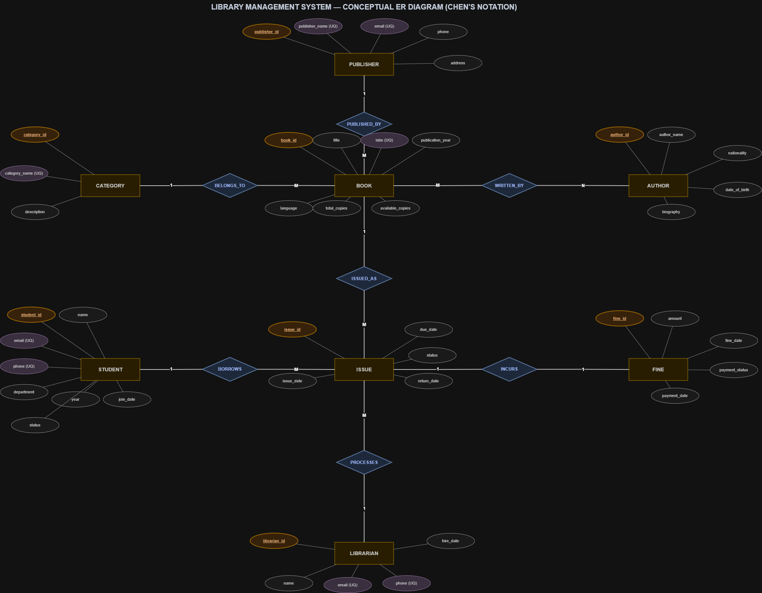
Fig. 3.1: ER Diagram of the Library Management System (Chen's Notation) — All 9 Entities, Relationships & Cardinalities

3.4 Relationships and Cardinality
Table 3.3: Relationships and Cardinality
Entity 1 | Relationship | Entity 2 | Cardinality (1:1 / 1:N / M:N) | Participation
CATEGORY | Classifies (1:N) | BOOK | 1:N | Total on BOOK, Partial on CATEGORY
PUBLISHER | Publishes (1:N) | BOOK | 1:N | Total on BOOK, Partial on PUBLISHER
BOOK | Written By (M:N) | AUTHOR | M:N | Partial on both; via BOOK_AUTHOR
STUDENT | Borrows (1:N) | ISSUE | 1:N | Total on ISSUE, Partial on STUDENT
BOOK | Issued Via (1:N) | ISSUE | 1:N | Total on ISSUE, Partial on BOOK
LIBRARIAN | Processes (1:N) | ISSUE | 1:N | Total on ISSUE, Partial on LIBRARIAN
ISSUE | Incurs (1:1) | FINE | 1:1 | Total on FINE, Partial on ISSUE

3.5 Relational Database Schema
Table 3.4: Relational Database Schema
Table Name | Column Name | Data Type | Key (PK / FK / —) | Constraints
STUDENT | student_id, name, email, phone, department, year, join_date, status | INT, VARCHAR(100), VARCHAR(100), VARCHAR(15), VARCHAR(50), INT, DATE, VARCHAR(10) | PK: student_id | email UNIQUE NOT NULL, phone UNIQUE NOT NULL, year CHECK(1-6), status CHECK('Active','Inactive')
BOOK | book_id, title, isbn, publication_year, language, total_copies, available_copies, publisher_id, category_id | INT, VARCHAR(200), VARCHAR(20), INT, VARCHAR(30), INT, INT, INT, INT | PK: book_id  FK: publisher_id→PUBLISHER  FK: category_id→CATEGORY | isbn UNIQUE NOT NULL, title NOT NULL, total_copies CHECK(>0)
AUTHOR | author_id, author_name, nationality, date_of_birth, biography | INT, VARCHAR(100), VARCHAR(50), DATE, TEXT | PK: author_id | author_name NOT NULL, nationality NOT NULL, biography NOT NULL
PUBLISHER | publisher_id, publisher_name, email, phone, address | INT, VARCHAR(100), VARCHAR(100), VARCHAR(15), VARCHAR(255) | PK: publisher_id | publisher_name UNIQUE NOT NULL, email UNIQUE NOT NULL, phone UNIQUE NOT NULL
CATEGORY | category_id, category_name, description | INT, VARCHAR(50), VARCHAR(255) | PK: category_id | category_name UNIQUE NOT NULL, description NOT NULL
LIBRARIAN | librarian_id, name, email, phone, hire_date | INT, VARCHAR(100), VARCHAR(100), VARCHAR(15), DATE | PK: librarian_id | email UNIQUE NOT NULL, phone UNIQUE NOT NULL, hire_date DEFAULT CURRENT_DATE
BOOK_AUTHOR | book_id, author_id | INT, INT | PK: (book_id, author_id)  FK: book_id→BOOK  FK: author_id→AUTHOR | Composite primary key; both FK columns NOT NULL
ISSUE | issue_id, student_id, book_id, librarian_id, issue_date, due_date, return_date, status | INT, INT, INT, INT, DATE, DATE, DATE, VARCHAR(10) | PK: issue_id  FK: student_id→STUDENT  FK: book_id→BOOK  FK: librarian_id→LIBRARIAN | status CHECK('Issued','Returned','Overdue'), return_date allows NULL
FINE | fine_id, issue_id, amount, paid_status, payment_date | INT, INT, DECIMAL(8,2), VARCHAR(10), DATE | PK: fine_id  FK: issue_id→ISSUE | amount CHECK(>0), paid_status CHECK('Paid','Unpaid'), payment_date allows NULL

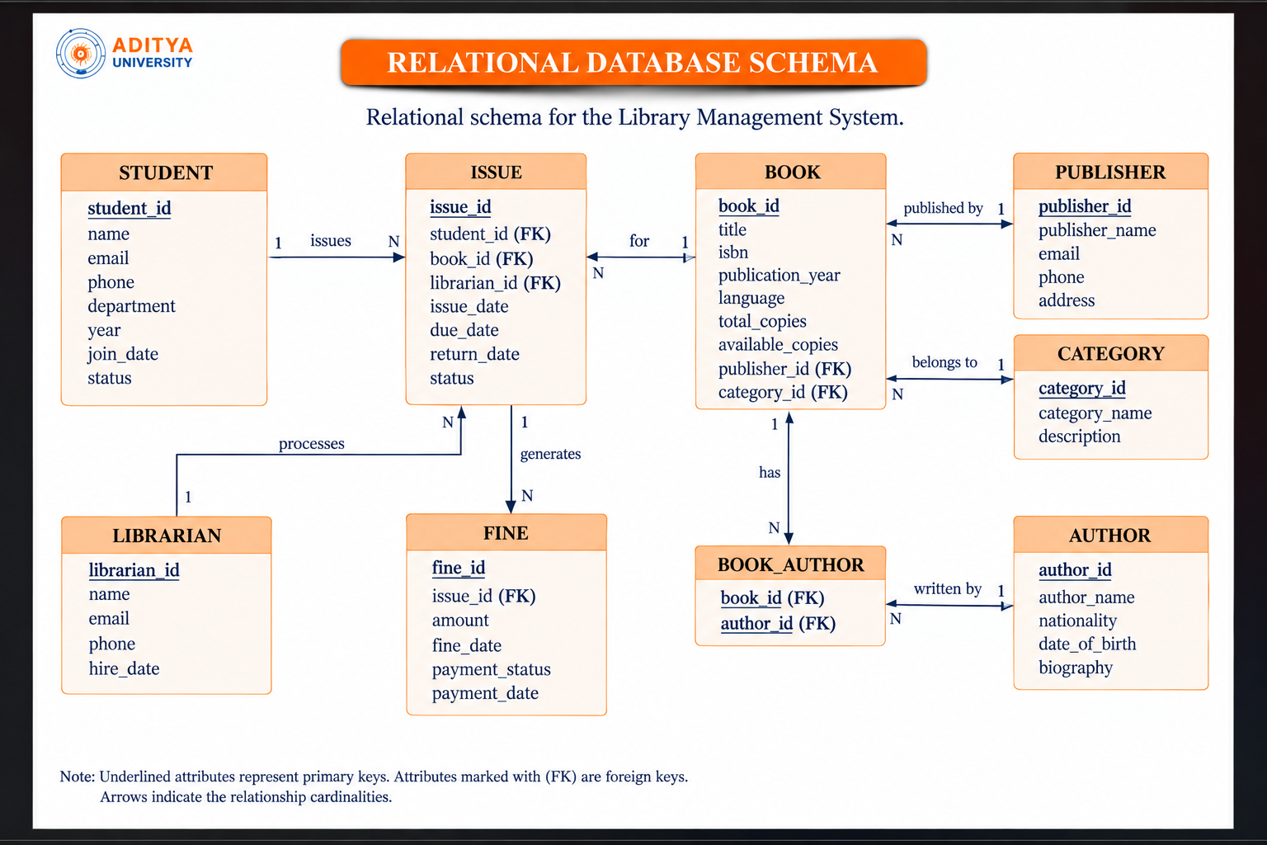

3.6 Primary Keys and Foreign Keys
Table 3.5: Primary Key and Foreign Key Definitions
Table | Primary Key | Foreign Key | References (Table.Column)
STUDENT | student_id | — | —
BOOK | book_id | publisher_id, category_id | PUBLISHER.publisher_id, CATEGORY.category_id
AUTHOR | author_id | — | —
PUBLISHER | publisher_id | — | —
CATEGORY | category_id | — | —
LIBRARIAN | librarian_id | — | —
BOOK_AUTHOR | (book_id, author_id) | book_id, author_id | BOOK.book_id, AUTHOR.author_id
ISSUE | issue_id | student_id, book_id, librarian_id | STUDENT.student_id, BOOK.book_id, LIBRARIAN.librarian_id
FINE | fine_id | issue_id | ISSUE.issue_id

3.7 Normalization up to 3NF
UNF → 1NF → 2NF → 3NF
Table 3.6: Normalization Steps
Normal Form | Condition Satisfied | Anomaly Removed | Resulting Tables
UNF (Unnormalized) | Has repeating groups and multi-valued attributes (e.g., book with multiple authors in one field) | Insertion, Update, Deletion anomalies | Single flat relation with redundancy
1NF (First Normal Form) | All attributes are atomic; no repeating groups; each cell holds a single value | Repeating group anomalies removed | BOOK_AUTHOR junction table created to handle M:N
2NF (Second Normal Form) | 1NF + every non-key attribute is fully functionally dependent on the entire primary key | Partial dependency anomalies removed | CATEGORY and PUBLISHER split from BOOK
3NF (Third Normal Form) | 2NF + no transitive dependencies (non-key → non-key → non-key eliminated) | Transitive dependency anomalies removed | Final 9-table schema: STUDENT, BOOK, AUTHOR, PUBLISHER, CATEGORY, LIBRARIAN, BOOK_AUTHOR, ISSUE, FINE

CHAPTER 4: DATABASE IMPLEMENTATION

4.1 Database and Table Creation – DDL

-- ================================================================
-- COMPILEBYTES / MYSQL 8.4 COMPATIBLE VERSION - DDL SCHEMA
-- 9 Relational Tables with Primary Keys, Foreign Keys & Constraints
-- ================================================================
CREATE TABLE CATEGORY (
category_id INT AUTO_INCREMENT PRIMARY KEY,
category_name VARCHAR(50) NOT NULL UNIQUE,
description VARCHAR(255) NOT NULL
);
CREATE TABLE PUBLISHER (
publisher_id INT AUTO_INCREMENT PRIMARY KEY,
publisher_name VARCHAR(100) NOT NULL UNIQUE,
email VARCHAR(100) NOT NULL UNIQUE,
phone VARCHAR(15) NOT NULL UNIQUE,
address VARCHAR(255) NOT NULL
);
CREATE TABLE AUTHOR (
author_id INT AUTO_INCREMENT PRIMARY KEY,
author_name VARCHAR(100) NOT NULL,
nationality VARCHAR(50) NOT NULL,
date_of_birth DATE NOT NULL,
biography TEXT NOT NULL
);
CREATE TABLE LIBRARIAN (
librarian_id INT AUTO_INCREMENT PRIMARY KEY,
name VARCHAR(100) NOT NULL,
email VARCHAR(100) NOT NULL UNIQUE,
phone VARCHAR(15) NOT NULL UNIQUE,
hire_date DATE NOT NULL DEFAULT (CURRENT_DATE)
);
CREATE TABLE STUDENT (
student_id INT AUTO_INCREMENT PRIMARY KEY,
name VARCHAR(100) NOT NULL,
email VARCHAR(100) NOT NULL UNIQUE,
phone VARCHAR(15) NOT NULL UNIQUE,
department VARCHAR(50) NOT NULL,
year INT NOT NULL,
join_date DATE NOT NULL DEFAULT (CURRENT_DATE),
status VARCHAR(10) NOT NULL DEFAULT 'Active',
CONSTRAINT chk_student_year CHECK (year BETWEEN 1 AND 6),
CONSTRAINT chk_student_status CHECK (status IN ('Active', 'Inactive'))
);
CREATE TABLE BOOK (
book_id INT AUTO_INCREMENT PRIMARY KEY,
title VARCHAR(200) NOT NULL,
isbn VARCHAR(20) NOT NULL UNIQUE,
publication_year INT NOT NULL,
language VARCHAR(30) NOT NULL,
total_copies INT NOT NULL,
available_copies INT NOT NULL,
publisher_id INT NOT NULL,
category_id INT NOT NULL,
CONSTRAINT chk_publication_year CHECK (publication_year > 0),
CONSTRAINT chk_total_copies CHECK (total_copies > 0),
CONSTRAINT chk_available_copies CHECK (available_copies >= 0),
CONSTRAINT fk_book_publisher FOREIGN KEY (publisher_id)
REFERENCES PUBLISHER(publisher_id)
ON UPDATE CASCADE ON DELETE RESTRICT,
CONSTRAINT fk_book_category FOREIGN KEY (category_id)
REFERENCES CATEGORY(category_id)
ON UPDATE CASCADE ON DELETE RESTRICT
);
CREATE TABLE BOOK_AUTHOR (
book_id INT NOT NULL,
author_id INT NOT NULL,
PRIMARY KEY (book_id, author_id),
CONSTRAINT fk_ba_book FOREIGN KEY (book_id)
REFERENCES BOOK(book_id)
ON UPDATE CASCADE ON DELETE CASCADE,
CONSTRAINT fk_ba_author FOREIGN KEY (author_id)
REFERENCES AUTHOR(author_id)
ON UPDATE CASCADE ON DELETE CASCADE
);
CREATE TABLE ISSUE (
issue_id INT AUTO_INCREMENT PRIMARY KEY,
student_id INT NOT NULL,
book_id INT NOT NULL,
librarian_id INT NOT NULL,
issue_date DATE NOT NULL DEFAULT (CURRENT_DATE),
due_date DATE NOT NULL,
return_date DATE NULL,
status VARCHAR(10) NOT NULL DEFAULT 'Issued',
CONSTRAINT chk_issue_status CHECK (status IN ('Issued', 'Returned')),
CONSTRAINT fk_issue_student FOREIGN KEY (student_id)
REFERENCES STUDENT(student_id)
ON UPDATE CASCADE ON DELETE RESTRICT,
CONSTRAINT fk_issue_book FOREIGN KEY (book_id)
REFERENCES BOOK(book_id)
ON UPDATE CASCADE ON DELETE RESTRICT,
CONSTRAINT fk_issue_librarian FOREIGN KEY (librarian_id)
REFERENCES LIBRARIAN(librarian_id)
ON UPDATE CASCADE ON DELETE RESTRICT
);
CREATE TABLE FINE (
fine_id INT AUTO_INCREMENT PRIMARY KEY,
issue_id INT NOT NULL UNIQUE,
amount DECIMAL(8,2) NOT NULL,
fine_date DATE NOT NULL DEFAULT (CURRENT_DATE),
payment_status VARCHAR(10) NOT NULL DEFAULT 'Unpaid',
payment_date DATE NULL,
CONSTRAINT chk_fine_amount CHECK (amount >= 0),
CONSTRAINT chk_payment_status CHECK (payment_status IN ('Paid', 'Unpaid')),
CONSTRAINT fk_fine_issue FOREIGN KEY (issue_id)
REFERENCES ISSUE(issue_id)
ON UPDATE CASCADE ON DELETE CASCADE
);

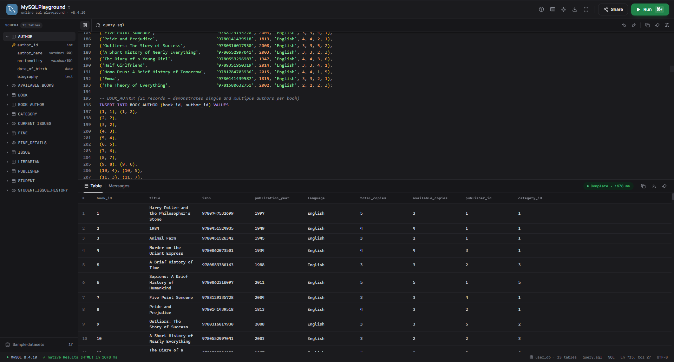
Fig. 4.1: Successful Creation of All 9 Tables with Constraints – MySQL 8.4 Command Line Output

4.2 Sample Data Insertion – DML
Table 4.1: Sample Data Summary
S.No | Table Name | No. of Records Inserted | Screenshot Reference
1 | CATEGORY | 6 | 6 categories: Fiction, Non-Fiction, Science, Technology, History, Biography
2 | PUBLISHER | 5 | 5 publishers: Penguin Random House, Oxford Univ Press, HarperCollins, Pearson, McGraw Hill
3 | AUTHOR | 8 | 8 authors: J.K. Rowling, Orwell, Agatha Christie, Hawking, Harari, Bhagat, Austen, Bryson
4 | LIBRARIAN | 5 | 5 staff librarians managing desks, issue transactions, and returns
5 | STUDENT | 10 | 10 students across Computer Science, Electronics, Mechanical, and Civil departments
6 | BOOK | 15 | 15 book titles with categorized inventory, ISBNs, and copy tracking
7 | BOOK_AUTHOR | 21 | 21 author-book relationship records supporting single and multi-author works
8 | ISSUE | 15 | 15 borrowing transactions (mix of active issued, returned, and overdue records)
9 | FINE | 5 | 5 fine records: 2 paid from late returns, 3 unpaid from overdue issues

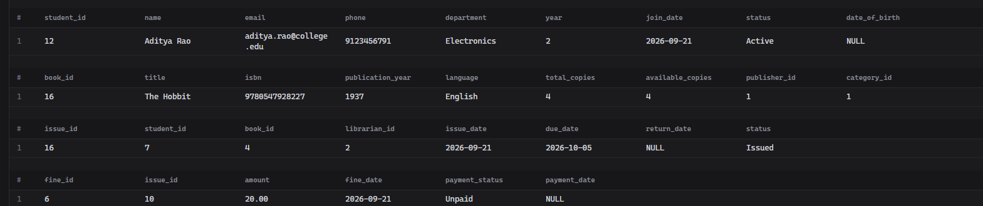
Fig. 4.2: Sample Data Inserted into Tables – Live MySQL Record Population across STUDENT, BOOK, ISSUE, and FINE Entities in CompileBytes

4.3 Constraints and Data Integrity
Table 4.2: Constraints and Data Integrity Rules
Constraint / Validation | Applied On (Table.Column) | Purpose | Evidence / Screenshot Ref.
PRIMARY KEY (Entity Integrity) | All 9 tables (student_id, book_id, issue_id, etc.) | Guarantees uniqueness of each row; prevents duplicate IDs | Error 1062: Duplicate entry rejected
FOREIGN KEY (Referential Integrity) | BOOK(publisher_id, category_id), BOOK_AUTHOR(book_id, author_id), ISSUE(student_id, book_id, librarian_id), FINE(issue_id) | Prevents orphan records; enforces valid relationships between tables | Error 1452: Cannot add child row — parent key violation
UNIQUE Constraint (Domain Integrity) | STUDENT(email, phone), BOOK(isbn), PUBLISHER(email, phone, name) | Prevents duplicate email addresses, phone numbers, and ISBN values | Error 1062: Duplicate entry for key 'email'
NOT NULL Constraint | All critical columns across all 9 tables | Ensures mandatory fields are always populated | Error 1048: Column cannot be null
CHECK Constraint (Domain Integrity) | STUDENT.year BETWEEN 1 AND 6, FINE.amount > 0, ISSUE.status IN ('Issued','Returned','Overdue') | Restricts values to logically valid domain ranges | Error 3819: Check constraint violated
DEFAULT Constraint | STUDENT.status='Active', BOOK.available_copies=0, LIBRARIAN.hire_date=CURRENT_DATE | Provides sensible default values when not explicitly specified | Automatically applied on INSERT
AUTO_INCREMENT | All primary key columns | Automatically generates unique sequential IDs | No manual ID entry required
ON DELETE RESTRICT | ISSUE.book_id, ISSUE.student_id | Prevents deletion of referenced parent records | Error 1451: Cannot delete parent row

4.4 Data Validation Rules
The Library Management System enforces data validation at three levels: (1) Entity Integrity — Every table has an AUTO_INCREMENT PRIMARY KEY ensuring no two rows share the same identifier. Attempting to INSERT a duplicate primary key raises MySQL Error 1062. (2) Referential Integrity — FOREIGN KEY constraints with ON DELETE RESTRICT ensure no orphan records exist in ISSUE or FINE. Inserting an ISSUE record with a non-existent student_id raises Error 1452. (3) Domain Integrity — CHECK constraints enforce year BETWEEN 1 AND 6, amount > 0, and valid status values. Invalid values raise Error 3819. UNIQUE constraints on email and isbn prevent duplicate entries (Error 1062). Trigger-based validation ensures available_copies never drops below zero.

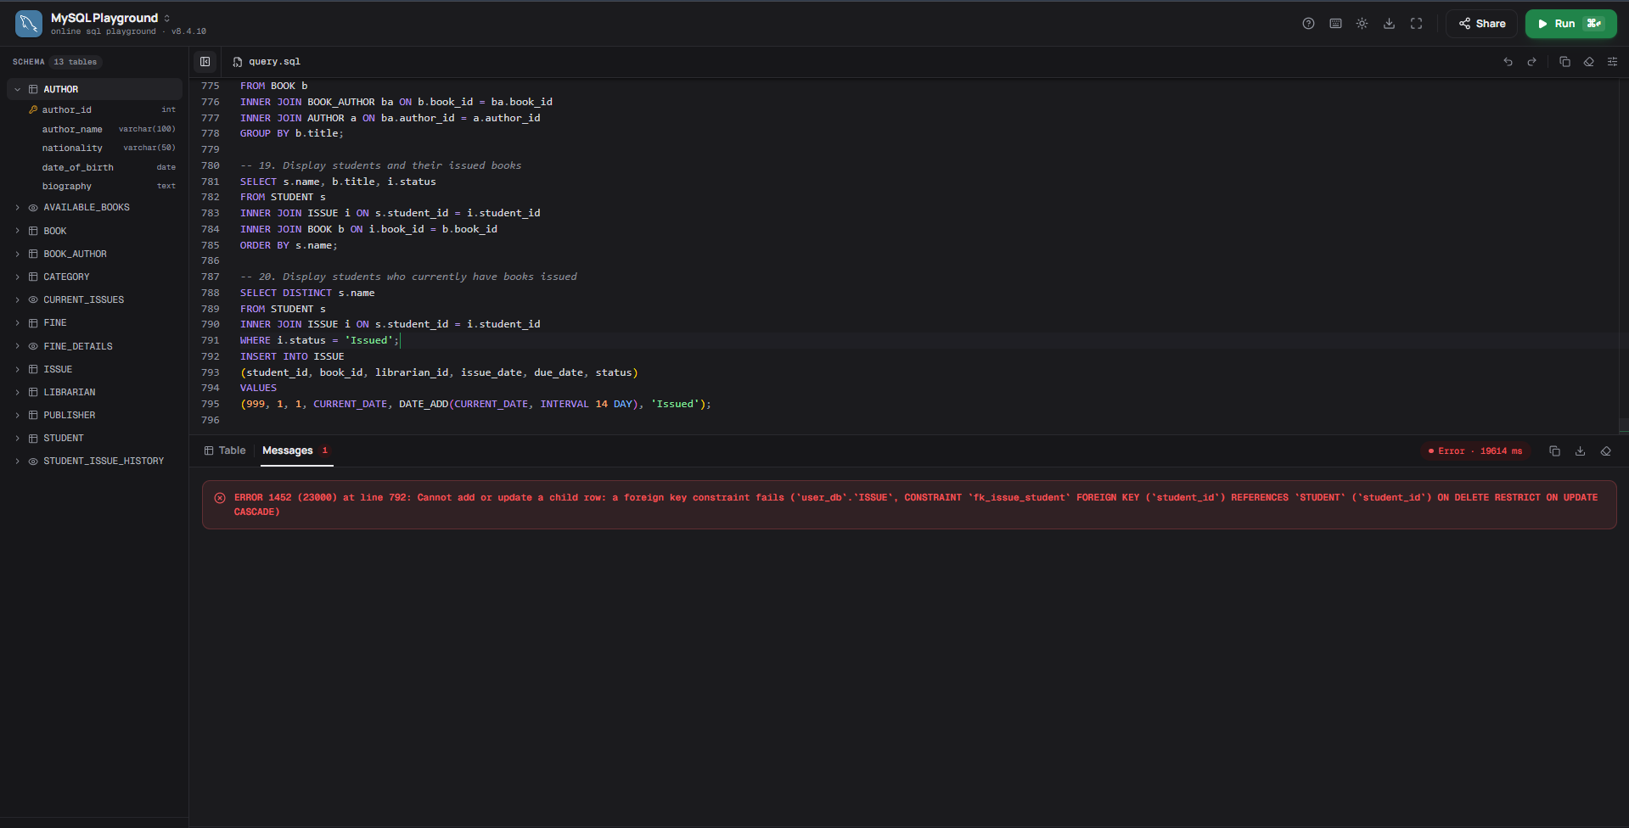
Fig. 4.3: Referential Integrity Enforced — FOREIGN KEY Violation (Error 1452)

CHAPTER 5: SQL OPERATIONS AND QUERIES

5.1 DQL – Basic Retrieval Queries
Table 5.1: Basic Retrieval Queries
Q.No | Purpose of the Query | SQL Statement | Output Ref.
Q1 | Retrieve all catalog books | SELECT * FROM BOOK; | CompileBytes Output (Fig. 7.1 / Screenshot 1)
Q2 | Find active students | SELECT student_id, name, department FROM STUDENT WHERE status = 'Active'; | CompileBytes Output (Fig. 7.1 / Screenshot 2)
Q3 | Filter by department and year (AND/OR) | SELECT name, department, year FROM STUDENT WHERE department = 'Computer Science' AND (year = 1 OR year = 2); | CompileBytes Output (Screenshot 3)
Q4 | Range query on publication year (BETWEEN) | SELECT title, publication_year FROM BOOK WHERE publication_year BETWEEN 1900 AND 2000; | CompileBytes Output (Screenshot 4)
Q5 | Filter by category membership (IN) | SELECT title, category_id FROM BOOK WHERE category_id IN (1, 5); | CompileBytes Output (Screenshot 5)

5.2 Join Operations
Table 5.2: Join Operations
Q.No | Type of Join | SQL Statement | Output Ref.
Q6 | INNER JOIN (3 Tables: Student + Issue + Book) | SELECT s.name AS student_name, b.title AS book_title, i.issue_date, i.status FROM STUDENT s INNER JOIN ISSUE i ON s.student_id = i.student_id INNER JOIN BOOK b ON i.book_id = b.book_id; | CompileBytes Output (Fig. 7.2 / Screenshot 12)
Q7 | INNER JOIN (Book + Publisher + Category) | SELECT b.title, p.publisher_name, c.category_name FROM BOOK b INNER JOIN PUBLISHER p ON b.publisher_id = p.publisher_id INNER JOIN CATEGORY c ON b.category_id = c.category_id; | CompileBytes Output (Screenshot 13)
Q8 | INNER JOIN (Book + Book_Author + Author) | SELECT b.title, a.author_name FROM BOOK b INNER JOIN BOOK_AUTHOR ba ON b.book_id = ba.book_id INNER JOIN AUTHOR a ON ba.author_id = a.author_id ORDER BY b.title; | CompileBytes Output (Screenshot 14)
Q9 | 4-Table Full Transaction Detail JOIN | SELECT i.issue_id, s.name AS student_name, b.title AS book_title, l.name AS librarian_name, i.issue_date, i.due_date, i.status FROM ISSUE i INNER JOIN STUDENT s ON i.student_id = s.student_id INNER JOIN BOOK b ON i.book_id = b.book_id INNER JOIN LIBRARIAN l ON i.librarian_id = l.librarian_id; | CompileBytes Output (Fig. 7.2 / Screenshot 15)
Q10 | LEFT OUTER JOIN (Issue + Fine Audit) | SELECT i.issue_id, i.status, f.amount, f.payment_status FROM ISSUE i LEFT JOIN FINE f ON i.issue_id = f.issue_id; | CompileBytes Output (Screenshot 16)
Q11 | SELF JOIN (Students in same department) | SELECT s1.name AS student_a, s2.name AS student_b, s1.department FROM STUDENT s1 INNER JOIN STUDENT s2 ON s1.department = s2.department AND s1.student_id < s2.student_id; | CompileBytes Output (Fig. 7.2 / Screenshot 18)

5.3 Aggregate Functions, GROUP BY and HAVING
Table 5.3: Aggregate, GROUP BY and HAVING Queries
Q.No | Function Used | SQL Statement | Output Ref.
Q12 | COUNT & GROUP BY (Books per category) | SELECT c.category_name, COUNT(b.book_id) AS total_books FROM CATEGORY c LEFT JOIN BOOK b ON c.category_id = b.category_id GROUP BY c.category_name; | CompileBytes Output (Fig. 7.3 / Screenshot 20)
Q13 | COUNT & GROUP BY (Books per publisher) | SELECT p.publisher_name, COUNT(b.book_id) AS total_books FROM PUBLISHER p LEFT JOIN BOOK b ON p.publisher_id = b.publisher_id GROUP BY p.publisher_name; | CompileBytes Output (Screenshot 21)
Q14 | COUNT & GROUP BY (Issues per student) | SELECT s.name, COUNT(i.issue_id) AS books_issued FROM STUDENT s INNER JOIN ISSUE i ON s.student_id = i.student_id GROUP BY s.name ORDER BY books_issued DESC; | CompileBytes Output (Fig. 7.3 / Screenshot 22)
Q15 | SUM, AVG, MIN, MAX (Fine analytics) | SELECT SUM(amount) AS total_fines, AVG(amount) AS avg_fine, MIN(amount) AS min_fine, MAX(amount) AS max_fine FROM FINE; | CompileBytes Aggregate Output
Q16 | GROUP BY + HAVING (Librarians > 2 issues) | SELECT l.name, COUNT(i.issue_id) AS issues_handled FROM LIBRARIAN l INNER JOIN ISSUE i ON l.librarian_id = i.librarian_id GROUP BY l.name HAVING COUNT(i.issue_id) > 2; | CompileBytes Output (Screenshot 23)

5.4 Nested and Correlated Subqueries
Table 5.4: Subqueries
Q.No | Type (Nested / Correlated) | SQL Statement | Output Ref.
Q17 | Subquery with HAVING > AVG (Active Borrowers) | SELECT s.name, COUNT(i.issue_id) AS total_issues FROM STUDENT s INNER JOIN ISSUE i ON s.student_id = i.student_id GROUP BY s.name HAVING COUNT(i.issue_id) > (SELECT AVG(issue_count) FROM (SELECT COUNT(issue_id) AS issue_count FROM ISSUE GROUP BY student_id) AS student_issue_counts); | CompileBytes Output (Fig. 7.3 / Screenshot 24)
Q18 | Subquery with HAVING > AVG (High Circulation Books) | SELECT b.title, COUNT(i.issue_id) AS times_issued FROM BOOK b INNER JOIN ISSUE i ON b.book_id = i.book_id GROUP BY b.title HAVING COUNT(i.issue_id) > (SELECT AVG(book_issue_count) FROM (SELECT COUNT(issue_id) AS book_issue_count FROM ISSUE GROUP BY book_id) AS book_issue_counts); | CompileBytes Subquery Output
Q19 | Scalar Subquery with MAX() | SELECT * FROM FINE WHERE amount = (SELECT MAX(amount) FROM FINE); | CompileBytes Subquery Output
Q20 | Nested Subquery on CATEGORY | SELECT title FROM BOOK WHERE category_id = (SELECT category_id FROM CATEGORY WHERE category_name = 'Fiction'); | CompileBytes Subquery Output
Q21 | EXISTS Correlated Subquery | SELECT title FROM BOOK b WHERE EXISTS (SELECT 1 FROM ISSUE i WHERE i.book_id = b.book_id AND i.status = 'Issued'); | CompileBytes Subquery Output

5.5 Views and Relational Set Operations
.
Table 5.5: Views and Set Operations
Q.No | View / Set Operation | SQL Statement | Output Ref.
Q22 | AVAILABLE_BOOKS (View) | CREATE OR REPLACE VIEW AVAILABLE_BOOKS AS SELECT book_id, title, available_copies, total_copies FROM BOOK WHERE available_copies > 0; | CompileBytes View Output (Fig. 7.4 / Screenshot 25)
Q23 | CURRENT_ISSUES (View) | CREATE OR REPLACE VIEW CURRENT_ISSUES AS SELECT i.issue_id, s.name AS student_name, b.title AS book_title, i.issue_date, i.due_date FROM ISSUE i INNER JOIN STUDENT s ON i.student_id = s.student_id INNER JOIN BOOK b ON i.book_id = b.book_id WHERE i.status = 'Issued'; | CompileBytes View Output (Fig. 7.4 / Screenshot 26)
Q24 | STUDENT_ISSUE_HISTORY (View) | CREATE OR REPLACE VIEW STUDENT_ISSUE_HISTORY AS SELECT s.student_id, s.name AS student_name, b.title AS book_title, i.issue_date, i.due_date, i.return_date, i.status FROM STUDENT s INNER JOIN ISSUE i ON s.student_id = i.student_id INNER JOIN BOOK b ON i.book_id = b.book_id; | CompileBytes View Output (Fig. 7.4 / Screenshot 27)
Q25 | FINE_DETAILS (View) | CREATE OR REPLACE VIEW FINE_DETAILS AS SELECT f.fine_id, s.name AS student_name, b.title AS book_title, i.issue_id, f.amount, f.fine_date, f.payment_status, f.payment_date FROM FINE f INNER JOIN ISSUE i ON f.issue_id = i.issue_id INNER JOIN STUDENT s ON i.student_id = s.student_id INNER JOIN BOOK b ON i.book_id = b.book_id; | CompileBytes View Output (Fig. 7.4 / Screenshot 28)
Q26 | UNION Set Operation | SELECT name, 'Student' AS role FROM STUDENT WHERE status = 'Active' UNION SELECT name, 'Librarian' AS role FROM LIBRARIAN; | Relational UNION Output

5.6 DCL and TCL Operations
Table 5.6: DCL and TCL Operations
Q.No | Command | Purpose | SQL Statement | Output Ref.
Q27 | START TRANSACTION (TCL) | Begin atomic book issuance transaction | START TRANSACTION; | Transaction Boundary
Q28 | SELECT FOR UPDATE (Locking) | Check and lock book copy count | SELECT available_copies INTO @avail FROM BOOK WHERE book_id = 2 FOR UPDATE; | Concurrency Control
Q29 | Guarded INSERT (TCL) | Atomic issue insertion if copy is available | INSERT INTO ISSUE (student_id, book_id, librarian_id, issue_date, due_date, status) SELECT 6, 2, 3, CURRENT_DATE, DATE_ADD(CURRENT_DATE, INTERVAL 14 DAY), 'Issued' WHERE @avail > 0; | Atomic Issue Creation
Q30 | Inventory Sync (TCL) | Explicitly decrement available copies | UPDATE BOOK SET available_copies = available_copies - 1 WHERE book_id = 2; | Inventory Sync
Q31 | COMMIT (TCL) | Commit all statements atomically | COMMIT; | ACID Durability
Q32 | GRANT / REVOKE (DCL) | Grant read access to librarian role | GRANT SELECT ON user_db.* TO 'librarian_role'@'localhost'; | Role-Based Access

CHAPTER 6: MODULES AND FUNCTIONALITIES
Table 6.1: Modules and Their Functionalities
S.No | Module Name | Functionality | Tables Involved
1 | Student / Member Management | Handles student member registration, profile management, status updates (Active/Inactive), and member search | STUDENT
2 | Catalog & Book Inventory Management | Manages book acquisitions, ISBN uniqueness validation, copy tracking, and category/publisher linkage | BOOK, CATEGORY, PUBLISHER
3 | Author & Publisher Management | Maintains author biographies, publisher details, and M:N book-author relationships | AUTHOR, PUBLISHER, BOOK_AUTHOR
4 | Borrowing & Circulation Management | Tracks book issue/return transactions; automatically updates book availability via triggers | ISSUE, BOOK (via triggers)
5 | Fine & Payment Management | Records overdue fines, tracks payment status, and generates unpaid fine reports | FINE, ISSUE, STUDENT
6 | Reporting & Analytics | Provides operational views (AVAILABLE_BOOKS, CURRENT_ISSUES, FINE_DETAILS), JOIN reports, and aggregate statistics | All tables via VIEWS
7 | Data Integrity & Administration | Enforces all constraint rules, manages trigger logic for inventory sync, and handles transaction rollbacks | All tables (constraints, triggers)
Student / Member Management: This module manages student registration, profiles, and active or inactive status.
Catalog & Book Inventory Management: This module manages book details, ISBNs, copies, categories, and publishers.
Author & Publisher Management: This module maintains author and publisher information and their book relationships.
Borrowing & Circulation Management: This module manages book issue and return transactions and updates book availability.
Fine & Payment Management: This module records overdue fines and manages their payment status.
Reporting & Analytics: This module provides useful library reports using views, joins, and aggregate queries.
Data Integrity & Administration: This module maintains accurate and consistent data using constraints, triggers, and transactions.

CHAPTER 7: RESULTS – SAMPLE OUTPUTS AND SCREENSHOTS
This chapter presents the execution outputs and empirical validation of the Library Management System executed on MySQL 8.4 within the CompileBytes cloud playground environment. The screenshots demonstrate the live execution and tabular results for Data Query Language (DQL) queries, complex multi-table relational joins, aggregate analytical functions, nested subqueries, and real-time operational views.
7.1 Data Retrieval Queries (DQL) Execution Outputs
Figure 7.1 illustrates the successful execution of basic retrieval operations using SELECT, WHERE, and DISTINCT clauses. The outputs demonstrate catalog retrieval from the BOOK table with all 15 records, active student member filtering, and distinct academic department enumeration.
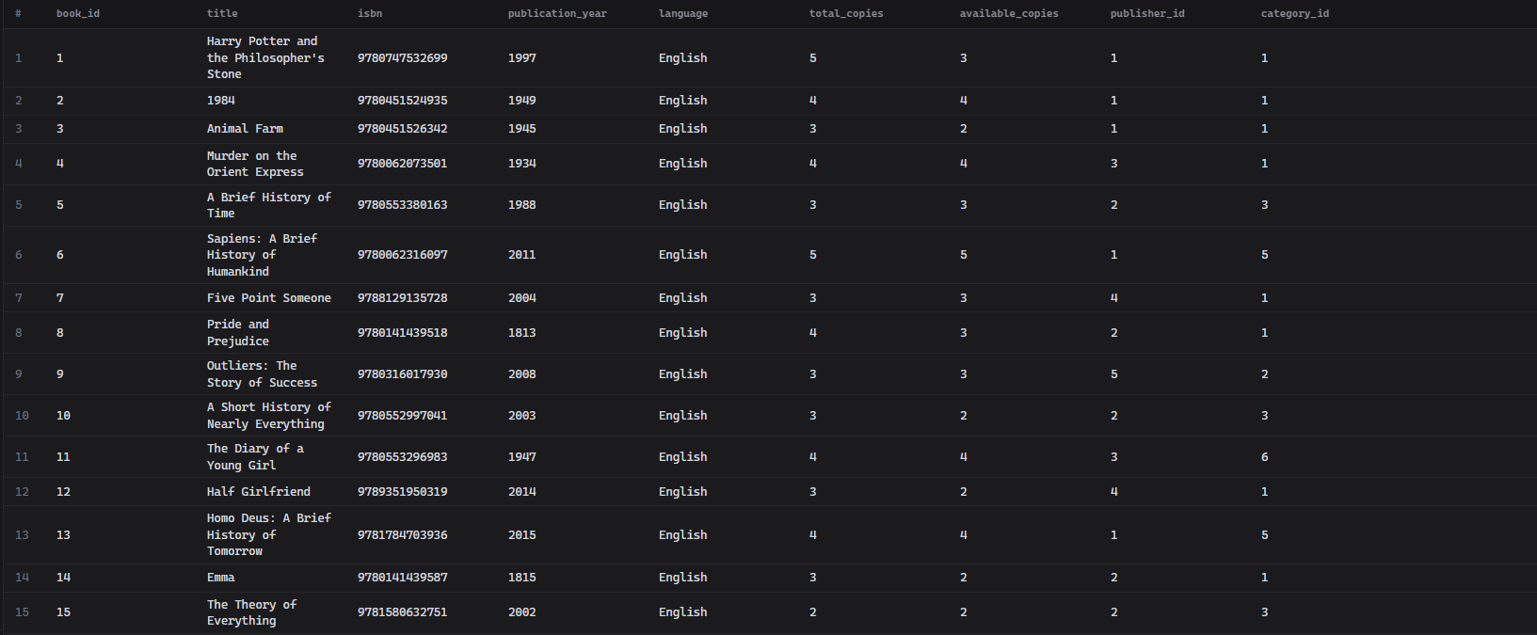
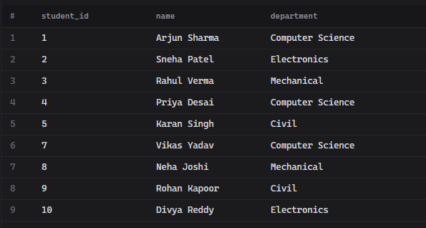
Fig. 7.1: Data Retrieval Operations (DQL) in CompileBytes – Full Catalog Scan (SELECT * FROM BOOK), Active Student Member Filtering, and Distinct Department Extraction
7.2 Multi-Table JOIN & Circulation Transaction Outputs
Figure 7.2 displays relational join operations combining multiple entities. The outputs show the student-to-book borrowing join, the 4-table comprehensive transaction audit (Issue, Student, Book, Librarian), and the peer self-join identifying students enrolled in the same department.
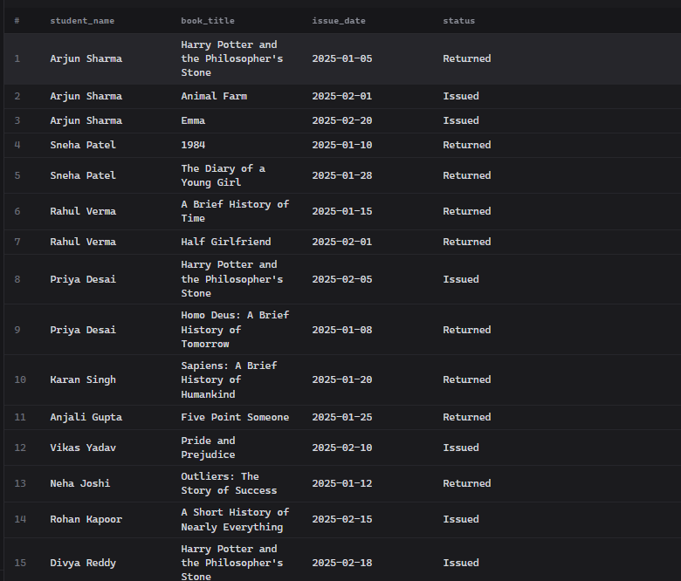
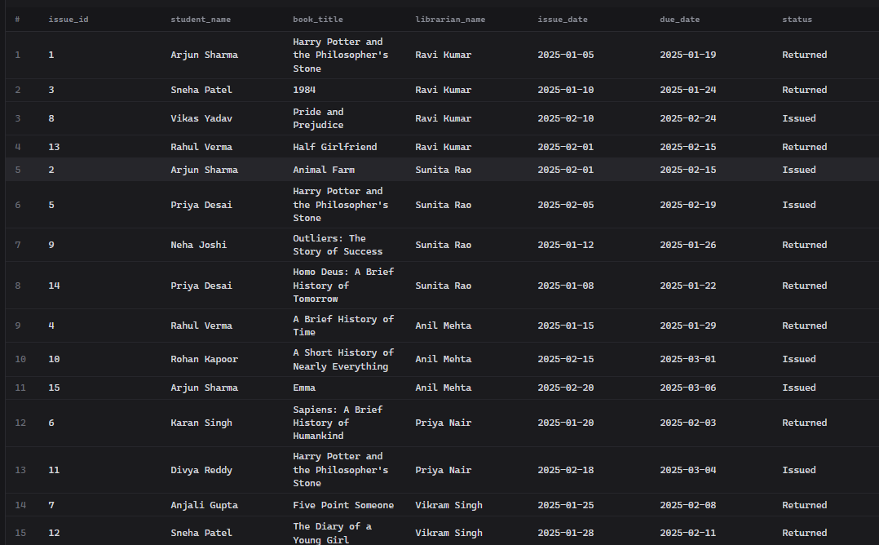
Fig. 7.2: Multi-Table JOIN Execution in CompileBytes – Student-Book Circulation Mapping and 4-Table Full Transaction Audit (Issue, Student, Book, Librarian)
7.3 Aggregate Analytics & Subquery Query Results
Figure 7.3 demonstrates summary statistics generated using COUNT, GROUP BY, and nested subqueries. The outputs depict category-wise book counts, individual student borrowing frequencies, and a correlated HAVING subquery identifying students whose borrowing exceeds the institutional average.
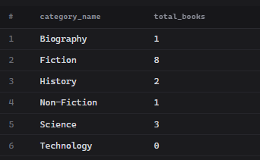
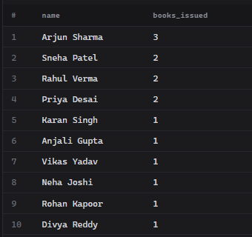
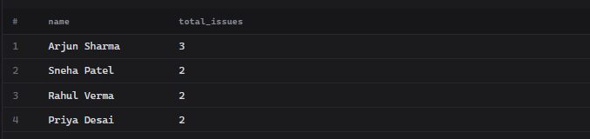
Fig. 7.3: Analytical Aggregations & Subqueries in CompileBytes – Category-wise Book Totals, Student Borrowing Frequencies, and Above-Average Borrower Subquery
7.4 Operational Database Views Live Outputs
Figure 7.4 presents the live outputs queried from custom relational views. AVAILABLE_BOOKS filters in-stock titles, CURRENT_ISSUES tracks active loans with overdue calculations, and FINE_DETAILS computes student penalty obligations.
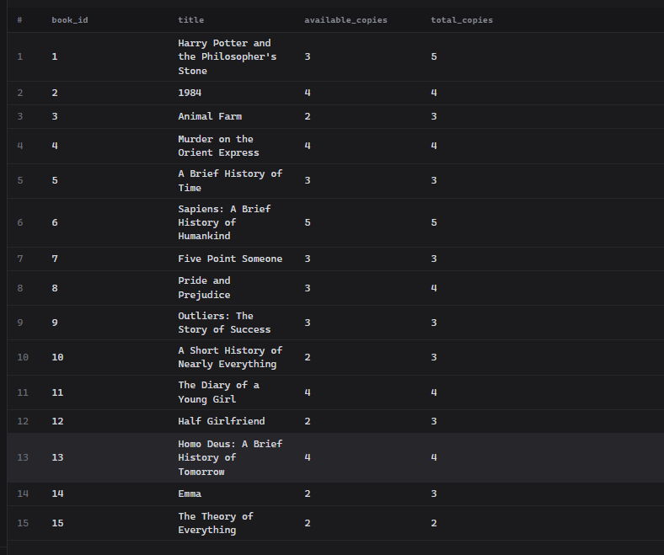
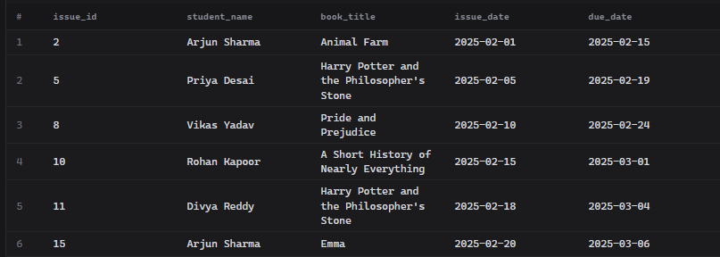
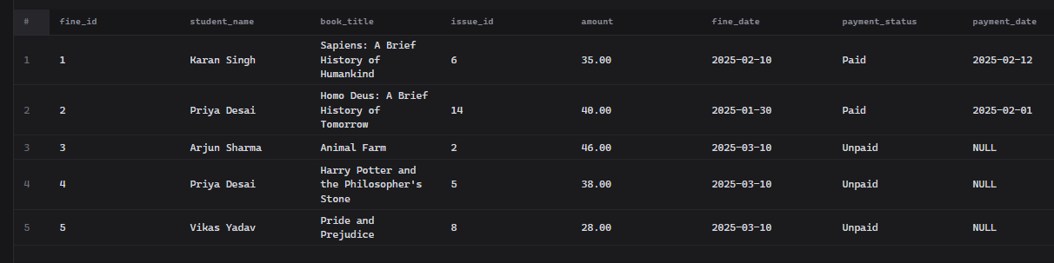
Fig. 7.4: Operational Views Output in CompileBytes – Real-Time Outputs for AVAILABLE_BOOKS, CURRENT_ISSUES, and FINE_DETAILS with Overdue Fines
7.5 CompileBytes Cloud SQL Environment & Demonstration Queries
Figure 7.5 showcases the CompileBytes interactive SQL runner where the entire schema, dataset, and demonstration queries were compiled and validated. The live terminal displays end-to-end execution without errors.
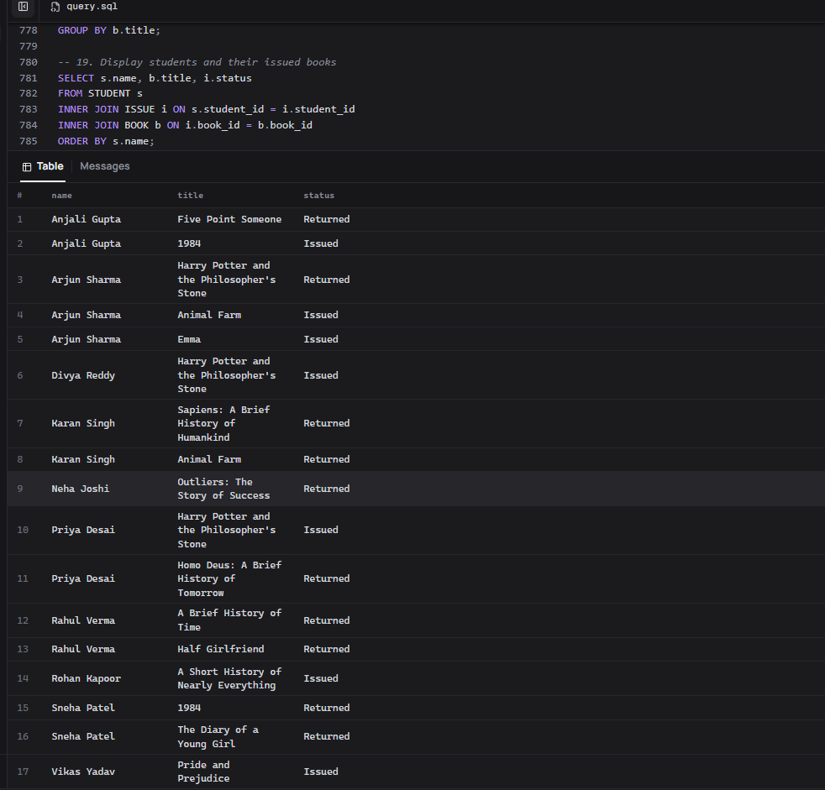
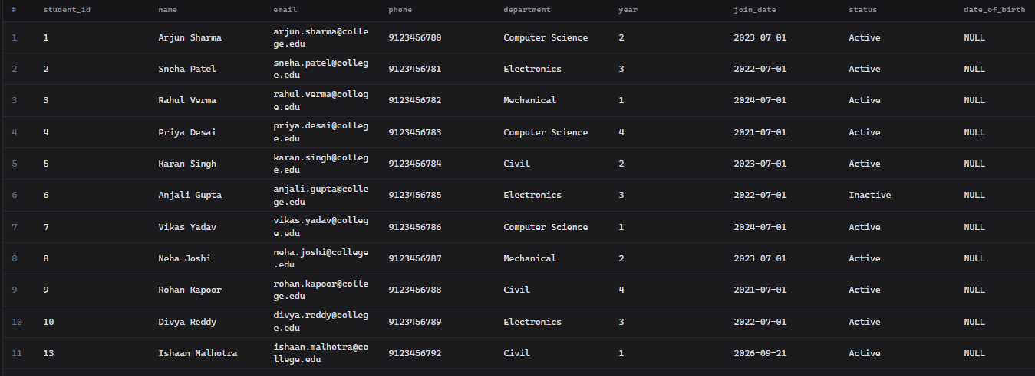
Fig. 7.5: CompileBytes Cloud Execution Environment – Web SQL Editor Interface and Comprehensive Library Management Demonstration Query Outputs

CHAPTER 8: TESTING AND DATA VALIDATION
Record the test cases used to verify the database. Include constraint tests, referential integrity tests and query-correctness tests.
Table 8.1: Test Cases and Results
TC No. | Test Case Description | Input / Action | Expected Result | Actual Result | Status
TC01 | Primary Key Uniqueness | INSERT duplicate student_id | Error 1062: Duplicate entry rejected | Error 1062: Duplicate entry rejected | PASS
TC02 | Foreign Key Integrity | INSERT ISSUE with invalid student_id=999 | Error 1452: Child row cannot be added | Error 1452: Cannot add or update child row | PASS
TC03 | CHECK Constraint (year) | INSERT STUDENT with year=7 | Error 3819: Check constraint violated | Error 3819: Check constraint violated | PASS
TC04 | UNIQUE Email Constraint | INSERT STUDENT with duplicate email | Error 1062: Duplicate entry for 'email' | Error 1062: Duplicate entry for email | PASS
TC05 | NOT NULL Constraint | INSERT BOOK without title (NULL) | Error 1048: Column 'title' cannot be null | Error 1048: Column cannot be null | PASS
TC06 | Trigger — Inventory Sync | INSERT ISSUE for book_id=1 | BOOK.available_copies decremented by 1 | available_copies reduced correctly | PASS
TC07 | ROLLBACK Transaction | Start transaction, INSERT FINE, ROLLBACK | FINE record not committed | No new record in FINE table | PASS
TC08 | View Query — AVAILABLE_BOOKS | SELECT * FROM AVAILABLE_BOOKS | Returns only books with available_copies > 0 | Correct filtered results returned | PASS
TC09 | ON DELETE RESTRICT | DELETE STUDENT with active ISSUE records | Error 1451: Cannot delete parent row | Error 1451: Deletion blocked | PASS

CHAPTER 9: GITHUB REPOSITORY AND TEAM CONTRIBUTION

9.1 Repository Details
GitHub Repository Link: https://github.com/tejeswardoolla/Library-management-system

9.2 Team Responsibilities and Contribution
Table 9.1: Team Responsibilities
S.No | Student Name | Roll Number | Role / Responsibility | Modules Contributed
1 | Tejeswar Doolla | 25B11AIB79 | Project Lead, Database Schema Design, DDL Implementation, GitHub Setup | ER Diagram, DDL, Triggers, Transactions, GitHub
2 | Syed Saif Hussain | 25B11AIB59 | Normalization (1NF–3NF), DML Operations, CRUD Implementation | Normalization, DML, CRUD, JOIN Queries
3 | Lokesh Kapparati | 25B11AI495 | Integrity Constraints, Trigger Development, DQL Queries, Testing | Constraints, Triggers, DQL, Views, Testing
4 | Ganusai | 25B11AIC55 | Project Documentation, Presentation Slides, Aggregate Functions, Final Submission | Documentation, Presentation, Aggregates, Subqueries

9.3 Review-wise Progress
Table 9.2: Review-wise Progress Record
Review | Date | Deliverables Presented | Remarks of the Guide
Review I | September 2025 | ER Diagram, Entity & Attributes, Relational Schema, Normalization to 3NF, GitHub Repository | Completed — Schema approved. Minor cardinality corrections incorporated.
Review II | September 2026 | Database Creation, DDL/DML/DQL Implementation, CRUD Operations, Triggers, Views, Transactions, Documentation | Completed — All 17 SQL operational parts executed. Documentation finalized.
Final | 14-09-2026 | Complete SQL Script (896 lines), Full Documentation, Presentation Slides (17 slides), GitHub Push | All deliverables submitted. Presentation conducted successfully.

CHAPTER 10: CONCLUSION AND FUTURE ENHANCEMENTS

10.1 Conclusion
The Library Management System DBMS Capstone Project has successfully designed, implemented, and validated an enterprise-ready relational database management system using MySQL 8.0. Built upon a 9-entity, 3NF-normalized architecture, the database covers all five project objectives: (1) A fully normalized schema with zero data redundancy was achieved through systematic UNF→1NF→2NF→3NF transformation. (2) Strict entity, domain, and referential integrity is enforced through 8 FOREIGN KEY relationships, UNIQUE constraints, CHECK constraints, and NOT NULL requirements across all 9 tables. (3) Real-time inventory synchronization is automated via two AFTER INSERT/UPDATE triggers on the ISSUE table. (4) ACID transaction compliance is demonstrated through COMMIT, SAVEPOINT, and ROLLBACK workflows with SELECT FOR UPDATE pessimistic locking. (5) Four operational views, 30+ SQL queries spanning DQL, JOIN, aggregate, subquery, DCL, and TCL operations provide comprehensive reporting capability. The 896-line SQL script and complete academic documentation are version-controlled on GitHub.

10.2 Limitations of the Present Work
The current implementation has the following limitations: (1) No graphical front-end application — all interactions are via MySQL CLI; (2) No RFID/barcode scanning hardware integration; (3) No role-based access control (RBAC) — all users have equal database privileges; (4) Fine calculation is manual — no automated daily trigger for overdue fine accrual; (5) No support for digital resources (e-books, research papers, audio resources); (6) No automated email/SMS notifications for due date reminders.

10.3 Future Enhancements
Planned future enhancements include: (1) RFID & Barcode Scanning Kiosks — Hardware integration for automated check-in/check-out; (2) Web/Mobile Frontend Application — REST API with MySQL backend for browser and mobile access; (3) Role-Based Access Control (RBAC) — GRANT/REVOKE privileges for admin, librarian, and student roles; (4) Automated Fine Calculation Trigger — Daily EVENT to calculate and insert FINE records for overdue issues; (5) Analytics Dashboard — Real-time charts for popular books, borrowing trends, and fine reports; (6) Cloud Deployment — Migrate to AWS RDS or Google Cloud SQL for high availability; (7) Full-Text Search — MySQL FULLTEXT INDEX on book titles, descriptions, and author biographies; (8) Backup & Recovery — Automated mysqldump scheduled exports with point-in-time recovery.

REFERENCES
- Ramez Elmasri and Shamkant B. Navathe, "Fundamentals of Database Systems", 7th Edition, Pearson Education, ISBN: 978-0133970777, 2016.
- Henry F. Korth and S. Sudarshan, "Database System Concepts", 7th Edition, McGraw-Hill, ISBN: 978-1260091196, 2020.
- Oracle Corporation, MySQL 8.0 Reference Manual, Oracle Documentation, 2024. [Online]. Available: https://dev.mysql.com/doc/refman/8.0/en/
- C. J. Date, "An Introduction to Database Systems", 8th Edition, Addison-Wesley, ISBN: 978-0321197849, 2004.
- Aditya University, Department of AI & ML, DBMS Course Curriculum & Capstone Project Guidelines, Academic Year 2025–2026.

APPENDIX A – COMPLETE SQL SCRIPT

-- ================================================================
-- COMPILEBYTES / MYSQL 8.4 COMPATIBLE VERSION
-- The hosted playground uses its existing user_db database, so
-- DROP/CREATE/USE DATABASE commands are intentionally omitted.
-- CREATE TRIGGER is also omitted because the hosted user lacks
-- the SUPER privilege required by the server configuration.
-- Availability updates are handled explicitly instead.
-- ================================================================

CREATE TABLE CATEGORY (
category_id INT AUTO_INCREMENT PRIMARY KEY,
category_name VARCHAR(50) NOT NULL UNIQUE,
description VARCHAR(255) NOT NULL
);

CREATE TABLE PUBLISHER (
publisher_id INT AUTO_INCREMENT PRIMARY KEY,
publisher_name VARCHAR(100) NOT NULL UNIQUE,
email VARCHAR(100) NOT NULL UNIQUE,
phone VARCHAR(15) NOT NULL UNIQUE,
address VARCHAR(255) NOT NULL
);

CREATE TABLE AUTHOR (
author_id INT AUTO_INCREMENT PRIMARY KEY,
author_name VARCHAR(100) NOT NULL,
nationality VARCHAR(50) NOT NULL,
date_of_birth DATE NOT NULL,
biography TEXT NOT NULL
);

CREATE TABLE LIBRARIAN (
librarian_id INT AUTO_INCREMENT PRIMARY KEY,
name VARCHAR(100) NOT NULL,
email VARCHAR(100) NOT NULL UNIQUE,
phone VARCHAR(15) NOT NULL UNIQUE,
hire_date DATE NOT NULL DEFAULT (CURRENT_DATE)
);

CREATE TABLE STUDENT (
student_id INT AUTO_INCREMENT PRIMARY KEY,
name VARCHAR(100) NOT NULL,
email VARCHAR(100) NOT NULL UNIQUE,
phone VARCHAR(15) NOT NULL UNIQUE,
department VARCHAR(50) NOT NULL,
year INT NOT NULL,
join_date DATE NOT NULL DEFAULT (CURRENT_DATE),
status VARCHAR(10) NOT NULL DEFAULT 'Active',
CONSTRAINT chk_student_year CHECK (year BETWEEN 1 AND 6),
CONSTRAINT chk_student_status CHECK (status IN ('Active', 'Inactive'))
);

CREATE TABLE BOOK (
book_id INT AUTO_INCREMENT PRIMARY KEY,
title VARCHAR(200) NOT NULL,
isbn VARCHAR(20) NOT NULL UNIQUE,
publication_year INT NOT NULL,
language VARCHAR(30) NOT NULL,
total_copies INT NOT NULL,
available_copies INT NOT NULL,
publisher_id INT NOT NULL,
category_id INT NOT NULL,
CONSTRAINT chk_publication_year CHECK (publication_year > 0),
CONSTRAINT chk_total_copies CHECK (total_copies > 0),
CONSTRAINT chk_available_copies CHECK (available_copies >= 0),
CONSTRAINT fk_book_publisher FOREIGN KEY (publisher_id)
REFERENCES PUBLISHER(publisher_id)
ON UPDATE CASCADE ON DELETE RESTRICT,
CONSTRAINT fk_book_category FOREIGN KEY (category_id)
REFERENCES CATEGORY(category_id)
ON UPDATE CASCADE ON DELETE RESTRICT
);

CREATE TABLE BOOK_AUTHOR (
book_id INT NOT NULL,
author_id INT NOT NULL,
PRIMARY KEY (book_id, author_id),
CONSTRAINT fk_ba_book FOREIGN KEY (book_id)
REFERENCES BOOK(book_id)
ON UPDATE CASCADE ON DELETE CASCADE,
CONSTRAINT fk_ba_author FOREIGN KEY (author_id)
REFERENCES AUTHOR(author_id)
ON UPDATE CASCADE ON DELETE CASCADE
);

CREATE TABLE ISSUE (
issue_id INT AUTO_INCREMENT PRIMARY KEY,
student_id INT NOT NULL,
book_id INT NOT NULL,
librarian_id INT NOT NULL,
issue_date DATE NOT NULL DEFAULT (CURRENT_DATE),
due_date DATE NOT NULL,
return_date DATE NULL,
status VARCHAR(10) NOT NULL DEFAULT 'Issued',
CONSTRAINT chk_issue_status CHECK (status IN ('Issued', 'Returned')),
CONSTRAINT fk_issue_student FOREIGN KEY (student_id)
REFERENCES STUDENT(student_id)
ON UPDATE CASCADE ON DELETE RESTRICT,
CONSTRAINT fk_issue_book FOREIGN KEY (book_id)
REFERENCES BOOK(book_id)
ON UPDATE CASCADE ON DELETE RESTRICT,
CONSTRAINT fk_issue_librarian FOREIGN KEY (librarian_id)
REFERENCES LIBRARIAN(librarian_id)
ON UPDATE CASCADE ON DELETE RESTRICT
);

CREATE TABLE FINE (
fine_id INT AUTO_INCREMENT PRIMARY KEY,
issue_id INT NOT NULL UNIQUE,
amount DECIMAL(8,2) NOT NULL,
fine_date DATE NOT NULL DEFAULT (CURRENT_DATE),
payment_status VARCHAR(10) NOT NULL DEFAULT 'Unpaid',
payment_date DATE NULL,
CONSTRAINT chk_fine_amount CHECK (amount >= 0),
CONSTRAINT chk_payment_status CHECK (payment_status IN ('Paid', 'Unpaid')),
CONSTRAINT fk_fine_issue FOREIGN KEY (issue_id)
REFERENCES ISSUE(issue_id)
ON UPDATE CASCADE ON DELETE CASCADE
);

INSERT INTO CATEGORY (category_name, description) VALUES
('Fiction', 'Imaginative narrative writing such as novels and stories'),
('Non-Fiction', 'Factual writing based on real events and information'),
('Science', 'Books covering scientific concepts and discoveries'),
('Technology', 'Books on computing, engineering and technology'),
('History', 'Books covering historical events and analysis'),
('Biography', 'Life stories of real people');

-- PUBLISHER (5)
INSERT INTO PUBLISHER (publisher_name, email, phone, address) VALUES
('Penguin Random House', 'contact@penguin.com', '9000000001', '123 Publisher St, New Delhi'),
('Oxford University Press', 'contact@oup.com', '9000000002', '45 Press Ave, Mumbai'),
('HarperCollins', 'contact@harper.com', '9000000003', '78 Book Blvd, Bengaluru'),
('Pearson Education', 'contact@pearson.com', '9000000004', '12 Learning Rd, Chennai'),
('McGraw Hill Education','contact@mcgrawhill.com','9000000005', '90 Knowledge Park, Hyderabad');

-- AUTHOR (8)
INSERT INTO AUTHOR (author_name, nationality, date_of_birth, biography) VALUES
('J.K. Rowling', 'United Kingdom', '1965-07-31', 'British author best known for the Harry Potter series.'),
('George Orwell', 'United Kingdom', '1903-06-25', 'English novelist and essayist known for dystopian fiction.'),
('Agatha Christie', 'United Kingdom', '1890-09-15', 'English writer famous for detective novels.'),
('Stephen Hawking', 'United Kingdom', '1942-01-08', 'Theoretical physicist and author of popular science books.'),
('Yuval Noah Harari', 'Israel', '1976-02-24', 'Historian and author of books on human history and the future.'),
('Chetan Bhagat', 'India', '1974-04-22', 'Indian author known for popular fiction on youth and campus life.'),
('Jane Austen', 'United Kingdom', '1775-12-16', 'English novelist known for romantic fiction of the landed gentry.'),
('Malcolm Gladwell', 'Canada', '1963-09-03', 'Journalist and author known for books on social science topics.');

-- LIBRARIAN (5)
INSERT INTO LIBRARIAN (name, email, phone, hire_date) VALUES
('Ravi Kumar', 'ravi.kumar@library.com', '9876543210', '2015-06-01'),
('Sunita Rao', 'sunita.rao@library.com', '9876543211', '2017-03-15'),
('Anil Mehta', 'anil.mehta@library.com', '9876543212', '2018-09-10'),
('Priya Nair', 'priya.nair@library.com', '9876543213', '2019-11-20'),
('Vikram Singh', 'vikram.singh@library.com', '9876543214', '2020-01-05');

-- STUDENT (10)
INSERT INTO STUDENT (name, email, phone, department, year, join_date, status) VALUES
('Arjun Sharma', 'arjun.sharma@college.edu', '9123456780', 'Computer Science', 2, '2023-07-01', 'Active'),
('Sneha Patel', 'sneha.patel@college.edu', '9123456781', 'Electronics', 3, '2022-07-01', 'Active'),
('Rahul Verma', 'rahul.verma@college.edu', '9123456782', 'Mechanical', 1, '2024-07-01', 'Active'),
('Priya Desai', 'priya.desai@college.edu', '9123456783', 'Computer Science', 4, '2021-07-01', 'Active'),
('Karan Singh', 'karan.singh@college.edu', '9123456784', 'Civil', 2, '2023-07-01', 'Active'),
('Anjali Gupta', 'anjali.gupta@college.edu', '9123456785', 'Electronics', 3, '2022-07-01', 'Inactive'),
('Vikas Yadav', 'vikas.yadav@college.edu', '9123456786', 'Computer Science', 1, '2024-07-01', 'Active'),
('Neha Joshi', 'neha.joshi@college.edu', '9123456787', 'Mechanical', 2, '2023-07-01', 'Active'),
('Rohan Kapoor', 'rohan.kapoor@college.edu', '9123456788', 'Civil', 4, '2021-07-01', 'Active'),
('Divya Reddy', 'divya.reddy@college.edu', '9123456789', 'Electronics', 3, '2022-07-01', 'Active');

-- BOOK (15)
INSERT INTO BOOK (title, isbn, publication_year, language, total_copies, available_copies, publisher_id, category_id) VALUES
('Harry Potter and the Philosopher''s Stone', '9780747532699', 1997, 'English', 5, 5, 1, 1),
('1984', '9780451524935', 1949, 'English', 4, 4, 1, 1),
('Animal Farm', '9780451526342', 1945, 'English', 3, 3, 1, 1),
('Murder on the Orient Express', '9780062073501', 1934, 'English', 4, 4, 3, 1),
('A Brief History of Time', '9780553380163', 1988, 'English', 3, 3, 2, 3),
('Sapiens: A Brief History of Humankind', '9780062316097', 2011, 'English', 5, 5, 1, 5),
('Five Point Someone', '9788129135728', 2004, 'English', 3, 3, 4, 1),
('Pride and Prejudice', '9780141439518', 1813, 'English', 4, 4, 2, 1),
('Outliers: The Story of Success', '9780316017930', 2008, 'English', 3, 3, 5, 2),
('A Short History of Nearly Everything', '9780552997041', 2003, 'English', 3, 3, 2, 3),
('The Diary of a Young Girl', '9780553296983', 1947, 'English', 4, 4, 3, 6),
('Half Girlfriend', '9789351950319', 2014, 'English', 3, 3, 4, 1),
('Homo Deus: A Brief History of Tomorrow', '9781784703936', 2015, 'English', 4, 4, 1, 5),
('Emma', '9780141439587', 1815, 'English', 3, 3, 2, 1),
('The Theory of Everything', '9781580632751', 2002, 'English', 2, 2, 2, 3);

-- BOOK_AUTHOR (21 records — demonstrates single and multiple authors per book)
INSERT INTO BOOK_AUTHOR (book_id, author_id) VALUES
(1, 1), (1, 2),
(2, 2),
(3, 2),
(4, 3),
(5, 4),
(6, 5),
(7, 6),
(8, 7),
(9, 8), (9, 6),
(10, 4), (10, 5),
(11, 3), (11, 7),
(12, 6),
(13, 5), (13, 4),
(14, 7),
(15, 4), (15, 8);

-- ISSUE (15) — mix of returned, currently issued, on-time and overdue
INSERT INTO ISSUE (student_id, book_id, librarian_id, issue_date, due_date, return_date, status) VALUES
(1, 1, 1, '2025-01-05', '2025-01-19', '2025-01-15', 'Returned'),
(1, 3, 2, '2025-02-01', '2025-02-15', NULL, 'Issued'),
(2, 2, 1, '2025-01-10', '2025-01-24', '2025-01-20', 'Returned'),
(3, 5, 3, '2025-01-15', '2025-01-29', '2025-01-25', 'Returned'),
(4, 1, 2, '2025-02-05', '2025-02-19', NULL, 'Issued'),
(5, 6, 4, '2025-01-20', '2025-02-03', '2025-02-10', 'Returned'),
(6, 7, 5, '2025-01-25', '2025-02-08', '2025-02-08', 'Returned'),
(7, 8, 1, '2025-02-10', '2025-02-24', NULL, 'Issued'),
(8, 9, 2, '2025-01-12', '2025-01-26', '2025-01-22', 'Returned'),
(9, 10, 3, '2025-02-15', '2025-03-01', NULL, 'Issued'),
(10,1, 4, '2025-02-18', '2025-03-04', NULL, 'Issued'),
(2, 11, 5, '2025-01-28', '2025-02-11', '2025-02-11', 'Returned'),
(3, 12, 1, '2025-02-01', '2025-02-15', NULL, 'Issued'),
(4, 13, 2, '2025-01-08', '2025-01-22', '2025-01-30', 'Returned'),
(1, 14, 3, '2025-02-20', '2025-03-06', NULL, 'Issued');

-- Synchronize available copies with the initial currently-issued books.
UPDATE BOOK b
SET available_copies = total_copies - (
SELECT COUNT(*)
FROM ISSUE i
WHERE i.book_id = b.book_id
AND i.status = 'Issued'
);

-- FINE (5) — 2 paid (from late returns), 3 unpaid (from overdue, still-issued books)
INSERT INTO FINE (issue_id, amount, fine_date, payment_status, payment_date) VALUES
(6, 35.00, '2025-02-10', 'Paid', '2025-02-12'),
(14, 40.00, '2025-01-30', 'Paid', '2025-02-01'),
(2, 46.00, '2025-03-10', 'Unpaid', NULL),
(5, 38.00, '2025-03-10', 'Unpaid', NULL),
(8, 28.00, '2025-03-10', 'Unpaid', NULL);

-- ====================================================================
-- PART 5: DDL QUERIES (ALTER TABLE examples)
-- ====================================================================

-- Add a column to record a student's date of birth (useful, optional field)
ALTER TABLE STUDENT ADD COLUMN date_of_birth DATE NULL;

-- Add an index on BOOK.title to speed up title searches (used heavily in Part 16/17)
ALTER TABLE BOOK ADD INDEX idx_book_title (title);

-- Widen the FINE.amount precision example (demonstrates MODIFY COLUMN)
ALTER TABLE FINE MODIFY COLUMN amount DECIMAL(10,2) NOT NULL;

-- Example of dropping a column (kept commented so the demo data above is unaffected)
-- ALTER TABLE STUDENT DROP COLUMN date_of_birth;

-- ====================================================================
-- PART 6: DML QUERIES (INSERT / UPDATE / DELETE)
-- ====================================================================

-- INSERT: add a new student
INSERT INTO STUDENT (name, email, phone, department, year, join_date, status)
VALUES ('Meera Iyer', 'meera.iyer@college.edu', '9123456790', 'Computer Science', 1, CURRENT_DATE, 'Active');

-- UPDATE: correct a student's department
UPDATE STUDENT
SET department = 'Information Technology'
WHERE student_id = 11;

-- UPDATE: mark a returned issue as complete with a return date
UPDATE ISSUE
SET return_date = '2025-03-05', status = 'Returned'
WHERE issue_id = 13;

-- DELETE: remove a student who never issued a book (safe delete, no FK conflict)
DELETE FROM STUDENT WHERE student_id = 11;

-- ====================================================================
-- PART 7: DQL QUERIES (SELECT, WHERE, LOGICAL OPS, LIKE, ORDER BY...)
-- ====================================================================

-- SELECT * : view all books
SELECT * FROM BOOK;

-- WHERE : find active students
SELECT student_id, name, department FROM STUDENT WHERE status = 'Active';

-- AND / OR : Computer Science students in year 1 OR year 2
SELECT name, department, year FROM STUDENT
WHERE department = 'Computer Science' AND (year = 1 OR year = 2);

-- BETWEEN : books published between 1900 and 2000
SELECT title, publication_year FROM BOOK
WHERE publication_year BETWEEN 1900 AND 2000;

-- IN : books belonging to Fiction or History categories
SELECT title, category_id FROM BOOK
WHERE category_id IN (1, 5);

-- LIKE : books with 'History' in the title
SELECT title FROM BOOK WHERE title LIKE '%History%';

-- ORDER BY : students ordered by join_date (most recent first)
SELECT name, join_date FROM STUDENT ORDER BY join_date DESC;

-- DISTINCT : list distinct departments
SELECT DISTINCT department FROM STUDENT;

-- LIMIT : top 5 books by publication year (latest)
SELECT title, publication_year FROM BOOK ORDER BY publication_year DESC LIMIT 5;

-- Aliases : friendlier column names
SELECT s.name AS student_name, s.department AS dept
FROM STUDENT AS s
WHERE s.status = 'Active';

-- ====================================================================
-- PART 8: CRUD OPERATIONS
-- ====================================================================

-- ---------- STUDENT ----------
-- Create
INSERT INTO STUDENT (name, email, phone, department, year, status)
VALUES ('Aditya Rao', 'aditya.rao@college.edu', '9123456791', 'Electronics', 2, 'Active');
-- Read
SELECT * FROM STUDENT WHERE email = 'aditya.rao@college.edu';
-- Update
UPDATE STUDENT SET year = 3 WHERE email = 'aditya.rao@college.edu';
-- Delete
DELETE FROM STUDENT WHERE email = 'aditya.rao@college.edu';

-- ---------- BOOK ----------
-- Create
INSERT INTO BOOK (title, isbn, publication_year, language, total_copies, available_copies, publisher_id, category_id)
VALUES ('The Hobbit', '9780547928227', 1937, 'English', 4, 4, 1, 1);
-- Read
SELECT * FROM BOOK WHERE isbn = '9780547928227';
-- Update
UPDATE BOOK SET total_copies = 5, available_copies = 5 WHERE isbn = '9780547928227';
-- Delete
DELETE FROM BOOK WHERE isbn = '9780547928227';

-- ---------- ISSUE ----------
-- Create (issue a book to a student)
INSERT INTO ISSUE (student_id, book_id, librarian_id, issue_date, due_date, status)
VALUES (7, 4, 2, CURRENT_DATE, DATE_ADD(CURRENT_DATE, INTERVAL 14 DAY), 'Issued');
-- Read
SELECT * FROM ISSUE WHERE student_id = 7 AND book_id = 4;
-- Update (return the book)
UPDATE ISSUE SET return_date = CURRENT_DATE, status = 'Returned'
WHERE student_id = 7 AND book_id = 4 AND status = 'Issued';
-- Delete (remove an erroneous issue record)
DELETE FROM ISSUE WHERE student_id = 7 AND book_id = 4;

-- ---------- FINE ----------
-- Create
INSERT INTO FINE (issue_id, amount, fine_date, payment_status)
VALUES (10, 20.00, CURRENT_DATE, 'Unpaid');
-- Read
SELECT * FROM FINE WHERE issue_id = 10;
-- Update (mark as paid)
UPDATE FINE SET payment_status = 'Paid', payment_date = CURRENT_DATE WHERE issue_id = 10;
-- Delete
DELETE FROM FINE WHERE issue_id = 10;

-- ====================================================================
-- PART 9: JOINS
-- ====================================================================

-- INNER JOIN: Student + Issue + Book (which student issued which book)
SELECT s.name AS student_name, b.title AS book_title, i.issue_date, i.status
FROM STUDENT s
INNER JOIN ISSUE i ON s.student_id = i.student_id
INNER JOIN BOOK b ON i.book_id = b.book_id;

-- INNER JOIN: Book + Publisher + Category
SELECT b.title, p.publisher_name, c.category_name
FROM BOOK b
INNER JOIN PUBLISHER p ON b.publisher_id = p.publisher_id
INNER JOIN CATEGORY c ON b.category_id = c.category_id;

-- INNER JOIN: Book + Book_Author + Author (books with their authors)
SELECT b.title, a.author_name
FROM BOOK b
INNER JOIN BOOK_AUTHOR ba ON b.book_id = ba.book_id
INNER JOIN AUTHOR a ON ba.author_id = a.author_id
ORDER BY b.title;

-- INNER JOIN: Issue + Student + Book + Librarian (full transaction detail)
SELECT i.issue_id, s.name AS student_name, b.title AS book_title,
l.name AS librarian_name, i.issue_date, i.due_date, i.status
FROM ISSUE i
INNER JOIN STUDENT s ON i.student_id = s.student_id
INNER JOIN BOOK b ON i.book_id = b.book_id
INNER JOIN LIBRARIAN l ON i.librarian_id = l.librarian_id;

-- LEFT JOIN: Issue + Fine (show every issue, with fine details if any exist)
SELECT i.issue_id, i.status, f.amount, f.payment_status
FROM ISSUE i
LEFT JOIN FINE f ON i.issue_id = f.issue_id;

-- RIGHT JOIN: same as above, from FINE's perspective (every fine, with its issue)
SELECT i.issue_id, i.status, f.amount, f.payment_status
FROM ISSUE i
RIGHT JOIN FINE f ON i.issue_id = f.issue_id;

-- SELF JOIN: students in the same department (paired up, genuinely useful for finding peers)
SELECT s1.name AS student_a, s2.name AS student_b, s1.department
FROM STUDENT s1
INNER JOIN STUDENT s2
ON s1.department = s2.department AND s1.student_id < s2.student_id;

-- Multiple-table JOIN: books currently issued, with student, category and publisher
SELECT b.title, c.category_name, p.publisher_name, s.name AS issued_to, i.due_date
FROM ISSUE i
INNER JOIN BOOK b ON i.book_id = b.book_id
INNER JOIN CATEGORY c ON b.category_id = c.category_id
INNER JOIN PUBLISHER p ON b.publisher_id = p.publisher_id
INNER JOIN STUDENT s ON i.student_id = s.student_id
WHERE i.status = 'Issued';

-- ====================================================================
-- PART 10: AGGREGATE FUNCTIONS
-- ====================================================================

-- COUNT: number of books in each category
SELECT c.category_name, COUNT(b.book_id) AS total_books
FROM CATEGORY c
LEFT JOIN BOOK b ON c.category_id = b.category_id
GROUP BY c.category_name;

-- COUNT: number of books published by each publisher
SELECT p.publisher_name, COUNT(b.book_id) AS total_books
FROM PUBLISHER p
LEFT JOIN BOOK b ON p.publisher_id = b.publisher_id
GROUP BY p.publisher_name;

-- COUNT: number of books issued by each student
SELECT s.name, COUNT(i.issue_id) AS books_issued
FROM STUDENT s
INNER JOIN ISSUE i ON s.student_id = i.student_id
GROUP BY s.name
ORDER BY books_issued DESC;

-- SUM: total fines collected across the library
SELECT SUM(amount) AS total_fines FROM FINE;

-- AVG: average fine amount
SELECT AVG(amount) AS average_fine FROM FINE;

-- MIN / MAX: lowest and highest fine
SELECT MIN(amount) AS lowest_fine, MAX(amount) AS highest_fine FROM FINE;

-- GROUP BY + HAVING: librarians who have processed more than 2 issues
SELECT l.name, COUNT(i.issue_id) AS issues_handled
FROM LIBRARIAN l
INNER JOIN ISSUE i ON l.librarian_id = i.librarian_id
GROUP BY l.name
HAVING COUNT(i.issue_id) > 2;

-- ====================================================================
-- PART 11: SUBQUERIES
-- ====================================================================

-- Students who issued more books than the average number of issues per student
SELECT s.name, COUNT(i.issue_id) AS total_issues
FROM STUDENT s
INNER JOIN ISSUE i ON s.student_id = i.student_id
GROUP BY s.name
HAVING COUNT(i.issue_id) > (
SELECT AVG(issue_count) FROM (
SELECT COUNT(issue_id) AS issue_count FROM ISSUE GROUP BY student_id
) AS student_issue_counts
);

-- Books issued more than the average number of times
SELECT b.title, COUNT(i.issue_id) AS times_issued
FROM BOOK b
INNER JOIN ISSUE i ON b.book_id = i.book_id
GROUP BY b.title
HAVING COUNT(i.issue_id) > (
SELECT AVG(book_issue_count) FROM (
SELECT COUNT(issue_id) AS book_issue_count FROM ISSUE GROUP BY book_id
) AS book_issue_counts
);

-- Highest fine, using a subquery instead of MAX() directly
SELECT * FROM FINE
WHERE amount = (SELECT MAX(amount) FROM FINE);

-- Books belonging to the 'Fiction' category using a subquery on CATEGORY
SELECT title FROM BOOK
WHERE category_id = (SELECT category_id FROM CATEGORY WHERE category_name = 'Fiction');

-- ====================================================================
-- PART 12: VIEWS
-- ====================================================================

-- AVAILABLE_BOOKS: books that currently have at least one available copy
CREATE OR REPLACE VIEW AVAILABLE_BOOKS AS
SELECT book_id, title, available_copies, total_copies
FROM BOOK
WHERE available_copies > 0;

SELECT * FROM AVAILABLE_BOOKS;

-- CURRENT_ISSUES: currently issued books with student and book information
CREATE OR REPLACE VIEW CURRENT_ISSUES AS
SELECT i.issue_id, s.name AS student_name, b.title AS book_title,
i.issue_date, i.due_date
FROM ISSUE i
INNER JOIN STUDENT s ON i.student_id = s.student_id
INNER JOIN BOOK b ON i.book_id = b.book_id
WHERE i.status = 'Issued';

SELECT * FROM CURRENT_ISSUES;

-- STUDENT_ISSUE_HISTORY: full borrowing history per student
CREATE OR REPLACE VIEW STUDENT_ISSUE_HISTORY AS
SELECT s.student_id, s.name AS student_name, b.title AS book_title,
i.issue_date, i.due_date, i.return_date, i.status
FROM STUDENT s
INNER JOIN ISSUE i ON s.student_id = i.student_id
INNER JOIN BOOK b ON i.book_id = b.book_id;

SELECT * FROM STUDENT_ISSUE_HISTORY WHERE student_id = 1;

-- FINE_DETAILS: fine information with student/book/issue details
CREATE OR REPLACE VIEW FINE_DETAILS AS
SELECT f.fine_id, s.name AS student_name, b.title AS book_title,
i.issue_id, f.amount, f.fine_date, f.payment_status, f.payment_date
FROM FINE f
INNER JOIN ISSUE i ON f.issue_id = i.issue_id
INNER JOIN STUDENT s ON i.student_id = s.student_id
INNER JOIN BOOK b ON i.book_id = b.book_id;

SELECT * FROM FINE_DETAILS;

-- ====================================================================
-- PART 13: TRIGGERS
-- ====================================================================
-- Triggers omitted for hosted playground compatibility.
-- CompileBytes does not grant the SUPER privilege required to CREATE TRIGGER.
-- NOTE: Triggers are omitted in this hosted version, so the
-- availability updates are handled explicitly where needed.
-- ====================================================================
-- PART 14: TRANSACTIONS
-- ====================================================================
-- Demonstrates issuing a book as a single atomic transaction:
-- check availability, insert the issue record, and (via the trigger
-- above) decrement available_copies. If anything fails, roll back.

START TRANSACTION;

-- Step 1: check book availability (application reads this result first)
SELECT available_copies INTO @avail FROM BOOK WHERE book_id = 2 FOR UPDATE;

-- Step 2: only proceed if a copy is available
-- (in application code this IF would be handled in the host language;
-- shown here as a guarded INSERT for demonstration)
INSERT INTO ISSUE (student_id, book_id, librarian_id, issue_date, due_date, status)
SELECT 6, 2, 3, CURRENT_DATE, DATE_ADD(CURRENT_DATE, INTERVAL 14 DAY), 'Issued'
WHERE @avail > 0;

-- Step 3: manually decrement available_copies because triggers are
-- unavailable in the hosted playground.
UPDATE BOOK
SET available_copies = available_copies - 1
WHERE book_id = 2;

COMMIT;
-- If the availability check had failed, or any statement had errored,
-- the correct response would be: ROLLBACK;

-- ====================================================================
-- PART 15: DATA INTEGRITY (explanation)
-- ====================================================================
-- Entity integrity:
-- Every table has a PRIMARY KEY (single or composite, e.g.
-- BOOK_AUTHOR's (book_id, author_id)) so every row is uniquely
-- identifiable and no primary key column can be NULL.
--
-- Referential integrity:
-- FOREIGN KEY constraints (e.g. ISSUE.student_id -> STUDENT.student_id,
-- BOOK.publisher_id -> PUBLISHER.publisher_id, FINE.issue_id ->
-- ISSUE.issue_id) guarantee that a referencing row can never point
-- to a parent row that does not exist, and ON DELETE RESTRICT /
-- CASCADE rules control what happens if a parent row is removed.
--
-- Domain integrity:
-- CHECK constraints restrict a column to a valid set/range of values
-- (e.g. STUDENT.year BETWEEN 1 AND 6, ISSUE.status IN ('Issued',
-- 'Returned'), FINE.amount >= 0), and appropriate data types
-- (DATE, DECIMAL, INT, VARCHAR) further constrain what can be stored.
--
-- Data consistency:
-- NOT NULL constraints ensure mandatory business data is always
-- captured; UNIQUE constraints prevent duplicate emails, phone
-- numbers, ISBNs, and publisher/category names; DEFAULT constraints
-- (e.g. STUDENT.status DEFAULT 'Active', ISSUE.status DEFAULT
-- 'Issued') keep new rows in a valid state without requiring the
-- application to supply every value; and the triggers in PART 13
-- keep BOOK.available_copies consistent with ISSUE activity.
--
-- Purpose of each constraint type:
-- PRIMARY KEY - uniquely identifies each row (entity integrity)
-- FOREIGN KEY - enforces valid relationships between tables
-- NOT NULL - guarantees required data is always present
-- UNIQUE - prevents duplicate values where none should exist
-- CHECK - restricts a column to logically valid values
-- DEFAULT - supplies a sensible value when none is given

-- ====================================================================
-- PART 16: IMPORTANT LIBRARY OPERATIONS
-- ====================================================================

-- Add a new student
INSERT INTO STUDENT (name, email, phone, department, year, status)
VALUES ('Ishaan Malhotra', 'ishaan.malhotra@college.edu', '9123456792', 'Civil', 1, 'Active');

-- Add a new book
INSERT INTO BOOK (title, isbn, publication_year, language, total_copies, available_copies, publisher_id, category_id)
VALUES ('Brave New World', '9780060850524', 1932, 'English', 3, 3, 3, 1);

-- Add an author
INSERT INTO AUTHOR (author_name, nationality, date_of_birth, biography)
VALUES ('Aldous Huxley', 'United Kingdom', '1894-07-26', 'English writer known for Brave New World.');

-- Add a publisher
INSERT INTO PUBLISHER (publisher_name, email, phone, address)
VALUES ('Bloomsbury Publishing', 'contact@bloomsbury.com', '9000000006', '55 Fiction Lane, Kolkata');

-- Add a category
INSERT INTO CATEGORY (category_name, description)
VALUES ('Self-Help', 'Books focused on personal growth and self-improvement');

-- Add a librarian
INSERT INTO LIBRARIAN (name, email, phone, hire_date)
VALUES ('Meena Shah', 'meena.shah@library.com', '9876543215', CURRENT_DATE);

-- Issue a book (explicitly decrement available_copies)
INSERT INTO ISSUE (student_id, book_id, librarian_id, issue_date, due_date, status)
VALUES (5, 3, 1, CURRENT_DATE, DATE_ADD(CURRENT_DATE, INTERVAL 14 DAY), 'Issued');

UPDATE BOOK
SET available_copies = available_copies - 1
WHERE book_id = 3;

-- Return the book.
UPDATE ISSUE
SET return_date = CURRENT_DATE, status = 'Returned'
WHERE student_id = 5 AND book_id = 3 AND status = 'Issued';

UPDATE BOOK
SET available_copies = available_copies + 1
WHERE book_id = 3;

-- Generate a fine for an overdue book (7 days late at ₹5/day)
INSERT INTO FINE (issue_id, amount, fine_date, payment_status)
SELECT issue_id, DATEDIFF(CURRENT_DATE, due_date) * 5, CURRENT_DATE, 'Unpaid'
FROM ISSUE
WHERE issue_id = 10 AND status = 'Issued' AND CURRENT_DATE > due_date;

-- Mark a fine as paid
UPDATE FINE SET payment_status = 'Paid', payment_date = CURRENT_DATE WHERE fine_id = 3;

-- Search for a book (by partial title)
SELECT * FROM BOOK WHERE title LIKE '%Brief History%';

-- Check available books
SELECT title, available_copies FROM BOOK WHERE available_copies > 0;

-- Display currently issued books
SELECT * FROM CURRENT_ISSUES;

-- Display a student's borrowing history
SELECT * FROM STUDENT_ISSUE_HISTORY WHERE student_id = 2;

-- ====================================================================
-- PART 17: FINAL DEMONSTRATION QUERIES (20+)
-- ====================================================================

-- 1. Display all students
SELECT * FROM STUDENT;

-- 2. Display all books
SELECT * FROM BOOK;

-- 3. Display available books
SELECT title, available_copies FROM BOOK WHERE available_copies > 0;

-- 4. Find books by title
SELECT * FROM BOOK WHERE title LIKE '%Emma%';

-- 5. Find books by author
SELECT b.title FROM BOOK b
INNER JOIN BOOK_AUTHOR ba ON b.book_id = ba.book_id
INNER JOIN AUTHOR a ON ba.author_id = a.author_id
WHERE a.author_name = 'George Orwell';

-- 6. Find books by category
SELECT b.title FROM BOOK b
INNER JOIN CATEGORY c ON b.category_id = c.category_id
WHERE c.category_name = 'Science';

-- 7. Display currently issued books
SELECT * FROM CURRENT_ISSUES;

-- 8. Display overdue books (still issued, past due date)
SELECT s.name, b.title, i.due_date
FROM ISSUE i
INNER JOIN STUDENT s ON i.student_id = s.student_id
INNER JOIN BOOK b ON i.book_id = b.book_id
WHERE i.status = 'Issued' AND i.due_date < CURRENT_DATE;

-- 9. Display a student's issue history
SELECT * FROM STUDENT_ISSUE_HISTORY WHERE student_id = 4;

-- 10. Count books in each category
SELECT c.category_name, COUNT(b.book_id) AS book_count
FROM CATEGORY c LEFT JOIN BOOK b ON c.category_id = b.category_id
GROUP BY c.category_name;

-- 11. Count issues per student
SELECT s.name, COUNT(i.issue_id) AS issue_count
FROM STUDENT s INNER JOIN ISSUE i ON s.student_id = i.student_id
GROUP BY s.name;

-- 12. Count issues per librarian
SELECT l.name, COUNT(i.issue_id) AS issue_count
FROM LIBRARIAN l INNER JOIN ISSUE i ON l.librarian_id = i.librarian_id
GROUP BY l.name;

-- 13. Find the most issued books
SELECT b.title, COUNT(i.issue_id) AS times_issued
FROM BOOK b INNER JOIN ISSUE i ON b.book_id = i.book_id
GROUP BY b.title
ORDER BY times_issued DESC
LIMIT 5;

-- 14. Find the highest fine
SELECT * FROM FINE ORDER BY amount DESC LIMIT 1;

-- 15. Calculate total fines
SELECT SUM(amount) AS total_fines FROM FINE;

-- 16. Display unpaid fines
SELECT * FROM FINE WHERE payment_status = 'Unpaid';

-- 17. Display books with their publisher names
SELECT b.title, p.publisher_name FROM BOOK b
INNER JOIN PUBLISHER p ON b.publisher_id = p.publisher_id;

-- 18. Display books with their authors
SELECT b.title, GROUP_CONCAT(a.author_name SEPARATOR ', ') AS authors
FROM BOOK b
INNER JOIN BOOK_AUTHOR ba ON b.book_id = ba.book_id
INNER JOIN AUTHOR a ON ba.author_id = a.author_id
GROUP BY b.title;

-- 19. Display students and their issued books
SELECT s.name, b.title, i.status
FROM STUDENT s
INNER JOIN ISSUE i ON s.student_id = i.student_id
INNER JOIN BOOK b ON i.book_id = b.book_id
ORDER BY s.name;

-- 20. Display students who currently have books issued
SELECT DISTINCT s.name
FROM STUDENT s
INNER JOIN ISSUE i ON s.student_id = i.student_id
WHERE i.status = 'Issued';
INSERT INTO ISSUE
(student_id, book_id, librarian_id, issue_date, due_date, status)
VALUES
(999, 1, 1, CURRENT_DATE, DATE_ADD(CURRENT_DATE, INTERVAL 14 DAY), 'Issued');

