1. import java.util.Scanner;  
public class taxslab {  
  
 public static void main(String[] args) {  
 Scanner scanner = new Scanner(System.*in*);  
 System.*out*.print("Enter the income: ");  
 double income = scanner.nextDouble();  
 double tax = *calculateIncomeTax*(income);  
 System.*out*.println("Income tax is: " + tax);  
 scanner.close();  
 }  
  
 public static double calculateIncomeTax(double income) {  
 double tax = 0;  
  
 if (income <= 50000) {  
 tax = 0;  
 } else if (income <= 60000) {  
 tax = (income - 50000) \* 0.1;  
 } else if (income <= 150000) {  
 tax = (10000 \* 0.1) + (income - 60000) \* 0.2;  
 } else {  
 tax = (10000 \* 0.1) + (90000 \* 0.2) + (income - 150000) \* 0.3;  
 }  
  
 return tax;  
 }  
 }

Output:

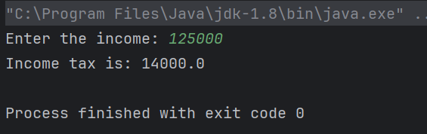

2. import java.util.Scanner;  
public class BankAccount {  
  
  
  
 private double balance;  
  
 public BankAccount() {  
 this.balance = 0;  
 }  
  
 public void deposit(double amount) {  
 if (amount > 0) {  
 balance += amount;  
 System.*out*.println("Deposit of " + amount + " successful");  
 } else {  
 System.*out*.println("Invalid deposit amount");  
 }  
 }  
  
 public void withdraw(double amount) {  
 if (amount > 0 && amount <= balance) {  
 balance -= amount;  
 System.*out*.println("Withdrawal of " + amount + " successful");  
 } else {  
 System.*out*.println("Invalid withdrawal amount or insufficient balance");  
 }  
 }  
  
 public double getBalance() {  
 return balance;  
 }  
  
 public static void main(String[] args) {  
 Scanner scanner = new Scanner(System.*in*);  
 BankAccount account = new BankAccount();  
  
 while (true) {  
 System.*out*.println("\n1. Deposit");  
 System.*out*.println("2. Withdraw");  
 System.*out*.println("3. Check Balance");  
 System.*out*.println("4. Exit");  
 System.*out*.print("Enter your choice: ");  
 int choice = scanner.nextInt();  
  
 switch (choice) {  
 case 1:  
 System.*out*.print("Enter deposit amount: ");  
 double depositAmount = scanner.nextDouble();  
 account.deposit(depositAmount);  
 break;  
 case 2:  
 System.*out*.print("Enter withdrawal amount: ");  
 double withdrawalAmount = scanner.nextDouble();  
 account.withdraw(withdrawalAmount);  
 break;  
 case 3:  
 System.*out*.println("Current balance: " + account.getBalance());  
 break;  
 case 4:  
 System.*out*.println("Exiting program...");  
 scanner.close();  
 System.*exit*(0);  
 default:  
 System.*out*.println("Invalid choice. Please enter a valid option.");  
 }  
 }  
 }  
 }

Output:

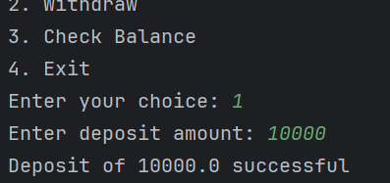

3. import java.util.Scanner;  
public class Clock {  
  
 private int hours;  
 private int minutes;  
 private int seconds;  
 private boolean isAM;  
  
 public Clock(int hours, int minutes, int seconds) {  
 if (isValidTime(hours, minutes, seconds)) {  
 this.hours = hours;  
 this.minutes = minutes;  
 this.seconds = seconds;  
 this.isAM = true; // By default set to AM mode  
 } else {  
 System.*out*.println("Invalid time provided");  
 }  
 }  
  
 private boolean isValidTime(int hours, int minutes, int seconds) {  
 return (hours >= 0 && hours < 24 && minutes >= 0 && minutes < 60 && seconds >= 0 && seconds < 60);  
 }  
  
 public void setAM(boolean isAM) {  
 this.isAM = isAM;  
 }  
  
 public void displayTime() {  
 String time = String.*format*("%02d:%02d:%02d %s", hours, minutes, seconds, (isAM ? "AM" : "PM"));  
 System.*out*.println(time);  
 }  
  
 public static void main(String[] args) {  
 Scanner scanner = new Scanner(System.*in*);  
  
 System.*out*.print("Enter hours: ");  
 int hours = scanner.nextInt();  
  
 System.*out*.print("Enter minutes: ");  
 int minutes = scanner.nextInt();  
  
 System.*out*.print("Enter seconds: ");  
 int seconds = scanner.nextInt();  
  
 System.*out*.print("Is it AM? (true/false): ");  
 boolean isAM = scanner.nextBoolean();  
  
 Clock clock = new Clock(hours, minutes, seconds);  
 clock.setAM(isAM);  
  
 System.*out*.println("Time set to:");  
 clock.displayTime();  
  
 scanner.close();  
 }  
 }

Output:

