**Software design (COSC 6353)**

**Home Work #1**

|  |  |
| --- | --- |
| Description | In this we will come up with an Application to  perform the following actions:  1. Prompt the user and read in user date of birth in (mm/dd/yyyy) format.  2. Print out following summary from the date of birth:  - What day of the week they were born? e.g. "You were born on a Friday."  - Their Zodiac sign. e.g. "Your zodiac sign is capricorn." |
| Authors | Tejeswini Jayaramareddy, UH ID: 1305699 📫 [tjayaramareddy@uh.edu](mailto:tjayaramareddy@uh.edu) |

Contents

Contents

1 How would you design this program 1

2 what programming language you would use 2

3 How you'd structure the program, what libraries you'd use 3

List of Figures

Figures

1 HighLevel Design of the Program 4

2 Discuss What programming language you would use 2

3 How would you structure the program and what libraries would you use? 3

## **1 How would you design this program**?

* The team has decided to develop this application in java developing UI to receive input date of birth from user in mm/dd/yyyy format as a String.
* Received String will be Formatted and parsed in Date format.
* Calendar class will be instantiated with the parsed input date.
* Using Calendar built-in methods and attributes, DAY_OF_WEEK will be read. Here, DAY_OF WEEK is an integer with value range from 1 correspond to Sunday through 7 correspond to Saturday.
* Zodiac sign will be determined with a switch case for Birth date and Month according to

**Aries** : March 21-April 20  
**Taurus** : April 21 - May 21  
**Gemini** : May 22 - June 21  
**Cancer** : June 22 - July 22  
**Leo** : July 23 - August 22  
**Virgo** : August 23 - September 22  
**Libra** : September 23 - October 22  
**Scorpio** : October 23 - November 21  
**Sagittarius** : November 22 - December 21  
**Capricorn** : December 22 - January 19  
**Aquarius** : January 20 - February 18  
**Pisces** : February 19 - March 20

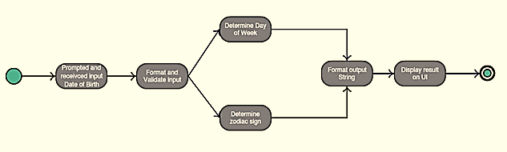

Figure 1: High Level Design of the Program

## **2 Discuss what programming language you would use?**

Using Java version 1.8.0

IDE : Eclipse

## **3 How would you structure the program and what libraries you would use?**

In this application, user will be prompted with UI to enter Date of Birth in MM/DD/YYYY format and click Process button in UI. Class **“ts_frame”** implements UI and gives the input user date of birth to Class **“ts_ProcessInput”**. Also, receives user birth day of week and zodiac sign results returned by **ts_ProcessInput.parseInput ()** function and displays as UI content.

Class “**ts_ProcessInput**” checks for valid input entered by user and and creates two instances of classes **“ts_DayofWeek”** and “**ts_ZodiacSign”. Also,** receives result returned by **ts_DayofWeek**.dayOfWeek() and **ts_ZodiacSign.zodiacSign(),** concatenates prepares a single string returned to **“ts_frame”**.

Class **ts_DayofWeek determines day of week** using java default libraries Calendar, Date and SimpleDateFormat. Also, returns the result computed by it’s method **ts_DayofWeek**.dayOfWeek() to “**ts_ProcessInput”.**

Class **ts_ZodiacSign determines zodiac sign for the given date of birth and returns the result computed by it’s method ts_ZodiacSign.zodiacSign() to** “**ts_ProcessInput”.**

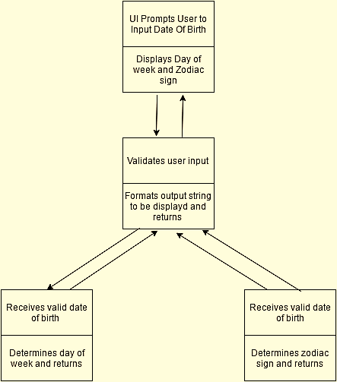

Figure 2: Structure of Application to find day of week and zodiac sign

Java default libraries used are:

**import** java.awt.BorderLayout;

**import** java.awt.Color;

**import** java.awt.Dimension;

**import** java.awt.FlowLayout;

**import** java.awt.event.ActionEvent;

**import** java.awt.event.ActionListener;

**import** java.io.File;

**import** javax.swing.BorderFactory;

**import** javax.swing.JButton;

**import** javax.swing.JFileChooser;

**import** javax.swing.JFrame;

**import** javax.swing.JLabel;

**import** javax.swing.JTextArea;

**import** javax.swing.JTextField;

**import** javax.swing.border.Border;

**import** java.util.Calendar;

**import** java.util.Date;

**import** java.util.GregorianCalendar;

**import** java.text.ParseException;

**import** java.text.SimpleDateFormat;

**UML Diagram**

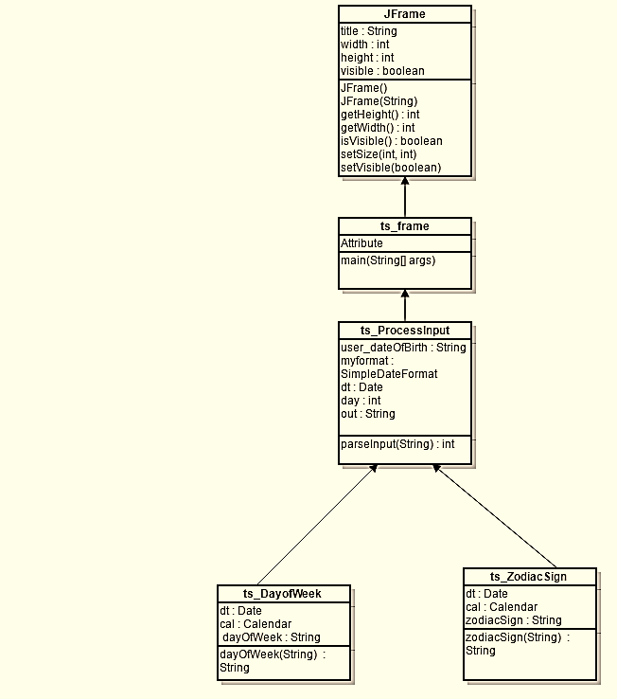

Figure 3: UML Diagram of the application to find day of week and zodiac sign