**UML Diagram for Application to find Day of Week and Zodiac sign**

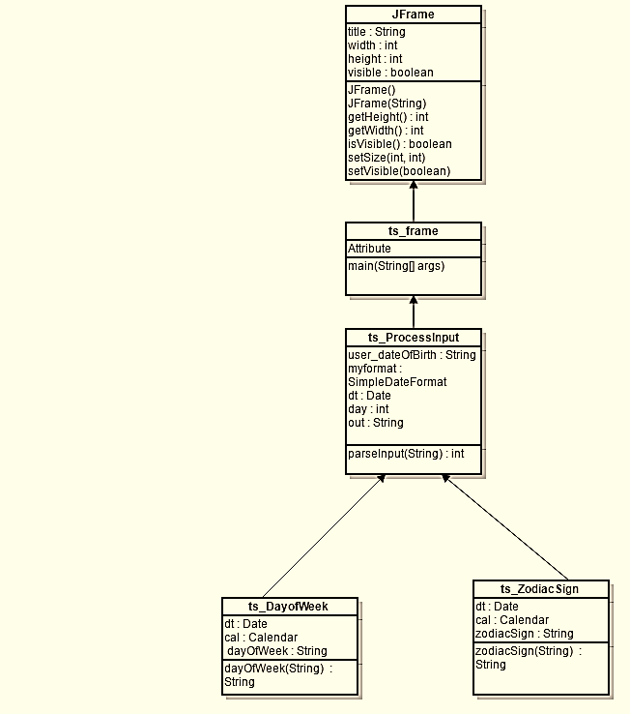

Figure 1: UML diagram for application determining day of week and zodiac sign