Important Assembly Notes
This project, being proof of concept, has two limitations that are easy to solve and involves manual soldering.
- Xiao Round Display does not provide connector for external switch

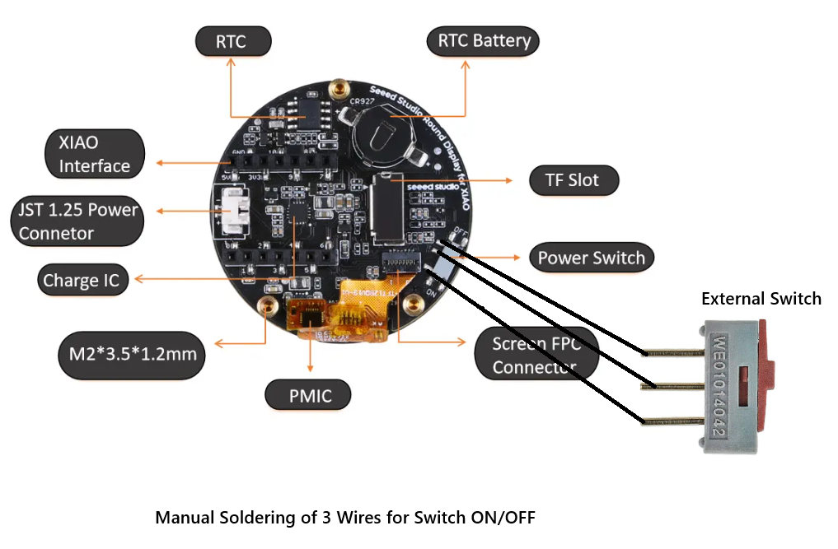

- Xiao Board also does not provide connector to I2C line
