# **HOMEWORK #1**

**Name: Tejas Harishchandra Acharya**

**Date: 23-07-2025**

**ID: 9933-6984-15**

**Problem 1(a): Image Demosaicing**

1. **Abstract and Motivation**

Image demosaicing is a critical step in digital image processing, aimed at reconstructing full-color images from incomplete color samples captured by image sensors using color filter arrays (CFAs), most commonly the Bayer pattern. Due to the spatial subsampling of color channels, raw sensor data lacks complete RGB information for each pixel, necessitating intelligent interpolation techniques to restore the missing color components.

Modern digital cameras rely on color filter arrays to capture color images. However, because each sensor pixel only records a single color (red, green, or blue), reconstructing a full-color image requires estimating the missing two channels per pixel. This process is fundamental to the camera image pipeline.

1. **Approach and Procedures**

Bilinear demosaicing is a spatial interpolation technique that estimates missing color values at each pixel in a Bayer-patterned image by averaging the values of known neighboring pixels. Since a typical image sensor records only one color component (R, G, or B) per pixel, the goal is to reconstruct the full RGB value at each pixel using the available data.

Bilinear demosaicing operates under the assumption that color values change smoothly across an image, so the missing values can be approximated by a weighted average of the nearby known values — hence the term bilinear interpolation.

* Identify Bayer Pattern
* Initialize Three Empty Channels (R, G, B)
* Image Padding
* Interpolation

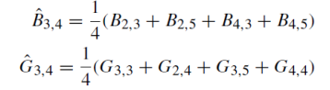

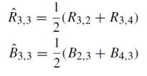

* Merge RGB Channels

1. **Experimental Results**

Demoisaiced Image from Bilinear Demosaicing

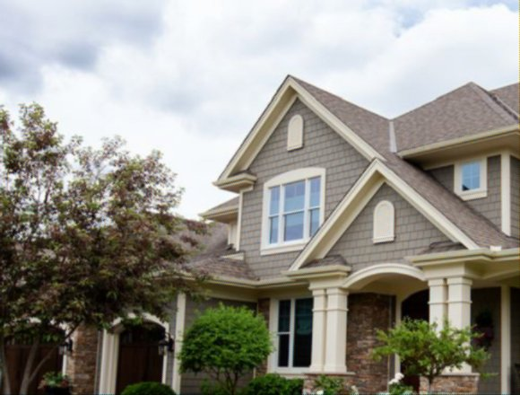

Demoisaiced Image from Advanced Demosaicing Algorithm

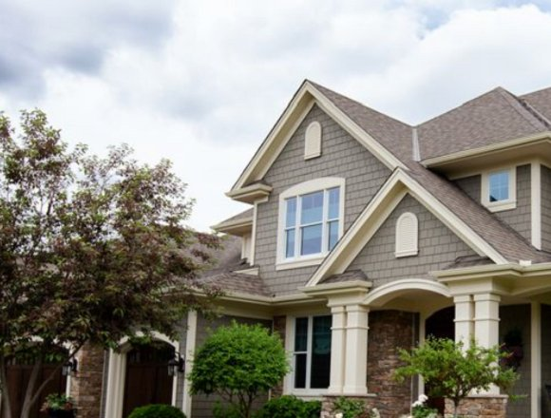

1. **Discussion**

|  |  |
| --- | --- |
| **Bilinear Demosaicing** | **Advanced Demosaicing** |
| Treats all pixels the same, there is no understanding of Image structure. | Image structure is usually considered, for e.g. Edge directed Interpolation, where Image Edges are considered. |
| Computationally simple, simple linear operations. | Computationally extensive. |
| Demosaiced images contain artifacts like blurred edges. | The demosaiced image seems to have preserved the edges, giving the demosaiced image a natural look. |