Assignemt 11
Problem Statement:
Perform and explain the code flow and the associated result for the below tasks. Candidates should
create and use their own employee dataset for the same. Share the screenshot of the commands used
and its associated result.
● Transfer data between Mysql and HDFS (Import and Export) using Sqoop.
First of All wil start all the services as given below using :
Start-all.shsudo service sshd start
Have to start mysql service as :sudo service mysqld.start
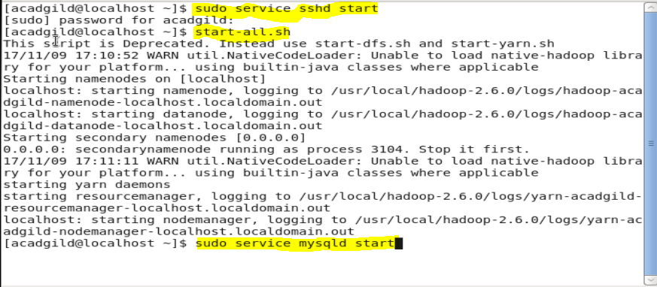

After this will go to the mysql by giving command:mysql-u root
Then see all t databases using:show databases;
Will creta our database using command :create database db1;
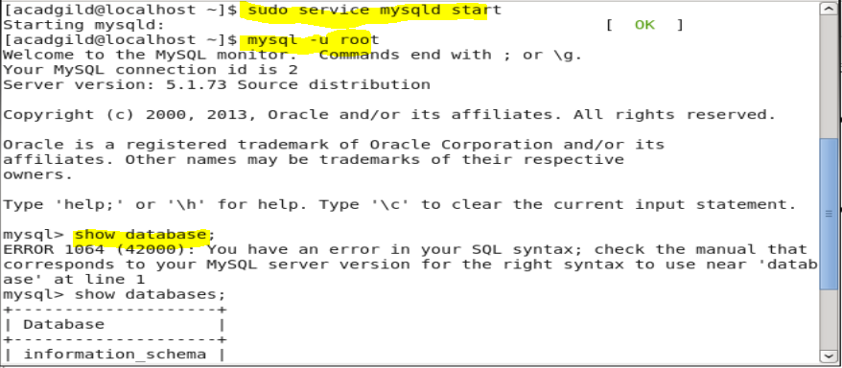
Will create a table emp1 and store insert some value into that table.
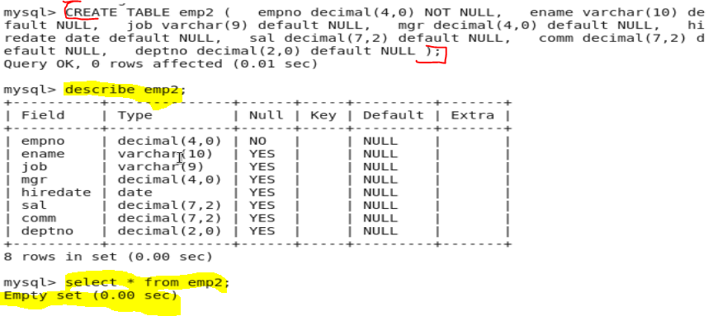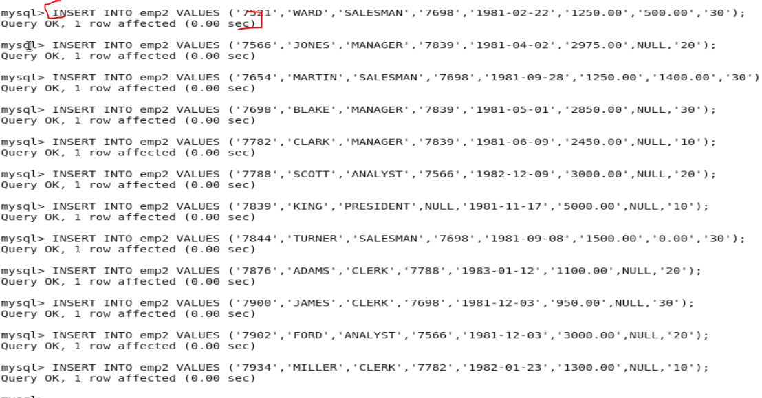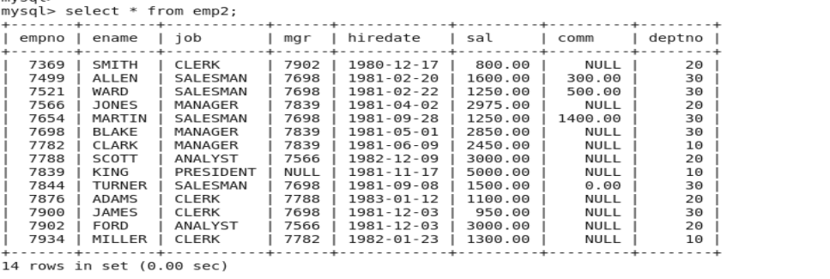
Grant all the permission and privileges to that table as shown:
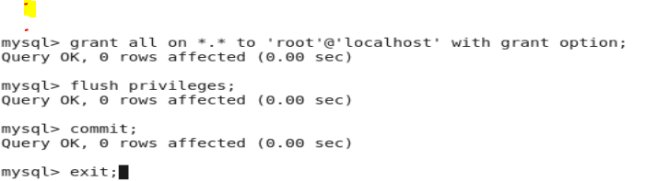
Now will import the data from mysql to the hdfs using command as :
Sqoop import –connect jdbc:mysql://localhost –username ‘root’ –table ‘emp2’ –m 1 –target-dir /’queryresult12’
After this data get imported to the hdfs location with the file name as queryresult12.

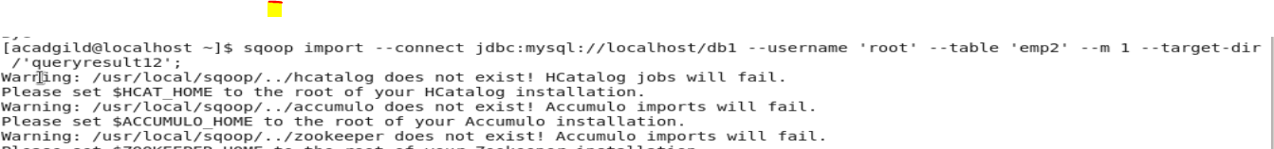

Can check weather the table content get into the hdfs location file by going to that location.

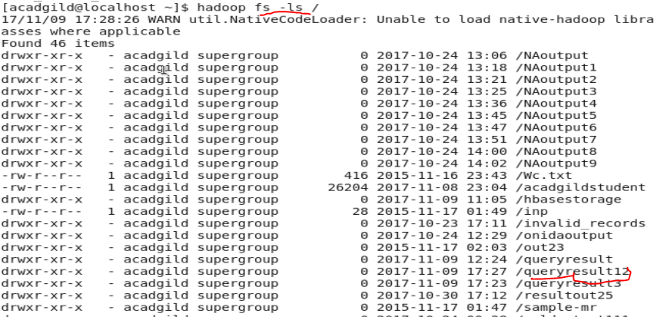
See the file created using the name as queryresult12
And content can be seen using –cat followed by the file name
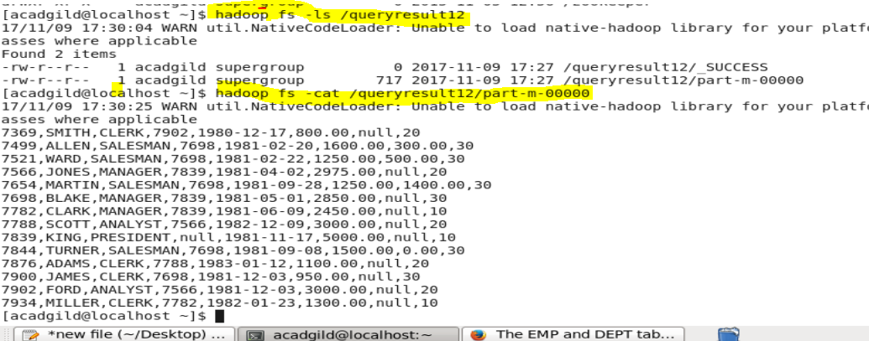

Export
● Transfer data between Mysql and Hive (Import and Export only selected columns) using Sqoop.
To export just create a table in the database under some database without anything in the tabe i.e an empty table
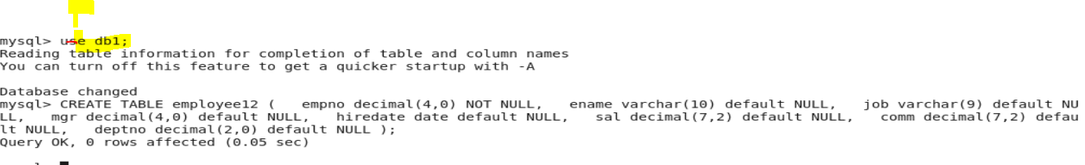
Grant all the permission to the table created and table should be empty.
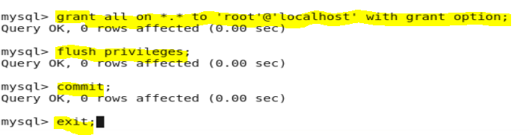
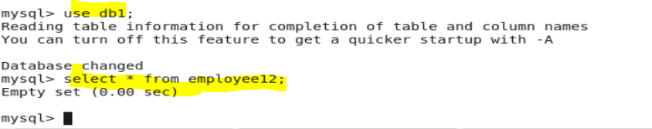
Can export the content from hdfs to database using command as :
Sqoop export –connect jdbc:mysql://localhost/db1 –username ‘root’ –table ‘employe12’ –m 1 –export-dir /’queryresult12’;
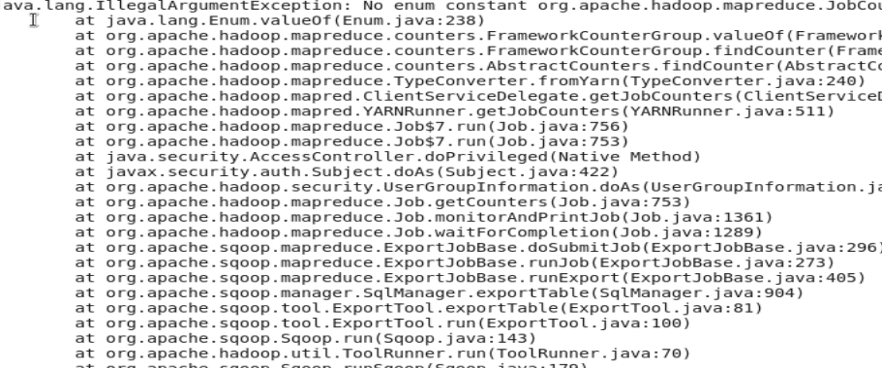
To check that data get exported or not go to that database and to that table and see the table.
Using select * statement
