**Session 11: Sqoop Flume**

**Assignment 2 Question**

**Perform incremental load in Hive**

**Read from MySQL Table and load it in Hive table.**

**Create hive table if it does not exist.**

**If it exists, perform the incremental load.**

**Load Data from MySQl Table and Load it in Hive Table**

sqoop import --connect jdbc:mysql:/localhost/db1/ --username ‘root’ –table ‘company’ –target-dir ‘/sqoopout’ –hive-import –m -1

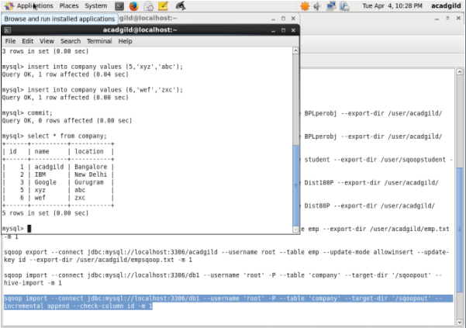

**Incremental Load:**

sqoop import --connect jdbc:mysql:/localhost/db1/ --username ‘root’ –table ‘company’ –target-dir ‘/sqoopout’ –incremental append –check-column id –last-value 5 –m -1;

