Streaming Twitter Data using Flume

Sol:

1. Login to  the twitter account
2. Go to <https://apps.twitter.com>
3. Create New app
4. Fill the details and click on create twitter application
5. Select ‘keys and access tokens tab’ and copy consumer key and consumer secret key
6. Click on create my access token button and note down acess token and acess secret key.
7. Make sure you’ve placed twitter4j-core-version.jar,twitter4j-stream and media support jars inside flume home /bin directory.
8. Create a new file flume.conf inside apacheflume1.6.0bin/conf directory

And add the above fields ,change the path and keyword of your choice.

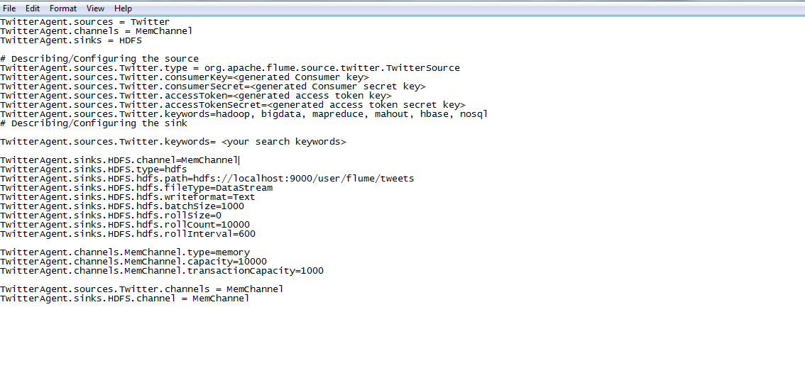

8.Create directory inside hdfs to store the tweets

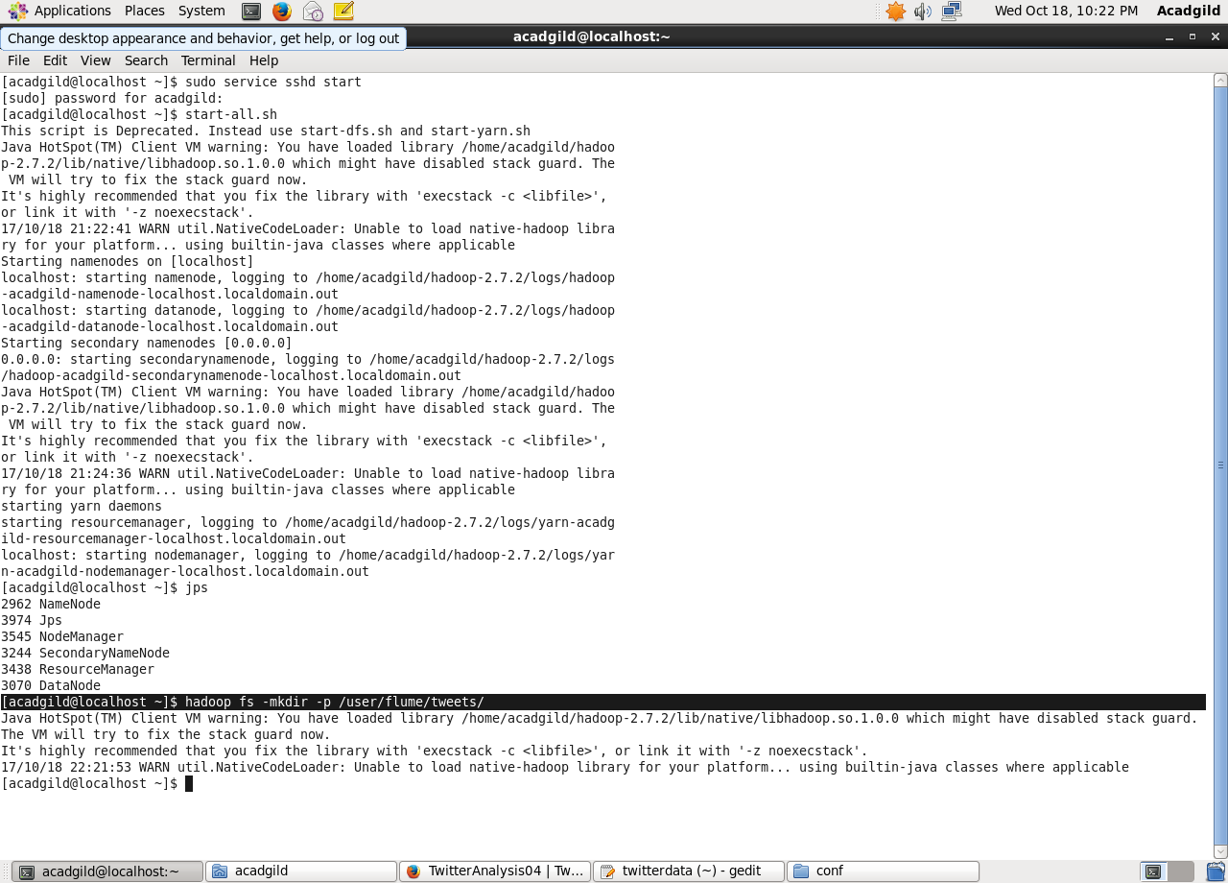

9.For fetching data from ,use the below flume command

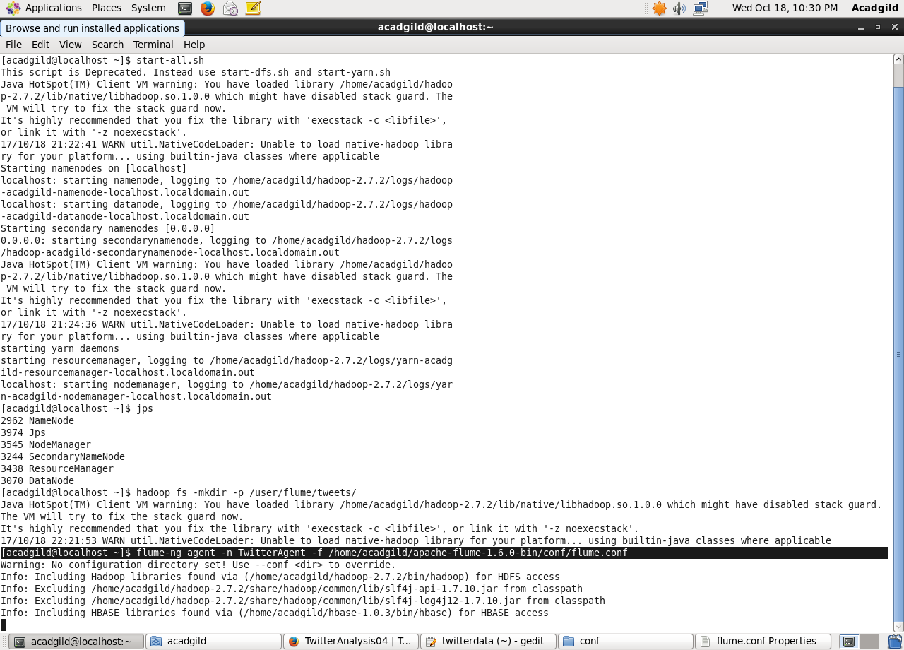

**Output:**

