Assignment12.2

Given a list of strings - List[String] (“alpha”, “gamma”, “omega”, “zeta”, “beta”)
First open the scala terminal,abd create a list of string in that as:
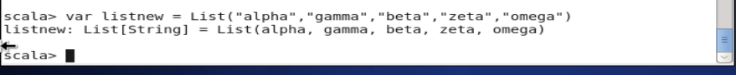
- find count of all strings with length 4
For this we will give the code in the scala terminal and will get the count of fields with string length ===4
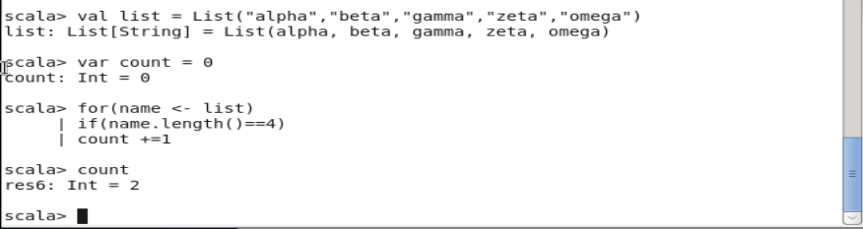
- convert the list of string to a list of integers, where each string is mapped to its
corresponding length

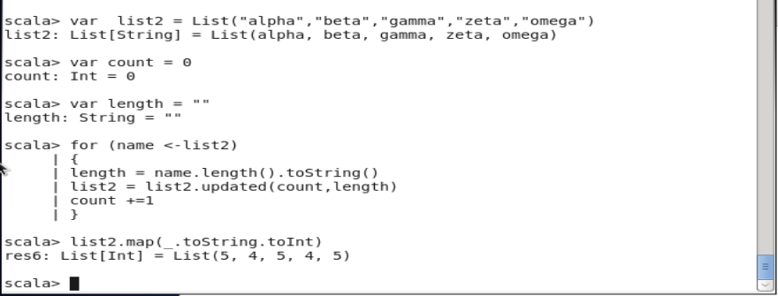

- find count of all strings which contain alphabet ‘m’
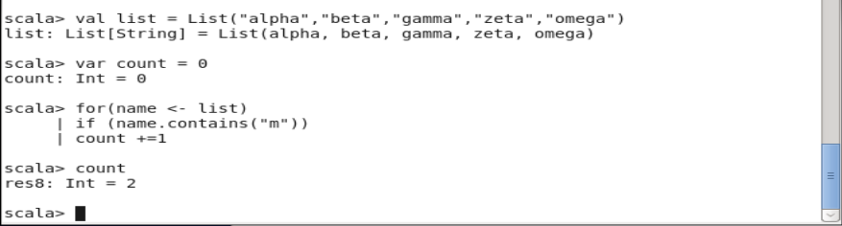

- find the count of all strings which start with the alphabet ‘a’
