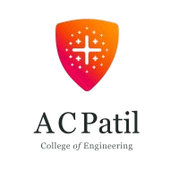
Jawahar Education Society's
A. C. Patil College of Engineering, Kharghar
Department of Artificial Intelligence & Data Science
Academic Year 2024-25 (Even Sem.)
Internal Assessment- I

Class & Sem: TE , Sem VI  Subject: Machine Learning | Date: 17.2.25  Total Marks: 20
Duration : 1hr
N.B. 1. Figures to the right indicate full marks. 2. Assume suitable data if necessary.
Questions |  | Max Marks | Mapped with CO | Cognitive Level (L1, L2, L3, L4)
Q.1 | Attempt the following questions (Any Five)
A | [1a] | [2] | [CO] | [CL]
B | [1b] | [2] | [CO] | [CL]
C | [1c] | [2] | [CO] | [CL]
D | [1d] | [2] | [CO] | [CL]
E | [1e] | [2] | [CO] | [CL]
F | [1f] | [2] | [CO] | [CL]
Q. 2A | [2a] | [5] | [CO] | [CL]
OR
Q. 2B | [2b] | [5] | [CO] | [CL]
Q. 3A | [3a] | [5] | [CO] | [CL]
OR
Q. 3B | [3b] | [5] | [CO] | [CL]
Cognitive Levels to be used:
L1 : Remembering L2 : Understanding L3 : Applying L4 : Analyzing

Subject In-charge | Internal Exam Coordinator  www.acpce.org | HOD

