DAY-1

Verilog code:

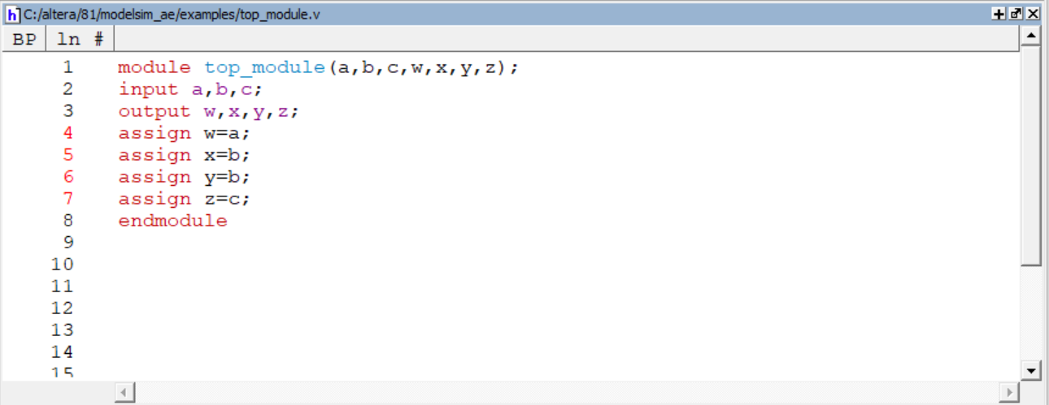

Testbench code:

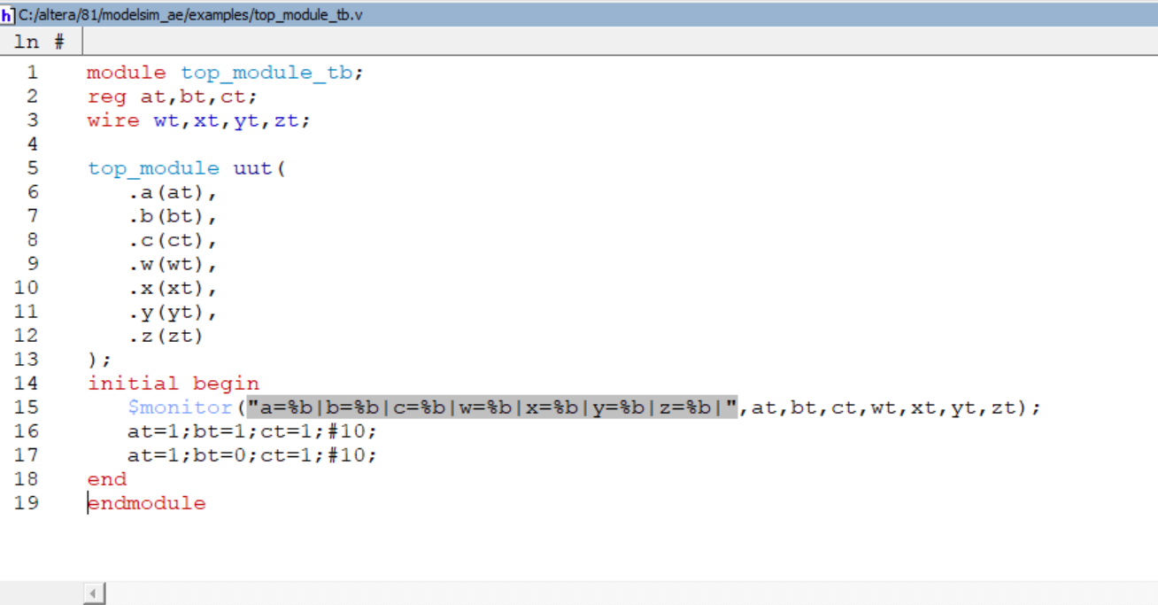

RESULT:

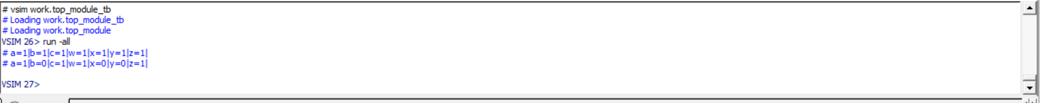

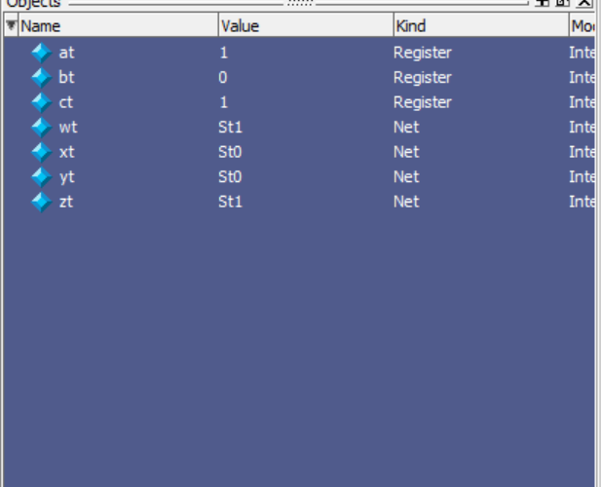

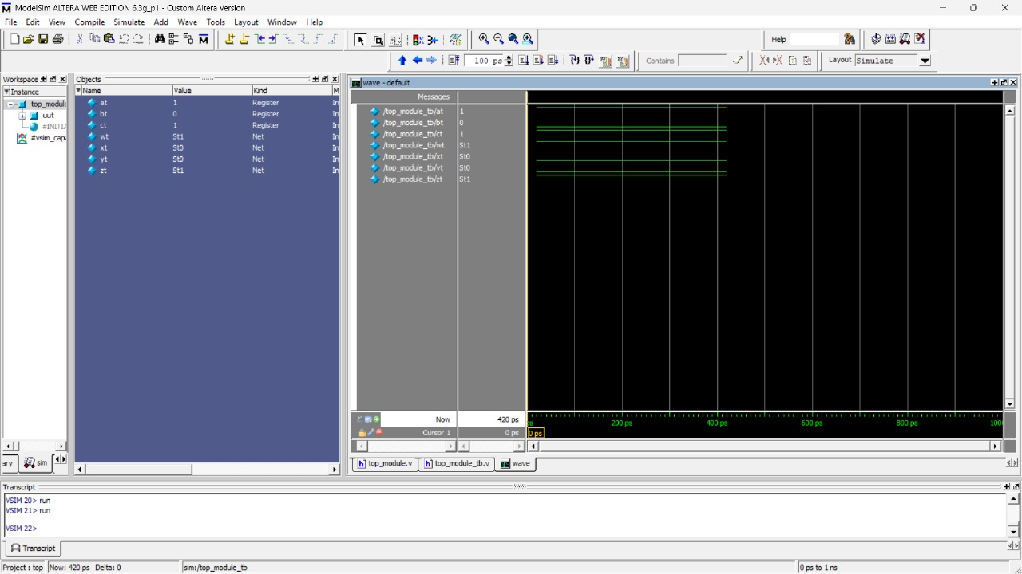

NAME : SAI TEJO VAISHNAVI MIDATHANA REG NO:126004230