VERILOG CODE:  
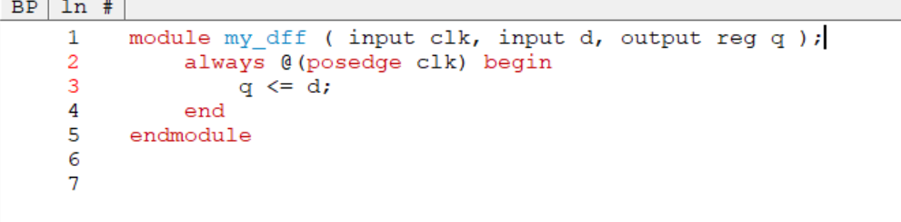

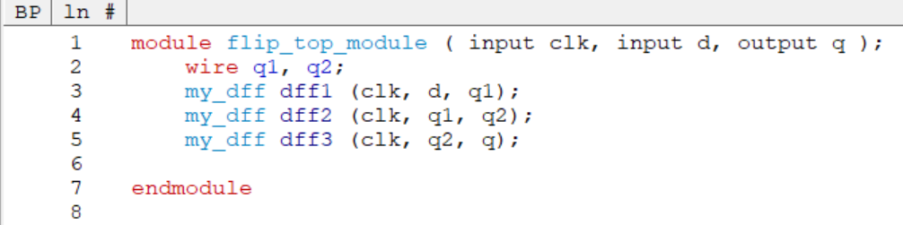

TESTBENCH CODE:

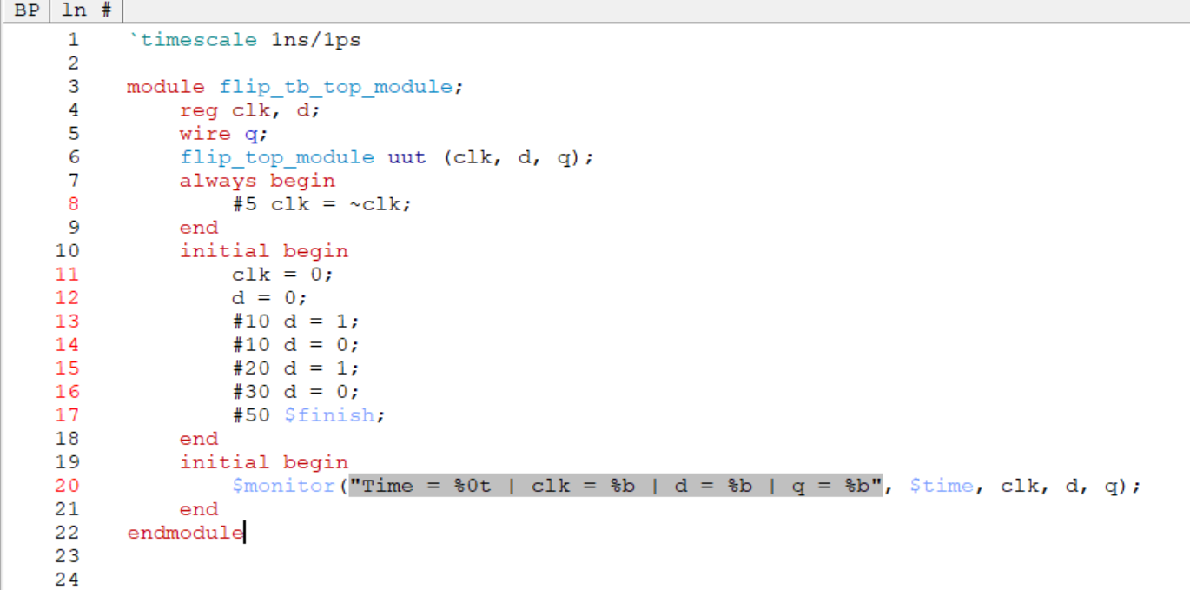

RESULTS:

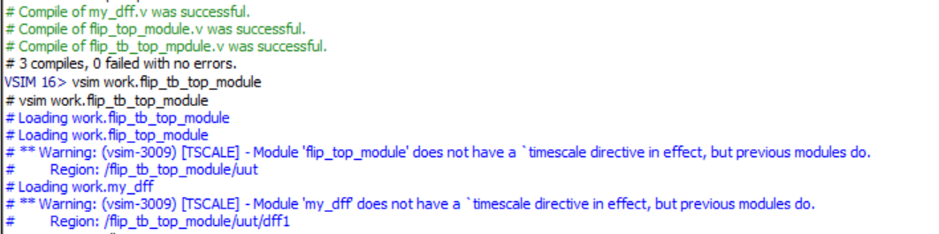

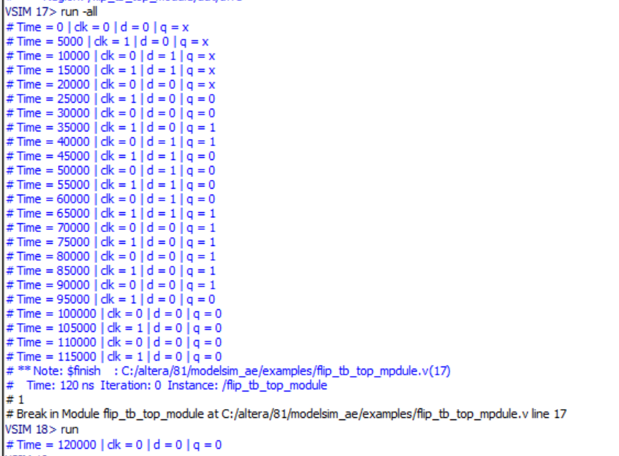

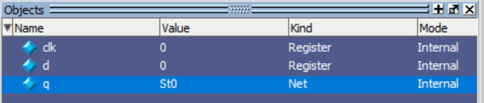

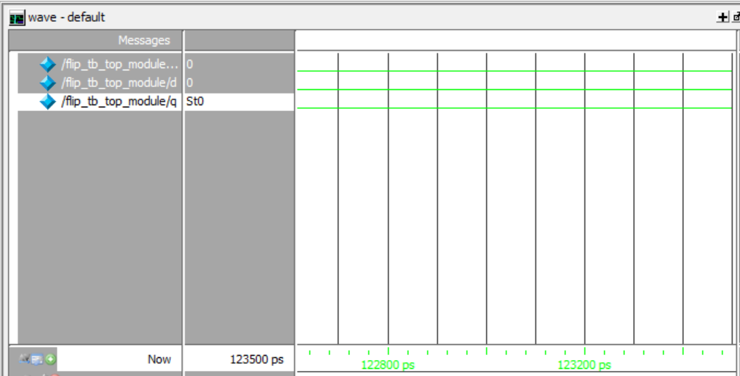

NAME : SAI TEJO VAISHNAVI MIDATHANA R.NO:126004230