VERILOG CODE:

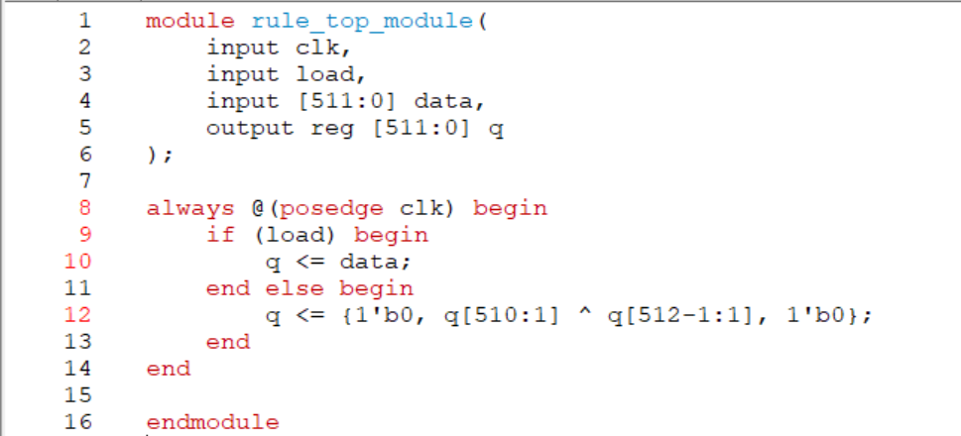

TESTBENCH CODE:

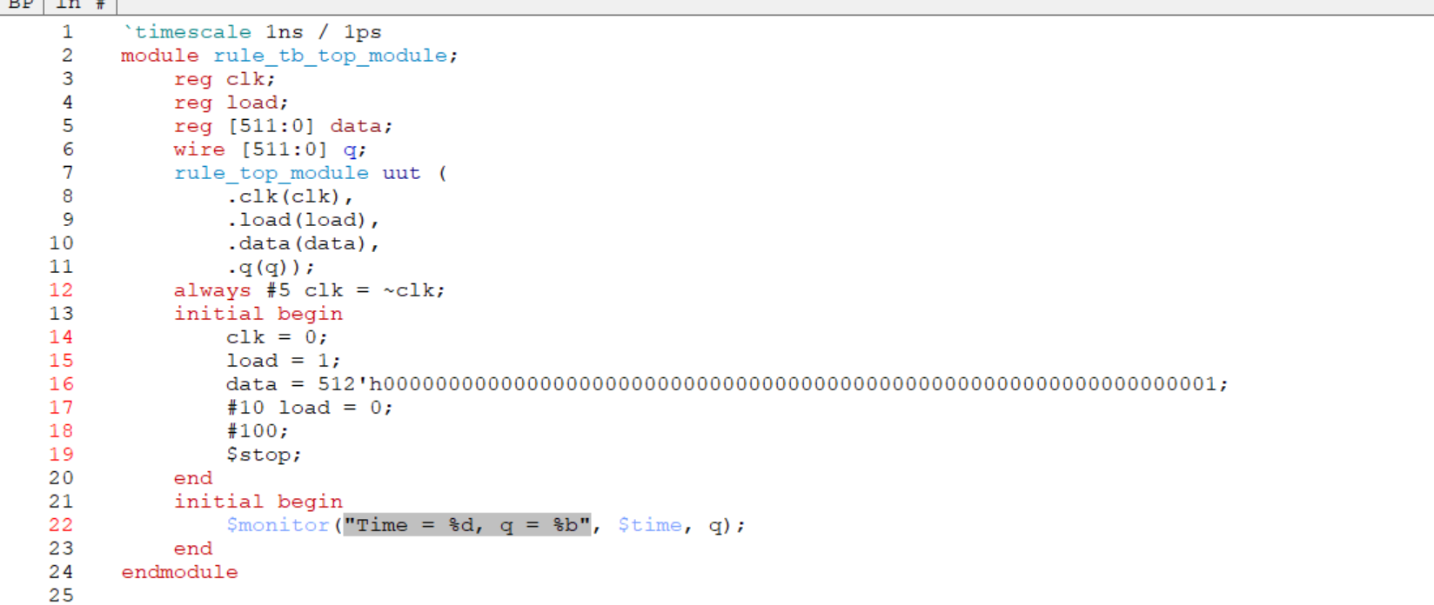

RESULTS:

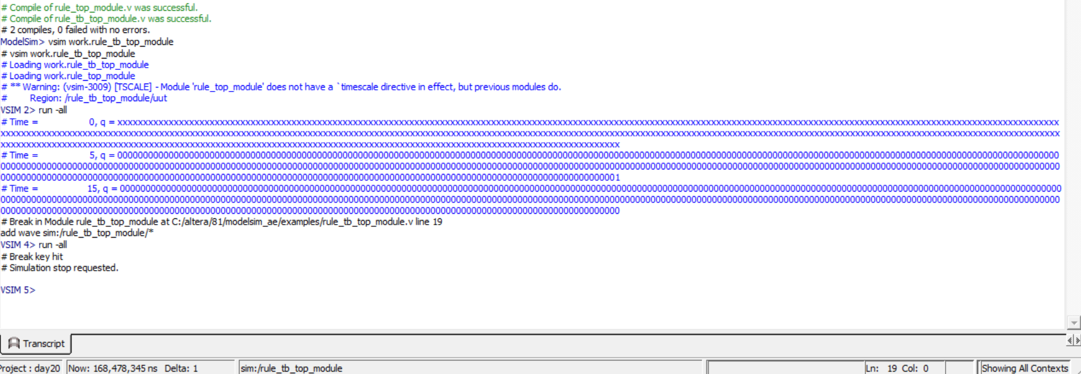

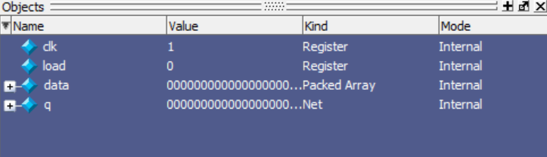

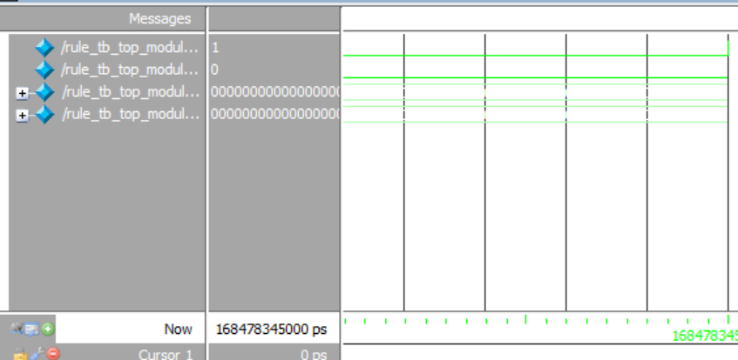

NAME : SAI TEJO VAISHNAVI MIDATHANA REG NO:126004230