VERILOG CODE:

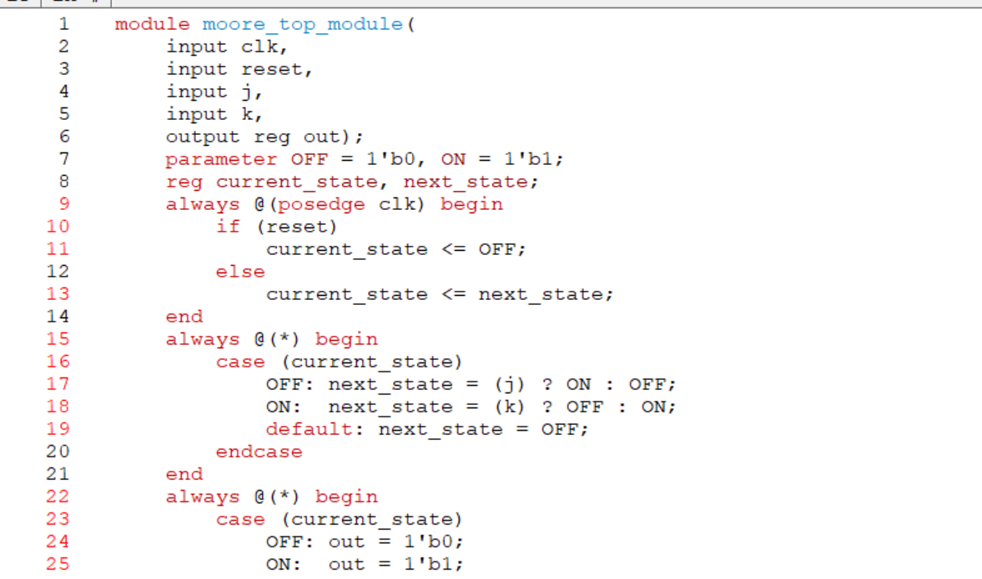

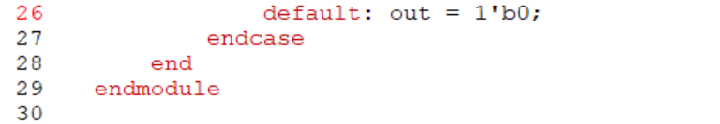

TESTBENCH CODE:

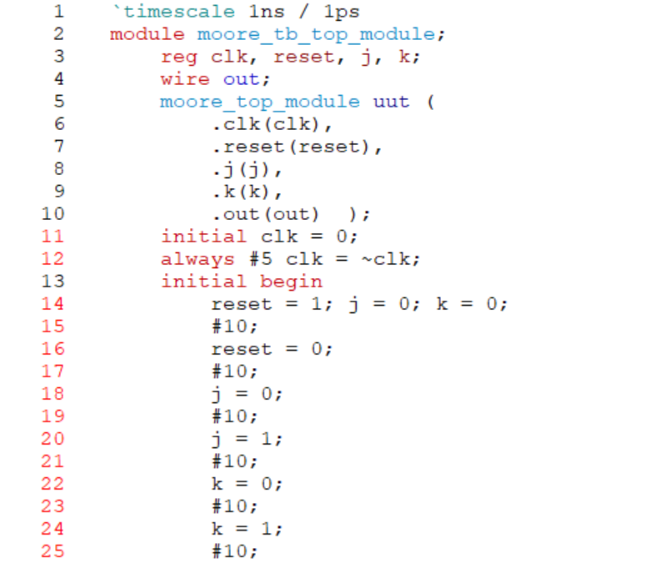

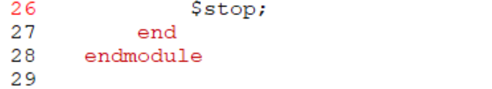

RESULT:

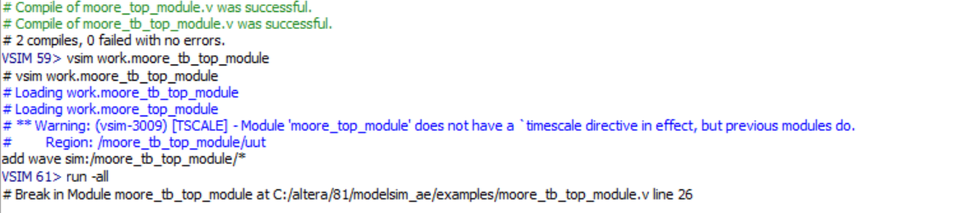

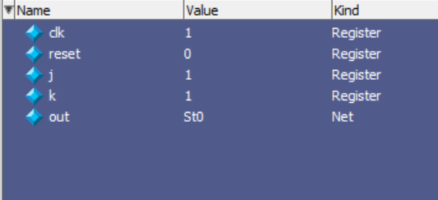

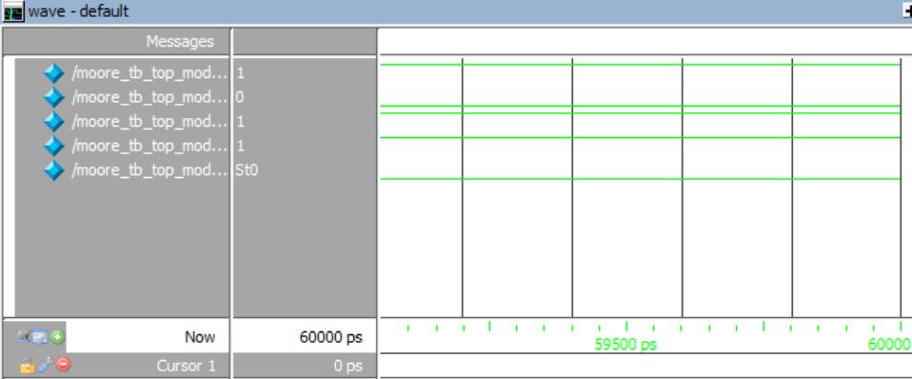

NAME :SAI TEJO VAISHNAVI MIDATHANA R.NO:126004230