**Project: Contacts Application**

Create a simple Contacts application that shows a list of contacts, showing their full name, email and profile photo. The user should have the ability to click on each contact to see more granular details. The user should also have the ability to add new contacts.  
The initial load of contacts should be retrieved from this API: <http://www.mocky.io/v2/5807df4a10000004122b74e2>

**Application:**

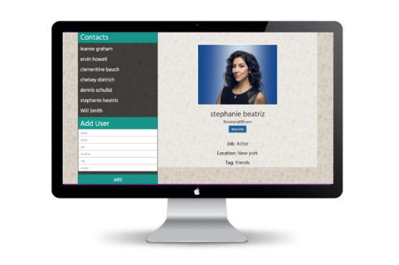

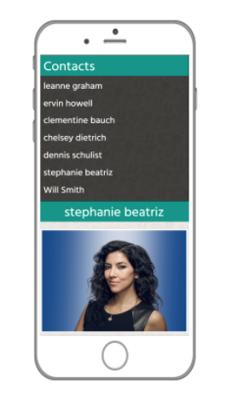

**How to Run the App/Local Env setup:**

1. Pull application from github repo
2. From within the directory run the following command **npm install**
3. Type command **npm run preInstall** (install protractor globally to run end to end tests)
4. Type command **npm run postInstall** (setup webdriver to end to end)
5. Type command **live-server**

The app will now run on local server in browser

**How to Run Unit Tests**

1. From terminal within the directory run the following command

**npm run unitTests**

**How to Run end2end Tests**

1. **Ensure live-server is running**
2. Ensure webdriver is running -> **npm run startWebDriver**

**Macintosh HD:Users:tejpal.sohal:Desktop:Screen Shot 2017-01-24 at 15.49.25.png**

1. From directory run command **npm run userTesting**

This will fire up webdriver and run through the user

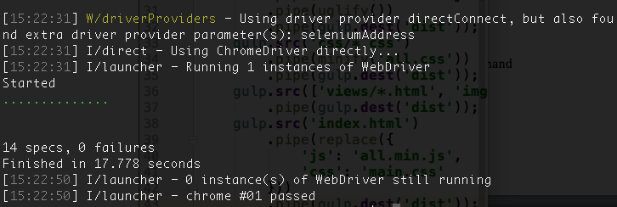

**For Application Production Build**

1. From within the directory run the following command **npm run prodBuild**

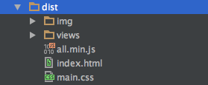

This will create a build for production in the dist folder, which can be dropped on the server.

**Conclusion**

If I had more time I would have liked to improve the UI make it more fancy and add in animation. however this is a prototype. I really wanted to use the $httpBackend as a mock for unit testing the backend but with the time scales was unable to implement this. The API handing has been done in the factory service which I have implemented the error status are handled but all redirect to the same url. The project structure has been created in such a way that it can be extended.