**A**

**PRACTICAL INTERNSHIP PROJECT REPORT**

**ON**

**(Financial Data & Cement Data Set Report Using DAX in Power BI)**

*In partial fulfillment of*

***B.Tech. III yr* (Information Technology)**



**Work Carried Out At “Poornima College of Engineering, Jaipur”**

Submitted To: Submitted by:

------------------- -------------------

Name of faculty/Lab in-charge Name of student

**Roshana Khalid T Devendra Singh** Designation Branch, Year

Assistant Professor CS , 3rd year

# Acknowledgment

I have undergone an Internship Project which was meticulously planned and guided at every stage so that it became a lifetime experience for me. This could not be realized without the help from numerous sources and people in the Poornima University and Celebal tech Pvt.

I am thankful to **Dr. Manoj Gupta, Provost, Poornima University** for providing us a platform to carry out this activity successfully.

I am also very grateful to **Mr. Amol Saxena (HOD, Information Technology)** for his kind support and guidance.

I would like to take this opportunity to show our gratitude towards Roshana Khalid T **mam** who helped me in successful completion of my training. She has been a guide, motivator & source of inspiration for us to carry out the necessary proceedings for completing this training and related activities successfully and grateful for her guidance and support. I am thankful for their kind support and providing us expertise of the domain to develop the project.

I would also like to express our hearts felt appreciation to all of our friends whom direct or indirect suggestions help us to develop this project and to entire team members for their valuable suggestions.

Lastly, thanks to all faculty members of Department of Computer Engineering for their moral support and guidance.

**Name : Devendra Singh Shekhawat**

**Btech Information Technology**

#### TABLE OF CONTENTS

**Chapter 1- Introduction 6-11**

* 1. **Project objective and scope 6**
  2. **Technology used 6-7**

**Chapter 2- About Technology 8-4**

* 1. **Introduction 8-13**
  2. **Steps to sign-up 13-31**
  3. **Power Bi services 32-41**

**Chapter 4- Conclusion & Future Scope 42-43**

* 1. **Conclusion 42**
  2. **Future Scope and Reference 43**

**Chapter-1**

**INTRODUCTION**

**1.1 PROJECT OBJECTIVE AND SCOPE**

PROJECT 1 ( ICH BOSS CEMENT PRIVATE LIMITED)

1.Calculate the variation in manufacturing of cement plant wise

and on the basis of the fiscal year.

2.Quantity should be in tons.

3.Show the visuals which give the target and target achieved in a

particular year the manufacturing of cement.

4. The number of delivery and number of orders received Plantwise and month-wise.

5. Total Quantity Sold to date, total delivery of cement last month,

total delivery last year, average delivery per day.

6. Total budget and production region wise.

7.Calculation against delivery of the cement on a yearly basis and plant wise.

Project 2

Complete and Prepare some sample reports on the attached data set.

Note: Before working on the Power BI report read the Power BI-designing Practice carefully.

Apply following Dax in Financial Data Set

1- Total Quantity Sold

2- Quantity Sold Last Month

3- Quantity Sold Last Year

4- Average Quantity Sold per Day

5- Quantity Sold in "Germany" and "Dell" & "HP"

6- Quantity Sold Two Months Ago

7- Quantity Sold Two Quarters Ago

8- Last Month Profit

9- Profit 2 Month Ago

10- Last Month Cumulative Profit

11- Cumulative Profit 2 Month Ago

12- Total Profit running total in Date.

13- Apply Currency Conversion in it.

14- How to apply the Fiscal Year.

**1.2 TECHNOLOGY USED**

***Power BI Desktop*** is a free application you install on your local computer that lets you connect to, transform, and visualize your data. With Power BI Desktop, you can connect to multiple different sources of data, and combine them (often called *modeling*) into a data model. This data model lets you build visuals, and collections of visuals you can share as reports, with other people inside your organization. Most users who work on business intelligence projects use Power BI Desktop to create reports, and then use the *Power BI service* to share their reports with others.

**Power BI Service** is a cloud-based variant of Power BI. With Power BI Service you can create lots of different types of visualization and perform variance analytics tasks in the cloud.It makes it very easy to access and share your data visualizations. You can also create your visualizations locally using the Power BI Desktop application and then publish them to the cloud using Power BI Service. Power BI service is also known as Power BI Online.

**PowerBI Mobile** In the mobile apps, you connect to and interact with your cloud and on-premises data.

You create reports in Power BI Desktop. You create dashboards, and view dashboards and reports in the Power BI report service. All these reports and dashboards are available in the Power BI mobile apps, whether they're on premises or in the cloud. Try viewing and interacting with them on your mobile device, be it iOS (iPad, iPhone, iPod Touch, or Apple Watch), Android phone or tablet, or Windows 10 device.

# Chapter-2

# About Technology

# 2.1 Introduction

# What is Power BI?

**Power BI** is a collection of software services, apps, and connectors that work together to turn your unrelated sources of data into coherent, visually immersive, and interactive insights. Your data may be an Excel spread sheet, or a collection of cloud-based and on-premises hybrid data warehouses. Power BI lets you easily connect to your data sources, visualize and discover what's important, and share that with anyone or everyone you want.

## The parts of Power BI

Power BI consists of several elements that all work together, starting with these three basics:

* A Windows desktop application called **Power BI Desktop**.
* An online SaaS (*Software as a Service*) service called the **Power BI service**.
* Power BI **mobile apps** for Windows, iOS, and Android devices.

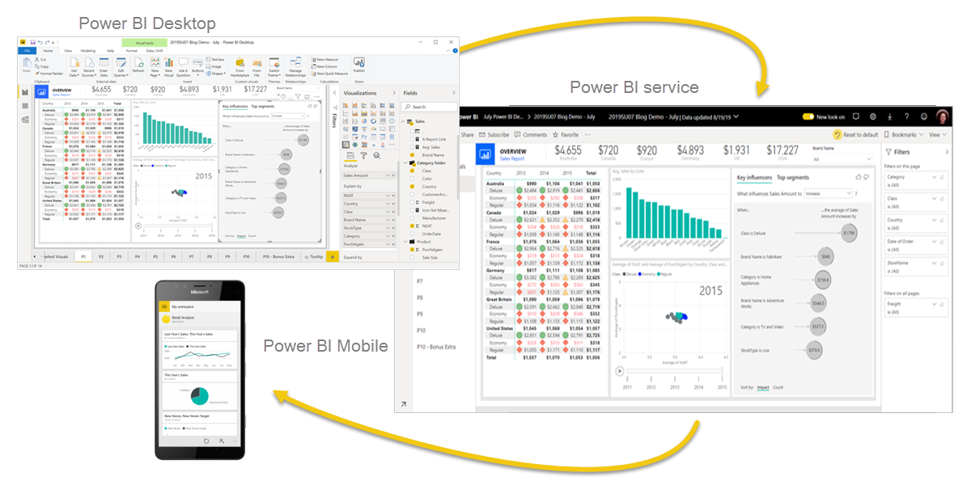

These three elements—Power BI Desktop, the service, and the mobile apps—are designed to let you create, share, and consume business insights in the way that serves you and your role most effectively.

Beyond those three, Power BI also features two other elements:

* **Power BI Report Builder**, for creating paginated reports to share in the Power BI service. Read more about paginated reports later in this article.
* **Power BI Report Server**, an on-premises report server where you can publish your Power BI reports, after creating them in Power BI Desktop. Read more about Power BI Report Server later in this article.

## How Power BI matches your role

How you use Power BI may depend on your role in a project or on a team. Other people, in other roles, might use Power BI differently.

For example, you might primarily use the **Power BI service** to view reports and dashboards. Your number-crunching, business-report-creating co-worker might make extensive use of **Power BI Desktop** or **Power BI Report Builder** to create reports, then publish those reports to the Power BI service, where you view them. Another co-worker, in sales, might mainly use the **Power BI phone app** to monitor progress on sales quotas, and to drill into new sales lead details.

If you're a developer, you might use Power BI APIs to push data into datasets or to embed dashboards and reports into your own custom applications. Have an idea for a new visual? Build it yourself and share it with others.

You also might use each element of Power BI at different times, depending on what you're trying to achieve or your role for a given project.

How you use Power BI can be based on which feature or service of Power BI is the best tool for your situation. For example, you can use Power BI Desktop to create reports for your own team about customer engagement statistics and you can view inventory and manufacturing progress in a real-time dashboard in the Power BI service. You can create a paginated report of mailable invoices, based on a Power BI dataset. Each part of Power BI is available to you, which is why it's so flexible and compelling.

Explore documents that pertain to your role:

* Power BI for business users
* Power BI Desktop for report creators
* Power BI Report Builder for [enterprise report creators](https://docs.microsoft.com/en-us/power-bi/paginated-reports/paginated-reports-report-builder-power-bi)
* Power BI for [administrators](https://docs.microsoft.com/en-us/power-bi/admin/service-admin-administering-power-bi-in-your-organization)
* Power BI for *developers*

## The flow of work in Power BI

One common workflow in Power BI begins by connecting to data sources in Power BI Desktop and building a report. You then publish that report from Power BI Desktop to the Power BI service, and share it so business users in the Power BI service and on mobile devices can view and interact with the report.

This workflow is common, and shows how the three main Power BI elements complement one another.

### Use the deployment pipeline tool

In the Power BI service, you can use the deployment pipeline tool to test your content before you release it to your users. The deployment pipeline tool can help you deploy reports, dashboards, datasets, and paginated reports.

## Paginated reports in the Power BI service

Another workflow involves paginated reports in the Power BI service. Enterprise report creators design paginated reports to be printed or shared. They can also share these reports in the Power BI service. They're called *paginated* because they're formatted to fit well on a page. They're often used for operational reports, or for printing forms such as invoices or transcripts. They display all the data in a table, even if the table spans multiple pages. Power BI Report Builder is the standalone tool for authoring paginated reports.

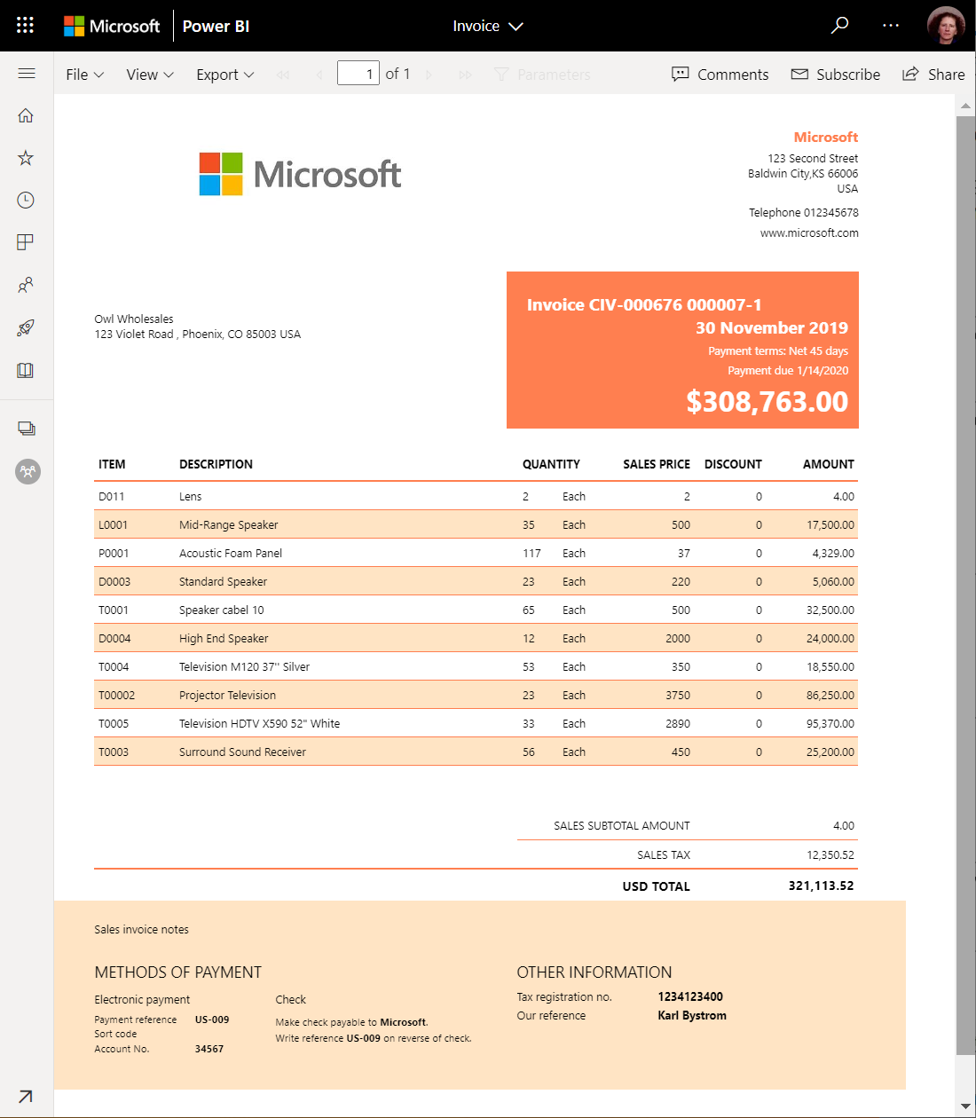

## On-premises reporting with Power BI Report Server

What if you need to keep your reports on premises, say, behind a firewall? Read on.

You can create, deploy, and manage Power BI reports in Power BI Desktop, and paginated reports in Report Builder, with the ready-to-use tools and services that Power BI Report Server provides.

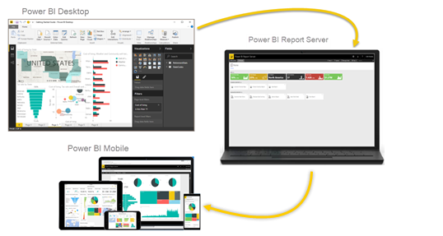

Power BI Report Server is a solution that you deploy behind your firewall and then deliver your reports to the right users in different ways, whether that's viewing them in a web browser, on a mobile device, or as an email. And because Power BI Report Server is compatible with Power BI in the cloud, you can move to the cloud when you're ready.

# Get started creating in the Power BI service

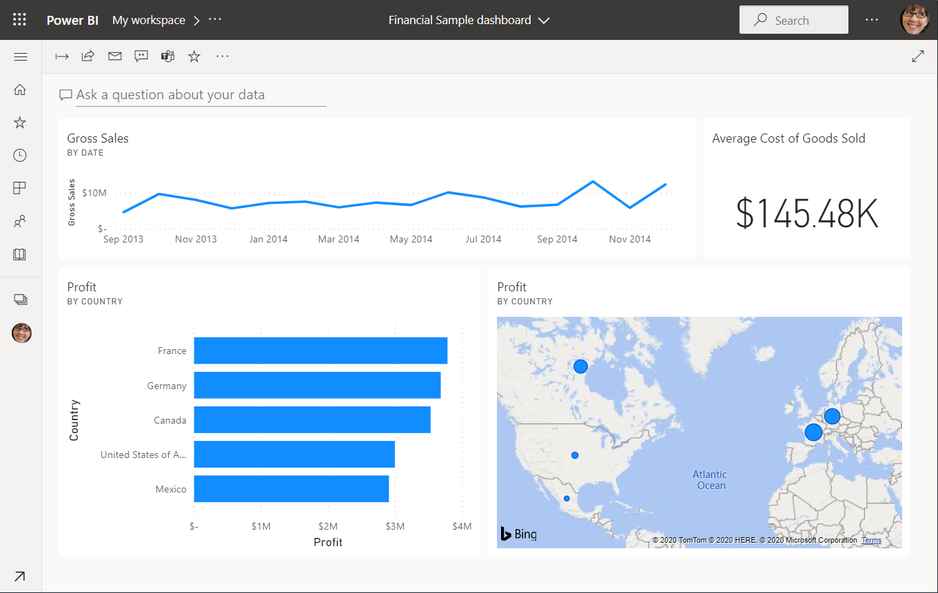

You must first complete the following steps:

* Sign in to your Power BI online account, or sign up, if you don't have an account yet.
* Open the Power BI service.
* Get some data and open it in report view.
* Use that data to create visualizations and save it as a report.
* Create a dashboard by pinning tiles from the report.
* Add other visualizations to your dashboard by using the Q&A natural-language tool.
* Resize, rearrange, and edit details for the tiles on the dashboard.
* Clean up resources by deleting the dataset, report, and dashboard.

# 2.2 Steps to sign up

You need a Power BI Pro or Premium Per User (PPU) license to create content in Power BI. If you don't have a Power BI account, and plan on creating content, sign up for a free Power BI Premium Per User 60-day trial before you begin. Complete the wizard to get a free license, open the Power BI service (app.powerbi.com), select the **Me** icon and choose either **Buy Pro now** or **try paid features for free**.

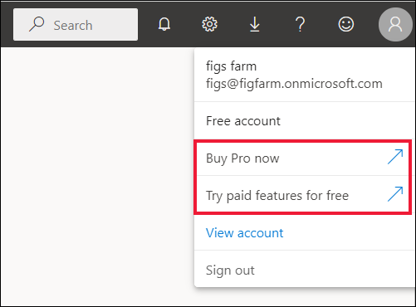

## Step 1: Get data

Often, when you want to create a Power BI report, you start in Power BI Desktop. Power BI Desktop offers more power. You can transform, shape, and model data, before you start designing reports. This time though, we're going to start from scratch creating a report in the Power BI service.

1. To begin, open the Power BI service (app.powerbi.com) in your browser.

Don’t have an account? No worries, you can sign up for a free Power BI Premium Per User 60 day trial

1. Select **My workspace** in the navigation pane.
2. In **My workspace**, select **New** > **Upload a file**.

The **Get Data** page opens.

1. Under the **Create new content** section, make sure **Files** is selected, then select the location where you saved the Excel file.

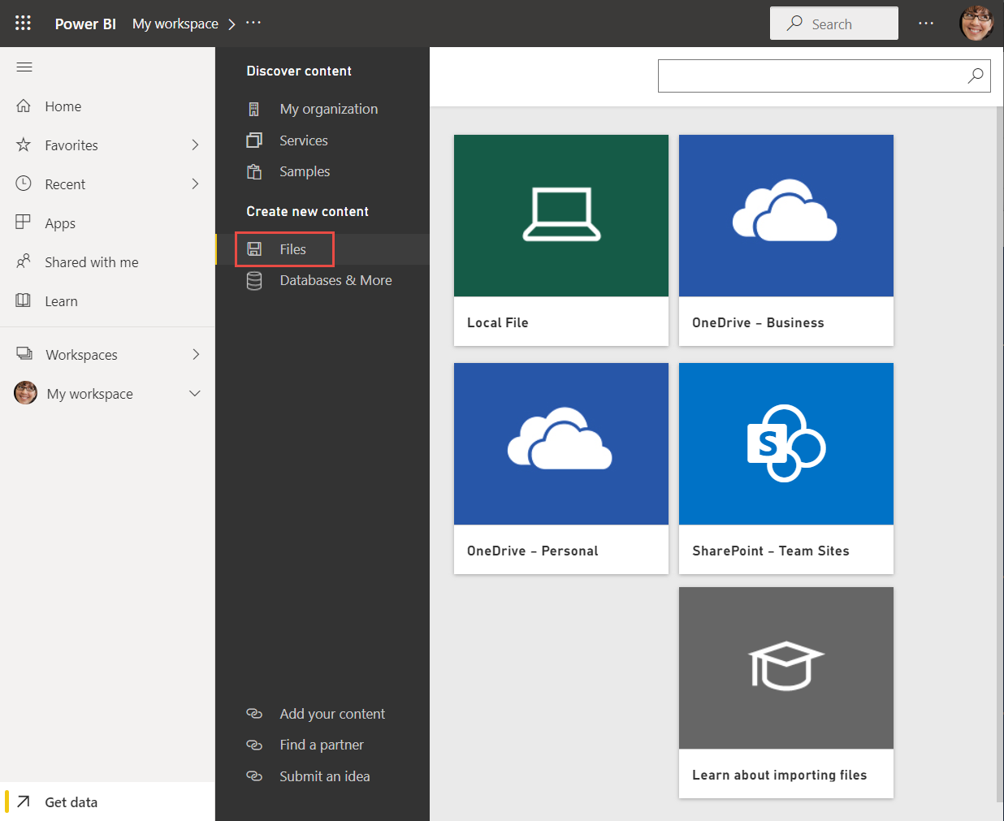

1. Browse to the file on your computer, and choose **Open**.
2. For this tutorial, we select **Import** to add the Excel file as a dataset, which we can then use to create reports and dashboards. If you select **Upload**, the entire Excel workbook is uploaded to Power BI, where you can open and edit it in Excel Online.

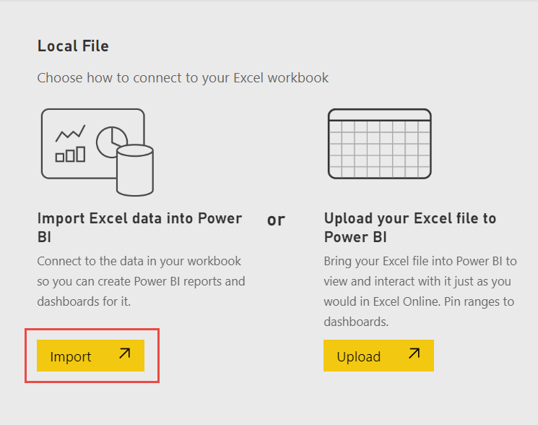

1. When your dataset is ready, select **More options (...)** next to your Financial Sample dataset, then select **Create report** to open the report editor.

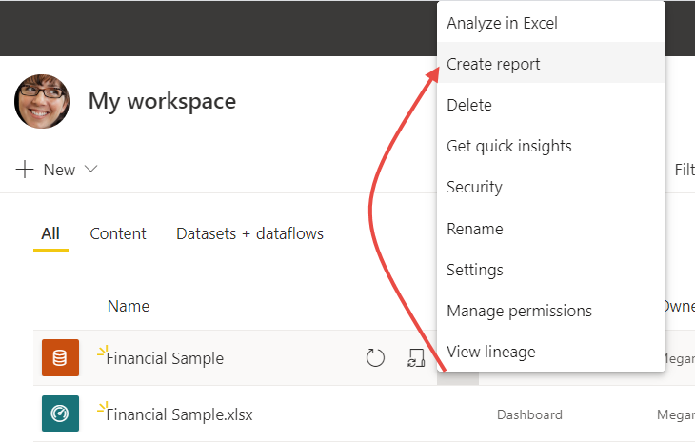

The report canvas is blank. We see the **Filters**, **Visualizations**, and **Fields** panes on the right.

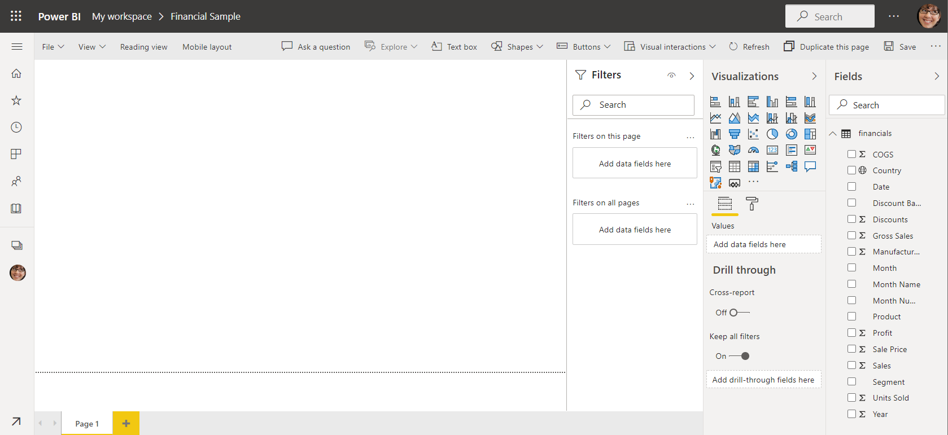

**Tip**

Select the global navigation button in the upper-left corner to collapse the navigation pane. That way your canvas has more room.

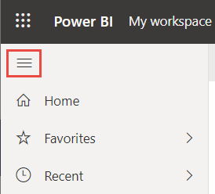

1. You are currently in Editing view. Notice the **Reading view** option in the menu bar.

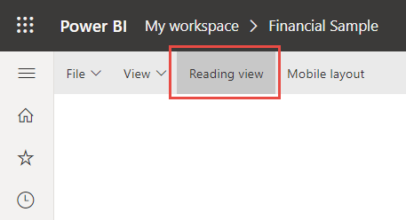

While in Editing view, you can modify reports, because you're the *owner* and *creator* of the report. When you share your report with colleagues, often they can only interact with the report in Reading view. They are *consumers* of reports in your **My workspace**.

## Step 2: Create a chart in a report

Now that you've connected to data, start exploring. When you've found something interesting, you can save it on the report canvas. Then you can pin it to a dashboard to monitor it and see how it changes over time. But first things first

1. In the report editor, start in the **Fields** pane on the right side of the page to build a visualization. Select the **Gross Sales** field, then the **Date** field.

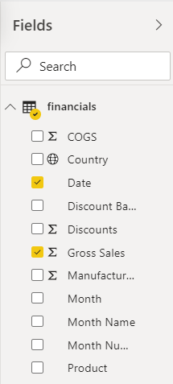

Power BI analyzes the data and creates a column chart visualization.

**Note:**

If you selected the **Date** field first instead of **Gross Sales**, you see a table. No worries! We're going to change the visualization in the next step.

Some fields have sigma symbols next to them because Power BI detected that they contain numeric values.

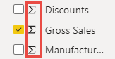

1. Let's switch to a different way of displaying this data. Line charts are good visuals for displaying values over time. Select the **Line chart** icon from the **Visualizations** pane.

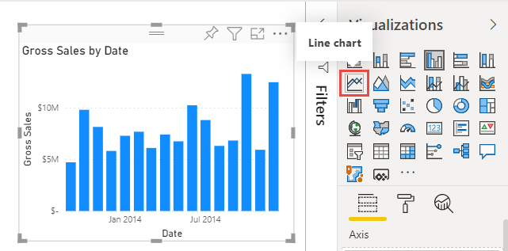

1. This chart looks interesting, so let's *pin* it to a dashboard. Hover over the visualization and select the pin icon that appears either above or below it.

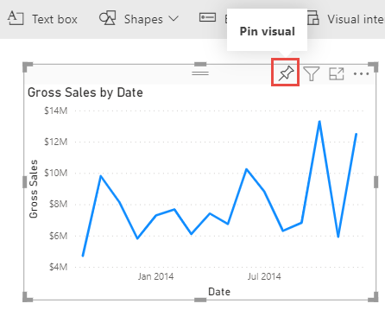

1. Because this report is new, you're prompted to save it before you can pin a visualization to a dashboard. Give your report a name (for example, *Financial Sample report*), then **Save**.

Now you're looking at the report in Reading view.

1. Select the **Pin** icon again.
2. Select **New dashboard** and name it *Financial Sample dashboard*, for example.

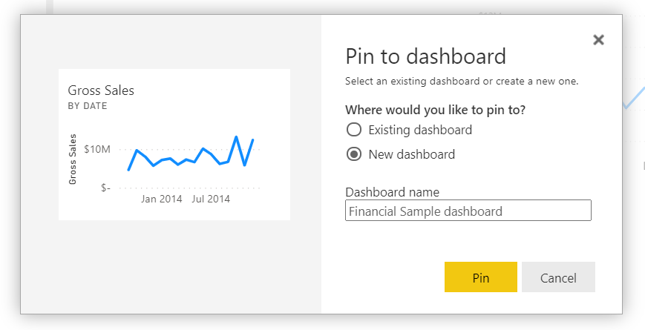

A success message (near the top-right corner) lets you know the visualization was added as a tile to your dashboard.

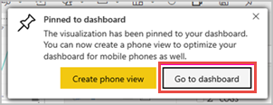

Now that you've pinned this visualization, it's stored on your dashboard. The data stays up-to-date so you can track the latest value at a glance. However, if you change the visualization type in the report, the visualization on the dashboard doesn't change.

1. Select **Go to dashboard** to see your new dashboard with the line chart that you pinned to it as a tile.

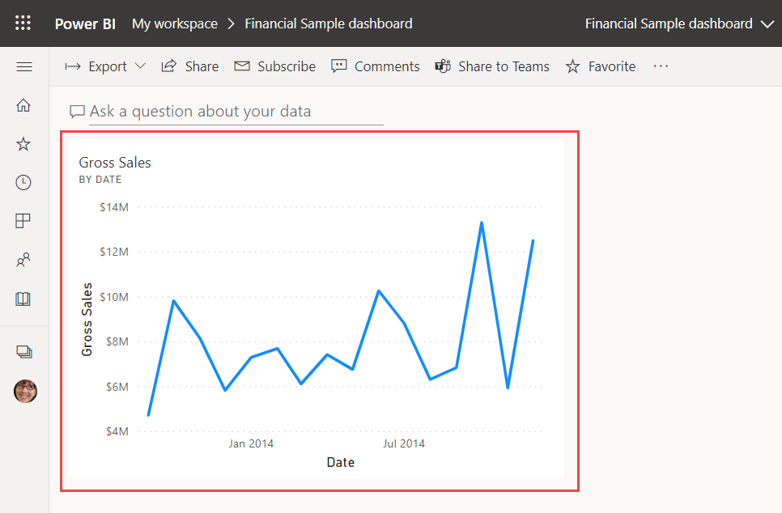

1. Select the new tile on your dashboard. Power BI returns you to the report in Reading view.
2. To switch back to Editing view, select **More options** (...) in the menu bar > **Edit**.

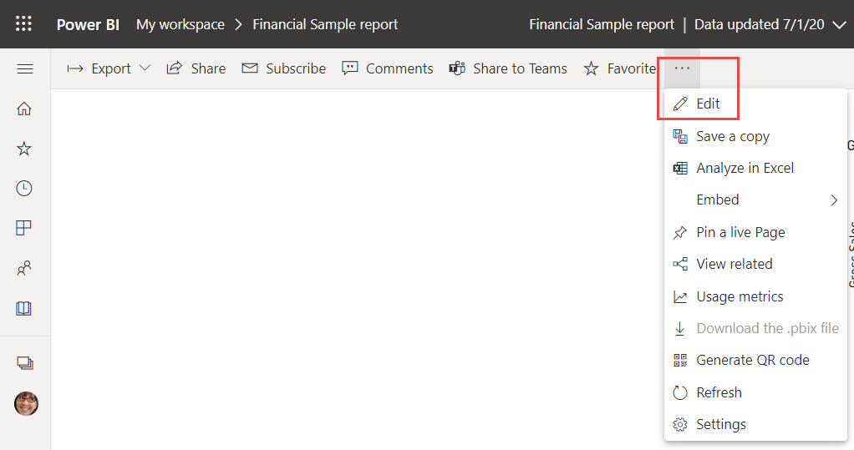

Back in Editing view, you can continue to explore and pin tiles.

## Step 3: Explore with Q&A

For a quick exploration of your data, try asking a question in the Q&A question box. Q&A lets you ask natural-language queries about your data. In a dashboard, the Q&A box is at the top (**Ask a question about your data**) under the menu bar. In a report, it's in the top menu bar (**Ask a question**).

1. To go back to the dashboard, select **My workspace** in the black **Power BI** header bar.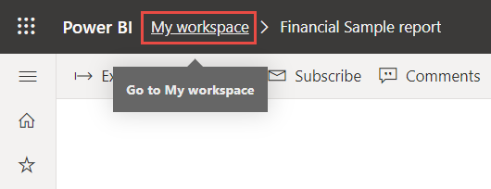
2. In **My workspace**, select your dashboard.

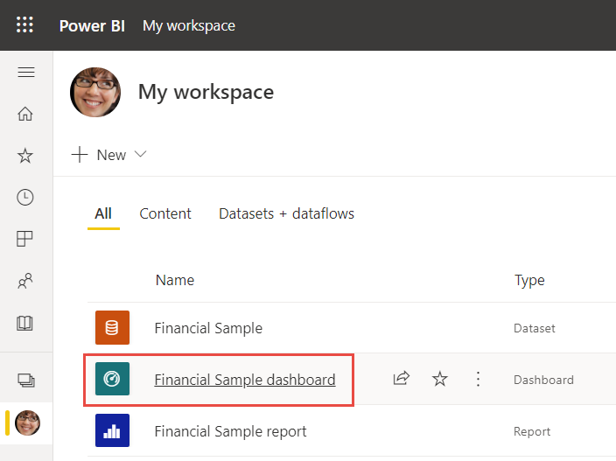

1. Select **Ask a question about your data**. Q&A automatically offers a number of suggestions.

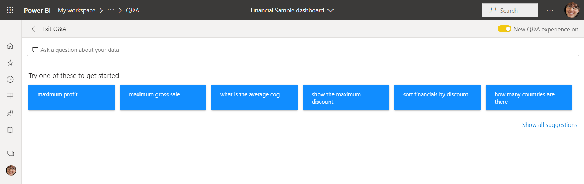

**Note**

If you don't see the suggestions, turn on **New Q&A experience**.

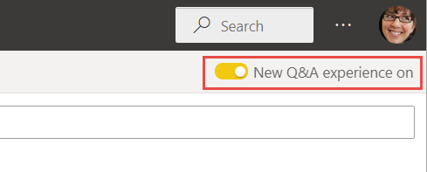

1. Some suggestions return a single value. For example, select **what is the average cog**.
2. Q&A searches for an answer and presents it in the form of a *card* visualization.
3. Select **Pin visual** and pin this visualization to the Financial Sample dashboard.

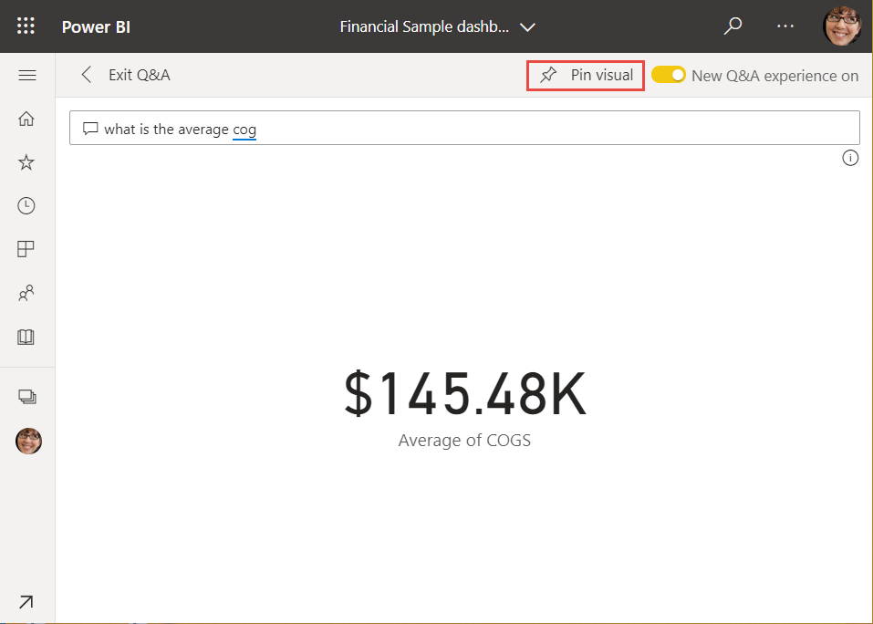

1. Go back to Q&A and select **Show all suggestions**.
2. Select **total profit by country**.

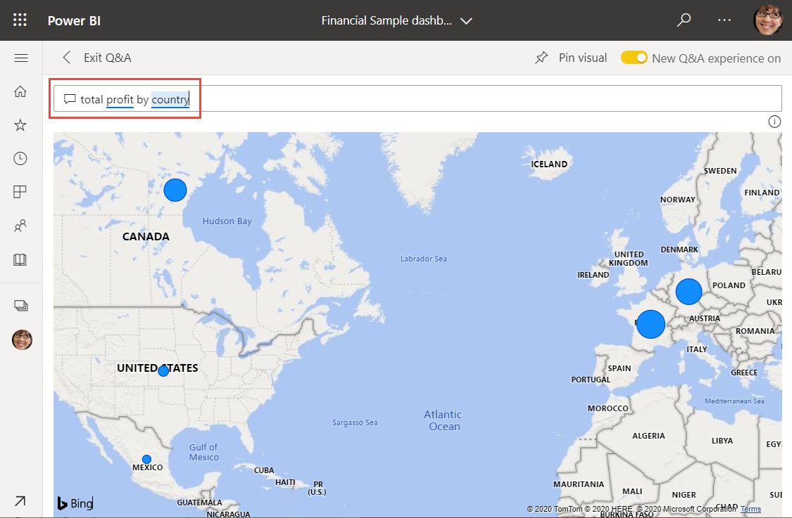

1. Pin the map to the Financial Sample dashboard, too.
2. On the dashboard, select the map you just pinned. See how it opens Q&A again?
3. Place the cursor after *by country* in the Q&A box and type *as bar*. Power BI creates a bar chart with the results.

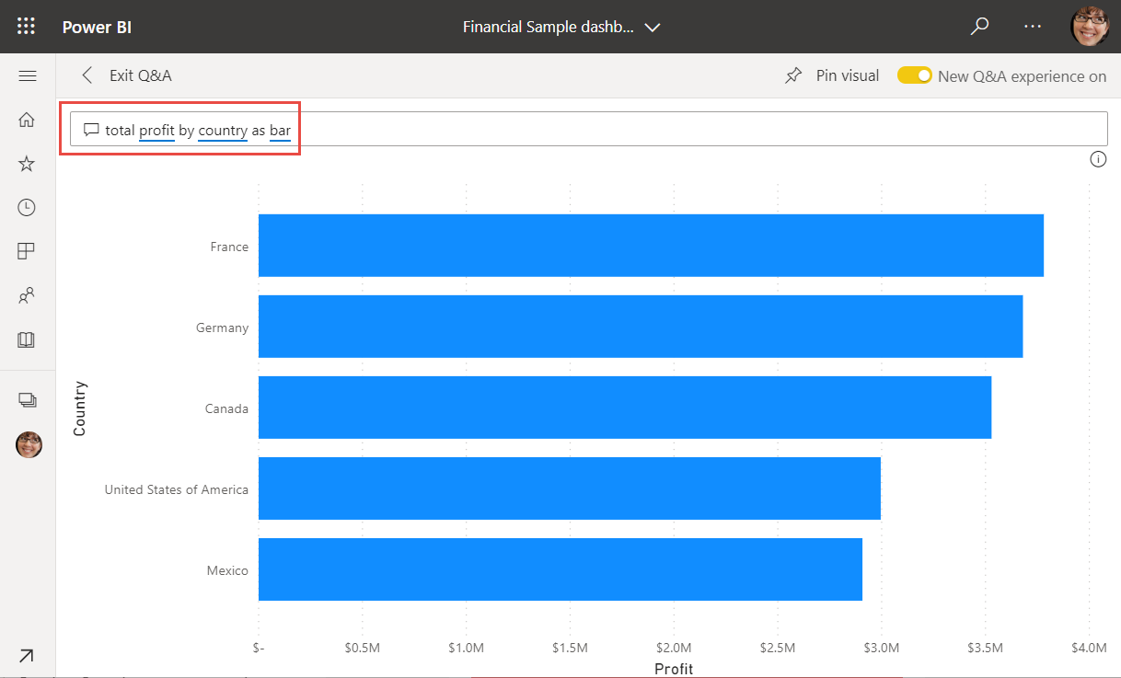

1. Pin the bar chart to your Financial Sample dashboard, too.
2. Select **Exit Q&A** to return to your dashboard, where you see the new tiles you created.

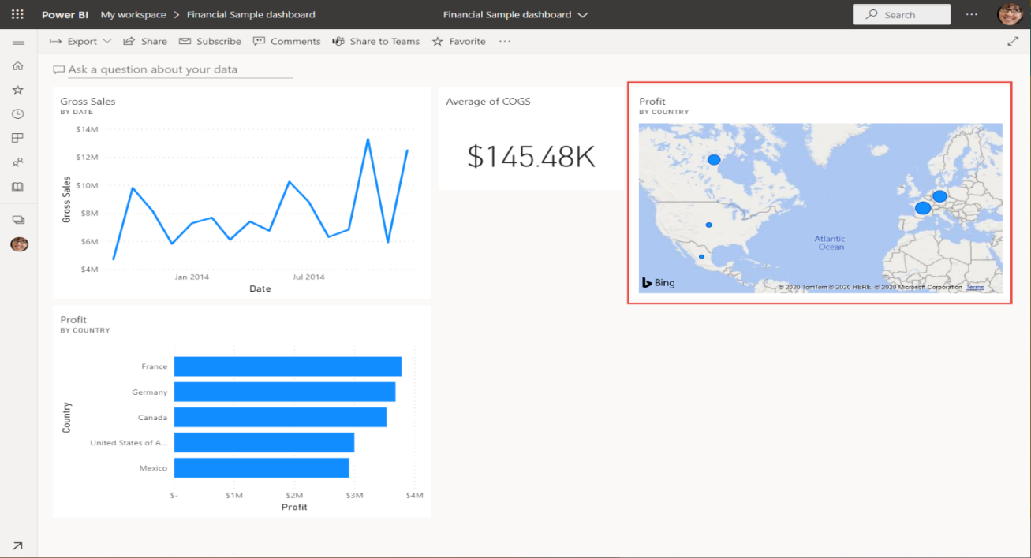

You see that even though you changed the map to a bar chart in Q&A, that tile remained a map because it was a map when you pinned it.

## Step 4: Reposition tiles

We can rearrange the tiles to make better use of the dashboard space.

1. Drag the lower-right corner of the *Gross Sales* line chart tile upward, until it snaps at the same height as the Sales tile, then release it.

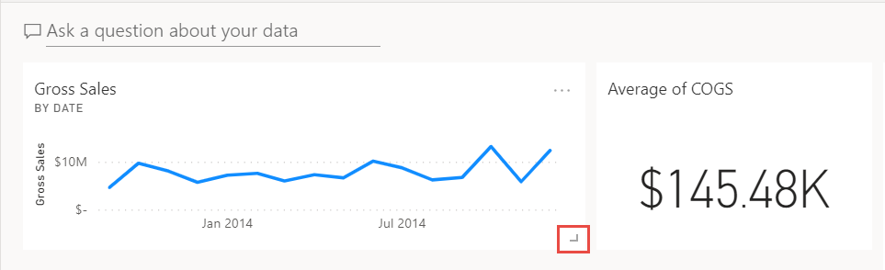

Now the two tiles are the same height.

1. Select **More options (...)** for the Average of COGS tile > **Edit details**.

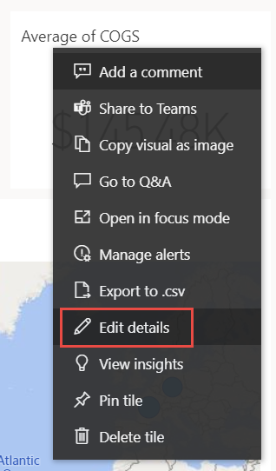

1. In the **Title** box, type *Average Cost of Goods Sold* > **Apply**.

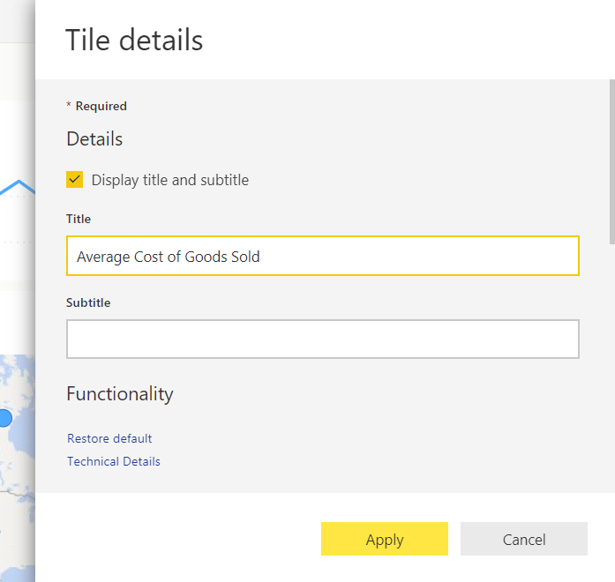

1. Rearrange the other visuals to fit together.



## Clean up resources

Now that you've finished the tutorial, you can delete the dataset, report, and dashboard.

1. Select **My workspace** in the black **Power BI** header bar.
2. Select **More options (...)** next to the Financial Sample dataset > **Delete**.

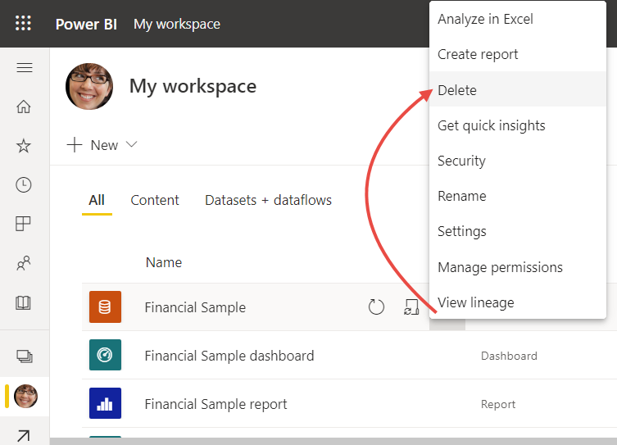

You see a warning that **All reports and dashboard tiles containing data from this dataset will also be deleted**.

1. Select **Delete**.

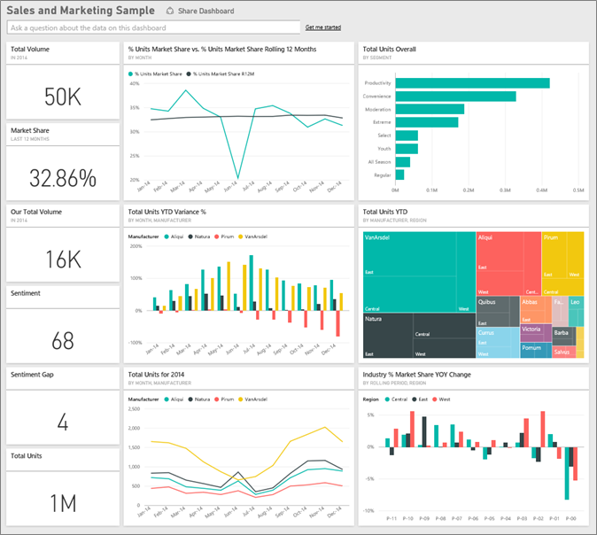

This sample is part of a series that shows how you can use Power BI with business-oriented data, reports, and dashboards. It was created by obviEnce with real data, which has been anonymized. The data is available in several formats: in-product sample, .pbix Power BI Desktop file, or Excel workbook.

This tutorial explores the Sales and Marketing sample in the Power BI service. Because the report experience is similar in Power BI Desktop and in the service, you can also follow along by using the sample .pbix file in Power BI Desktop.

You don't need a Power BI license to explore the samples in Power BI Desktop. If you don't have a Power BI Pro or Premium Per User (PPU) license, you can save the sample to your My Workspace in the Power BI service.

Before you can use the sample, you must first download the dashboard, report, and dataset, .pbix file, or Excel workbook.

# 2.3 Power Bi Services

### Get the sample from the Power BI service

1. Open the Power BI service (app.powerbi.com), sign in, and open the workspace where you want to save the sample.

If you do not have a Power BI Pro or Premium Per User (PPU) license, you can save the sample to your My Workspace.

1. In the bottom-left corner, select **Get Data**.

Select Get Data

1. On the **Get Data** page that appears, select **Samples**.
2. Select **Sales and Marketing Sample**, then choose **Connect**.

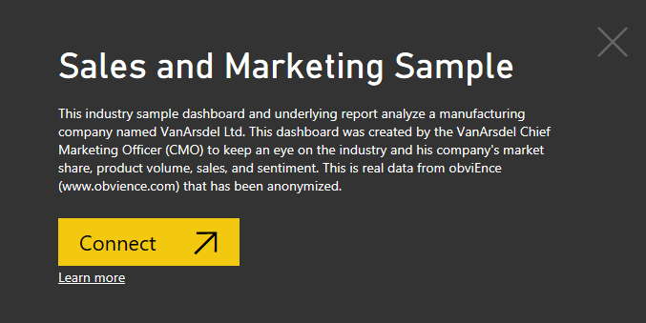

1. Power BI imports the sample and then adds a new dashboard, report, and dataset to your current workspace.



### Get the .pbix file for this sample

Alternatively, you can download the Sales and Marketing sample as a .pbix file, which is designed for use with Power BI Desktop.

### Get the Excel workbook for this sample

If you want to view the data source for this sample, it's also available as an Excel workbook. The workbook contains Power View sheets that you can view and modify. To see the raw data, enable the Data Analysis add-ins, and then select **Power Pivot > Manage**. To enable the Power View and Power Pivot add-ins, see Explore the Excel samples in Excel for details.

## What is our dashboard telling us?

Let's start our tour at the dashboard and look at the tiles the CMO has chosen to pin. We see information about our market share, sales, and sentiment. Data is broken down by region, time, and competition.

* The number tiles along the left column show industry sales volume for the past year (50,000), market share (32.86%), sales volume (16,000), sentiment score (68), sentiment gap (4), and total units sold (1 million).
* The top line chart (**% Units Market Share vs. % Units Market Share Rolling 12 Months**) shows how our market share fluctuates over time. Notice the large drop in June. Our rolling 12-month (R12M) share, which was increasing for a while, is now starting to stall.
* Our biggest competitor is Aliqui, as evident in the middle column chart tile (**Total Units YTD Variance %**).
* Most of our business is in the East and Central regions.
* The line chart at the bottom (**Total Units for 2014**) shows that our dip in June isn't seasonal; none of our competitors show the same trend.
* The **Total Units Overall** and **Total Units YTD** tiles on the right show units sold, by segment and by region/manufacturer. The largest market segments for our industry are **Productivity** and **Convenience**.

### Which segments drive our sales? Do they match the industry trend?

1. Select the **Total Units Overall by Segment** tile, which opens Q&A and populates it with the query, *total units by segment*.
2. At the end of the existing query, add: *for VanArsdel*. Q&A interprets the question and displays an updated chart with the answer. Notice that our product volume is mostly from the **Convenience** and **Moderation** segments.

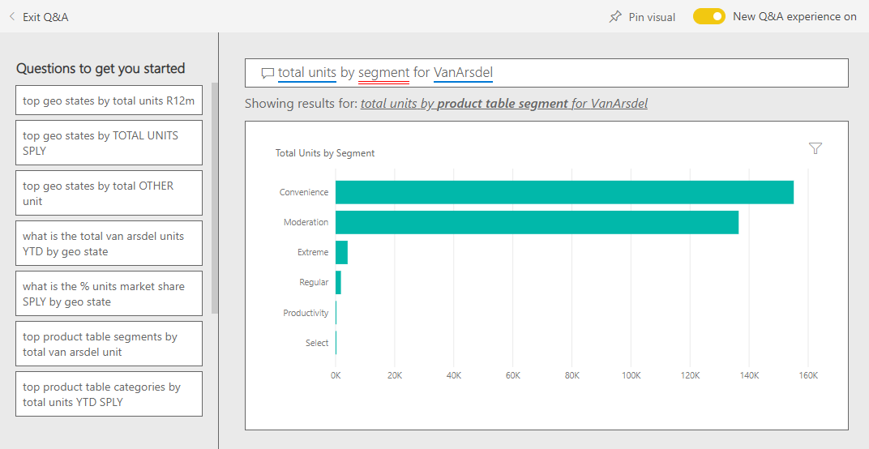

1. Our share in the **Moderation** and **Convenience** categories is high; these segments are the ones where we compete.
2. Return to the dashboard by selecting the **Sales and Marketing Sample** in the top nav pane.

### What does total unit market share look like for category (versus region)?

1. Notice the **Total Units YTD by Manufacturer, Region** tile. What is the total unit market share by category?

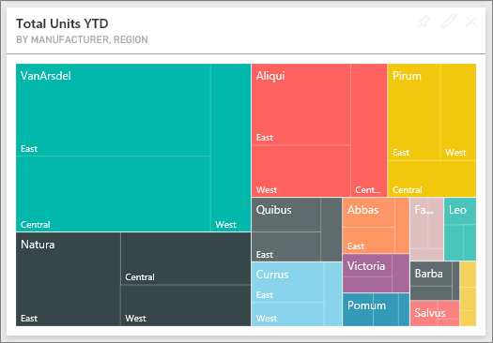

1. Select the question box at the top of the dashboard and type the question, *total units by manufacturer and category for 2014 as a treemap*. Notice how the visualization updates as you type the question.

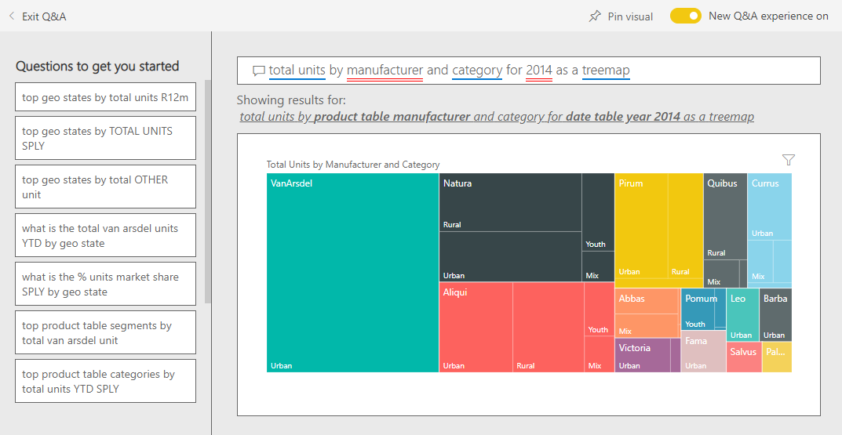

1. To compare the findings, pin the chart to your dashboard. Notice this interesting fact: In 2014, VanArsdel sold only products in the **Urban** category.
2. Return to the dashboard.

## Sales and Marketing Sample report

Dashboards are an entry point into reports. If a tile was created from an underlying report, selecting that tile opens the report.

On our dashboard, the **% Units Market Share R12M** line in the **% Units Market Share vs. % Units Market Share Rolling 12 Months** chart shows that our market share is no longer increasing over time. It's even declining a bit. And why do we have a large market share dip in June?

The report for the Sales and Marketing sample has four pages.

### VanArsdel - Market Share page

Page one of the report focuses on VanArsdel's market share.

1. On the dashboard, select the **% Units Market Share vs. % Units Market Share Rolling 12 Months** chart to open the **VanArsdel - Market Share** page of the Sales and Marketing Sample report.

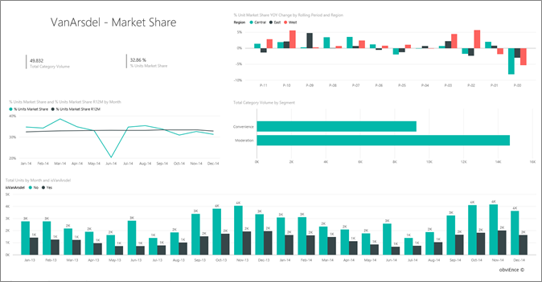

1. Look at the **Total Units by Month and isVanArsdel** column chart at the bottom of the report. The black column represents VanArsdel (our products) and the green column is our competition. The drop in June 2014 that VanArsdel experienced was not experienced by the competition.
2. The **Total Category Volume by Segment** bar chart on the right is filtered to show VanArsdel's top two segments. Take a look at how this filter was created:

a. Select the **Total Category Volume by Segment** chart.

b. Select the **Filters** pane on the right to expand it.

c. Under **Visual level filters**, notice that **Segment** is filtered to include only the **Convenience** and **Moderation** segments.

d. Modify the filter by selecting **Segment** to expand it, and then check **Productivity** to add that segment.

1. In the **Total Units by Month and isVanArsdel** chart, select **Yes** in the legend to cross-filter the page by VanArsdel. In the **Total Category Volume by Segment** chart, notice that we don't compete in the **Productivity** segment.
2. Select the **Yes** again in the legend to remove the filter.
3. Look at the **% Units Market Share and % Units Market Share R12M by Month** line chart. It shows our monthly market share and rolling 12-month market shares. Rolling-months data helps to smooth out monthly fluctuations and shows the long-term trends. In the **Total Category Volume by Segment** bar chart, select **Convenience**, and then **Moderation** to see the fluctuation in market share for each segment. Notice that the **Moderation** segment shows much more fluctuation in market share.

We're still looking to find out why our market share dipped so low in June. Next, let's check the **Sentiment Analysis** page of the report.

### Sentiment Analysis page

Page three of the report focuses on consumer sentiment.

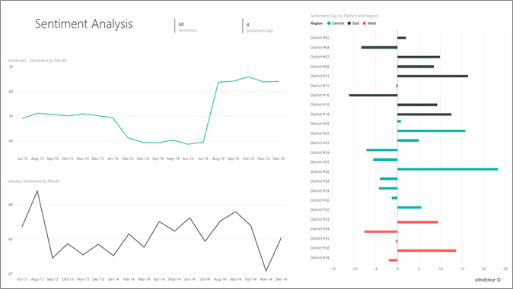

Tweets, Facebook, blogs, and articles all contribute to consumer sentiment, which is shown in the two line charts on left side of the page. The **VanArsdel - Sentiment by Month** chart in the top-left corner shows that sentiment for our products was mostly neutral up until February. Then, a large drop started in February and bottomed out in June. What happened to cause this drop in sentiment?

Let's look at external sources. In February, several articles and blog posts rated VanArsdel's customer service as the worst in the industry. This bad press had a direct correlation to customer sentiment and sales. VanArsdel worked hard to improve customer service, and customers and the industry took note. In July, positive sentiment started to rise and then reached an all-time high in the 60s. This uptick in sentiment is reflected in the **Total Units by Month** charts on pages one and two of the report. Perhaps this partially explains our market share dips for June?

Sentiment gap might be another area to explore. Which districts have the highest sentiment gap, how can management capitalize on it, and how can they replicate it in other districts?

### YTD Category Trend Analysis page

Page two of the report focuses on the year-to-date category trend.

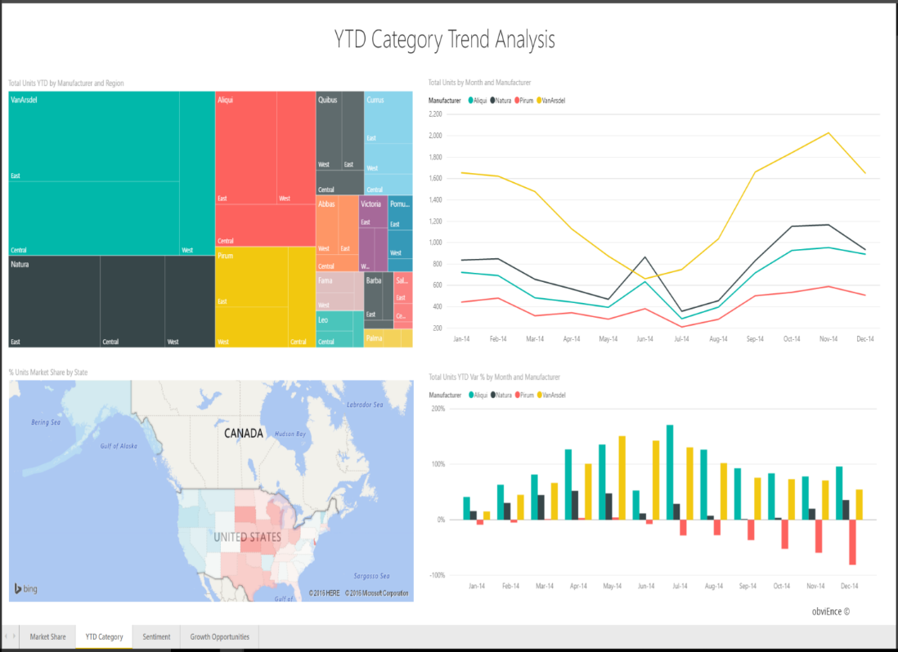

Notice the following details:

* VanArsdel is the largest company in this category and its biggest competitors are Natura, Aliqui, and Pirium. We'll keep our eyes on them.
* Aliqui is growing, but product volume compared to us is still low.
* The treemap shows VanArsdel in green. In the East region, customers prefer our competition, but in the Central region we're doing okay. Our share in the East region is our lowest.
* Geography has an impact on units sold. The East region is the dominant region for most manufacturers and VanArsdel has a strong presence in the Central region as well.
* On the **Total Units YTD Var % by Month and Manufacturer** chart in the bottom right, notice that we have positive variance, which is a good sign. We're doing better than last year, but so is our competitor, Aliqui.

### Growth Opportunities page

Page four of the report focuses on competitive product analysis.

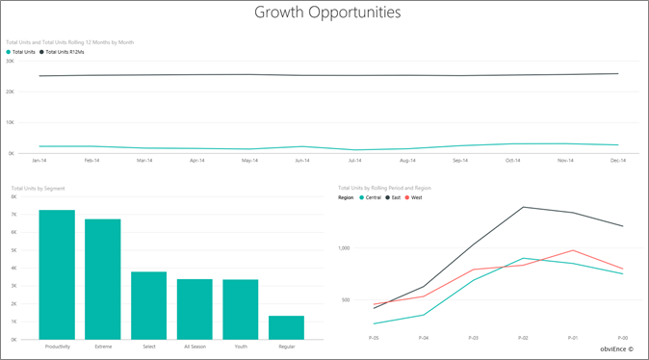

Notice the following details:

* The **Total Units by Segment** chart in the bottom-left shows all the category segments, except for VanArsdel's two strongest segments. Select each of the segments in turn to identify potential expansion areas for VanArsdel.

# Chapter 3

# Conclusion and future scope

# 3.1 Conclusion

Notice that the **Extreme** and **Productivity** segments are growing faster than others. However, we don't compete in those segments; if we want to move into these segments, we can use our data to see which segments are popular in which regions. We can further investigate such questions as which regions are growing faster and who would be our biggest competitor in that segment.

Remember our market share dip in June? June is a significant month for the **Productivity** segment, a segment we don't compete in at all. This detail could help explain our market share dip in June.

* Development and design of Commercial Group for mobile views- Met coke commodity
* Data validation and business analysis for Commercial Group- Met coke
* Daily and weekly review of team tasks, internal scrum updates and communication of relevant updates with Celebal Technologies.

**3.2 Reference**

[Microsoft Power Apps Documentation https://docs.microsoft.com/en-in/powerapps/](https://docs.microsoft.com/en-in/powerapps/)

1. [Microsoft Power Automate Documentation https://docs.microsoft.com/en-in/power-automate/](https://docs.microsoft.com/en-in/power-automate/)
2. [Microsoft Power BI Documentation https://docs.microsoft.com/en-in/power-bi/](https://docs.microsoft.com/en-in/power-bi/)
3. [Microsoft SQL Server Documentation https://docs.microsoft.com/en-in/sql/?view=sql-server-ver15](https://docs.microsoft.com/en-in/sql/?view=sql-server-ver15)
4. [Azure Cloud Adoption Framework https://docs.microsoft.com/en-in/azure/cloud-adoption-framework/](https://docs.microsoft.com/en-in/azure/cloud-adoption-framework/)
5. [Microsoft SharePoint Documentation https://docs.microsoft.com/en-in/sharepoint/](https://docs.microsoft.com/en-in/sharepoint/)
6. <https://www.stitchdata.com/resources/7-reasons-power-bi/>
7. <https://docs.microsoft.com/en-us/power-bi/fundamentals/power-bi-overview>
8. <https://intellipaat.com/blog/tutorial/power-bi-tutorial/>
9. <https://www.kamind.com/microsoft-power-bi/>