

Configuration Manual

MSc Research Project

Programme Name

Tej Rup Sai Munagala

Student ID: x19196628

School of Computing

National College of Ireland

Supervisor: Cristina Muntean

Student Name: | Tej Rup Sai Munagala
Student ID: | X19196628
Programme: | MSc Data Analytics | Year: | 2020-2021
Module: | Research Project
Lecturer: | Cristina Muntean
Submission | 17/12/2020
Due Date:

Project Title: Deepfake video detection using convolutional neural network

Word Count: Page Count:

I hereby certify that the information contained in this (my submission) is information pertaining to research I conducted for this project. All information other than my own contribution will be fully referenced and listed in the relevant bibliography section at the rear of the project.

ALL internet material must be referenced in the references section. Students are encouraged to use the Harvard Referencing Standard supplied by the Library. To use other author's written or electronic work is illegal (plagiarism) and may result in disciplinary action. Students may be required to undergo a viva (oral examination) if there is suspicion about the validity of their submitted work.

Signature: Tej Rup Sai Munagala

Date: 17.12.2020

PLEASE READ THE FOLLOWING INSTRUCTIONS:

- Please attach a completed copy of this sheet to each project (including multiple copies).

- Projects should be submitted to your Programme Coordinator.

- You must ensure that you retain a HARD COPY of ALL projects, both for your own reference and in case a project is lost or mislaid. It is not sufficient to keep a copy on computer. Please do not bind projects or place in covers unless specifically requested.

- You must ensure that all projects are submitted to your Programme Coordinator on or before the required submission date. Late submissions will incur penalties.

- All projects must be submitted and passed in order to successfully complete the year. Any project/assignment not submitted will be marked as a fail.

Office Use Only

Signature:

Date:

Penalty Applied (if applicable):


Configuration Manual

Tej Rup Sai Munagala
Student ID: x19196628

Pre Requisites

The prerequisites that are required for implementation of this research are as follows:

Hardware:
The intel core i7 processer with 1.8GHz dual-core, Turbo boost of 2.6Ghz with 4MB, 500GB SSD, 16 GB of 2400MHz on board memory, Windows OS.

Software:
To run the program Anaconda navigator with jupyter notebook are required and latest version of python is needed to be installed.

Libraries

Few libraries packages are needed to be installed in the anaconda navigator before running the code file. Tensorflow packages, matplotlib, tqdm, and torch are the packages that needed to be installed in the anaconda environment.

Import Libraries

For executing code, the libraries from figure 1 needed to be installed in the jupyter notebook.
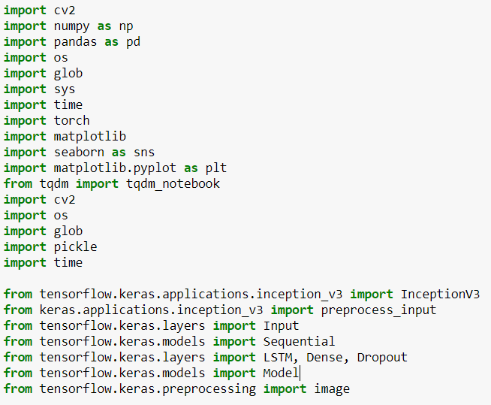
Figure 1 libraries

Dataset:
The dataset can be downloaded from two different sources. One is from the official website of Facebook AI and the other one is from Kaggle. Facebook has reposited the whole deepfake dataset in the Kaggle website for research purpose.
Figure 2 illustrates the direct dataset download from the Kaggle website and the Kaggle repository is deepfake detection challenge.
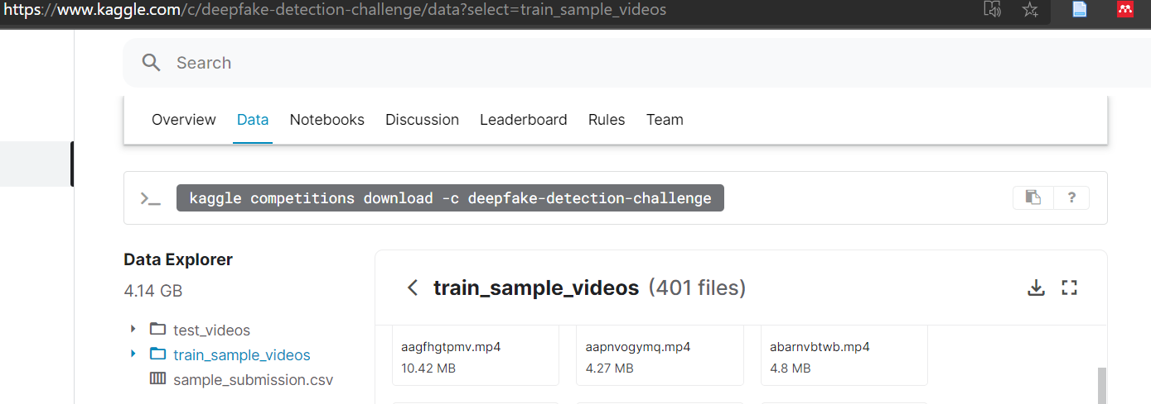
Figure 2 Data set
Figure 3 shows the procedural process to download the dataset from Facebook AI
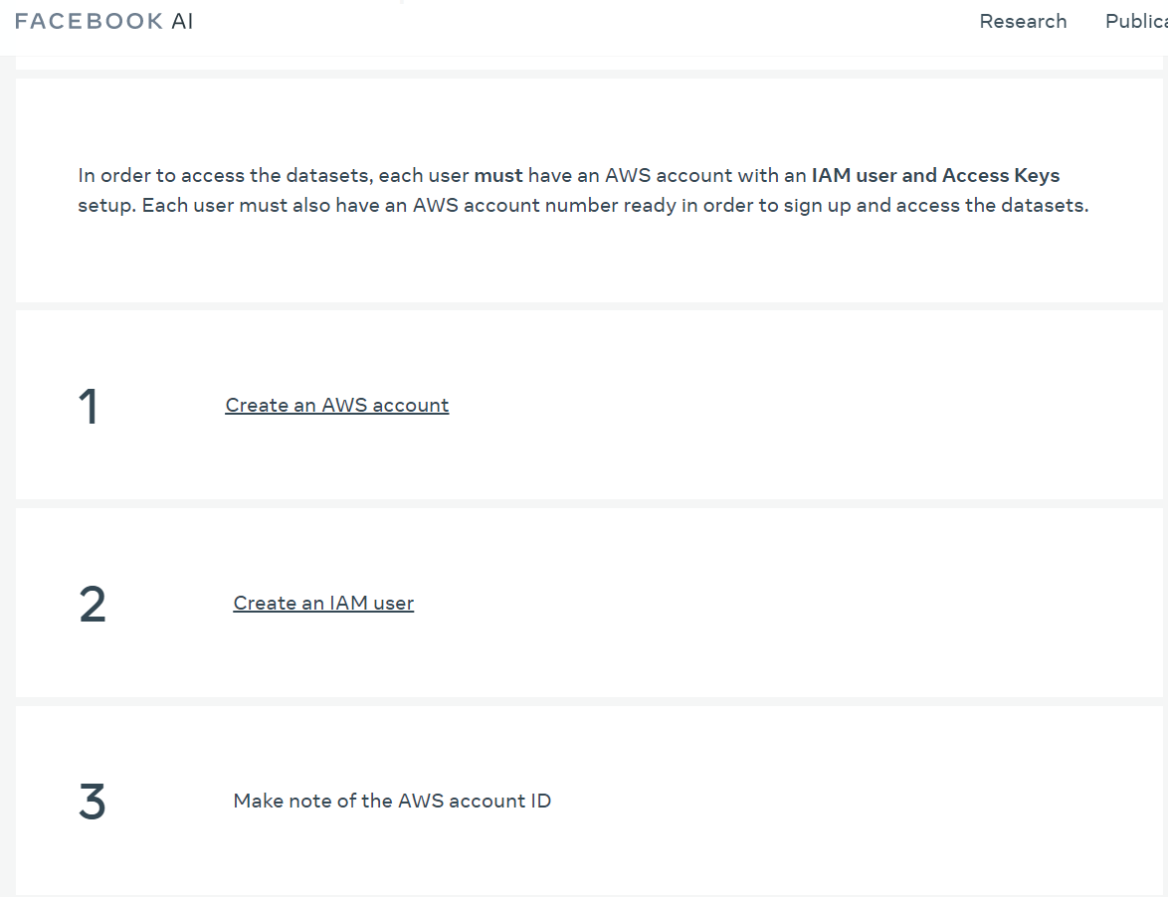
Figure 3 Facebook AI

The dataset from the Facebook AI is about 500GB which consist 124K videos in total. However, Facebook has provided a sample version of the dataset in the Kaggle for research purpose.

Kaggle dfdc dataset: Deepfake Detection Challenge | Kaggle
Facebook Ai: https://ai.facebook.com/datasets/dfdc/

