Hadoop Admin Assignment — Part 1
My lab notes: Docker + Kind + HDFS / YARN / ZK / Kafka / HBase / Solr

Part 1 — Environment Setup (Docker + Kubernetes)
What I did in this part: I set up a small Hadoop ecosystem on Kubernetes using Kind on my lab VM, then brought up HDFS, YARN, ZooKeeper, Kafka, HBase and Solr so they can talk to each other inside the cluster.
My setup
- VM: 10.1.0.213 (hostname alphtatalakehouse6)
- Kind cluster name: hadoop-lab
- Namespace: hadoop
- Working folder: /opt/hadoop-lab
I kept all configs and YAML under /opt/hadoop-lab so I can find everything later.

How the pieces fit (my understanding)
On the VM I installed Docker. Then I used Kind to create a Kubernetes cluster (1 control-plane + 2 workers). Each Kind “node” is just a Docker container.
Inside that cluster I run my services as Pods. The important thing I learned: don’t hardcode Pod IPs. Pod IPs change when pods restart. I used Kubernetes Service names instead, like namenode, resourcemanager, zk-0.zk-hs.hadoop.svc.cluster.local.
Rough picture:
VM
-> Docker
-> Kind nodes
-> Pods (HDFS, YARN, ZK, Kafka, HBase, Solr)

Step 1 — Install Docker
I needed Docker first because Kind and all my service images run as containers.
dnf install -y dnf-plugins-core
dnf config-manager --add-repo https://download.docker.com/linux/rhel/docker-ce.repo
dnf install -y docker-ce docker-ce-cli containerd.io docker-buildx-plugin docker-compose-plugin
systemctl enable --now docker
docker --version
To confirm Docker was actually working I ran:
docker run --rm hello-world
I got the “Hello from Docker!” message, so Docker was fine.

Step 2 — Install kubectl
kubectl is what I use to create pods, check status, apply YAML, etc.
cd /tmp
curl -LO "https://dl.k8s.io/release/$(curl -L -s https://dl.k8s.io/release/stable.txt)/bin/linux/amd64/kubectl"
install -o root -g root -m 0755 kubectl /usr/local/bin/kubectl
kubectl version --client

Step 3 — Install Kind and create the cluster
Kind = Kubernetes in Docker. I used this instead of Minikube.
cd /tmp
curl -Lo kind https://kind.sigs.k8s.io/dl/v0.30.0/kind-linux-amd64
chmod +x kind
install -o root -g root -m 0755 kind /usr/local/bin/kind
Cluster config I used (1 control-plane, 2 workers):
cat > /root/kind-cluster.yaml <<'EOF'
kind: Cluster
apiVersion: kind.x-k8s.io/v1alpha4
nodes:
- role: control-plane
- role: worker
- role: worker
EOF
kind create cluster --name hadoop-lab --config /root/kind-cluster.yaml
kubectl get nodes
kubectl cluster-info
All 3 nodes came up as Ready.
Then I created the namespace and my project folders:
kubectl create namespace hadoop
kubectl get namespaces
mkdir -p /opt/hadoop-lab/{hdfs,yarn,spark,kafka,hbase,solr,zookeeper,scripts,docs}
mkdir -p /opt/hadoop-lab/hdfs/{conf,manifests,data}
Note: my VM has about 8 vCPU / 32 GiB RAM. The Kind nodes share that. So I kept resource requests small.

Step 4 — Pull the Docker images I used
I pulled the images on the host first:
docker pull apache/hadoop:3.3.6
docker pull zookeeper:3.9
docker pull apache/kafka:3.9.1
docker pull openeuler/hbase:2.6.5-oe2403sp3
docker pull solr:9.8
Service | Image I used
HDFS / YARN | apache/hadoop:3.3.6
ZooKeeper | zookeeper:3.9
Kafka | apache/kafka:3.9.1
HBase | openeuler/hbase:2.6.5-oe2403sp3
Solr | solr:9.8
I also kept a simple Dockerfile in each service folder (basically FROM <image>) under /opt/hadoop-lab/*/Dockerfile.
When pods started, Kind pulled the images as needed (imagePullPolicy: IfNotPresent).

Step 5 — HDFS (1 NameNode + 2 DataNodes)

Configs I wrote
Location: /opt/hadoop-lab/hdfs/conf/
In core-site.xml I set:
- fs.defaultFS = hdfs://namenode:9000
I used the Service name namenode, not a Pod IP.
In hdfs-site.xml I mainly set:
- dfs.replication = 2 (I only have 2 DataNodes in Part 1; for Part 2 when they ask RF=3 I will add one more DataNode first)
- name/data dirs
- dfs.namenode.rpc-bind-host = 0.0.0.0 so it listens properly inside the container
- dfs.namenode.datanode.registration.ip-hostname-check = false (this avoided hostname mismatch issues in K8s)

Commands I ran to deploy
kubectl -n hadoop create configmap hdfs-config \
--from-file=/opt/hadoop-lab/hdfs/conf/core-site.xml \
--from-file=/opt/hadoop-lab/hdfs/conf/hdfs-site.xml \
--dry-run=client -o yaml | kubectl apply -f -
kubectl apply -f /opt/hadoop-lab/hdfs/manifests/
kubectl get pods -n hadoop -o wide

How I verified
kubectl exec -n hadoop namenode-0 -- hdfs dfsadmin -report
kubectl exec -n hadoop namenode-0 -- hdfs dfs -ls /
Result: NameNode Running, Live datanodes (2).
Screenshot: see Appendix → HDFS.

Step 6 — YARN (1 ResourceManager + 2 NodeManagers)
This part gave me some trouble at first.

Problem I hit
If I only put ports in yarn-site.xml and don’t think about how NodeManagers advertise themselves, NMs don’t register properly after restart. Hardcoding a Pod IP is also bad because the IP changes.

What I did instead
- ResourceManager address uses the Service name: resourcemanager:8032
- RM binds on 0.0.0.0
- For NodeManager hostname I used the Pod IP at runtime
In config I kept a placeholder:
<property>
<name>yarn.nodemanager.hostname</name>
<value>${env.POD_IP}</value>
</property>
In the NM pod start command I take status.podIP from Kubernetes, replace ${env.POD_IP}, then start yarn nodemanager.
Configs are under /opt/hadoop-lab/yarn/conf/ (yarn-site.xml, mapred-site.xml, capacity-scheduler.xml).
I also prepared capacity scheduler queues already (production 60%/max 80%, development 40%/max 100%) because Part 3 will need that.

Commands I ran
kubectl apply -f /opt/hadoop-lab/yarn/manifests/
kubectl get pods -n hadoop | grep -E 'resourcemanager|nodemanager|jobhistory'
kubectl exec -n hadoop deploy/resourcemanager -- yarn node -list
Result: Total Nodes: 2, both RUNNING.
Screenshot: see Appendix → YARN.

Step 7 — ZooKeeper (3 nodes)
Kafka, HBase and Solr all need ZooKeeper, so I brought this up before those services.
kubectl apply -f /opt/hadoop-lab/zookeeper/manifests/
kubectl rollout status statefulset/zk -n hadoop --timeout=300s
kubectl get pods -n hadoop -l app=zk
I wait until all 3 are Ready (zk-0, zk-1, zk-2).
Health check I used:
kubectl exec -n hadoop zk-0 -- bash -lc 'echo ruok | nc 127.0.0.1 2181'
Expected output: imok
DNS names I used later:
- zk-0.zk-hs.hadoop.svc.cluster.local:2181
- zk-1.zk-hs.hadoop.svc.cluster.local:2181
- zk-2.zk-hs.hadoop.svc.cluster.local:2181
Screenshot: see Appendix → ZooKeeper.

Step 8 — Kafka (3 brokers with ZooKeeper)
I deployed Kafka as a StatefulSet with 3 replicas.
Important points in my config:
- broker.id comes from the pod number (kafka-0 → 0, etc.)
- advertised.listeners uses stable DNS like kafka-0.kafka-hs.hadoop.svc.cluster.local:9092
- zookeeper.connect points to the 3 ZK pods
Commands:
kubectl apply -f /opt/hadoop-lab/kafka/manifests/
kubectl get pods -n hadoop -l app=kafka
kubectl logs -n hadoop kafka-0 --tail=50
In the logs I checked for Kafka started successfully (ZK mode). Then I also checked brokers like this:
kubectl exec -n hadoop kafka-0 -- \
/opt/kafka/bin/kafka-broker-api-versions.sh \
--bootstrap-server kafka-0.kafka-hs.hadoop.svc.cluster.local:9092
All 3 brokers (kafka-0, kafka-1, kafka-2) are Running.
Screenshot: see Appendix → Kafka.

Step 9 — HBase (1 Master + 2 RegionServers on HDFS)
HBase needs HDFS for storage and ZooKeeper for coordination.
In hbase-site.xml I set:
- hbase.rootdir = hdfs://namenode:9000/hbase
- ZK quorum = the 3 ZK DNS names
- hbase.master.hostname = hbase-master (Service name)
One issue I faced: at first the master registered with the pod hostname (hbase-master-xxxxx), and RegionServers couldn’t resolve that name. After I forced hbase.master.hostname=hbase-master, the RegionServers connected fine.
Also for each RegionServer I set hostname to:
hbase-rs-0.hbase-rs.hadoop.svc.cluster.local (and same pattern for rs-1).
Commands:
kubectl -n hadoop create configmap hbase-config \
--from-file=/opt/hadoop-lab/hbase/conf/hbase-site.xml \
--from-file=/opt/hadoop-lab/hdfs/conf/core-site.xml \
--from-file=/opt/hadoop-lab/hdfs/conf/hdfs-site.xml \
--dry-run=client -o yaml | kubectl apply -f -
kubectl -n hadoop create configmap hbase-scripts \
--from-file=/opt/hadoop-lab/hbase/scripts/start-master.sh \
--from-file=/opt/hadoop-lab/hbase/scripts/start-rs.sh \
--dry-run=client -o yaml | kubectl apply -f -
kubectl apply -f /opt/hadoop-lab/hbase/manifests/
kubectl get pods -n hadoop | grep hbase
Verify:
kubectl exec -n hadoop deploy/hbase-master -- bash -lc 'echo -e "status\nexit" | hbase shell -n'
Result I got:
1 active master, 0 backup masters, 2 servers, 0 dead, 1.0000 average load
Screenshot: see Appendix → HBase.

Step 10 — Solr (2-node SolrCloud with ZooKeeper)
For SolrCloud I pointed both nodes to the same ZK ensemble.
One issue: Kubernetes was injecting env vars like SOLR_PORT=tcp://... because I had a Service named solr. That broke the Solr start script. I fixed it by setting enableServiceLinks: false on the Solr pods and starting with --force (needed when running as root).
Commands I ran:
kubectl -n hadoop create configmap solr-scripts \
--from-file=/opt/hadoop-lab/solr/scripts/start-solr.sh \
--dry-run=client -o yaml | kubectl apply -f -
kubectl apply -f /opt/hadoop-lab/solr/manifests/
kubectl get pods -n hadoop -l app=solr
kubectl get pods -n hadoop -l app=solr -o wide
Both solr-0 and solr-1 came to Ready 1/1.
(Creating collection / schema / queries is for Part 7. Here I only needed SolrCloud up.)
Screenshot: see Appendix → Solr.

Step 11 — Bring the whole stack up (commands I use)
I don’t rely on a wrapper script for submission. These are the exact commands, in order.
First make sure the namespace exists:
kubectl get ns hadoop || kubectl create namespace hadoop
Refresh configmaps if I changed XML/scripts:
kubectl -n hadoop create configmap hdfs-config \
--from-file=/opt/hadoop-lab/hdfs/conf/core-site.xml \
--from-file=/opt/hadoop-lab/hdfs/conf/hdfs-site.xml \
--dry-run=client -o yaml | kubectl apply -f -
kubectl -n hadoop create configmap yarn-config \
--from-file=/opt/hadoop-lab/yarn/conf/ \
--dry-run=client -o yaml | kubectl apply -f -
kubectl -n hadoop create configmap hbase-config \
--from-file=/opt/hadoop-lab/hbase/conf/hbase-site.xml \
--from-file=/opt/hadoop-lab/hdfs/conf/core-site.xml \
--from-file=/opt/hadoop-lab/hdfs/conf/hdfs-site.xml \
--dry-run=client -o yaml | kubectl apply -f -
kubectl -n hadoop create configmap hbase-scripts \
--from-file=/opt/hadoop-lab/hbase/scripts/start-master.sh \
--from-file=/opt/hadoop-lab/hbase/scripts/start-rs.sh \
--dry-run=client -o yaml | kubectl apply -f -
kubectl -n hadoop create configmap solr-scripts \
--from-file=/opt/hadoop-lab/solr/scripts/start-solr.sh \
--dry-run=client -o yaml | kubectl apply -f -
Then apply manifests service by service (order matters — ZK before Kafka/HBase/Solr):
kubectl apply -f /opt/hadoop-lab/hdfs/manifests/
kubectl apply -f /opt/hadoop-lab/yarn/manifests/
kubectl apply -f /opt/hadoop-lab/zookeeper/manifests/
kubectl rollout status statefulset/zk -n hadoop --timeout=300s
kubectl apply -f /opt/hadoop-lab/kafka/manifests/
kubectl apply -f /opt/hadoop-lab/hbase/manifests/
kubectl apply -f /opt/hadoop-lab/solr/manifests/
Check everything:
kubectl get pods,svc -n hadoop -o wide

Step 12 — Final checks I ran (with outputs)

Full pod list
kubectl get pods -n hadoop -o wide
All main pods are Running:
- namenode-0, datanode-0, datanode-1
- resourcemanager, 2 nodemanagers, jobhistory
- zk-0, zk-1, zk-2
- kafka-0, kafka-1, kafka-2
- hbase-master, hbase-rs-0, hbase-rs-1
- solr-0, solr-1

HDFS
kubectl exec -n hadoop namenode-0 -- hdfs dfsadmin -report
→ Live datanodes (2)

YARN
kubectl exec -n hadoop deploy/resourcemanager -- yarn node -list
→ Total Nodes: 2 (RUNNING)

ZooKeeper
kubectl exec -n hadoop zk-0 -- bash -lc 'echo ruok | nc 127.0.0.1 2181'
→ imok

Kafka
kubectl get pods -n hadoop -l app=kafka
→ kafka-0/1/2 Running

HBase
kubectl exec -n hadoop deploy/hbase-master -- bash -lc 'echo -e "status\nexit" | hbase shell -n'
→ 1 active master, 2 servers

Solr
kubectl get pods -n hadoop -l app=solr
→ solr-0 and solr-1 Ready 1/1

Deliverables for Part 1 (what was asked)
Asked for | What I prepared
Dockerfiles for HDFS, YARN, HBase, Kafka, Solr | /opt/hadoop-lab/*/Dockerfile
Kubernetes manifests (StatefulSets / Deployments / Services / ConfigMaps) | /opt/hadoop-lab/*/manifests/
Services can communicate inside the cluster | Using Service DNS names (shown in configs + running status)
Steps to bring cluster up | Commands in Step 11 above
Documentation + screenshots + commands | This document + Appendix screenshots
Config files are also in:
- /opt/hadoop-lab/hdfs/conf/
- /opt/hadoop-lab/yarn/conf/
- /opt/hadoop-lab/zookeeper/conf/
- /opt/hadoop-lab/kafka/conf/
- /opt/hadoop-lab/hbase/conf/
- /opt/hadoop-lab/solr/conf/

Small issues I faced (what I changed, with paths)

1) YARN / NodeManager registration
Problem: NodeManagers were not registering cleanly after restart if hostname/IP was wrong.
Files I changed:
- /opt/hadoop-lab/yarn/conf/yarn-site.xml
- /opt/hadoop-lab/yarn/manifests/nodemanager.yaml
What I added / set in `yarn-site.xml`:
<!-- ResourceManager uses Service DNS, not Pod IP -->
<property>
<name>yarn.resourcemanager.hostname</name>
<value>resourcemanager</value>
</property>
<property>
<name>yarn.resourcemanager.address</name>
<value>resourcemanager:8032</value>
</property>
<property>
<name>yarn.resourcemanager.bind-host</name>
<value>0.0.0.0</value>
</property>
<!-- NodeManager hostname filled at runtime from Pod IP -->
<property>
<name>yarn.nodemanager.hostname</name>
<value>${env.POD_IP}</value>
</property>
<property>
<name>yarn.nodemanager.bind-host</name>
<value>0.0.0.0</value>
</property>
What I added in `nodemanager.yaml`:
- env POD_IP from status.podIP
- start script does sed to replace ${env.POD_IP} with the real IP, then starts yarn nodemanager

2) HBase RegionServers couldn’t find master
Problem: Master registered in ZK using pod name like hbase-master-xxxxx, which other pods cannot resolve.
Files I changed:
- /opt/hadoop-lab/hbase/conf/hbase-site.xml
- /opt/hadoop-lab/hbase/scripts/start-rs.sh
- /opt/hadoop-lab/hbase/manifests/hbase.yaml (uses those files via ConfigMaps)
What I added in `hbase-site.xml`:
<property>
<name>hbase.master.hostname</name>
<value>hbase-master</value>
</property>
<property>
<name>hbase.master.ipc.address</name>
<value>0.0.0.0</value>
</property>
<property>
<name>hbase.zookeeper.quorum</name>
<value>zk-0.zk-hs.hadoop.svc.cluster.local,zk-1.zk-hs.hadoop.svc.cluster.local,zk-2.zk-hs.hadoop.svc.cluster.local</value>
</property>
What I added in `start-rs.sh` (per RegionServer):
HOSTNAME_FQDN="${POD_NAME}.hbase-rs.hadoop.svc.cluster.local"
# then inject into hbase-site.xml:
# hbase.regionserver.hostname = hbase-rs-0.hbase-rs.hadoop.svc.cluster.local
# (same pattern for hbase-rs-1)
After this, status showed: 1 active master ... 2 servers.

3) Solr crash loop
Problem: Because I had a Service named solr, Kubernetes injected env like SOLR_PORT=tcp://10.x.x.x:8983. Solr start script treated that as a port number and crashed.
Files I changed:
- /opt/hadoop-lab/solr/manifests/solr.yaml
- /opt/hadoop-lab/solr/scripts/start-solr.sh
What I added in `solr.yaml`:
spec:
template:
spec:
enableServiceLinks: false # stop bad SOLR_PORT injection
What I added / used in `start-solr.sh`:
unset SOLR_PORT SOLR_SERVICE_PORT SOLR_PORT_8983_TCP || true
export SOLR_HOST="${POD_NAME}.solr-hs.hadoop.svc.cluster.local"
export SOLR_PORT=8983
exec solr-fg -cloud -z "$ZK_HOST" -p 8983 --force
(--force is needed because the container runs as root.)

4) Replication factor (Part 1 vs Part 2)
File: /opt/hadoop-lab/hdfs/conf/hdfs-site.xml
What I set for Part 1 (only 2 DataNodes):
<property>
<name>dfs.replication</name>
<value>2</value>
</property>
For Part 2 (RF=3) I will first scale DataNodes to 3, then change this to 3 and run hdfs dfs -setrep -R 3 /....

Appendix — Screenshots
I attached the screenshots from my running cluster below (same files under docs/screenshots/).

Appendix — Screenshots from my running cluster
These are from my Kind cluster after everything came up. I kept the raw command output as well.

Full cluster — pods and services
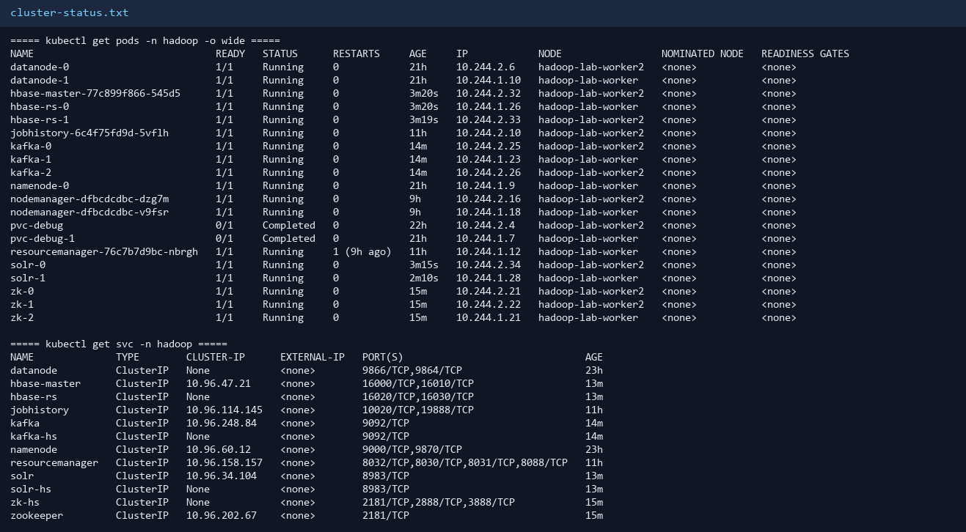

HDFS — hdfs dfsadmin -report
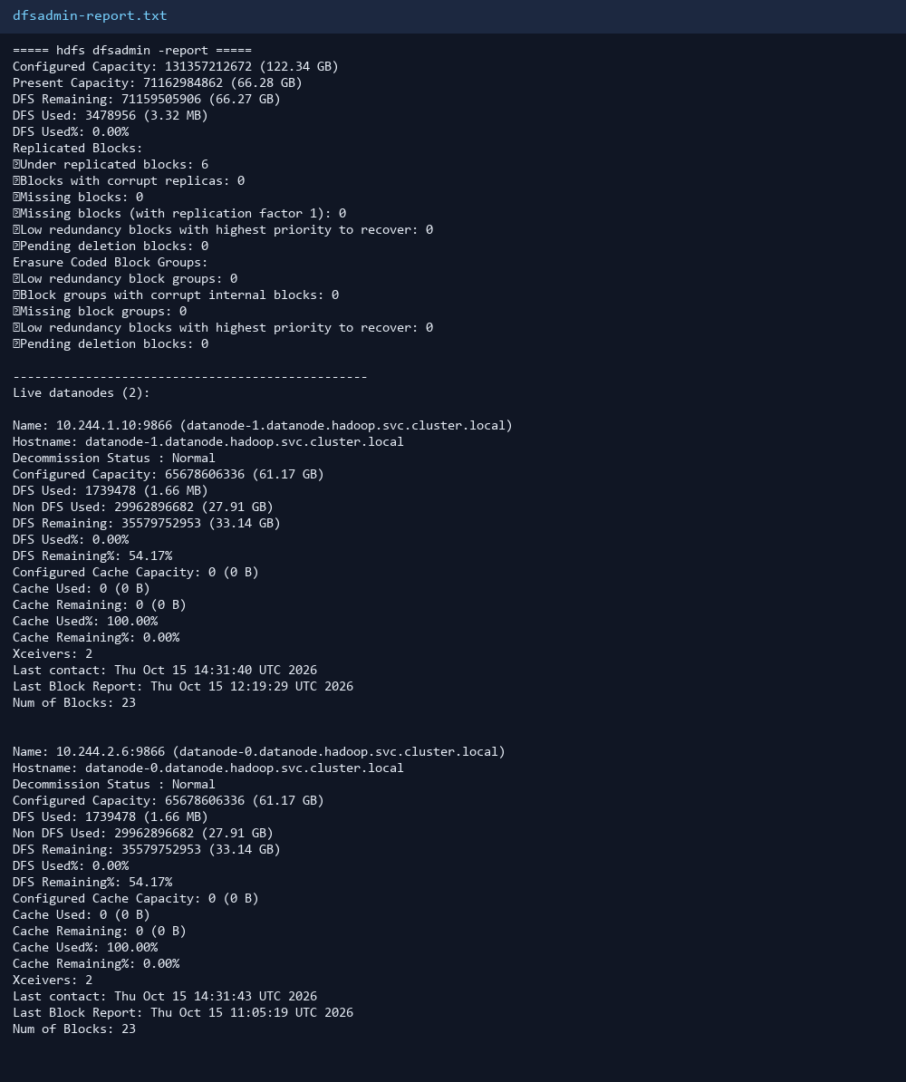

YARN — yarn node -list
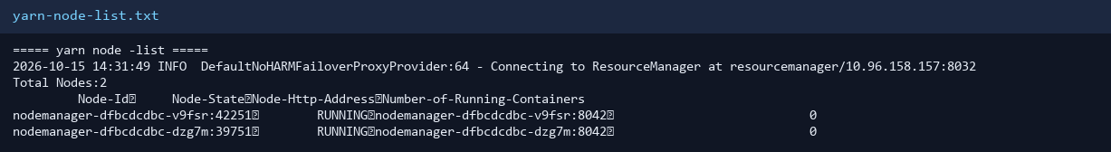

ZooKeeper — ruok check
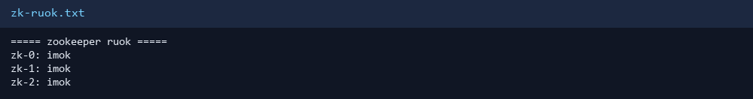

Kafka — broker check
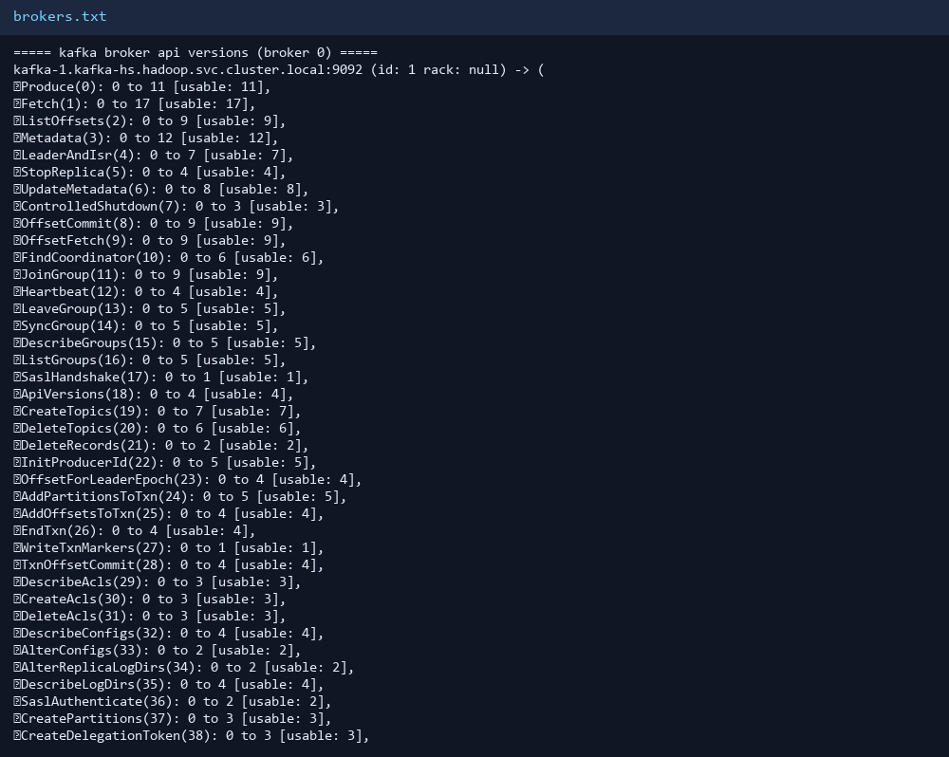

HBase — status
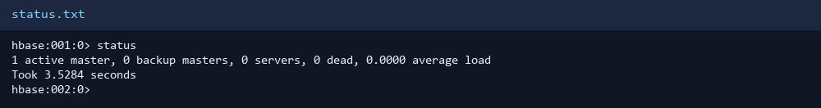

Solr — pods Ready
