

Ms Swathi
Pamarthy Tejaswini
2520030011
CSE
CO 1
Pet Medical Record Management using BST and AVL Trees
PetCare Veterinary Clinics maintain pet medical records using unique Pet IDs. To manage these records efficiently, Binary Search Tree (BST) and AVL Tree data structures were implemented. Pet IDs were inserted into the tree, and the balance factor was checked after each insertion. When an imbalance occurred, AVL rotations were performed to maintain a balanced tree structure. The AVL Tree was used to perform insertion, searching, and deletion operations efficiently. The implementation demonstrated how AVL Trees maintain logarithmic time complexity and improve record retrieval performance compared to a normal BST. This approach is suitable for managing hierarchical pet medical records in the PetCare – Smart Veterinary Clinic & Pet Health Management System

Implementation Details:
- Inserted Pet IDs: 30, 20, 10, 40, 50.
- Constructed a Binary Search Tree.
- Identified imbalance using balance factors.
- Performed LL and RR rotations to balance the tree.
- Implemented searching operation for Pet ID 30.
- Implemented deletion operation for Pet ID 10.
- Displayed AVL Tree using inorder traversal.
- Compared BST and AVL Tree performance using complexity analysis.

Github Link: https://github.com/tejsree2007-design/2520030011_DSA-2
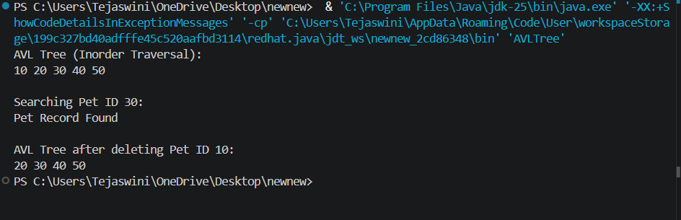
The AVL Tree efficiently managed pet records by maintaining a balanced structure. Search and deletion operations were performed successfully with O(log n) time complexity.

Results/Output:

