

Ms Swathi
Pamarthy Tejaswini
2520030011
CSE
CO 2
PetCare – Smart Veterinary Clinic Appointment Management using B-Tree, B+ Tree, Segment Tree, and Fenwick Tree
Pet-care Veterinary Clinics maintain appointment records and daily consultation data across multiple branches. In this case study, B-Tree and B+ Tree structures were used for efficient appointment indexing and retrieval. Segment Tree and Fen-wick Tree concepts were applied to perform range sum and cumulative consultation queries. These data structures help improve data access efficiency and support faster analysis of clinic operations.

Implementation Details:

- Stored appointment IDs using B-Tree indexing.
- Demonstrated appointment retrieval using B+ Tree structure.
- Calculated consultations from Day 2 to Day 4 using Segment Tree concepts.
- Calculated cumulative consultations up to Day 5 using Fen-wick Tree concepts.
- Analyzed the performance of all four data structures.
- Verified efficient query processing for appointment management.

Github Link: https://github.com/tejsree2007-design/2520030011_DSA-2

Result/Output:-

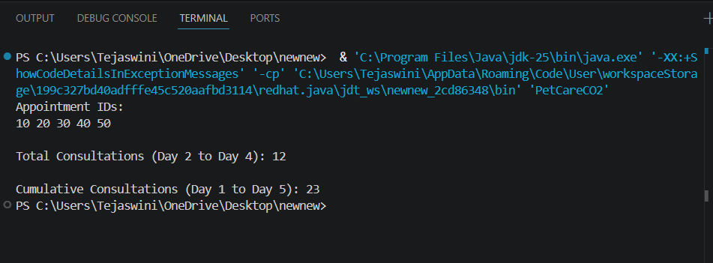

The data structures efficiently handled appointment indexing and consultation analysis. Range and cumulative queries were performed successfully with logarithmic time complexity.

