

Ms Swathi
Pamarthy Tejaswini
2520030011
CSE
CO 3
Pet-care – Smart Veterinary Clinic Branch Connectivity and Emergency Routing using BFS, DFS, Kruskal's Algorithm, and Prim's Algorithm
PetCare operates multiple veterinary clinic branches connected through a transportation network for emergency pet care and medicine delivery. In this case study, BFS and DFS were used to traverse the clinic network, while Kruskal's and Prim's algorithms were used to determine the minimum cost connections between branches. These graph algorithms help improve connectivity and optimize resource distribution across the PetCare network.

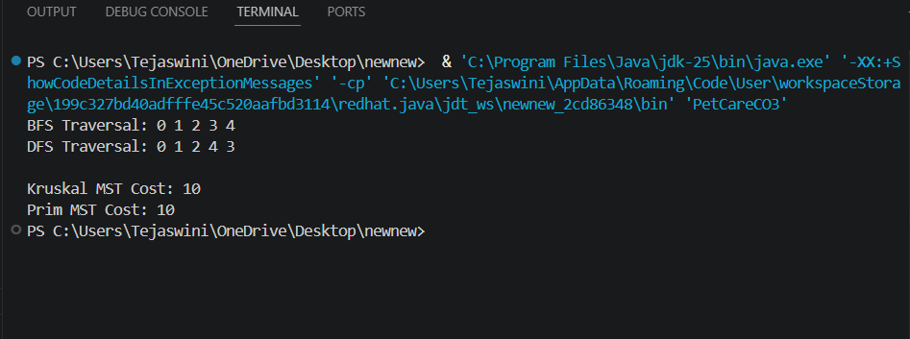
The graph algorithms successfully analyzed clinic connectivity and emergency routing. BFS, DFS, Kruskal's, and Prim's algorithms efficiently traversed the network and determined the minimum connection cost.

Implementation Details:-
Result/Output:-
- Represented veterinary clinic branches as graph nodes.
- Applied BFS traversal to visit all connected branches.
- Applied DFS traversal to explore the complete network.
- Used Kruskal's algorithm to find the Minimum Spanning Tree (MST).
- Used Prim's algorithm to find the Minimum Spanning Tree (MST).
- Analyzed network connectivity and minimum connection cost.

https://github.com/tejsree2007-design/2520030011_DSA-2

