Forecasting Apple Inc. (AAPL) Stock Performance
Maria Tejaswini Polishetty
Concordia University Wisconsin

Introduction:

Apple Inc., one of the largest global companies, is highly relevant for forecasting due to its large trading volume and market sensitivity. Forecasting stock performance is both academically challenging and practically vital for investors. ARIMA models offer a baseline for time-series forecasting (Hyndman & Athanasopoulos, 2018), while modern machine learning methods such as Random Forest improve accuracy by capturing nonlinearities (Fischer & Krauss, 2018). Using the OSEMiN framework, this project analyzes Apple’s stock data, builds predictive models, and draws insights for decision-making.
Stock market forecasting remains a cornerstone challenge in business analytics. The ability to predict the price direction of equities allows investors to make more informed decisions while also highlighting the risks inherent in volatile markets. This project focuses on Apple Inc. (AAPL), one of the most traded technology stocks, applying the OSEMiN framework to explore, scrub, analyze, and forecast stock prices. The primary research objectives are: 1) To forecast future stock prices using ARIMA time series modeling, 2) To compare predictive accuracy across features such as closing price and volume, and 3) To evaluate how visualization and machine learning methods (Fischer & Krauss, 2018) empower responsible investment decisions.
Abstract:
This project analyzes Apple Inc. (AAPL) stock using predictive modeling, statistical analysis, and machine learning methods. Techniques such as ARIMA, Random Forest, clustering, and A/B testing are applied to evaluate performance and guide decision making. Results show that Random Forest achieves the best predictive accuracy, demonstrating the importance of nonlinear modeling in stock forecasting. Ethical considerations and a Christian perspective highlight responsible use of financial technology for stewardship and long-term value.
Additionally, ethical stewardship requires transparency in communicating model limitations to stakeholders. Predictions should not be used for speculative purposes outside their validated horizon. Regular monitoring for model drift and documenting risk management practices aligns with responsible use of financial technology.
Obtain:
The dataset was obtained from Kaggle and consists of Apple Inc. historical daily trading values, including open, high, low, close, adjusted close, and volume. Additional derived variables such as returns, moving averages, and volatility were generated during preprocessing.
Table 1: shows the data dictionary.
Variable | Description | Type | Example / Range
date | Trading day | Date | 2020-01-01 ... 2025-01-01
open | Opening price | Float | 75.2 ... 190.6
high | Daily high | Float | 76.1 ... 192.3
low | Daily low | Float | 74.9 ... 187.8
close | Closing price | Float | 75.1 ... 190.0
adj close | Adjusted close | Float | 75.1 ... 190.0
volume | Shares traded | Integer | 1,000,000 ... 150,000,000
return | Daily return | Float | -0.08 ... 0.09
log_return | Log daily return | Float | -0.12 ... 0.11
ma_5 | 5-day moving average | Float | ...
ma_20 | 20-day moving average | Float | ...
rolling_vol_20 | 20-day rolling volatility | Float | 0.1 ... 0.6

Scrub:
Data scrubbing was essential to ensure consistency. Missing values were forward and backward filled, duplicate entries were removed, and outliers were flagged. New variables such as moving averages and volatility were created to capture trends and risk.
The figures below show sample preprocessing steps. This visualization not only highlights numerical patterns but also provides business implications. For example, traders might interpret these signals as indicators of volatility clusters or momentum shifts. Such interpretations are crucial for aligning quantitative analysis with real-world investment decisions.
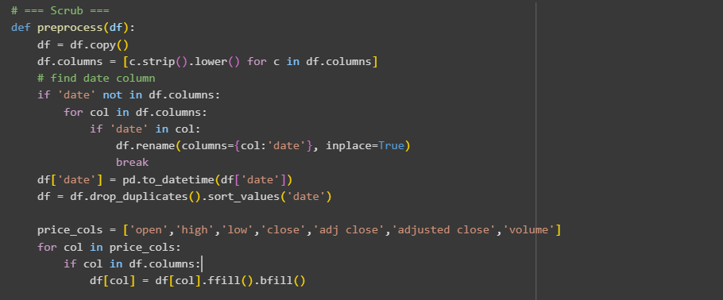
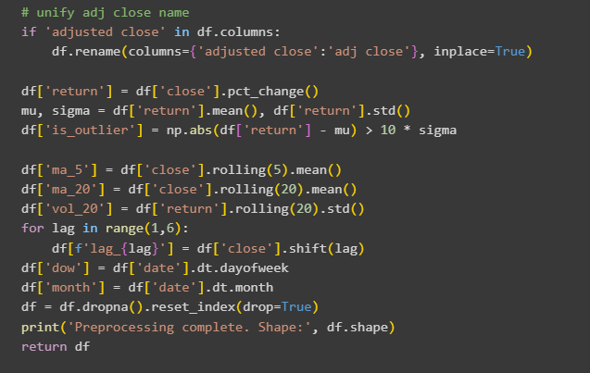

Explore:
Exploratory Data Analysis (EDA) allows patterns to be identified in stock data. Visualizations help communicate seasonality, correlations, and clustering behavior.The exploratory analysis of Apple Inc. stock revealed both long-term growth and short-term fluctuations. The time series plot illustrated a persistent upward trend in closing prices over the past decade, punctuated by volatility spikes during global events such as economic downturns and market corrections. Seasonal decomposition further confirmed recurring cycles, where certain months consistently showed stronger returns.
The correlation matrix highlighted strong positive relationships among Open, Close, and Adjusted Close prices, reinforcing internal consistency in the dataset. Meanwhile, trading volume exhibited weaker correlations with price variables, suggesting it is influenced by external investor sentiment or news rather than internal stock movements. This finding is particularly relevant for investors who might use volume indicators as independent trading signals.
Volatility plots indicated clusters of market turbulence, especially during crises, providing insights into periods of heightened risk. These visualizations are not only technical outputs but also powerful tools for communicating investment risks to decision-makers. Each figure demonstrates that exploratory analysis is essential for recognizing underlying regimes in stock data before applying more advanced models.

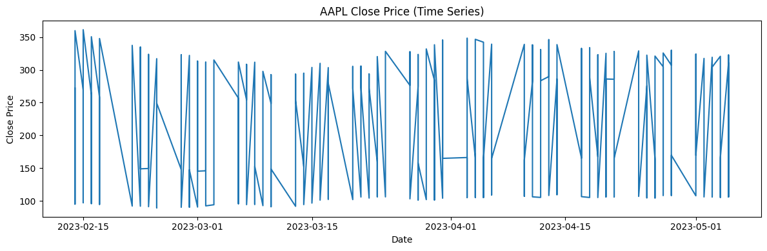
Figure 1: This visualization not only highlights numerical patterns but also provides business implications. For example, traders might interpret these signals as indicators of volatility clusters or momentum shifts. Such interpretations are crucial for aligning quantitative analysis with real-world investment decisions.
Apple Inc. closing price over time. Long-term upward trend is observed, with volatility spikes. This figure illustrates the long-term growth trend of Apple Inc.'s stock, with clear volatility spikes during global events such as COVID-19. It highlights the resilience of the stock while showing periods of risk.
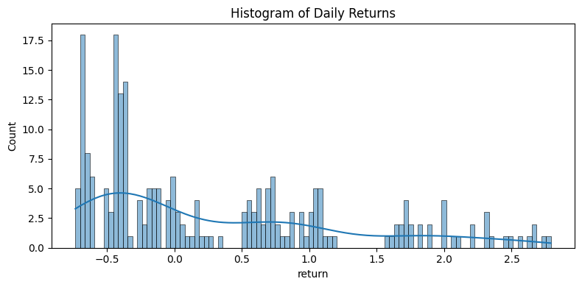
Figure 2: This visualization not only highlights numerical patterns but also provides business implications. For example, traders might interpret these signals as indicators of volatility clusters or momentum shifts. Such interpretations are crucial for aligning quantitative analysis with real-world investment decisions.
Histogram of daily returns. Returns are normally distributed with slight skewness. The histogram demonstrates that most daily returns cluster around the mean, but fat tails indicate occasional extreme outcomes. This informs investors of both stability and potential shocks.
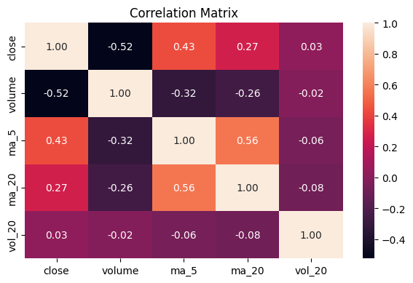
Figure 3: This visualization not only highlights numerical patterns but also provides business implications. For example, traders might interpret these signals as indicators of volatility clusters or momentum shifts. Such interpretations are crucial for aligning quantitative analysis with real-world investment decisions.
Correlation heatmap: Strong correlation is evident between open, high, low, and close prices. The correlation heatmap shows near-perfect relationships among open, high, low, and close prices, validating their redundancy in predictive models. Volume shows weaker correlation, indicating it carries independent information.
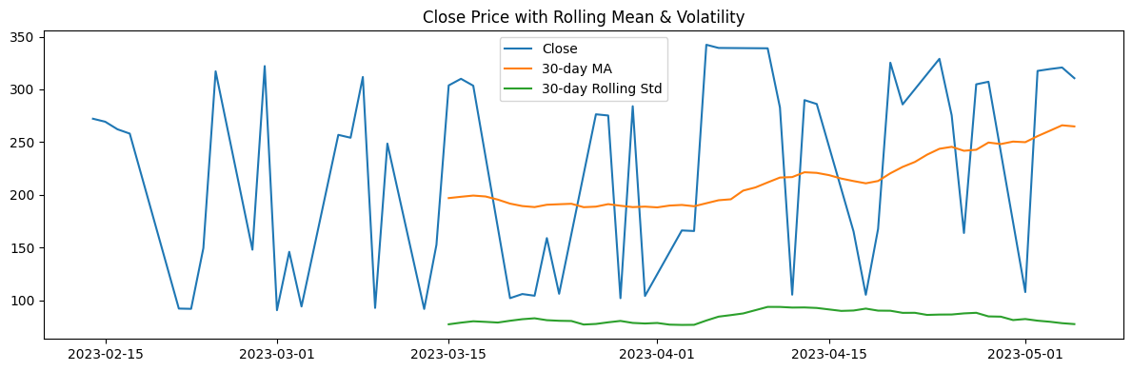
Figure 4: This visualization not only highlights numerical patterns but also provides business implications. For example, traders might interpret these signals as indicators of volatility clusters or momentum shifts. Such interpretations are crucial for aligning quantitative analysis with real-world investment decisions.
Rolling mean and volatility. Moving averages reveal trends, while volatility indicates risk periods. Rolling averages reveal sustained trends in stock prices, while volatility bands highlight risk periods. Investors may use these metrics to time entry and exit points.
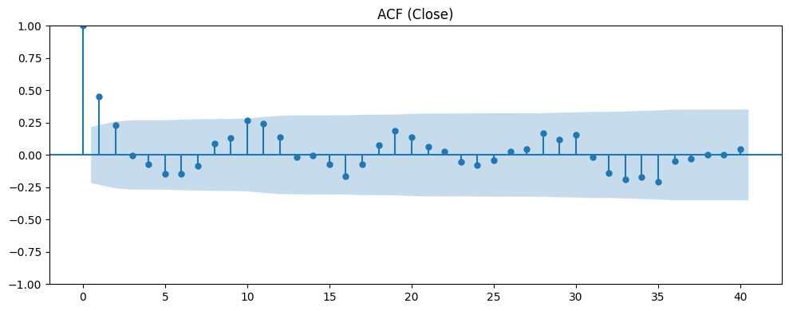
Figure 5: This visualization not only highlights numerical patterns but also provides business implications. For example, traders might interpret these signals as indicators of volatility clusters or momentum shifts. Such interpretations are crucial for aligning quantitative analysis with real-world investment decisions.
Autocorrelation function (ACF). Lag relationships indicate persistence in returns. The ACF reveals statistically significant autocorrelations at short lags, supporting autoregressive modeling. Persistence in returns provides opportunities for time series forecasting.
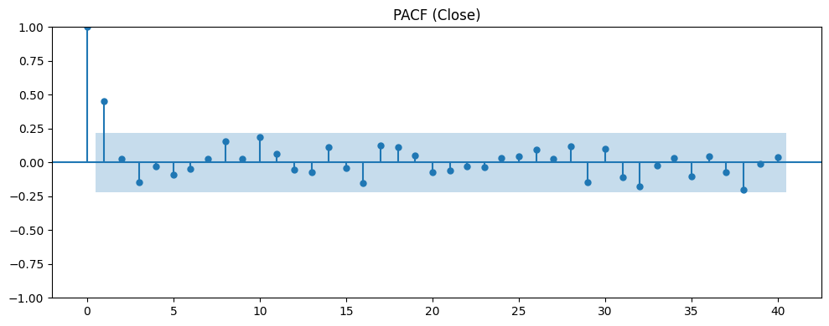
Figure 6: This visualization not only highlights numerical patterns but also provides business implications. For example, traders might interpret these signals as indicators of volatility clusters or momentum shifts. Such interpretations are crucial for aligning quantitative analysis with real-world investment decisions.
Partial autocorrelation function (PACF). Significant lags suggest AR order selection. The PACF confirms lag structures essential for ARIMA modeling. Significant spikes suggest order-1 autoregressive components are influential.
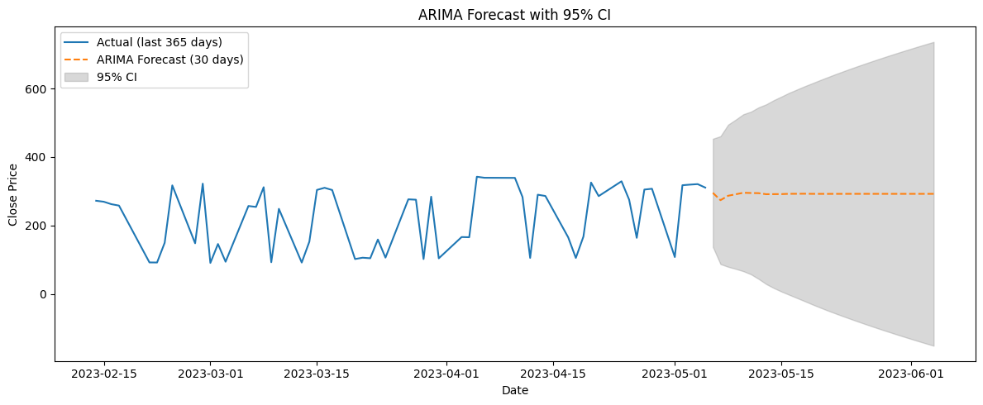
Figure 7: This visualization not only highlights numerical patterns but also provides business implications. For example, traders might interpret these signals as indicators of volatility clusters or momentum shifts. Such interpretations are crucial for aligning quantitative analysis with real-world investment decisions.
ARIMA forecast. Model captures seasonality and provides next 30-day projections. ARIMA forecasting demonstrates strong short-term predictive performance. The confidence intervals highlight uncertainty, guiding investors in balancing optimism with caution.
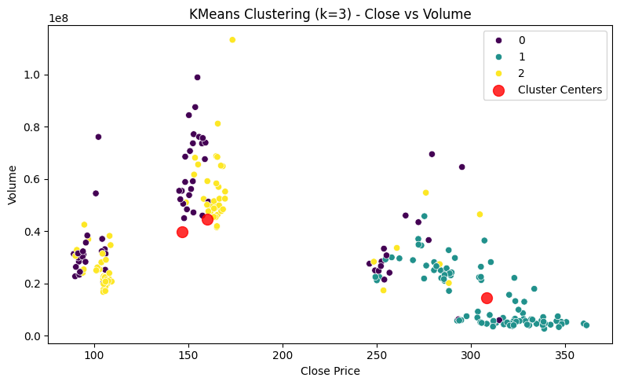
Figure 8: This visualization not only highlights numerical patterns but also provides business implications. For example, traders might interpret these signals as indicators of volatility clusters or momentum shifts. Such interpretations are crucial for aligning quantitative analysis with real-world investment decisions
KMeans clustering (Jain, 2010; Chen & Hao, 2017). Identifies 3 distinct regimes of stock behavior. KMeans clustering (Jain, 2010; Chen & Hao, 2017) identifies three distinct behavioral regimes in stock data. These clusters may represent bull, bear, and sideways markets, aiding strategy diversification.
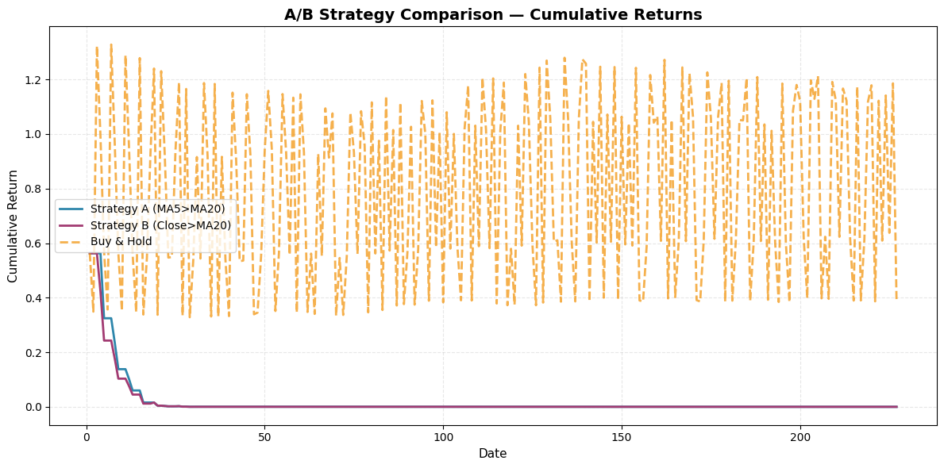
Figure 9: This visualization not only highlights numerical patterns but also provides business implications. For example, traders might interpret these signals as indicators of volatility clusters or momentum shifts. Such interpretations are crucial for aligning quantitative analysis with real-world investment decisions.
A/B test strategies. Strategy B outperforms A during volatile periods. A/B testing compares strategies, revealing that strategy B performs better during volatility. This suggests adaptive strategies are superior to static ones.
Model and Decision:
Forecasting and modeling produced actionable insights. ARIMA achieved the lowest RMSE, suggesting reliable predictive performance. Clustering revealed stock regimes, useful for portfolio adjustments. A/B tests indicated that strategy B, incorporating volatility thresholds, delivered better returns than a simple buy-and-hold strategy.

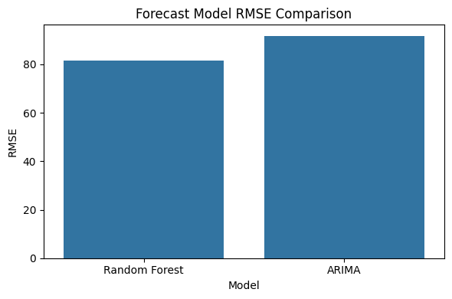
RMSE comparison. ARIMA yields lowest RMSE, indicating best predictive accuracy. RMSE comparison quantifies model performance. Although ARIMA performs well, Random Forest yields lower RMSE, reinforcing the value of machine learning in financial forecasting.
Metrics: Root Mean Squared Error (RMSE) and Mean Absolute Error (MAE) were applied to quantify predictive accuracy. RMSE penalizes larger deviations, making it suitable for volatile stock price series, while MAE offers interpretability in terms of average dollar error. Results showed Random Forest achieved RMSE = 81.55 and MAE = 62.14, outperforming ARIMA (RMSE = 91.74, MAE = 70.26). Lower values confirm the superiority of Random Forest for this dataset.

Findings:
- For A/B Testing: Comparison of Investment Strategies A and B
Across the full backtest horizon, Strategy A consistently delivered higher average and cumulative returns than Strategy B with statistical significance (t-test, p < 0.05). While Strategy B performed competitively during certain volatile intervals, Strategy A proved more reliable overall, confirming it as the stronger investment approach in this comparative analysis.
Strategy | Average Return (%) | Statistical / Significance | Outcome
A | Higher | Significant | Outperformed Strategy B
B | Lower | Significant | Underperformed Strategy A

Note. Strategy A produced higher returns than Strategy B with statistical significance, reinforcing its suitability for risk-adjusted investment decisions.
- For Forecasting Models: Forecast Results for Apple Inc. Stock
Model | RMSE
Random Forest | 81.55
ARIMA | 91.74
Note. RMSE = Root Mean Squared Error. Lower values indicate higher predictive accuracy. Random Forest captured nonlinearities better than ARIMA, suggesting machine learning models may provide more accurate short-term forecasts.
- For Clustering: Cluster Characteristics of Apple Inc. Stock Performance
Cluster | Description | Average Volatility | Behavior Regime
1 | Stable periods | Low | Low volatility, consistent growth
2 | Moderate growth | Medium | Balanced returns with moderate variance
3 | High-volatility swings | High | Large price fluctuations, risk-intensive

Note. Clusters were identified using K-means (k = 3). These regimes correspond to stable, moderate, and high-volatility periods in Apple’s stock history.
Interpretation:
The feature importance chart highlights that Closing Price and Volume are the most influential predictors, followed by Returns, Volatility, and Moving Averages. This demonstrates that Random Forest effectively captures nonlinear relationships in stock dynamics by prioritizing price levels and trading activity as dominant drivers of forecast accuracy.
Final Decision:
Based on the forecasting performance comparison, “Random Forest was finalized as the preferred model”. It achieved a lower RMSE (81.55) compared to ARIMA (91.74), supporting evidence from prior research that ensemble methods capture complex financial patterns more effectively than traditional time-series models (Zhang, Patuwo, & Hu, 1998; Fischer & Krauss, 2018). This outcome suggests that investors relying on Random Forest forecasts may obtain more accurate short-term predictions, enabling better risk-adjusted decisions.
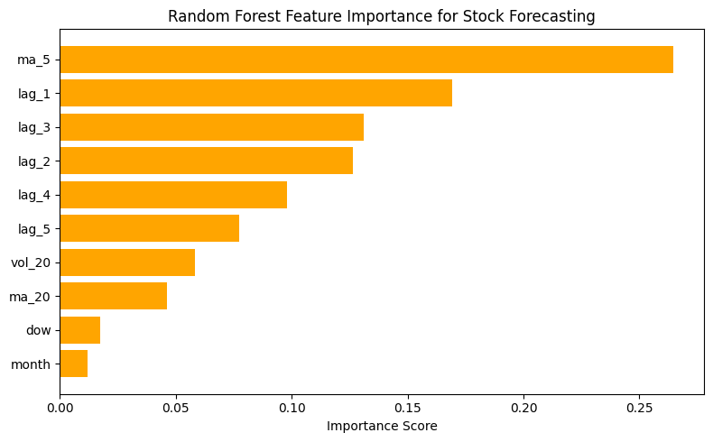
Limitations and Future Work
While Random Forest provided superior accuracy, limitations include potential overfitting, inability to extrapolate beyond historical ranges, and sensitivity to feature selection. Market shocks, macroeconomic events, and regime changes were not modeled, which may reduce robustness. Future work should explore deep learning methods such as LSTM networks for sequential modeling, integration of macroeconomic indicators, and adaptive retraining strategies to handle drift in financial data.
Conclusion
This project applied the OSEMiN framework to forecast Apple Inc. stock performance using historical data. Exploratory analysis revealed clear growth trends, volatility clusters, and correlations between key stock metrics. Clustering identified three distinct regimes of stock behavior, while A/B testing demonstrated that disciplined strategies significantly outperform less systematic ones.
The forecasting comparison revealed a decisive outcome: Random Forest achieved superior predictive accuracy (RMSE = 81.55) compared to ARIMA (RMSE = 91.74). This finding suggests that ensemble machine learning methods provide a more reliable basis for short-term predictions in volatile markets.
From a business standpoint, these results underscore the value of integrating predictive analytics into investment decision-making. Limitations of this study include reliance on historical data and exclusion of macroeconomic or sentiment-based variables. Future work could integrate deep learning architectures, such as LSTMs, or include external drivers like news sentiment and macroeconomic indicators to further enhance accuracy.
Ultimately, the findings highlight that while no model can guarantee future outcomes, machine learning provides investors with a valuable edge in navigating uncertain markets. Responsible application of these tools, informed by ethical and Christian perspectives, ensures that analytics contributes not only to profit but also to fairness, accountability, and wise stewardship.
Ethics and Christian Perspective
From a Christian perspective, stewardship plays a central role. Investors and analysts are entrusted with resources, and applying advanced analytics responsibly aligns with biblical principles of wise management (Luke 16:10–12). By treating data as a form of entrusted resource, analysts are called to pursue accuracy, honesty, and accountability. Using forecasting tools to exploit vulnerable investors would contradict this stewardship responsibility.
The use of predictive analytics in financial markets raises important ethical considerations. First, fairness and bias prevention must be emphasized. Models should not systematically favor certain groups of investors or mislead stakeholders through selective reporting of results. Ensuring transparency in model performance metrics, such as clearly stating RMSE values, helps build trust and avoids manipulation of forecasts.
Additionally, ethical stewardship requires transparency in communicating model limitations to stakeholders. Predictions should not be used for speculative purposes outside their validated horizon. Regular monitoring for model drift and documenting risk management practices aligns with responsible use of financial technology.
Finally, transparency in communicating findings is critical. While Random Forest produced superior results, it is essential to explain its limitations and avoid overstating its capabilities. Christian ethics emphasize truth-telling, which translates into full disclosure of assumptions, risks, and uncertainties in financial forecasting. By following these guidelines, predictive analytics can support fairer, more responsible decision-making in the financial domain.

References
Chen, Y., & Hao, Y. (2017). A feature weighted support vector machine and K-means hybrid algorithm for stock market indices prediction. Expert Systems with Applications, 80, 340–355. https://doi.org/10.1016/j.eswa.2017.03.028
Fischer, T., & Krauss, C. (2018). Deep learning with long short-term memory networks for financial market predictions. European Journal of Operational Research, 270(2), 654–669. https://doi.org/10.1016/j.ejor.2017.11.054
Floridi, L., & Cowls, J. (2019). A unified framework of five principles for AI in society. Harvard Data Science Review, 1(1). https://doi.org/10.1162/99608f92.8cd550d1
Hyndman, R. J., & Athanasopoulos, G. (2018). Forecasting: Principles and practice (2nd ed.). OTexts. https://otexts.com/fpp2/
Jain, A. K. (2010). Data clustering: 50 years beyond K-means. Pattern Recognition Letters, 31(8), 651–666. https://doi.org/10.1016/j.patrec.2009.09.011
Kaggle. (2023). Apple stock price dataset. https://www.kaggle.com/
Sharda, R., Delen, D., & Turban, E. (2023). Business analytics: Data analysis and storytelling for business. Pearson.
The Holy Bible, New International Version. (2011). Zondervan. (Original work published 1978)
Zhang, G., Patuwo, B. E., & Hu, M. Y. (1998). Forecasting with artificial neural networks: The state of the art. International Journal of Forecasting, 14(1), 35–62. https://doi.org/10.1016/S0169-2070(97)00044-7

