**Codes:**

**1.**

org 100h

jmp start

msg: db "Hello, World!", 0Dh, 24h

start: mov dx, msg

mov ah, 09h

int 21h

mov ah, 0

int 16h

ret

**OutPut:**

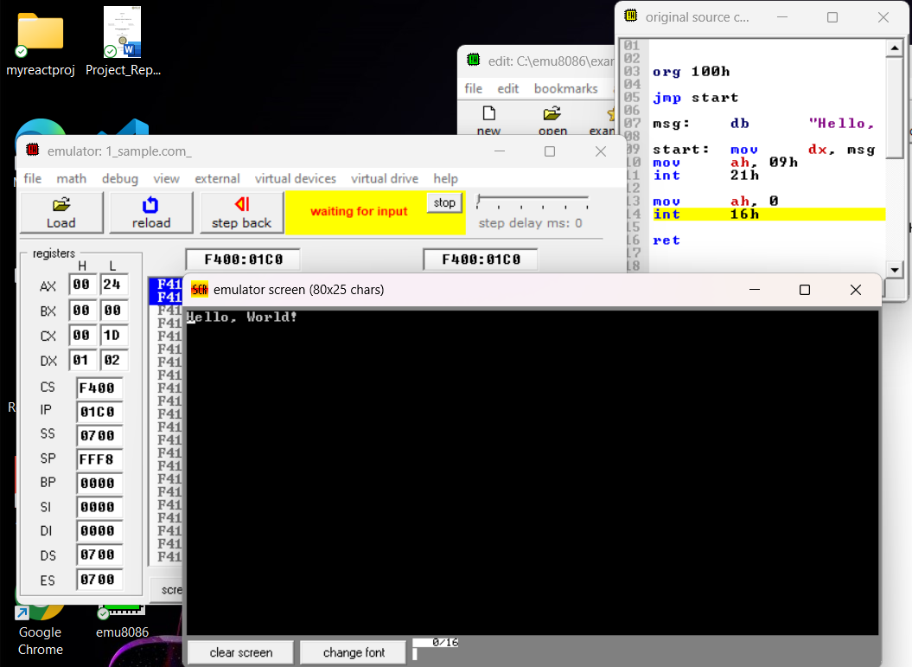

**2.**

org 100h

jmp start

msg: db "Tejaswini!", 0Dh,0Ah, 24h

start: mov dx, msg

mov ah, 09h

int 21h

mov ah, 0

int 16h

ret

**OutPut** :

