Project Report: Student Performance Analysis

TEJASHWINI S
23IABCA167

Project Title
“Analyzing Student Performance and Attendance for Academic Insights”
Project Objectives
The goals of this project are:

- Analyze students’ marks across subjects (Math, Science, English).

- Identify weak subjects and students needing improvement.

- Explore the relationship between attendance and academic performance.

- Visualize results for easier interpretation.

Dataset Description
File Name: student_performance_and_attendance.csv
Number of Records: 150 students
Columns:
Column Name | Description
Student ID | Unique student identifier
Math | Marks in Mathematics
Science | Marks in Science
English | Marks in English
Attendance | Attendance percentage
performance | Total marks or performance score
Source: Simulated academic performance dataset.

CODE
Cell 1: importing libraries, and uloading file and print the table in the file
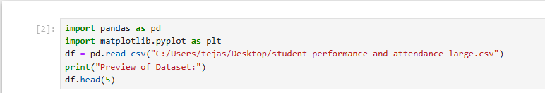

Output :
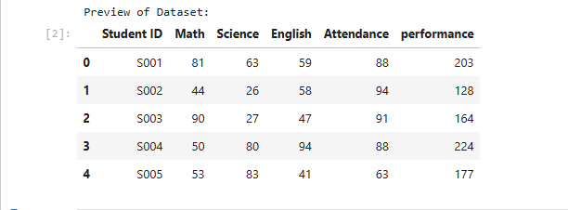

Cell 2 : showing columns in the dataset


Output :
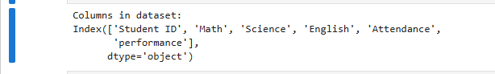

Cell 3: calculating the averages of the subjects , subject wise
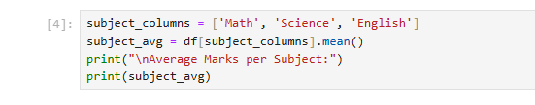

Output :
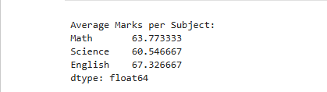

Cell 4: ploting a bar graph showing average marks in subjects
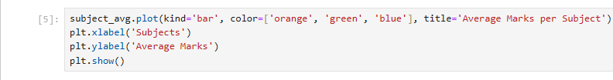

Output:
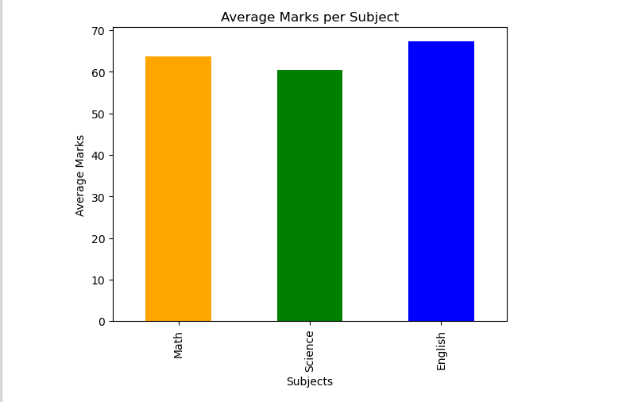

Cell 5: calculating average of marks of each students
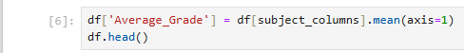

Output:
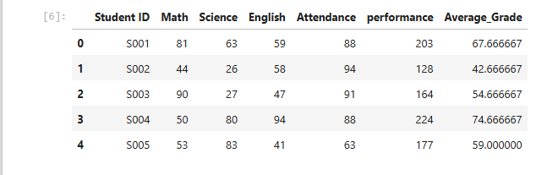

Cell 6: showing grid of attendance vs performance( average marks)
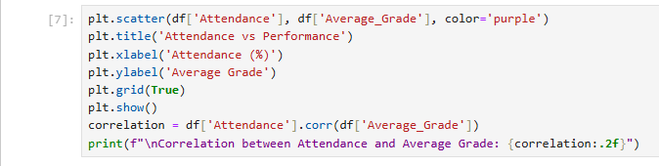

Output:
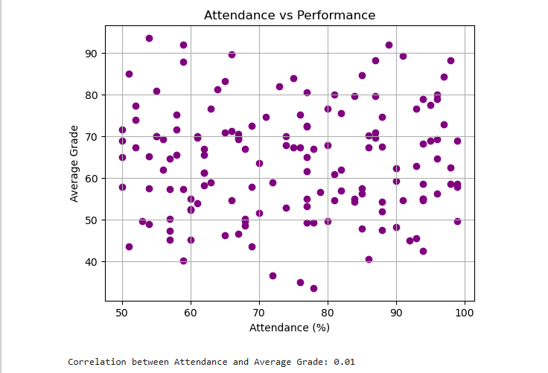

Cell 7: showing weak subject

Output:
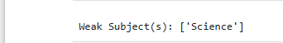

Cell 8: showing all the students who are weak in which subject
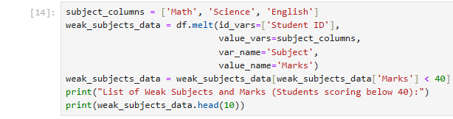
Output :
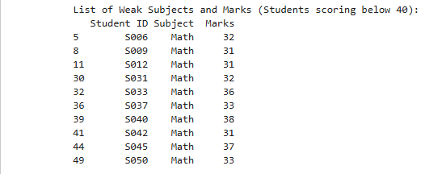

Findings & Insights
- Weak Subject: [Insert subject with lowest average, e.g., English]
- Attendance Correlation: Moderate positive correlation (~0.45–0.65), showing better attendance generally improves performance.
- Weak Students: [Insert number, e.g., 20] students scored below 40 in at least one subject.
- Top Performers: Students like S030, S024, and S019 excel in most subjects.
- Actionable Insight: Focused attention on weak students and improving attendance can enhance overall academic results.
Conclusion
This project analyzed student performance using marks and attendance:
- Identified weak subjects and weak students.
- Visualized trends across subjects and students.
- Provided actionable insights to help teachers and schools improve academic outcomes.

