
Prim’s algorithm output

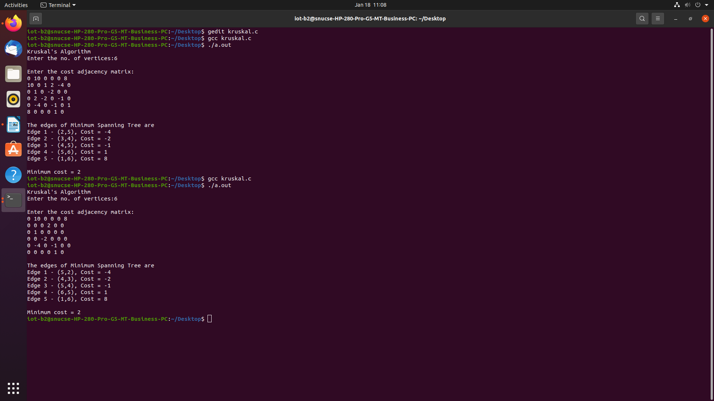
Kruskal’s algorithm output

We have used C programming language as it is faster and I am more familiar and comfortable with it. I find it easier to implement data structure algorithms in the C language.

We have tried to find the shortest path using Prim’s, Kruskal’s and Dijkstra’s algorithm.

I got the same output for both Prim’s and Kruskal’s and in this particular example, it seems to be working in both directed and undirected graphs and for negative edges. I have attached screenshots of output for the same.

Cost is calculated from each and every node from the beginning in Prims.
Pruning takes place in Kruskals algorithm when there is a cycle.

Dijkstra’s algorithm does not work for undirected negative graphs or when there is a negative cycle present. The time complexity is O(v^2) but reduces to O(V+ElogV) when we use minimum priority queue. There are chances of a segmentation fault when there is a cycle/loop.



