**Introduction to Tableau and Installation**

**Tableau** is a data visualization tool that provides pictorial and graphical representations of data. It is used for data analytics and business intelligence. Tableau provides limitless data exploration without interrupting flow of analysis. With an intuitive drag and drop interface, user can uncover hidden insights in data and make smarter decisions faster.

Tableau can be downloaded from the following website:

<https://www.tableau.com/products/public/download>

after downloading, the following is the screen appears.



Click the licence agreement checkbox and then click on install button. After installation, click on Tableau Public icon to run Tableau. Following is the Tableau Public home screen.



**Program 1: Getting Started - Tableau Workspace, Tableau terminologies, basic functionalities.**

## ****Menu Commands****

On closing the getting started window, you get the main interface with all the available Menu commands. They represent the entire set of features available in Tableau. Various sections of the menu are shown in the following diagram. Next, you can see some details of each menu.

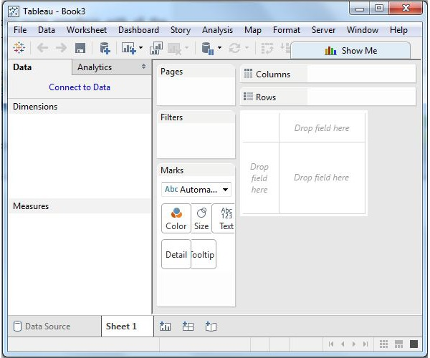

## ****File Menu****

This menu is used to create a new Tableau workbook and open existing workbooks from both the local system and Tableau server. The important features in this menu are −

* **Workbook Locale** sets the language to be used in the report.
* **Paste Sheets** pastes a sheet into the current workbook, which is copied from another workbook.
* **Export Packaged Workbook** option is used to create a packaged workbook, which will be shared with other users.

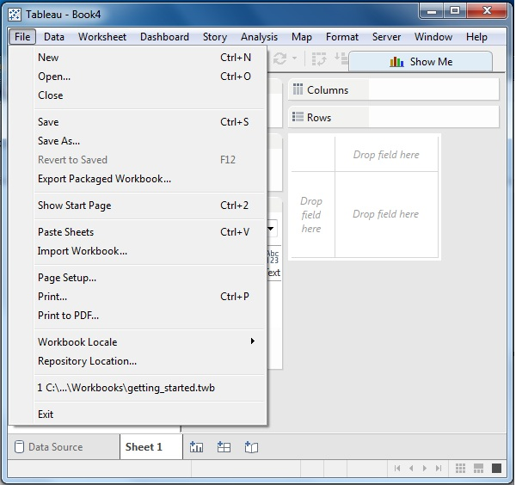

## ****Data Menu****

This menu is used to create new data source to fetch the data for analysis and visualization. It also allows you to replace or upgrade the existing data source.

The important features in this menu are as follows −

* **New Data Source** allows to view all the types of connections available and choose from it.
* **Refresh All Extracts** refreshes the data from the source.
* **Edit Relationships** option defines the fields in more than one data source for linking.

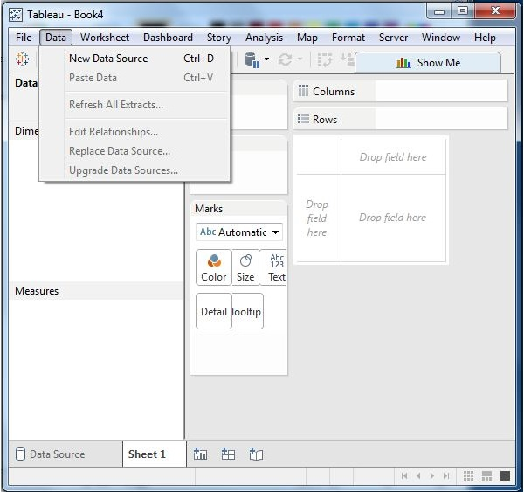

## ****Worksheet Menu****

This menu is used to create a new worksheet along with various display features such as showing the title and captions, etc.

The important features in this menu are as follows −

* **Show Summary** allows to view the summary of the data used in the worksheet such as, count, etc.
* Tooltip shows the tooltip when hovering above various data fields.
* **Run Update** option updates the worksheet data or filters used

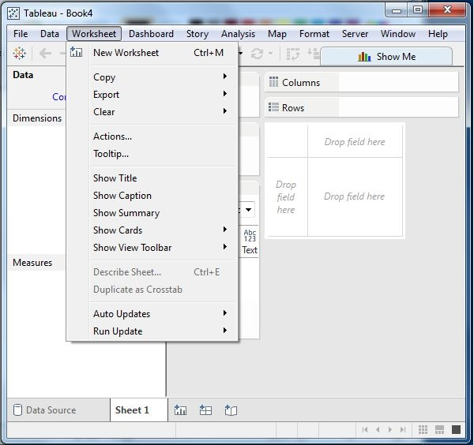

## ****Dashboard Menu****

This menu is used to create a new dashboard along with various display features, such as showing the title and exporting the image, etc.

The important features in this menu are as follows −

* **Format** sets the layout in terms of colors and sections of the dashboard.
* **Actions** link the dashboard sheets to external URLs or other sheets.
* **Export Image** option exports an image of the Dashboard.

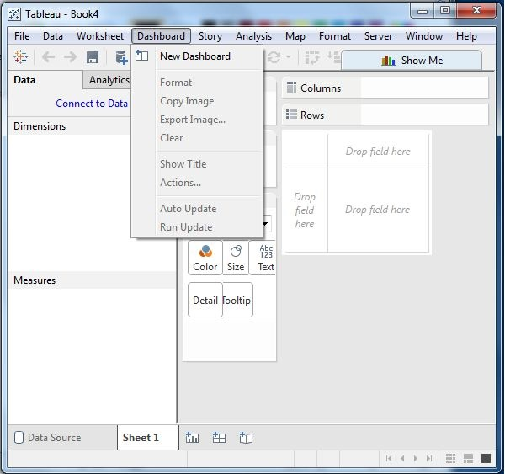

## ****Story Menu****

This menu is used to create a new story which has many sheets or dashboards with related data.

The important features in this menu are as follows −

* **Format** sets the layout in terms of colors and sections of the story.
* **Run Update** updates the story with the latest data from the source.
* **Export Image** option exports an image of the story.

This menu is used to create a new story which has many sheets or dashboards with related data.

The important features in this menu are as follows −

* **Format** sets the layout in terms of colors and sections of the story.
* **Run Update** updates the story with the latest data from the source.
* **Export Image** option exports an image of the story.

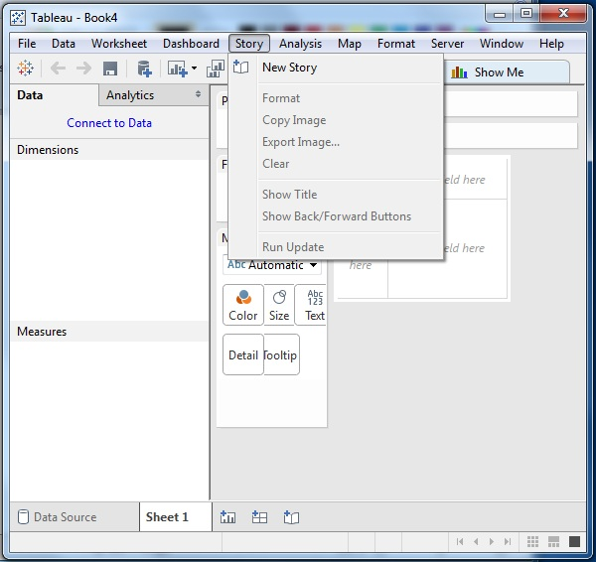

## ****Analysis Menu****

This menu is used for analyzing the data present in the sheet. Tableau provides many outof-the-box features, such as calculating the percentage and performing a forecast, etc.

The important features in this menu are as follows −

* **Forecast** shows a forecast based on available data.
* **Trend Lines** shows the trend line for a series of data.
* **Create Calculated Field** option creates additional fields based on certain calculation on the existing fields.

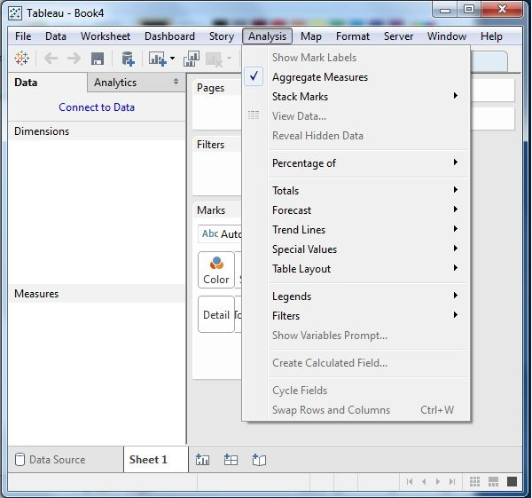

## ****Map Menu****

This menu is used for building map views in Tableau. You can assign geographic roles to fields in your data.

The important features in this menu are as follows −

* **Map Layers** hides and shows map layers, such as street names, country borders, and adds data layers.
* **Geocoding** creates new geographic roles and assigns them to the geographic fields in your data.

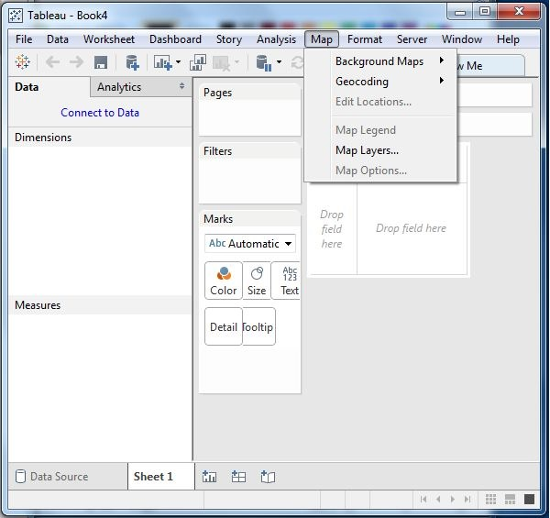

## ****Format Menu****

This menu is used for applying the various formatting options to enhance the look and feel of the dashboards created. It provides features such as borders, colors, alignment of text, etc.

The important features in this menu are as follows −

* **Borders** applies borders to the fields displayed in the report.
* **Title & Caption** assigns a title and caption to the reports.
* **Cell Size** customizes the size of the cells displaying the data.
* **Workbook Theme** applies a theme to the entire workbook.

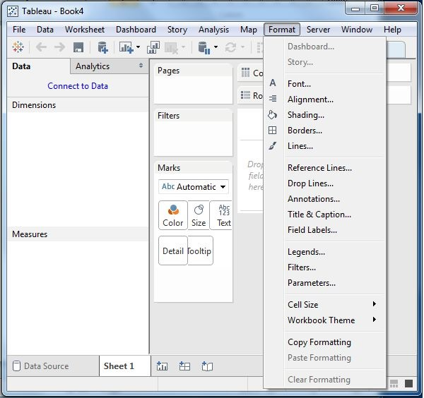

## ****Server Menu****

Server Menu is used to login to the Tableau server if you have access, and publish your results to be used by others. It is also used to access the workbooks published by others.

The important features in this menu are as follows −

* **Publish Workbook** publishes the workbook in the server to be used by others.
* **Publish Data Source** publishes the source data used in the workbook.
* **Create User Filters** creates filters on the worksheet to be applied by various users while accessing the report.

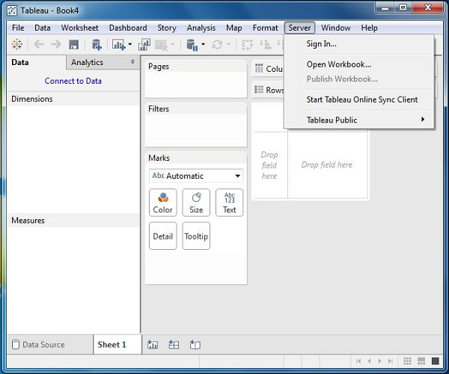

Following table lists the description of data types supported by Tableau.

|  |  |  |
| --- | --- | --- |
| **Data Type** | **Description** | **Example** |
| **STRING** | Any sequence of zero or more characters. They are enclosed within single quotes. The quote itself can be included in a string by writing it twice. | 'Hello' 'Quoted' 'quote' |
| **NUMBER** | These are either integers or floating points. It is advised to round the floating point numbers while using them in calculations. | 3  142.58 |
| **BOOLEAN** | They are logical values. | TRUE  FALSE |
| **DATE & DATETIME** | Tableau recognizes dates in almost all formats. But in case we need to force Tableau to recognize a string as date, then we put a # sign before the data. | "02/01/2015"  "#3 March 1982" |

# Tableau - Show Me

As an advanced data visualization tool, Tableau makes the data analysis very easy by providing many analysis techniques without writing any custom code. One such feature is Show Me. It can be used to apply a required view to the existing data in the worksheet. Those views can be a pie chart, scatter plot, or a line chart.

Whenever a worksheet with data is created, it is available in the top right corner as shown in the following figure. Some of the view options will be greyed out depending on the nature of selection in the data pane.

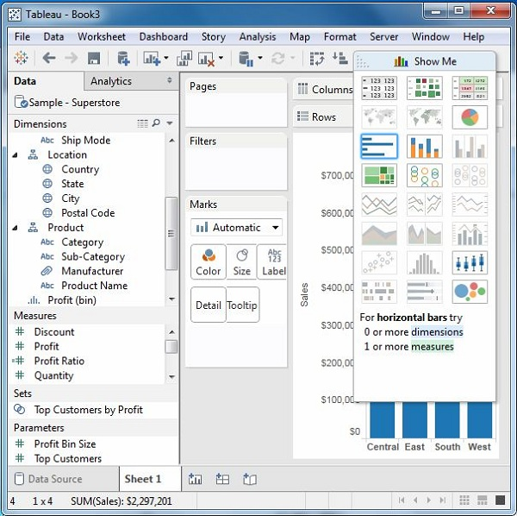

## Show Me with Two Fields

The relation between two fields can be visually analyzed easily by using various graphs and charts available in Show Me. In this case, we choose two fields and apply a line chart. Following are the steps −

* **Step 1** − Select the two fields (order date and profit) to be analyzed by holding the control key.
* **Step 2** − Click the Show Me bar and choose line chart.
* **Step 3** − Click the Mark Label button on the scrollbar.

The following diagram shows the line chart created using the above steps.

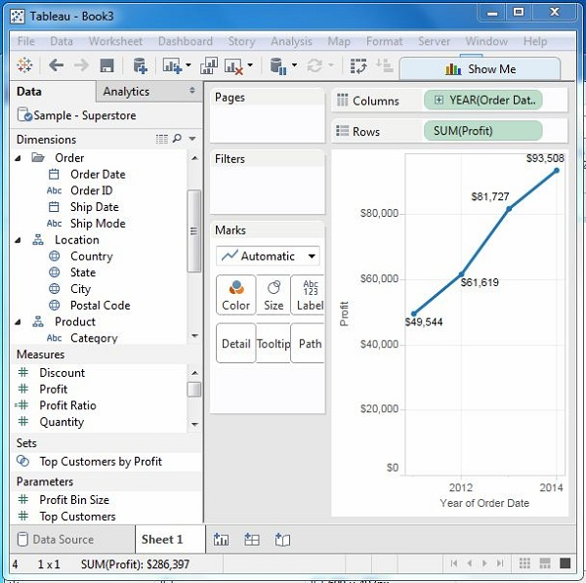

## Show Me with Multiple Fields

We can apply a similar technique as above to analyze more than 2 fields. The only difference in this case will be the availability of fewer views in active form. Tableau automatically greys out the views that are not appropriate for the analysis of the fields chosen.

In this case, choose the field’s product name, customer name, sales and profit by holding down the control key. As you can observe, most of the views in Show Me are greyed out. From the active views, choose Scatter View.

The following diagram shows the Scatter View chart created.

