**Program 1: Getting Started - Tableau Workspace, Tableau terminologies, basic functionalities.**

### Getting Started with Tableau

**Tableau** is a powerful data visualization tool that helps in transforming raw data into an understandable format. It’s widely used for creating a wide range of interactive and shareable dashboards. Here's a guide to help you get started with Tableau, understand its workspace, terminologies, and basic functionalities.

### 1. ****Tableau Workspace Overview****

When you open Tableau, you’ll typically see the following components:

* **Start Page**: This is the initial screen where you can open existing workbooks, connect to data sources, or access sample workbooks.
* **Data Pane**: Located on the left side, this pane shows all the fields in your data source, organized into dimensions (categorical data) and measures (quantitative data).
* **Analytics Pane**: Provides tools for adding analytics features like trend lines, reference lines, and forecasts to your visualization.
* **Shelves**: Rows, Columns, Filters, Pages, and Marks shelves where you drop fields to build your visualizations.
  + **Rows & Columns**: Determine the layout of the visualization.
  + **Marks Card**: Controls the appearance of marks in the view, such as color, size, shape, and labels.
* **View/Canvas**: The central area where your data is visualized. It shows the results of the fields placed in the Rows and Columns shelves.
* **Show Me Panel**: Offers a selection of pre-defined visualization types (e.g., bar charts, line charts, maps) based on the fields you've selected.
* **Filters Shelf**: Allows you to filter out unnecessary data points from your visualization.
* **Pages Shelf**: Enables you to break a view into a series of pages for better analysis.
* **Dashboard & Story Tabs**: Allows you to create a dashboard (a collection of visualizations) or a story (a sequence of dashboards or sheets) to convey a narrative.

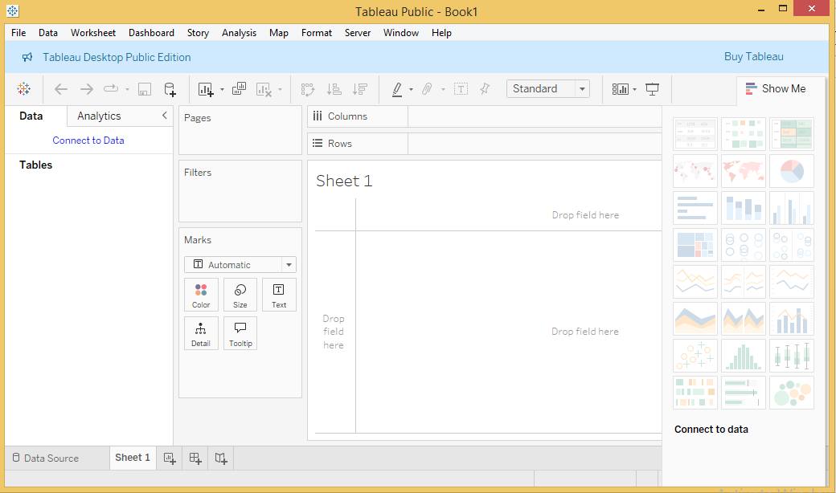

### 2. ****Key Tableau Terminologies****

|  |  |
| --- | --- |
| Sl.No | Terms & Meaning |
| 1 | **Alias** An alternative name that you can assign to a field or to a dimension member. |
| 2 | **Bin** A user-defined grouping of measures in the data source. |
| 3 | **Bookmark** A .tbm file in the Bookmarks folder in the Tableau repository that contains a single worksheet. Much like web browser bookmarks, .tbm files are a convenient way to quickly display different analyses. |
| 4 | **Calculated Field** A new field that you create by using a formula to modify the existing fields in your data source. |
| 5 | **Crosstab** A text table view. Use text tables to display the numbers associated with dimension members. |
| 6 | **Dashboard** A combination of several views arranged on a single page. Use dashboards to compare and monitor a variety of data simultaneously. |
| 7 | **Data Pane** A pane on the left side of the workbook that displays the fields of the data sources to which Tableau is connected. The fields are divided into dimensions and measures. The data pane also displays custom fields such as calculations, binned fields, and groups. You build views of your data by dragging fields from the data pane onto the various shelves that are a part of every worksheet. |
| 8 | **Data Source Page** A page where you can set up your data source. The data source page generally consists of four main areas − left pane, join area, preview area, and metadata area. |
| 9 | **Dimension** A field of categorical data. Dimensions typically hold discrete data such as hierarchies and members that cannot be aggregated. Examples of dimensions include dates, customer names, and customer segments. |
| 10 | **Extract** A saved subset of a data source that you can use to improve performance and analyze offline. You can create an extract by defining filters and limits that include the data you want in the extract. |
| 11 | **Filters Shelf** A shelf on the left of the workbook that you can use to exclude data from a view by filtering it using measures and dimensions. |
| 12 | **Format Pane** A pane that contains formatting settings that control the entire worksheet, as well as individual fields in the view. When open, the Format pane appears on the left side of the workbook. |
| 13 | **Level Of Detail (LOD) Expression** A syntax that supports aggregation at dimensionalities other than the view level. With the level of detail expressions, you can attach one or more dimensions to any aggregate expression. |
| 14 | **Marks** A part of the view that visually represents one or more rows in a data source. A mark can be, for example, a bar, line, or square. You can control the type, color, and size of marks. |
| 15 | **Marks Card** A card to the left of the view, where you can drag fields to control mark properties such as type, color, size, shape, label, tooltip, and detail. |
| 16 | **Pages Shelf** A shelf to the left of the view that you can use to split a view into a sequence of pages based on the members and values in a discrete or continuous field. Adding a field to the Pages shelf is like adding a field to the Rows shelf, except that a new page is created for each new row. |
| 17 | **Rows Shelf** A shelf at the top of the workbook that you can use to create the rows of a data table. The shelf accepts any number of dimensions and measures. When you place a dimension on the Rows shelf, Tableau creates headers for the members of that dimension. When you place a measure on the Rows shelf, Tableau creates quantitative axes for that measure. |
| 18 | **Shelves** Named areas to the left and top of the view. You build views by placing fields onto the shelves. Some shelves are available only when you select certain mark types. For example, the Shape shelf is available only when you select the Shape mark type. |
| 19 | **Workbook** A file with a .twb extension that contains one or more worksheets (and possibly also dashboards and stories). |
| 20 | **Worksheet** A sheet where you build views of your data by dragging fields onto shelves. |

**3. Tableau basic functionalities**

These basic functionalities provide a solid foundation for using Tableau to explore and visualize data effectively. As you become more comfortable with these tools, you can begin to explore more advanced features and techniques.

### 1. ****Connecting to Data****

* **Data Sources**: Tableau allows you to connect to a wide variety of data sources, including Excel files, text files (CSV), databases (like SQL Server, MySQL), and cloud-based services (like Google Sheets, Salesforce).
* **Live vs. Extract**: You can choose to connect live to your data source, which means Tableau queries the database directly. Alternatively, you can create an extract, which is a snapshot of the data stored locally to improve performance.

### 2. ****Data Pane and Data Preparation****

* **Data Pane**: After connecting to a data source, Tableau organizes your data into Dimensions (categorical data) and Measures (quantitative data).
* **Data Cleaning**: Tableau provides options to clean and prepare data, such as renaming fields, changing data types, splitting columns, and joining multiple data sources.

### 3. ****Building Visualizations****

* **Drag and Drop**: To create a visualization, simply drag fields from the Data Pane onto the Rows, Columns, or Marks shelves. Tableau automatically generates a suitable visualization.
* **Choosing Visualization Types**: The "Show Me" panel suggests different chart types (e.g., bar, line, map) based on the data you've selected. You can quickly switch between different visualization types.
* **Marks Card**: The Marks Card allows you to customize how data is displayed, including options to change the color, size, shape, and detail of data points. You can also add labels, tooltips, and more.

### 4. ****Filtering Data****

* **Filters Shelf**: Drag fields to the Filters shelf to include or exclude data from your visualization. Filters can be applied to specific sheets or across the entire workbook.
* **Interactive Filters**: You can add filters to dashboards that allow users to interactively filter the data in real-time.

### 5. ****Sorting and Grouping****

* **Sorting**: Sort data in ascending or descending order by clicking on axis headers or by using the sort options in the Data Pane.
* **Grouping**: Group similar data points together, either manually or automatically, to consolidate categories and simplify your analysis.

### 6. ****Calculated Fields****

* **Creating Calculations**: Calculated fields allow you to create new data fields by applying custom formulas to existing data. For example, you might calculate profit margin by dividing profit by sales.
* **Types of Calculations**: Tableau supports a variety of calculations, including basic arithmetic, string manipulations, logical operations, and more complex Level of Detail (LOD) expressions.

### 7. ****Creating Dashboards and Stories****

* **Dashboards**: A dashboard is a collection of multiple sheets on a single canvas. You can arrange sheets, add interactivity (like filters and actions), and customize the layout.
* **Stories**: A story is a sequence of sheets or dashboards that convey a narrative or guide the user through an analysis. Each "story point" represents a different view or conclusion.

### 8. ****Adding Interactivity****

* **Actions**: Actions in Tableau allow you to add interactivity to your visualizations. For example, you can set up a filter action so that clicking on a data point in one sheet filters the data in another sheet.
* **Highlighting**: Use highlighting actions to emphasize specific data points when hovering or clicking.

### 9. ****Formatting****

* **Formatting Visuals**: Tableau provides various formatting options to customize the appearance of your visualizations. You can format axes, titles, tooltips, borders, and backgrounds.
* **Customizing Tooltips**: Tooltips appear when you hover over a data point and can be customized to display relevant information and even include images or additional visualizations.

### 10. ****Publishing and Sharing****

* **Tableau Server/Tableau Online**: After creating your visualizations, you can publish them to Tableau Server or Tableau Online, making them accessible to others.
* **Tableau Public**: For public sharing, you can publish your work to Tableau Public, where anyone can view your visualizations online.
* **Exporting**: You can also export visualizations as images, PDFs, or PowerPoint presentations for offline sharing.

### 11. ****Data Blending****

* **Combining Data Sources**: Data blending allows you to combine data from different sources within the same visualization, useful when data is spread across multiple databases or files.
* **Primary and Secondary Data Sources**: Tableau designates one data source as primary and others as secondary when blending, linking them based on common fields.

### 12. ****Using Parameters****

* **Dynamic Inputs**: Parameters are user-driven inputs that can be used in calculations, filters, or reference lines. They allow users to dynamically change the values in a visualization.
* **Interactive Controls**: Parameters can be displayed as dropdown menus, sliders, or input boxes on a dashboard, providing flexibility for the end-user.

### 13. ****Table Calculations****

* **In-Depth Analysis**: Table calculations allow for advanced data manipulation directly in the visualization, such as running totals, moving averages, or percentage differences.
* **Quick Table Calculations**: Tableau provides built-in options for common table calculations, which can be applied with just a few clicks.

### 14. ****Hierarchies and Drill-Down****

* **Creating Hierarchies**: You can organize dimensions into hierarchies (e.g., Year > Quarter > Month) to enable drill-down capabilities in your visualizations.
* **Drill-Down**: Users can click on a higher-level dimension (e.g., Year) to drill down to more detailed levels (e.g., Month), exploring data at different levels of granularity.

### 15. ****Saving and Exporting Work****

* **Save Workbook**: Save your Tableau workbook as a .twb or .twbx file, with the latter including the data source.
* **Exporting Views**: Export individual views as images, PDFs, or other formats, allowing for easy sharing outside of Tableau.