**Program no 2:static subtraction**

**Program-**

num1= 15

num2= 6

sub= int(num1)-int(num2)

print ('The subtraction of {0} and {1} is {2}'.format (num1,num2,sub))

**Output-**

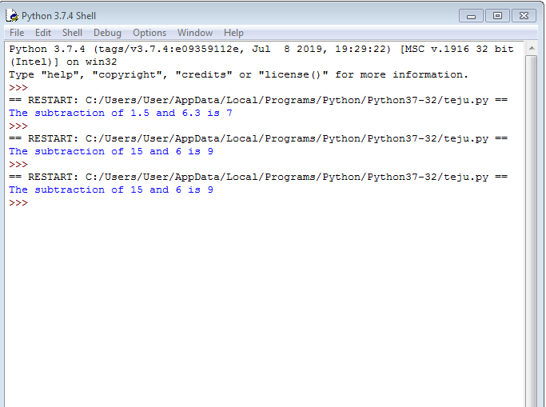

**Program no2:Dynamic subtraction**

**Program-**

num1= input ('Enter frist number')

num2= input ('Enter second number')

sub= float(num1)-float(num2)

print ('The sum of {0} and {1} is {2}'.format(num1,num2,sub))

**Output-**

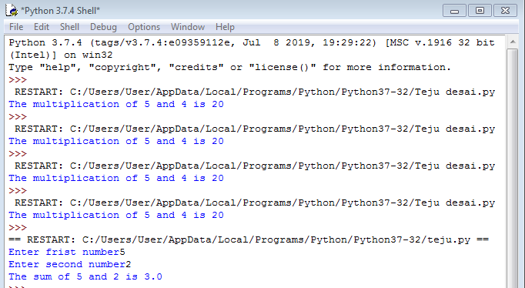

**Program no 3:static multiplication**

**Program-**

num1= 5

num2= 4

multiplication= int(num1)*int(num2)

print ('The multiplication of {0} and {1} is {2}'.format (num1,num2,multiplication))

**Output-**

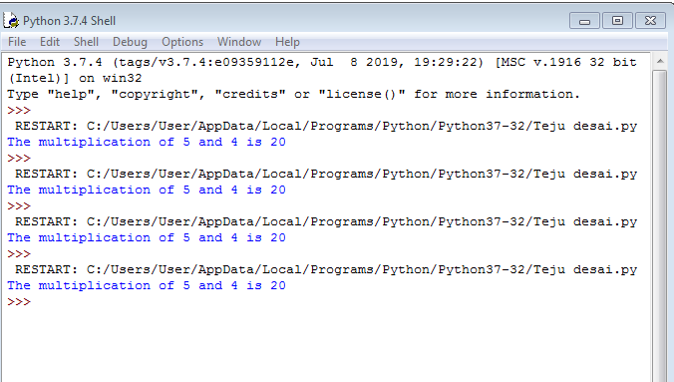

**Program no 3:Dynamic Multiplication**

**Program-**

num1= input ('Enter frist number')

num2= input ('Enter second number')

multiplication= float(num1)*float(num2)

print ('The multiplication of {0} and {1} is {2}'.format(num1,num2,multiplication))

**Output-**

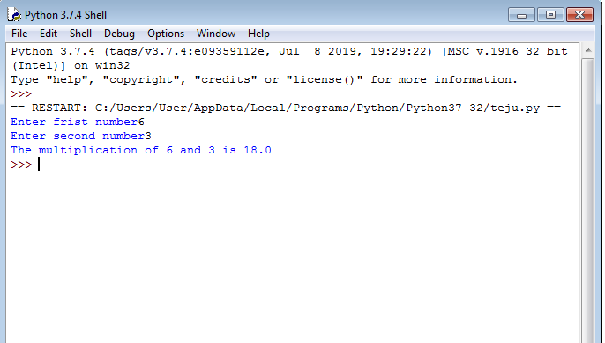

**Program no 4:static division**

**Program-**

num1= 12

num2= 6

division= int(num1)/int(num2)

print ('The division of {0} and {1} is {2}'.format (num1,num2,division))

**Output-**

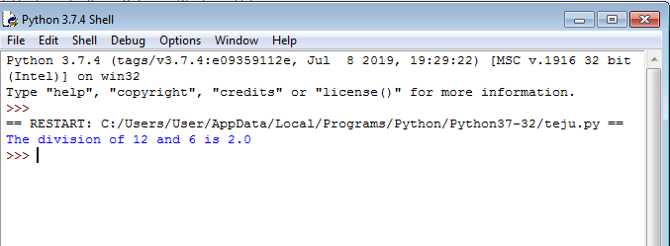

**Program no 4:Dynamic division**

**Program-**

num1= input ('Enter frist number')

num2= input ('Enter second number')

division= float(num1)/float(num2)

print ('The division of {0} and {1} is {2}'.format(num1,num2,division))

**Output-**

