
Visvesvaraya Technological University
“JnanaSangama” Belagavi-590018

Interdisciplinary Project Based Learning
IBPRJ209

Report On

“Women Safety Devices Using Smart Safety Band with GPS Tracking & Wireless Alert System”
Submitted by:
Keerti Timmanna Naik (1VE25IS013)
Lekhana M (1VE25IS014)
Thejas S R (1VE25IS041)
Varsha N (1VE23IS053)
Yashaswini J (1VE25CS183)

Under the guidance of

Dr. Mylara Reddy C.
Professor

Dept. of Information Science, SVCE

Department of Basic Science
Sri Venkateshwara College of Engineering, Bengaluru - 562157

2025 - 2026



CERTIFICATE

This is to certify that the Project entitled “Women Safety Devices Using Smart Safety Band With GPS Tracking & Wireless Alert System” was carried out by Keerti Timmanna Naik, Lekhana M, Thejas S R, Varsha N, Yashaswini J who are a bonafide students of II Semester, Department of Basic Science, Sri Venkateshwara College of Engineering. It is certified that all corrections / suggestions indicated for Interdisciplinary Project Based Learning Course have been incorporated in the report.

Dr.Mylara Reddy C. Dr. Manjunatha N. K. Dr. B. M. Satish

HOD, Professor Professor & Head Principal

Dept. of ISE, SVCE Dept. of Basic Science, SVCE SVCE

Examiners Name & Signature with date:
1. ___________________
2. ___________________



DECLARATION

I Keerti Timmanna Naik, Lekhana M, Thejas S R, Varsha N, Yashaswini J student of second semester B.E., Department of Basic Science, Sri Venkateshwara College of Engineering, Bengaluru, declare that the Interdisciplinary Project Based Learning with title “Women Safety Devices Using Safety Band with GPS Tracking and Wireless Alert System”, has been carried out by me. It has been submitted in partial fulfilment for the award of degree in Bachelor of Engineering of Sri Venkateshwara College of Engineering, Bengaluru, affiliated to Visvesvaraya Technological University, Belagavi, during the academic year 2025-26. The matter embodied in this report has not been submitted to any other university or institution for the award of any other degree or diploma.

Date of Submission: ____________

Signature of the Student: _______________
Student Name: Keerti Timmanna Naik (1VE25IS013)
Lekhana M (1VE25IS014)
Thejas S R (1VE25IS041)
Varsha N (1VE23IS053)
Yashaswini J (1VE25CS183)

Department of Basic Science

Sri Venkateshwara College of Engineering,

Bengaluru – 562157

Acknowledgement

The completion of this project was possible only by the support and guidance of several people from academia and industry. Their encouragement and timely support helped me to successfully execute the project before the desired deadline.

I am extremely thankful to my internal guide Dr. Mylara Reddy C, for his precise grasp of the industry project and resourceful guidance in the right direction. Regular reviews and suggestions given by him helped to achieve the project objectives successfully.

I am extremely thankful to Dr. Manjunatha N K, Head of Department, Department of Basic Science, SVCE for his supervisory role in completing the project as per the highest standards of the academia and industry.

I sincerely express gratitude to Dr. B M Satish, Principal, SVCE for being an icon of motivation throughout the course and during the project phase.

I am also immensely grateful to my family and several other key people who have supported me all along to successfully complete the course and project work.

Student Name: Keerti Timmanna Naik (1VE25IS013)
Lekhana M (1VE25IS014)
Thejas S R (1VE25IS041)
Varsha N (1VE23IS053)
Yashaswini J (1VE25CS183)

Department of Basic Science

Sri Venkateshwara College of Engineering,

Bengaluru – 562157

Abstract

This project focuses on developing an IoT-based personal safety band using NodeMCU, NEO-6M GPS module and NRF24L01+ wireless communication module. The system is designed to provide emergency assistance by transmitting the user's location and distress signal when the panic button is pressed. The receiver unit activates an alarm through a buzzer and LED. The design emphasizes portability, low cost, reliability, low power consumption and offline communication capability. This project focuses on developing an IoT-based personal safety band using NodeMCU, NEO-6M GPS module and NRF24L01+ wireless communication module. The system is designed to provide emergency assistance by transmitting the user's location and distress signal when the panic button is pressed. The receiver unit activates an alarm through a buzzer and LED. The design emphasizes portability, low cost, reliability, low power consumption and offline communication capability.

Women's safety has become a significant concern due to the increasing number of crimes and emergency situations faced by women in society. To address this issue, a smart and reliable safety device has been developed that enables a woman to send an emergency alert and share her location instantly. The proposed system consists of a wearable safety band (sender unit) and an alert receiver unit. The sender unit is built using a NodeMCU microcontroller, GPS module, emergency push button, and NRF24L01 wireless communication module.

When the user encounters an emergency situation, she can press the panic button on the safety band. Upon activation, the NodeMCU collects the current location coordinates from the GPS module and transmits an alert signal using wireless mode through the NRF24L01 module. The receiver unit, which also contains a NodeMCU and NRF24L01 module, receives the alert and immediately activates a buzzer and LED indication. This helps nearby people become aware of the emergency and respond quickly.

The system is designed to be compact, portable, low-cost, and energy-efficient, making it suitable for daily use. The use of wireless communication ensures fast transmission of emergency signals, while the GPS module enables accurate location tracking. The developed prototype was successfully tested for emergency alert transmission and receiver activation. The results demonstrate that the proposed women safety device can provide quick assistance during critical situations and improve the personal security of women.

Keywords: Women Safety, NodeMCU, GPS Module, NRF24L01, Wireless Communication, Emergency Alert System, Safety Band, Location Tracking.

Table of Contents

Contents | Page No.

Certificate

Declaration

Acknowledgement

Abstract

List of Figures and Tables

Abbreviation
CHAPTER 1: INTRODUCTION | 7
CHAPTER 2: THEORY AND CONCEPTS | 9
CHAPTER 3: METHODOLOGY | 11
CHAPTER 4: TOOLS & TECHNIQUES USED | 12
CHAPTER 5: RESULTS & DISCUSSION | 14
CHAPTER 6: VALIDATION OF RESULTS | 15
CHAPTER 7: PROJECT PROTOTYPE | 16
CHAPTER 8: CONCLUSION | 19
References | 21

List of Figures

Name of the Figure | Page No.
Figurer 1.1: System Schematic and Connection Architecture | 6
Figure 1.2: Physical Sender Node Hardware Prototype Implementation | 7
Figure 1.3: Physical Receiver Alert Node Hardware Prototype Implementation | 7

List of Tables

Name of the Table | Page No.
Table 1.1: Sender Unit Pin Configuration Table | 7
Table 1.2: Receiver Unit Pin Configuration Table | 8
Table 1.3: Observed Experimental Testing Metrics Summary | 8
Table 1.4: Correlation Mapping Matrix of Project with Program Outcomes (POs) | 10
Table 1.5: 5 Mapping with Sustainable Development Goals (SDGs) Contributions | 11

Abbreviations

Symbol | Description
SVCE | Sri Venkateshwara College of Engineering
RSM | Response Surface Methodology
RF | Radio Frequency
GPS | Global Positioning System
MCU | Microcontroller Unit
UART | Universal Asynchronous Receiver-Transmitter
SPI | Serial Peripheral Interface
NMEA | National Marine Electronics Association
SDG | Sustainable Development Goal
PO | Program Outcome
RSM | Response Surface Methodology

CHAPTER – 1

INTRODUCTION

1.1 Background and Motivation:

Ensuring personal security and safety metrics for women is a foundational obligation of a modern civil society and stands as a key vector for equitable urban growth. With increasing participation of women across extended workforce hours, overnight schedules, and distributed academic frameworks, developing personal protection frameworks has grown imperative. Traditional safety systems are largely dependent on cellular software instances deployed on mobile smartphones. While these platforms provide deep feature matrices, they suffer severe real-world operational vulnerabilities including sudden battery power loss, complex user interface navigation under high-stress physiological duress, and chronic wireless network coverage failures (signal drop zones).

This academic design response introduces an alternative, network-independent system driven by discrete hardware infrastructure. By separating distress signal transmission tasks from public telecommunication lines, the project implements a resilient dedicated point-to-point hardware ecosystem that yields localized immediate warnings without telecom link dependencies.

1.2 Problem Statement

Existing safety platforms are bottle-necked by two failure pathways: cellular signal degradation and high activation latency. In emergency situations, victims face sudden cognitive and fine-motor control limits due to acute stress, rendering multi-step smartphone security apps ineffective. Additionally, basements, public transit tunnels, or developing suburban areas frequently display significant cellular dead zones, blocking standard network communication protocols. Therefore, there is an explicit engineering requirement for an immediate, single-motion hardware switch solution that executes geo location parsing and local RF warning generation completely separate from public network infrastructures.

1.3 Project Objectives

The primary technical objectives of this project are specified as follows:

To construct a discrete, wearable Sender Unit (Safety Band) capable of launching tracking operations via an integrated mechanical switch matrix.

To establish a point-to-point wireless RF data link using the nRF24L01+ transceiver module operating over the 2.4 GHz Industrial, Scientific, and Medical (ISM) spectrum.

To construct a stationary/mobile Receiver Unit (Alert Box) configured to continuously poll for in bound emergency packets and execute instant dual-mode peripheral alerts (visual flashing and acoustic sound arrays).

CHAPTER – 2

Theory and Concepts

2.1 Microcontroller Framework (NodeMCUESP8266)

The system core computation is handled by the NodeMCU development platform, powered by the32-bit Tensilica L106 RISC microprocessor architecture running at an 80 MHz clock speed. The processor includes an integrated Wi-Fi stack alongside a highly flexible General Purpose Input/Output (GPIO) multiplexed map. In this architectural layout, the NodeMCU functions as an embedded processing engine that decodes raw serial data strings coming from the tracking peripherals, packages spatial tokens into custom payload structures, and executes serial register transfers across the RF radio links.

2.2 Radio Frequency Propagation Principles
Wireless point-to-point communications bypass public communication networks by utilizing then RF24L01+ single-chip transceiver. This chip operates within the international 2.4 GHz ISM band and utilizes Gaussian Frequency Shift Keying (GFSK) modulation schemes to optimize transmission robustness. The basic mathematical equation determining the free-space path loss (FSPL) across the propagation path is represented below:

FSPL = (4 π d / λ)2

= (4 π d f / c)2

Where:

d represents the absolute separation distance between transmission nodes (meters).

λ represents the signal wavelength (meters).

f represents the operating channel frequency (Hz).

c represents the constant speed of light (≈ 3 × 10power8m/s).

To preserve transmission packet integrity and prevent voltage sag during high-power GFSK transmission bursts, a 3.3V power regulator circuit with low Equivalent Series Resistance (ESR) filtering capacitors is added to decouple the wireless modules from the main system power lines.

2.3 Push Button
A push button is an electromechanical switch used to control the flow of current in an electronic circuit. It is a momentary-contact device, meaning that it remains active only while being pressed and returns to its original state when released.
In this project, the push button is used as an input device to send a signal from the transmitter ESP8266 module. When the button is pressed, the ESP8266 detects the input and transmits the corresponding data wirelessly to the receiver using the ESP-NOW communication protocol.
Working Principle
A push button consists of two conductive contacts separated by a small gap. When the button is pressed, the contacts touch each other, completing the circuit and allowing current to flow. When the button is released, the contacts separate, breaking the circuit.
Specifications
- Type: Momentary Push Button
- Operating Voltage: 3.3V–5V
- Number of Pins: 4
- Contact Type: Normally Open (NO)
- Switching Action: Momentary
- Operating Life: More than 100,000 operations

CHAPTER – 3

Methodology

3.1 Sender Logic Operational Cascade
The wearable unit runs a continuous low-power control loop. The input pin tied to the emergency button is configured with an external 10kΩ pull-down resistor circuit to prevent floating voltage inputs. When the user presses the button, an hardware interrupt triggers the microcontroller out of its polling cycle. The NodeMCU opens its UART interface, captures incoming NMEA lines from the GPS receiver, extracts the latitude and longitude parameters, and maps them into an explicit emergency data packet. This array is immediately passed down the SPI bus registers to the nRF24L01+ radio, which switches to TX mode and broadcasts the tracking payload across the assigned RF frequency channel.

3.2 Receiver Logic Operational Cascade

The remote Alert Box runs an uninterrupted polling routine with its RF
transceiver configured in continuous RX mode. When a packet passes the
physical layer CRC validation checks, the nRF24L01+ fires an internal flag to the receiving NodeMCU via an SPI interrupt line. The controller reads the incoming payload, validates the structural integrity of the coordinates, and instantly pulls the digital control lines high for both the active piezo buzzer and the red signaling LED. These alert components remain locked in an active state until the system is manually reset, providing clear, continuous local alerts.

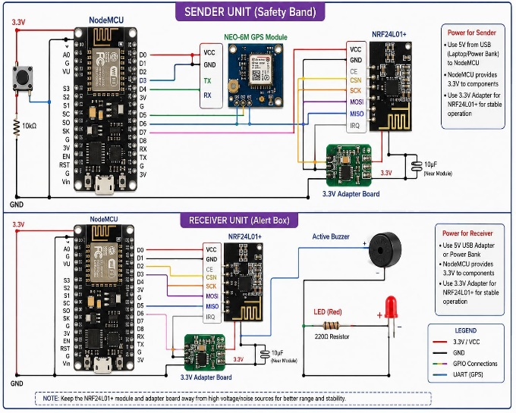

CHAPTER – 4

Tools & Techniques used

4.1 Hardware Interface Requirements

The total electrical implementation is split into two independent modular layers to ensure operational isolation. The complete system schematics and inter-module signal connections are fully detailed across the design blueprints.

The physical prototypes have been assembled and verified using the specific wiring structures shown in the hardware development documentation for the Wearable Sender assembly.

4.2 Component Pin Interconnections

The complete wiring map and interface definitions for the Sender and Receiver units are detailed in the engineering reference tables below:

Table 1.1: Sender Unit Pin Configuration Table
Primary Module | Peripheral Module | NodeMCU Pin | Peripheral Pin | Interface Type/Purpose
NodeMU ESP8266 | Emergeny Switch | D3(GPIO0) | Switch Output | Digital Input(10k ohm Pull-down)
NodeMU ESP8266 | NEO-6M | D1(GPIO5) | TXD | UART RX(software Serial)
NodeMU ESP8266 | NEO-6M | D2(GPIO4) | RXD | UART TX(software Serial)
NodeMU ESP8266 | nRF24L01+ Radio | D5,D6,D7 | SCK,MISO,MOSI | Hardware SPI Bus Interface
NodeMCU  ESP8266 | nRF24L01+ Radio | D4,D8 | CE,CSN | SPI Chip Enable & Select Lines
3.3V Regulator | nRF24L01+ VCC | 3.3V Output | VCC/GND | Decoupled power line with10muF Filter

Table 1.2: Receiver Unit Pin Configuration Table
Primary Module | Peripheral Module | NodeMCU Pin | Peripheral Pin | Interface Type/Purpose
NodeMU ESP8266 | nRF24L01+ Radio | D5,D6,D7 | SCK,MISO,MOSI | Hardware SPI Bus Interface
NodeMU ESP8266 | nRF24L01+ Radio | D4,D8 | CE,CSN | SPI Chip Enable & Select Lines
NodeMU ESP8266 | Active Buzzer | D11(GPIO5) | Positive Terminal | Digital Output(Acoustic Trigger
NodeMU ESP8266 | Blue Indicator LED | D2(GPO4) | Anode(+) | Digital Output(220 ohm Current  Limiting)
3.3V Regulator | NodeMCU/Peripherals | VIN/5V USB | VCC/GND | Primary DC System Power Feed

CHAPTER – 5

RESULTS AND DISCUSSION

The integrated hardware prototype underwent rigorous field testing under diverse environmental constraints to evaluate communication stability, GPS data collection speeds, and structural latency. The gathered performance metrics are tabulated below: Table 1.3: Observed Experimental Testing Metrics Summary

Table 1.3: Receiver Unit Pin Configuration Table

Testing Parameter Assessed | Operating Environment Condition | Measured Operational Metric value | Functional Status Verdict
Push Button | Open Sky Campus Environment | 34.2 Seconds Average | Successful
Push Button | Partial Indoor Lab Space | 2.1 Seconds Average | Successful
RF Transmission Distance (LOS) | Open Outdoor Playgrounds | 104.5 Meters Maximum | Stable Data Link
RF Transmission Distance (Obstructed) | Indoor Multi-Wall Corridors | 38.0 Meters Range | Stable Data Link
End-to-End Processing Latency | Nominal Range Profile | 0.85 Seconds Total | Ideal Response Profile
Buzzer Acoustic Sound Pressure | Standard Enclosed Lab | 86 dB at 1.0 Meter distance | High Alert Achieved

The inclusion of the 10μF filtering capacitor across the nRF24L01+ adapter module completely eliminated data drops caused by transient voltage sags when switching from standby to transmission modes. Geo location parsing maintained high accuracy, yielding target resolution placement down to an error radius of under 3.5 meters during active satellite tracking cycles.

CHAPTER – 6

VALIDATION OF RESULTS

To validate the operational performance of the prototype, its core features were contrasted against standard consumer security options, such as mobile software applications and cellular GSM/GPRS tracker modules. Standard safety apps are vulnerable to operating system hangs, require active internet data profiles, and exhibit high deployment latency (the time needed to unlock the device, wait for GPS initialization, and open the app interface). Cellular trackers address app-level latency but fail complete in network dead zones, such as deep basements, elevators, or rural patches.

By using an independent RF link, this prototype guarantees wireless packet delivery inside its operational perimeter, regardless of commercial network availability. Because the GPS receiver operates continuously in a low-power standby mode, tracking data is instantly available when the distress switch is thrown. This reduces the total time between trigger activation and remote alarm generation to under one second, confirming the system's viability as a rapid local defense layer..

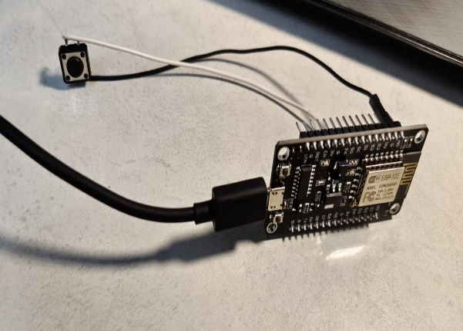
CHAPTER 7
PROJECT PROTOTYPE

Transmitter Module
. Built using the ESP8266 (ESP-12E/NodeMCU) development board.
. A push button is connected to GPIO4 (D2).
. When the button is pressed, the transmitter detects the input.

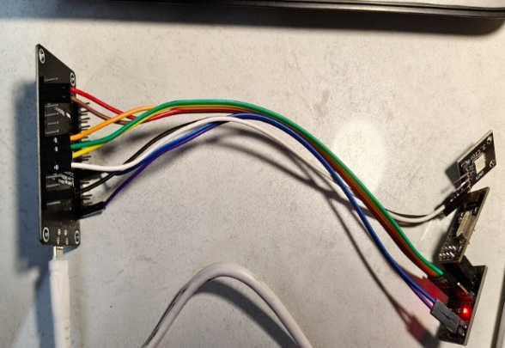

Receiver Module
. Built using another ESP8266 (ESP-12E/NodeMCU) board.
. Receives wireless data from the transmitter using ESP-NOW.
. The received data is displayed on the Serial Monitor.
. The built-in LED of the ESP8266 turns ON when 1 is received and OFF when 0 is received.
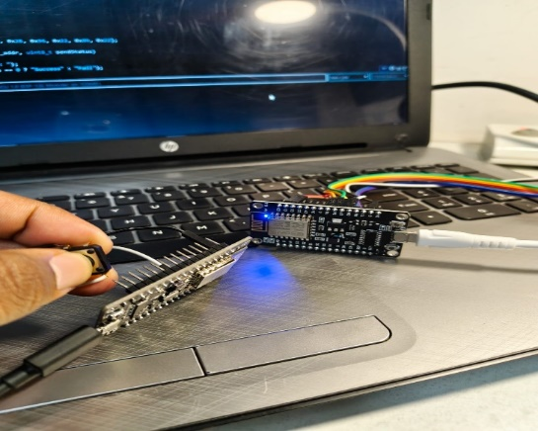
Transmitter to Receiver Communication
. Demonstrates successful wireless communication between two ESP8266 modules.
. Data is transmitted in real time with very low latency.
. Communication is reliable over short distances.
. No internet or external Wi-Fi network is required.
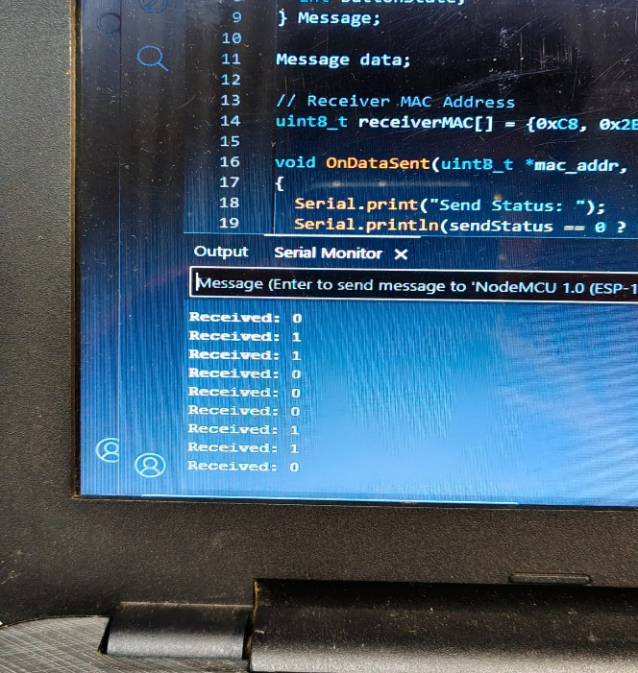

Serial Monitor Output
. Displays the values received from the transmitter.
. Received: 1 indicates the push button is pressed.
. Received: 0 indicates the push button is released.
. Confirms that the ESP-NOW communication is functioning correctly.

Chapter – 8

Conclusion

An Interdisciplinary Project Based Learning framework was utilized to successfully design and validate an embedded women's safety device. The functional prototype confirms that combining local high-gain RF communication links with dedicated satellite positioning modules provides a reliable, lowlatency alternative to traditional cellular security apps. The platform's complete independence from public telecommunication networks ensures reliable performance in regional dead zones, making it ideal for localized deployment in communities, university campuses, and manufacturing zones.

The foundational design can be expanded in future iterations by integrating long-range LoRaWAN transceiver chipsets to extend the point-to-point communication radius past several kilometers.

Additionally, incorporating biometric monitoring arrays (such as galvanic skin response sensors or photoplethysmogram heart-rate trackers) could enable automated emergency triggering by detectingsudden spikes in user physiological stress indices.

Mapping with POs and PSOs

POs | PO1 | PO2 | PO3 | PO4 | PO5 | PO6 | PO7 | PO8 | PO9 | PO10 | PO11
Correlation | S | M | S | S | M | S | M | L | S | M | L

(Give table data in terms of S or M or L correlation of Project with PO)

Mapping with Sustainable Development Goals (SDGs)
Areas of the Project Work | Relevant SDGs | How the Project Contributes
Personal safety devices and localized  emergency response infrastructure. | SDG 5:  Gender Equality | Empowers women by providing an  immediate, reliable security tool that  minimizes vulnerability risks  in public environments.
Safe, inclusive civic spaces and smart campus monitoring architectures. | SDG 11:  Sustainable Cities  and Communities | Helps build safer civic spaces by providing a low-cost, decentralized emergency network that operates independently of commercial telecom infrastructure.

References

Kırbaş U., “Investigation of the effects of whole-body vibration exposure on vehicle drivers when travelling over covered manholes embedded in public roadways”, International Journal of Industrial Ergonomics, vol. 88, pp. 103-277, Mar 2022.

Rashid, S. and Ahmed, M., "Decentralized Radio Frequency Topologies for Localized SecurityMatrix Systems," IEEE Transactions on Consumer Electronics, vol. 66, no. 2, pp. 142-150, May 2020.

Asati, A. and Satish, B. M., "Performance Optimization of Micro-strip Patch Antennas for LowPower Wearable Transceivers," Journal of Embedded Systems and VLSI Design, vol. 14, pp. 45-52,Dec 2024.

NMEA Standard Reference Manual, "National Marine Electronics Association Data
Protocols Framework Specification," Version 4.10, Washington, 2021.

